SCHOENBRUNN COMMUNITY MORAVIAN CHURCH
Christ called, Christ centered, Christ sent…loving all.
2200 EAST HIGH AVENUE

NEW PHILADELPHIA, OH 44663
Phone 330.339.1940
Website: scmchurch.org

Good Friday Tenebrae

Readings for Holy Week – April 7th, 2023

Pastor Rev. Ben Lippert
Music Director/Organist Angie Miller
Holy Week Readers Paula Drumm
Missy Martin
Ministers All of Us!

***********************************************************************************
“Watchword for Good Friday – “For God so loved the world that he gave his only Son, so that everyone who believes in him may not perish but may have eternal life.” John 3:16 †
***********************************************************************************
Please sign the friendship register and pass down your pew, then to the pew behind you. Thank you!

Welcome and Announcements

Prelude

*Hymn "Were You There" # 354

Holy Week Readings The Acts of Friday #84-106 or 108
(Pg. 95-122 or Music Ed. Pg. )

(Please Leave in Silence)

*Please stand, as able.
† Reprinted with permission from "Moravian Daily Texts 2019" © 2018
Interprovincial Board of Communications, PO Box 1245, Bethlehem, PA, 18016-1245.
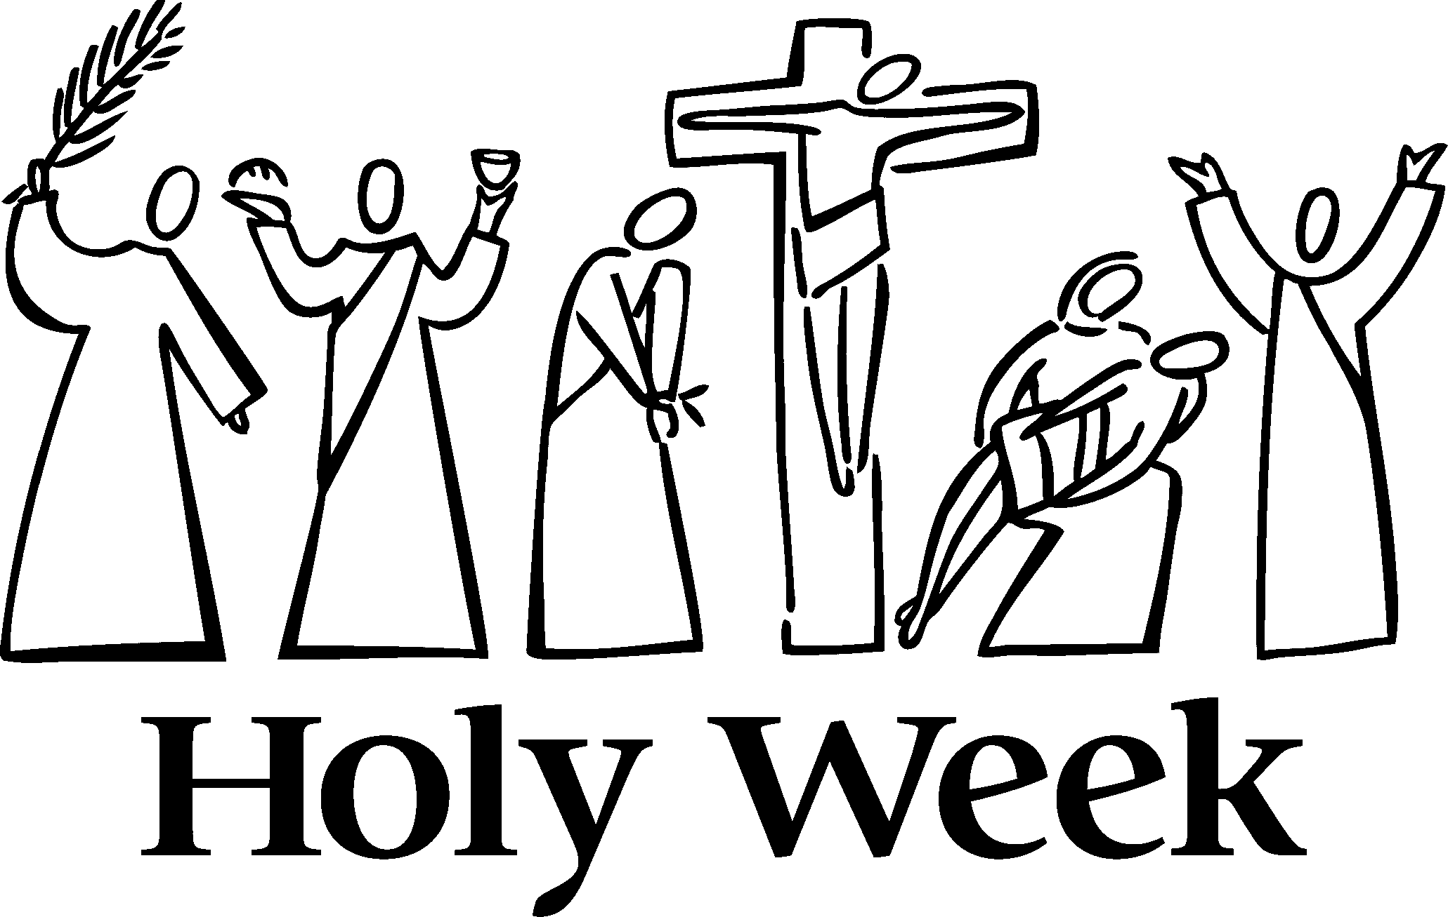

Monday, March 25th – Wednesday, March 27th
7:00 PM – Holy Week Readings @SCMC 7 p.m.
Maundy Thursday, March 28th
7:00 PM – Worship/Holy Communion @ SCMC 7 p.m.
Good Friday, March 29th – Good Friday Tenebrae Service @ SCMC 7 p.m.
Great Sabbath, Saturday, March 30th
10:00 AM – Easter Egg Hunt at Schoenbrunn Moravian
Easter Sunday, March 31st
7:00AM – Sunrise Service at Schoenbrunn Village
9:15 AM – Combined Sunday School
10:30 AM – Worship

Prayers of the People
Church and World: For all families and churches of Tuscarawas County; for the ministries of our Eastern District and Northern Province; for the shared work of the worldwide Moravian Unity; for all who risk their lives for the gospel; for refugees and victims of natural disasters and violence around the world and for those who work to provide shelter, healing, and peace. We think especially of the people of Ukraine.
Military and Families: Jack Pasquinelli, Carter Baker, Adam Porter, Bret Penik, Kyle Springer, Nathan Zinser, Anna Sandoval, Ben Miller.
Healing, Comfort and Peace: Veronica Knisely, Callie Reynolds, Paul Robinson, Caroline Duprow, Tim and Tammi Reynolds, Todd Reynolds, Joyce Troyer, Mike Slater, Joe McDonald, Tyler Kastor, Shirley Hill, Missy Martin, Alvin Conkey, Doris Gardner, Joan Beorn, Julie Kerns, Fred Sullivan, Jackie Pasquinelli, Scott Weston, John Bihari, Shawn Regula, Evan Davis, Rev. Brandon Keck, Jack Moore, Steph Heavilin, Rev. Scott Anderson, Janet West, Rev. Steve Patrick, Tyler Cox, Tammy Bennett.
Families Bereaved: Fred Sullivan, James Knisely II, Frank Reynolds.

Homebound Members and Friends: Lynne Capretta (Northwood Inn), Janet West (Hennis).

