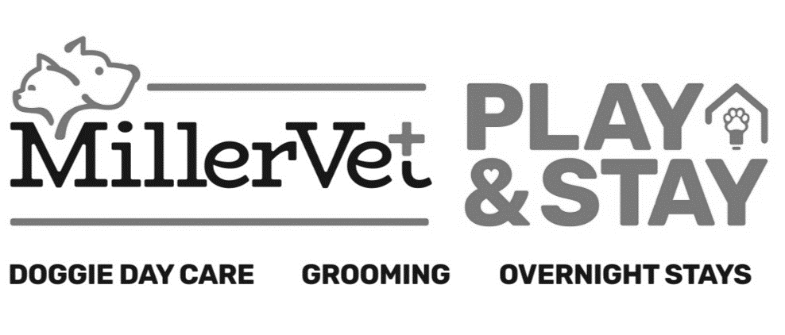
Select Kennel Size –
Extra Small ($32/night) Small ($36/night)
Medium ($40/night) Large ($44/night)
Feline ($23/night) Feline Suite ($25/night)

(470) - 363 – 8578
2242 Roswell Road Marietta, Georgia 30062

Boarding Information
Pet’s Name:  _____________________________ |  |  | Boarding dates: _________________________________ |  |  | Check out time is 12:00 noon during the week and holidays. An additional charge will be added for late check-outs. Sunday hours are 5 to 6 p.m. only.
By signing below, you are acknowledging that all information below is correct, and you agree to the waiver and release you previously signed.
X_______________________________________________
Would you like any services while your pet stays with us during this stay?
Exit Bath  Includes nail trim and ear cleaning. Please let us know what day you would like this scheduled.  *Prices vary based on size; Anal gland expression upon request | Nail Trim  $15.00 per pet  Nail Dremel  (Electric nail grind)  $20.00 per pet |  | Full Groom or Mini Groom  Prices vary based on cut and size. Appointment only, based on availability during stay. |  | Vet Services  If checked, please fill out back sheet. Must be scheduled beforehand with clinic.
Temperament Test for Doggie Day Care  $15 per pet  FREE WITH BOARDING  **Additional paperwork needed |  | Doggie Day Care  $12 per day per dog  Monitored group play with other dogs |  | Individual Play Time  $8 per day per dog  30 minutes of one-on-one time with staff members

Feeding Information
(Please note there is an additional fee if we have to use our kennel food, this includes if you bring your own food, but it runs out before picking up)
Brought own food?  Yes No |  | How much per serving? |  |  |  | How many times a day?
*** Food Allergies? *** Yes / No
If yes, please list: _________________________________________________________________________
Personal Items
Please list all personal items you will be leaving for boarding visit. This includes bedding, bowls, toys, etc.
_________________________________________________________________
Medication Information
Medication Name: | How many times per day is it given? |  |  | Time & Quantity  (please include AM/PM) | How do you administer it?  (we provide peanut butter, pill pockets, wet food or we can give by hand)

