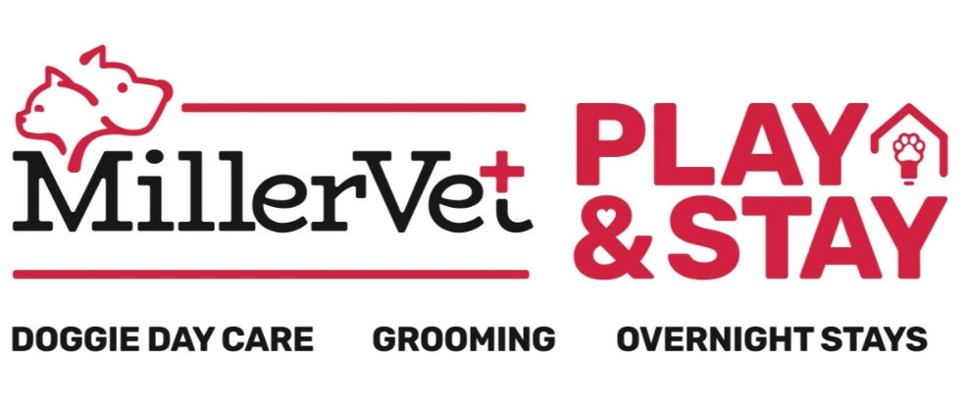
BOARDING SUITE
# _____________________

(470) - 363 - 8578
2242 Roswell Road Marietta, Georgia 30062
Boarding Form
Pet’s Name:  __________________________ |  | Date:  __________________________ |  | DAY BOARDING
Client Name: |  |  | Client Phone Number in case we need to contact during boarding stay:
Do you authorize anyone else as a designated representative to pick up your pet from boarding? Yes / No
If yes, please list: Name: ________________________________Number: __________________________
In the case that you are unavailable during an emergency, is this person authorized to make decisions on your behalf for your pet? Yes / No

Would you like any services while your pet stays with us during this stay?
GROOM/CUT BATH VET SERVICES NAIL TRIM
Feeding
(Please note there is an additional fee if we have to use our kennel food)
Food: __________________________ |  | How Much: __________________________ |  | How often: __________________________________
*** Allergies? *** Yes / No
If yes, please list: _____________________________________________________________________
Personal Items
Please list all personal items you will be leaving for boarding visit:
____________________________________________________________________________________________________________________________________
____________________________________________________________________________________________________________________________________
Medication Information
There is an additional charge for administering some medications during your pets stay. Please ask our staff if you have any questions about this.
Medication | How many times a day? |  |  |  | Time & Quantity (please include AM/PM)
Medical Release
Here at Miller Vet Play and Stay, we strive to provide your dog with excellent care and a fun experience during their stay. Although animals are supervised at all times, injuries and illness can still occur despite our best efforts. It is important that a sick or injured pet receive timely medical care. We will try to contact you and/or your designated representative if this happens. However, in the event that there is a problem and we are not able to reach you and/or your designated representative would you prefer treatment from:

**Please read through these very carefully and thoroughly before initialing**
(please initial one of the following)

______ Miller Mobile Veterinary Services and Animal Hospital

OR

______ The veterinarian listed as your preferred veterinarian on your pet's registration form

Please read and initial.

_____ My regular vet has been notified of our absence and knows they will be contacted in the case of an emergency.

Regular Vet Hospital Name: ________________________________________________________________
Veterinarian’s Name: _____________________________________________________________________
Vet Hospital’s Phone Number: ______________________________________________________________
Please read and initial.
_____ I understand that in some cases pets experience stress while boarding, this may cause diarrhea.
Please read and initial.
_____ I understand that if fleas or ticks are seen on my pet that the staff will be required to administer medication. I accept full responsibility for additional cost incurred in the treatment of ticks/fleas of my pet.

I understand all that I have read and have asked any questions for clarification of any information listed above that I did not fully understand. I am aware that no person is on the premise for 24-hour care. I hereby release Miller Vet Services/Play & Stay Resort and its representatives from any and all liability for any injuries or illnesses incurred while my pet is boarded. I also understand that Miller Vet Services/Play & Stay Resort is not responsible or liable for any personal property brought with my pet, this includes any damage, cleanliness and/or loss that may occur.
Pet Owner Signature: ____________________________________Date:____/_____/_________

Rules, Regulations & Waiver
INJURIES & ILLNESS: Here at Miller Vet Play and Stay, we strive to provide your pet with excellent care and a fun experience during their stay. Although animals are supervised at all times, injuries can still occur while dogs are playing together such as scratches, cuts or sprained joints. Such injuries are rare, but they happen at all doggie daycares. In addition, while infrequent, dogs can get into fights, even under close supervision. Common areas for bites as a result of these fights are the snout, ears, tuft of the neck and paws. At Miller Vet Play and Stay, we have procedures to screen dogs for aggressive behavior and we do not allow aggressive dogs to play with other dogs. However, even the friendliest of dogs can get into fights with very little or no warning. In addition to injuries, it is possible for dogs to transfer illness such as upper respiratory infections and kennel cough, even with the required vaccinations and boosters. This is just like at a daycare for children where illness such as pink eye and the flu can be transferred from one child to another. Such illnesses do not occur often and all pets must have the necessary vaccinations to check-in.
AGE & GENDER: Pet’s of all ages are allowed at Miller Vet Play and Stay as long as they meet the facility’s criteria of vaccinations. All dogs participating in doggie daycare must be spayed or neutered if over 6 months of age.
ABANDONMENT OF ANIMALS: I understand if I do not pick up my pet by 5 days after the agreed upon pick up date, a certified letter will be sent regarding the animal’s abandonment. Should the animal not be removed within the specified time I, the client, hereby relinquish all claims to my animal, but shall not relieve me of my contractual liability of any treatment, boarding or care furnished.
PHOTOGRAPHS: I understand that photographs, video or digital recordings are taken of the facility, pets, customers and staff on a regular basis for, among other things, use in advertising by Miller Vet Play and Stay. I acknowledge that all such images, together with prints and copyrights, therein are the property of Miller Vet Play and Stay. I give Miller Vet Play and Stay my consent, permission, and authorization, without compensation to me, to use, reproduce, and alter the images, in print and electronic format (including the internet), either alone or in combination with other texts and graphics. I waive my right to approve the finished photograph, advertising copy, print material or electronic files that may be used in conjunction with the images.
1. I agree that Miller Vet Play and Stay will not be liable for any claims of injury, illness, damage or death to my pet during its stay and that under no circumstances will Miller Vet Play and Stay be liable for consequential damages.
2. I certify that I have informed Miller Vet Play and Stay of all pet and human aggression. I agree that I am responsible for any harm caused by my dog while in the care of Miller Vet Play and Stay. I shall indemnify Miller Vet Play and Stay against any claims made against it or for losses or damages suffered by Miller Vet Play and Stay as a result of my pet.
3. I understand that, in the event my pet appears to be ill or at significant risk of experiencing a medical problem, Miller Vet Play and Stay will attempt to contact me for instructions prior to seeking veterinary care. If I cannot be reached, I agree that Miller Vet Play and Stay may use its reasonable discretion in seeking veterinary care on my behalf and I will be responsible for all related expenses. I understand that Miller Vet Play and Stay will attempt to use my preferred veterinarian, but if my preferred veterinarian is unavailable or other circumstances mandate, I authorize Miller Vet Play and Stay to use the veterinarians of its choice. I agree that Miller Vet Play and Stay will not be liable for the actions and decisions of the veterinarian. I also agree to be responsible for any reasonable fees assessed by Miller Vet Play and Stay for emergency care and transportation.
4. I authorize my veterinarian to share the medical records of my dog with Miller Vet Play and Stay and other veterinarians. I assume full responsibility for payment of all veterinary services rendered, including, but not limited to, diagnosis, treatment, necessary grooming, medical supplies, transportation, and boarding. I agree to make such payments directly to the attending veterinarian or reimburse Miller Vet Play and Stay if direct payment cannot be made.
5. I have released all medical information to Miller Vet Play & Stay about any known conditions my pet may or does have. If my pet has a medical condition that will not allow my pet to be properly vaccinated for overnight stay, I understand that my pet may be susceptible to diseases and illness such as distemper, parvo, etc., and that Miller Vet will not be liable for any illness or disease my pet may get after boarding with us.
This agreement and waiver is valid from the date below on and grants permission for future veterinary care without the need for additional authorization each time Miller Vet Play and Stay cares for one or more of my pets.
Owner Signature: ______________________________________ Date: ______/___

