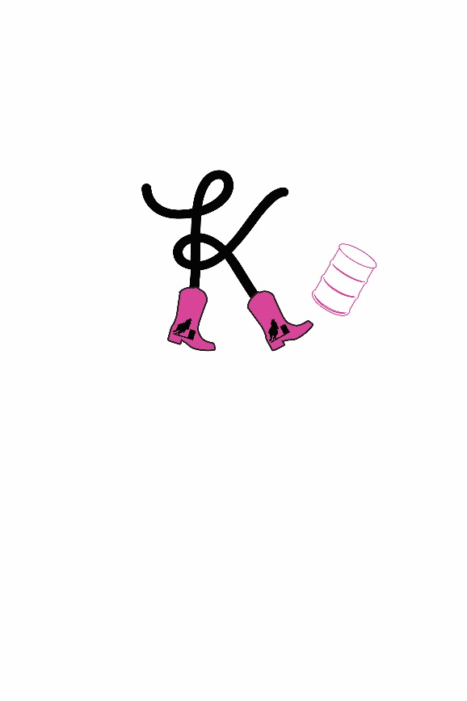
KICK EM UP CANS: Buffalo
Date: June 29th and 30th

Name
Address
City/State/Zip
Email
Phone

This barrel race is subject to the rules supplied by the Kick Em Up Cans and it’s representatives. I (we) have read and agreed to all the provisions contained therein as part of this contract. I (we) agree that ALL decisions made by the Kick EM Up Cans are FINAL. I (we) release the Kick EM Up Cans, it’s officers, employees, volunteers, sponsors, and the Johnson County Fairgrounds from any and all claims for loss or injury. This includes but is not limited to any loss or injury to myself, family members, my riders, my employees, horses, pets, vehicles, or equipment.

Signature |  | Date:
Parent/Guardian Signature:
HORSE NAME |  | Cowboy State Stallion | OPEN  All ages |  | RANCHER  All ages |  | SENIOR  50 & Over |  | YOUTH  15 & Under |  | PEE-WEE  6 & Under |  | CARRY OVER | Total | Run in Late Draw
 |  |  | Sat  $50 | Sun  $50 | Sat  $50 | Sun  $50 | Sat  $20 | Sun  $20 | Sat  $20 | Sun  $20 | Sat  $5 | Sun  $5 | Y/N |  | Y/N
1.
2.
3.
 |  |  |  |  |  |  |  |  | TOTAL FEES:
 | ALL HORSES KEPT AT THE GROUNDS MUST BE STALLED |  |  |  |  |  |  |  | STALLS X $15 (per night)
 |  |  |  |  |  |  |  |  | HOOKUPS X $15 (per night)
 | *PEE-WEE’S NO ASSISTANCE AND NO OFFICE CHARGE |  |  |  |  |  |  |  | OFFICE CHARGE |  |  |  | $20.00
 | *LATE FEES IS A ONE TIME CHARGE |  |  |  |  |  |  |  | LATE FEE’S $15.00
 |  |  |  |  | CHECK #: |  |  |  | CASH: TOTAL:

- Saturday $1,500 added. Race start time 5:00pm
- Sunday $1,500 added. Race start time 11:00am
- Cowboy State $2,500 added for both days
- Entries Postmarked by June 21st
Mail entries to:
Colette Fenster
29263 Old Hwy 87
Buffalo, WY 82834

