**TRUE WISDOM**

**TRUE IMMUNITY**

**DIET**

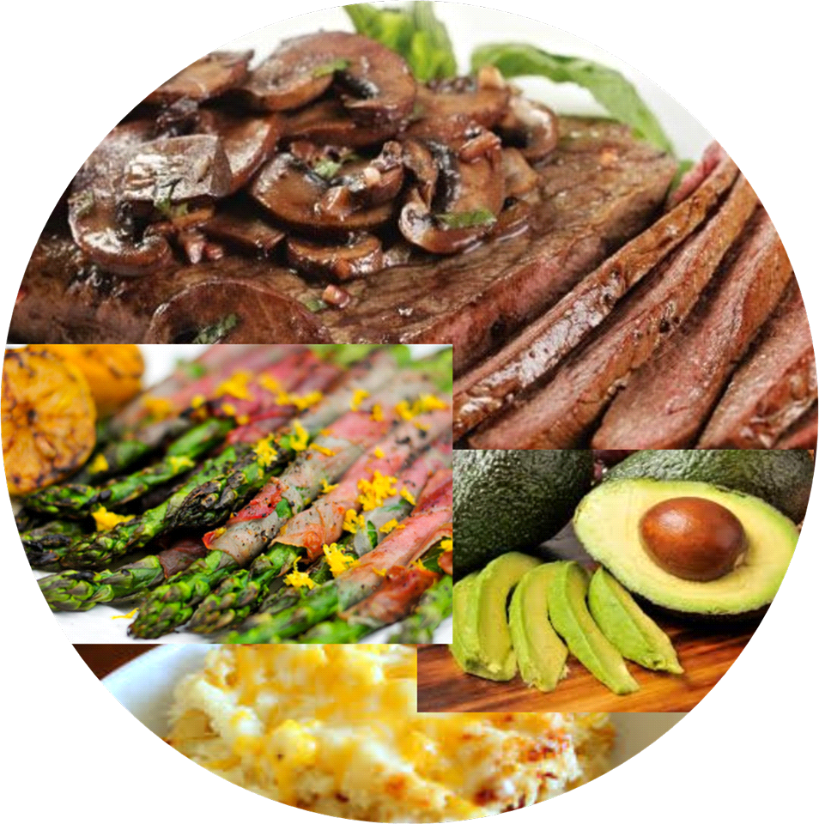

**TABLE OF CONTENTS PAGE**

**INTRODUCTION 3**

**THE DIET 6**

**CONCLUSION 10**

**FOOD LIST 13**

**MEAL IDEAS WITH PHOTOS 17**

**LINKS TO ONLINE RECIPES AND IDEAS 22**

**INTRODUCTION**

Welcome to the True Wisdom True Immunity Diet package!

This document will greatly assist you in knowing what the diet consists of, why there is a diet, what recipes you can use, photos with descriptions that will inspire you and links to approved meal recipes.

*The TWTI Diet is necessary for the quickest path to*

*curing disease and bringing immunity.*

We have developed this package to assist you in smoothly and easily changing your eating choices to successfully complete the TWTI treatment.

After the treatment is completed, you will be able to go back to normal eating habits, except without many of the fears over food that you may have had before.

The dietary period is a combination of:

* The state of your health before TWTI treatment
* Your age
* The nature of your signs and symptoms
* The amount and quality of sleep and rest you get during the dietary period

The following are the most common dietary periods for consideration:

* 7 days for children not seriously ill.
* 14 days for most adults up to age 50, not seriously ill.
* 21 days for most adults over 50, not seriously ill.
* 30 days for the seriously ill.

More time on the diet may be assessed based on firsthand experience during treatment. If someone undergoing treatment runs into some extenuating circumstances out of their control or our control, we may need to add a few days more. Examples of extenuating circumstances would be some form of life tragedy upsetting one’s peace of mind.   
Your practitioner will test your immune functions during the process. The results will indicate the speed at which you are being cured of disease and attaining immunity. The repair phase of resumed immune functions will continue for some time after True Wisdom True Immunity treatment – up to many months depending on the conditions you have.

This includes conditions in your body that are addressed by fully restarted immune functions, but that exist outside of actual disease.

For example:

* Bone spurs
* Nail regrowth from fungus *in* the body
* Negative viral test can take 6 months to a year for existing antibodies to age and naturally die off. Though there is no proof viruses exist, antibody counts drop into negative range in a year or less and all so called signs and symptoms of supposed "viral" diseases can disappear in a matter of weeks except warts which can take two to three month to slough off.
* Fertility can require two to eight months, however those who have waited many years to be cured may never become fertile if the existing organs have been permanently damaged.
* Panic Attacks with difficulty breathing may take up to two months to fully address and eliminate.
* Migraines can sometimes take a full chemical makeover causing some people to require 2 to 3 months after immunity is established.
* Any restoration that requires complete cell replacement can take some time after immunity is restored.

The above list is the most common issues that requires added time. Most diseases can be eliminated fully in a month.

*We highly recommend being familiar with the Beliefs chapter in the True Wisdom True Immunity Guide, to help you to see that being immune to disease and having your body’s immune function operating fully – as they were designed to do – will free you from any fear-based dietary choices post-TWTI treatment.*

The foundation of the treatment that is True Wisdom True Immunity rests in acknowledging that curing of disease, biological repair and immunity to disease is accomplished by *YOUR* brain’s immune functions being commanded to do their job, *WITHOUT* the need for special dietary concerns (outside of the treatment period), including ‘nutritional’ food, ‘health foods’, pills, supplements, herbs, any water other than good ol’ H2O that tastes good. Specifically – *NOTHING* external to your body.

**THE DIET**

Simply stated:

*NO CARBOHYDRATES AND NO SUGARS, INCLUDING FRUIT*

*DAIRY PRODUCTS AND MILK ALLOWED WITHOUT ADDED SUGAR*

The True Wisdom True Immunity diet is UNIQUE.

You may think that it is like this or that other diet, but there are some key important differences. If the TWTI Diet is like anything else, it most closely resembles the Atkins diet. Though it closely resembles the Atkins diet, it's purpose does not.

It holds to different rules and understanding of diet as per the unique approach to True Wisdom True Immunity. It is based upon years of development to ensure it works for its intended purpose – to *assist* the full resumption of immune functions in a timely fashion.

The TWTI diet is intended for the period of the treatment only, and after the diet is completed, you may gradually begin consuming carbohydrates and sugars.

**NOTE**:

* Adequate water is mandatory for obtaining and maintaining full immunity. However, tapering off drinking water in the late afternoon or evening is critical so one can maintain sleep without having to get up to urinate. Purified H20, a.k.a. plain water is the key to aiding immune functions and maintaining them. Once you experience simple purified water and you use it to establish your full immunity, you will be able to easily recognize water that is not pure H2O and use your own taste buds for quality control.
* Constipation is common during the treatment period, likely because the body extracts as much nutrition as it can, potentially causing bowels to compact with some brief discomfort.

**WHY IS THERE A DIET?**

The diet was developed over many years to assist

resumption of immune functions in a timely manner.

Following the diet closely, for the appropriate time period for YOU, is important because:

* This is the quickest way to establish immunity and makes it possible to avoid side effects sometimes observed during healing processes and killing of pathogens. An example of a ‘side effect’ would be migraine headaches – thus the need for adequate water which will help avoid this. Obviously, the existing signs and symptoms of existing disease may still be there during the time of treatment, until the body finishes the cure. We can prevent most signs and symptoms with the treatment alone.
* Cheating or being sloppy with diet will draw the diet period out *much longer*
* Precise testing allows for knowing if immunity is *holding* and *set,* or whether a longer period is needed.

Additionally, after the True Wisdom True Immunity treatment, the Diet assists the resumption of immune functions for the following suggested reasons.

We speculate these are the reasons since there is no science conducted yet to confirm the Why.

* It takes a tremendous amount of energy – calories – for the body to take the ACTIONS that the brain is commanding to immune system functions. The TWTI Diet supports this caloric need.
* In general, fungus inside the body forms very quickly and can overwhelm the body, which then produces many different signs and symptoms called ‘disease’. The diet of no carbs, no sugars STARVES the fungus, making it easier for the body and its immune functions to get a handle on it, until it and it alone will deal with any fungus.

Furthermore, *during the diet and after*, the following are important complementary factors:

* It takes a lot of SLEEP and REST to allow for periods of time where the body ONLY focuses on **healing and repair.**
* It takes a lot of water for the body to flush out anything that does not serve biological balance. Water that is pure and tastes good is the guide here.
* Do not use antiperspirants, including many deodorants. It is critical to keep the lymphatic system open and clear to flush out toxins.
* If you need to use something, we recommend salt crystal based products whose key function is controlling armpit bacteria.

*When immune function is restored, the diet may be ended.*

*The person who treated you will directly help you with this determination.*

Because of this document, you will find that the diet is not so bad after all. There is a growing list of approved foods as more people are conducting the diet and getting creative. They key is to not get hung up on the diet as we are focusing primarily on restoring immunity to your body, so we have found that for most folks, a couple or few weeks of this diet are easily completed.

**NOTE:** Our repeated experience is that the human body cures all disease within, on average, ***two weeks*** when:

* True Wisdom True Immunity commanding Immune System ON
* True Wisdom True Immunity Diet followed closely for recommended time-period
* Plenty of uninterrupted, good quality sleep: 8 to 10 hrs
* Plenty of good clean water
* Low stress in life, including releasing harmful beliefs about health

At the point of immune functions ‘setting’, the body will continue with biological repairs to all aspects of human physiology in the immune system’s domain.

It can take a little longer for those who are very ill or much older.

If in the future, immune functions fail again, they can be reset with usually only 7 days on the TWTI Diet being required.

**REASONS WHY IMMUNE FUNCTIONS FAIL**

Thus, you may ask: I did the diet, I had the TWTI treatment, why would that immune function ever fail again?

* Reckless living: alcoholism and drug use. Excessive exercise without adequate water and rest.
* Lack of good quality sleep – 8 to 10 hours a night
* Stressful life or extended physical or mental trauma – i.e. your job, or family life
* Holdover beliefs that only harm you – i.e. that you need something outside of you to be ‘healthy’.
* Starvation
* Fear
* Dehydration

The GREAT NEWS is that being a trained True Wisdom True Immunity practitioner, you can accurately know the status of immune functions and tune yourself up at any time! You only need a willing arm to pull on!

Therefore, being trained in TWTI is preferable to just being treated. It will be easy for those trained to follow up with personal testing. It will be necessary for those not trained to adhere to the discipline longer to prevent a personal follow up with practitioner.

**CONCLUSION**

After immunity is established through TWTI treatment the diet can be ended. We strongly advise you to avoid binging on carbs and sugars right away after treatment. We suggest easing into adding carbs and sugars to give the body a smoother transition into its new defense against fungus.   
  
We wish we could suggest and recommend a so-called “healthy” diet for our clients to consume after the initial TWTI Treatment Diet but we have seen no evidence of the body requiring any of the current healthcare industries notion of a “healthy” diet. We have seen nothing that confirms there is anything we humans can eat to improve our immune performance.   
  
Though there is likely no such thing as a “health” food, there are foods that can potentially be harmful, or more precisely products that can potentially be harmful like excessive amounts of caffeine, alcohol, drugs which includes marijuana and excessive amounts of processed foods that do not make a usable calorie if such products exist.   
  
The rule of thumb is eating what you enjoy and do so without reservation and fear and see how your body responds. If you have reservations or fear about eating a food because your previous or existing beliefs make you feel like the food is harmful *YOU WILL VERY LIKELY EXPERIENCE A MENTALLY INDUCED REACTION* that will not be related to the actual food. For example, if you believe pizza is bad for you, your state of mind during and after eating the pizza will cause you to experience an undesirable after effect that is a result of your frame of mind not the pizza.

Any food can cause a terrible reaction with vomiting, diarrhea, headaches and other symptoms if a person becomes fearful during or after consuming the food.

Common sense and observation in *your* body’s responses to various types of foods or food preparations may suggest NOT eating deep fried foods before a physical activity. Some may find themselves feeling sluggish after fried foods, perhaps because of the oil or maybe because it is easy to overindulge on such an enjoyable food. Let your body guide you but understand your body can only guide you if you leave your mind and belief out of the equation. If your mind and belief enter the equation, your body will not be guiding you, your mind will and it will follow your belief.

Binging on “fried foods” or other foods generally *believed* to be potentially harmful can also be followed by drinking more water to help remove the potential excess of oil or other products that are not calories. For example, someone might feel sluggish after eating a giant plate of fried Tempura dipped in a decadent salty sweet Tempura sauce, but if they drink a lot of water with the meal or shortly after the meal they may avoid the sluggish feeling.   
  
Does a sluggish feeling mean a food is “bad”? Maybe it does, maybe it doesn’t. It is also possible that avoiding pleasurable foods and limiting one’s joy is more harmful than a sluggish feeling after eating. The whole point of TWTI is to restore immunity so Man can enjoy life and the simple pleasures of food which make life so much more enjoyable. If a person can remain immune to disease and enjoy all foods, why wouldn’t they?

It is extremely wise to plan immune restoration outside of any particular environmental allergy season, as any already existing allergies will complicate immune restoration, slowing progress down. Please try to plan your trip to attend TWTI treatment before an environmental allergy season is upon you or shortly thereafter. Allergic reactions are to be avoided during the TWTI treatment and immune restoration, so naturally one will avoid any foods one might be allergic too when doing the TWTI diet.

Additionally, from the TWTI Guide, on allergies:

Allergies are easily cured by restored immune functions. Any return of allergies is an IMMEDIATE indication for a needed correction/follow up. Those trained will be able to detect and correct the failure that allows for allergies to return, those not trained will need to see a TWTI practitioner for a follow-up treatment.

Allergies are a factual sign of a failing, inadequate immune system. It is extremely common for people recently cured of food allergies to feel some residual sensations when first consuming a food they were once allergic too. We speculate these sensations to be fear-generated by the mind, and typically only occur the first time a food is introduced. If the client were to consume the food without knowing, there would likely be no noticeable mental reaction at all.

We are here for you and your success in your True Wisdom True Immunity treatment and in supplying all the information and support we can regarding successfully following the TWTI Diet. Following this section, will be the food and meal list: we welcome any further recipes and ideas of food combinations and will put these into future versions of this document.

**FOOD LIST**

**FOODS NOT ALLOWED**

Alcohol

All bread products (including cakes, cookies, muffins, bagels etc) made with *ANY* grains, including *WHEAT, QUINOA, RYE, SPELT, OATS*

All crackers and chips

All starches, including rice

All types of pasta made from grains

Caffeine

Chocolate (due to caffeine, not just the sugar)

Fruit

Potatoes

Rice

Sugars, sweeteners

**NOTE:** If you have any questions regarding foods not allowed by the True Wisdom True Immunity Diet, please *DO* ask your practitioner for assistance. We’re here for you to *SUCCEED* as quickly as possible in curing any disease and gaining immunity to disease!

**FOODS ALLOWED**

Though True Wisdom True Immunity practitioners can provide the commands for your body to cure all disease and restore full immunity, we are not scientists with laboratories to study "sweeteners". As such, we consider it wise to avoid using any artificial, natural, or so-called sugar-free sweeteners. Though artificial sweeteners may not cause fungal issues, they may load the lymphatic system unnecessarily, which may already be working overtime processing the things it needs to remove to restore full immunity.

All Vegetables as follows…

* Non-starchy vegetables including pumpkin,
* Avocados
* Bok Choy, Brussels sprouts, string beans
* Cabbage, Broccoli, cauliflower
* Carrots, parsnips, beet, Celeriac, Radish, Turnips
* Celery
* Cucumber, Onions, Mushrooms, peppers, etc
* Greens… lettuces, spinach, Collard greens, Kale
* Pickles, without sugar
* Squash (summer and winter)
* Seaweed fresh and dried
* Tofu
* Tomatoes, Tomato puree & sauce, Tomato juice, without any additives apart from salt

Eggs

All meats

* Chicken, beef, turkey, pork, lamb, game etc

Seafood

* Fish, fresh or frozen, canned in its juice or oil, shrimp, scallops etc

Dairy

* Without added sugar - cheese (hard and soft), yogurt, milk, ricotta, cottage cheese, cream, sour cream, kefir, buttermilk, goat’s milk, whipping cream

Spices & herbs

* without any sugar. Garlic, parsley, capers etc.

All Nuts

* Almond, cashews, macadamia, pecans, pistachios, peanuts etc.
* Nut flour or ground nuts (usually ground blanched almonds)

Coconut

* Coconut, fresh or dried (shredded) without any additives
* Coconut milk, coconut water, coconut flour

Lentils

Peas - dried split and fresh green

Fats - Coconut oil, olive oil, vegetable oils, nut oils, butter, avocado oil

Things to drink:

**Water – good clean water. Bottled is fine.**

* Almond milk
* Coconut water
* Herbal teas - no caffeine
* Protein powder without added sugar
* Seltzers, flavored, but without sweetener, including artificial sweeteners
* Soy
* Vegetable juices, no added sugar

Condiments:

* Mayonnaise, mustard, non-sugar hot sauce, non-sugar salsa sauce.
* Salad dressings without sugar. Ranch dressing with little to no sugar for all your dipping purposes and any other condiment that clearly has little to no sugar or carbs.
* Pickles (no sugar), olives.
* Vinegar (cider or white)

Helpful Kitchen utensils

* Bamboo Steamer
* Food processor
* Hand electric mixer
* High speed blender
* Non-stick sauté pans
* Spiralizer for veggie pastas (fun and adds variety)

**MEAL IDEAS WITH PHOTOS**

The first section of meals with photos are tried and tested by True Wisdom True Immunity attendees. A team effort helps in preparation and variety; however, anyone can put the approved foods together in a yummy way with good variety.

There are many substitutions and replacements for starches.

For example, substitute **lettuce** (Butter Crunch and Romaine have great large leaves) for bread and tortillas

* BLT with added cheese wrapped in a lettuce leaf
* Any ‘sandwich’ wrapped in lettuce
* Tacos - everything but the tortilla on a bed of lettuce
* Any ‘burger’ can be eaten without a bun! Beef, Pork, Turkey, Chicken burgers

Other ideas

* Spiraled zucchini makes a very good pasta
* Any spiraled veggie can be sautéed and seasoned to go with any protein
* Experiment with non-sweetened veggie dip recipes and keep handy with cut up veggies for snacking
* Protein powder (no sugar added) in coconut or almond milk is fast and easy, add a raw egg or some almond butter with lots of ice
* Stuffed Jalapeños - Jalapeños stuffed with sautéed garlic, onion, green onion, salt n pepper in butter mixed w/cream cheese, wrapped in bacon and baked
* Sliced meat, sliced cheese, and pickles are very transportable and convenient
* Cauliflower mashed ‘potatoes’ are a good substitute for potatoes (you can use fresh or frozen)

Muffin tins lined with bacon or ham, crack an egg in the middle, season and bake

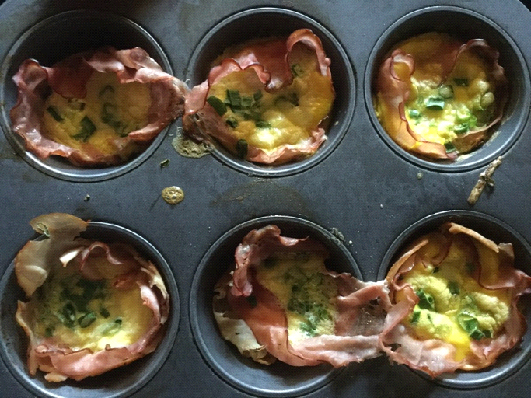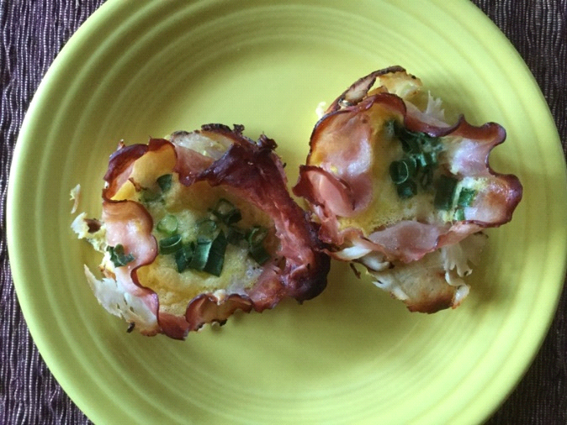

Cauliflower rice with chicken breast and mushroom onion sauce and Caesar salad.

Sauce is thickened with a bit of arrowroot powder.

Cauliflower rice is made by pulsing cauliflower chunks in food processor and then steam or sauté

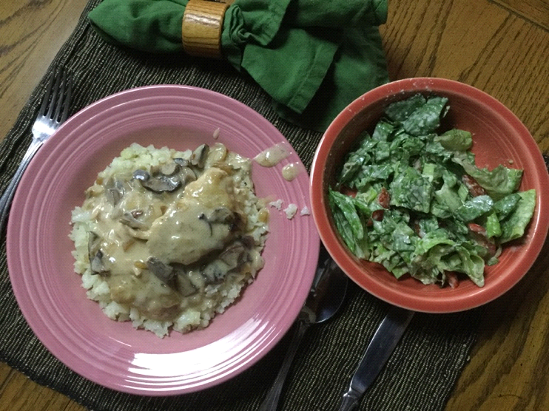

Cauliflower crust pizza.

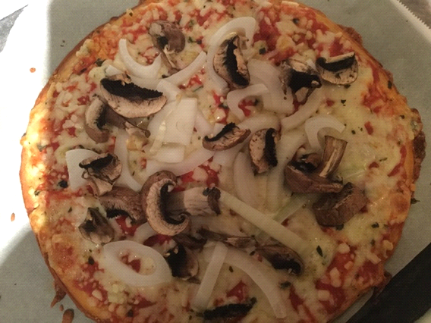

Cauliflower mashed potatoes with chicken and salad

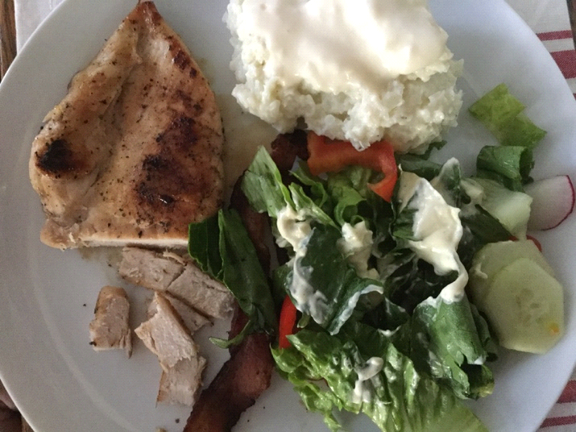

Brunch of eggs, cheese, sausage and pickles

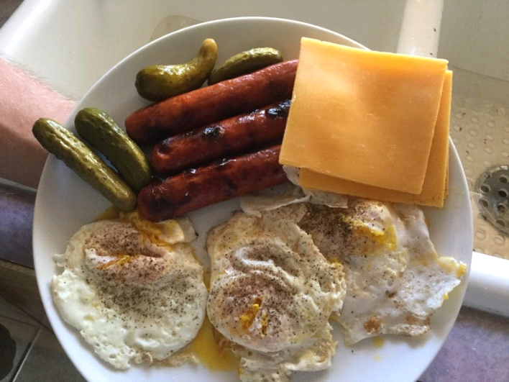

Snack of raw veggies & dip, nuts and pickles

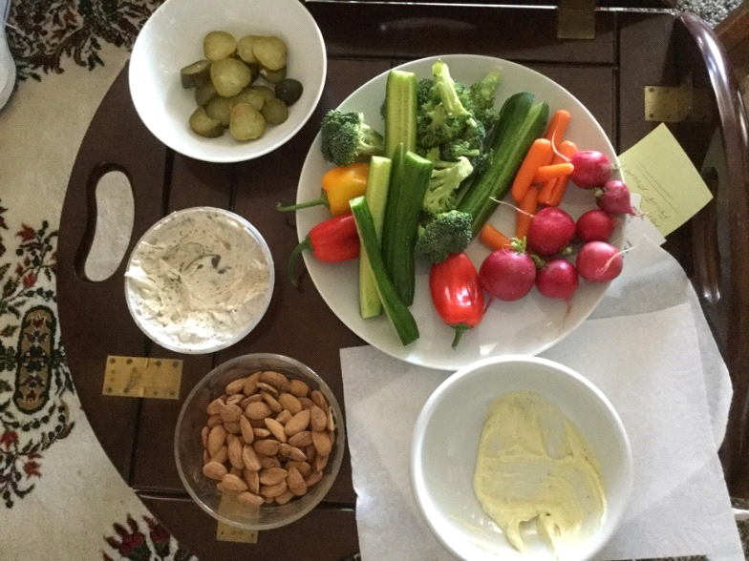

Tacos with taco seasoned meat cut up veggies, cheese on romaine lettuce… a little salsa and sour cream tops it off nicely

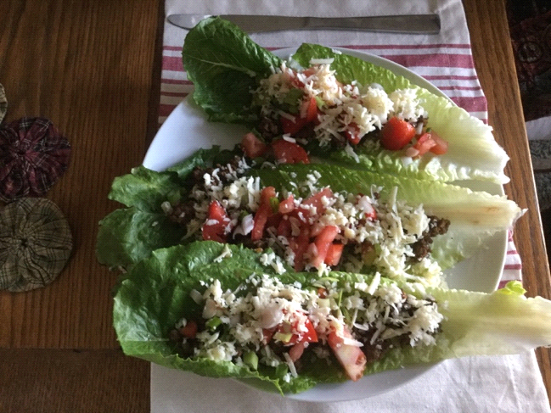

Sautéed parsnip and onions (parsnips were spiralized)

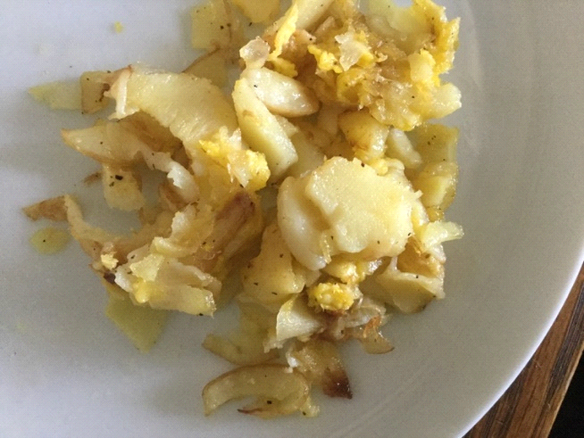

Taco salad

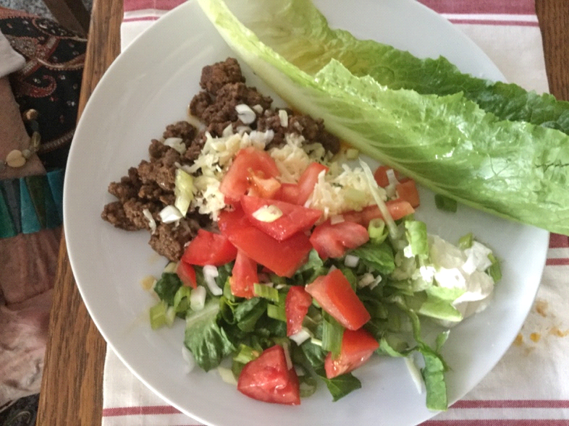

A meal of lettuce tomato and bacon, grilled chicken, cheese and Caesar salad

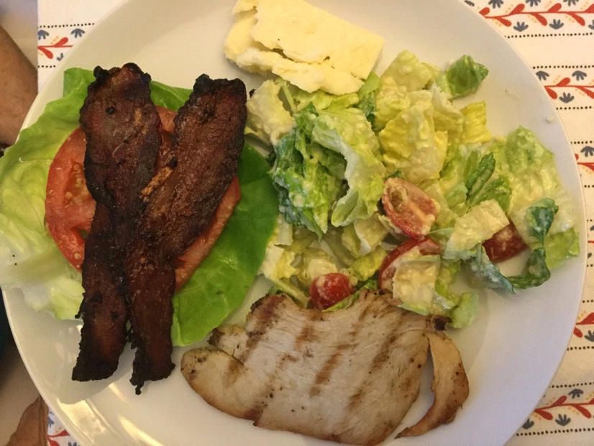

SOME LINKS TO GREAT MEALS WITH PICTURES:

Awesome ways to use cauliflower!

[https://www.buzzfeed.com/mercedessandoval/learn-how-to-use-cauliflower-in-so-many-ways-with-these-9?utm_term=.igm62VMRD#.ntjRNMdDZ](https://www.buzzfeed.com/mercedessandoval/learn-how-to-use-cauliflower-in-so-many-ways-with-these-9?utm_term=.igm62VMRD)

Cheesesteak stuffed peppers!

<http://www.delish.com/cooking/recipe-ideas/recipes/a51551/cheesesteak-stuffed-peppers-recipe/>

Balsamic glazed steak rolls!

<https://www.tablespoon.com/recipes/balsamic-glazed-steak-rolls/c723300c-8122-462d-b8ff-2c85ecd7325d>

Bacon-wrapped brussel sprouts!

[https://blog.paleohacks.com/bacon-wrapped-brussels-sprouts/#](https://blog.paleohacks.com/bacon-wrapped-brussels-sprouts/)

BLT Sushi!

<http://www.delish.com/cooking/recipe-ideas/recipes/a51582/blt-sushi-recipe/>

Cauliflower grilled-cheese!

<http://www.delish.com/cooking/recipe-ideas/recipes/a51638/cauliflower-grilled-cheese-recipe/>