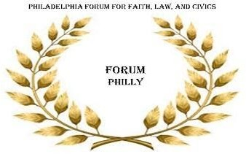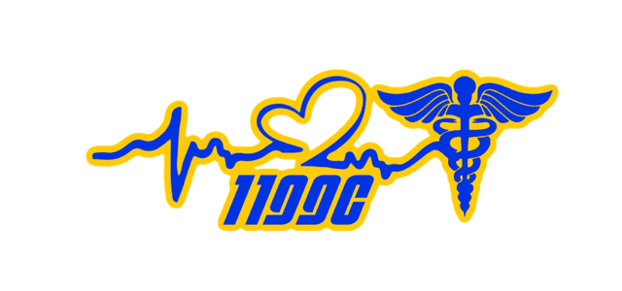

# Good&NecessaryTrouble
Nonpartisan Positive Voter Messaging Campaign
Greetings Respected Leader,

As you are aware there are new election laws, rules, locations, and methods for voting that require communication and some explanation. With your assistance and participation in the #Good&NecessaryTrouble nonpartisan voter messaging campaign we can help voters to exercise their civic duty.

Please join Forum Philly, District 1199C, and our many collaborators in launching the
#Good&NecessaryTrouble nonpartisan positive voter messaging campaign, encouraging, and equipping Black and Brown voters with essential information needed to knowledgably participate in the upcoming election. As trusted, validated leaders, you have community standing, influence and respect with Black and Brown people across sectors throughout Philadelphia and the region.

We are confident that we can collectively use our community standing and positive influence to leverage our constitutional rights and political capital for the good of our people. Let’s share #Good&NecessaryTrouble nonpartisan positive voter messages with our constituencies, networks and spheres of influence.
You can help by recording and posting a #Good&NecessaryTrouble short video on your preferred social media platform [Facebook, Instagram, Snapchat, Tik Tok and Twitter], personal or professional website, with one of several provided sample scripted
#Good&NecessaryTrouble non-partisan voter messages that you can customize for your audience. The attached suggested scripts focus on the different aspects of the voting process that you may want to emphasize. Remember Our efforts are designed to maximize voter awareness and their informed participation in the upcoming election.

Thank you,

Rev. Dr. Malcolm T. Byrd, President & CEO
www.forumphilly.org
Committed to growing the Equity, respecting the Dignity and honoring the Significance of African Americans and our cause

Chris Woods, President, 1199C NUHHCE Salima Pace, Treasurer, 1199C NUHHCE
www.1199cnuhhce.org

Mail in Ballot suggested script #1
“Hello, this is (your name, title and affiliation). In the spirit of the late Cong. John Lewis, I have some Good & Necessary Trouble advice for voters. I’m urging everyone to take important steps for the benefit of our community. The first step is making sure that your voter registration is up to date and you are able to vote in the upcoming election. You can find out by visiting VotesPA.com.

I am also urging all Pennsylvania voters to apply for and utilize the mail-in ballot option as soon as possible. Every voter has the right to request a mail-in ballot and it is very easy to apply. Learn more at VotesPA.com/MailBallot.

If you choose this option, it is important for you to upon receipt of the Ballot sent to you by the County Board of Elections, to fully complete it according to instructions and return it by mail immediately.

I stand with Forum Philly and District 1199C of the National Union of Hospital and Healthcare Workers, in assuring you that voting by mail is the safest and most secure way to vote during the COVID-19 pandemic.
Thank you for participating in this #Good&NecessaryTrouble, please share this positive voter message with those you care about.
+++++++++++++++++++++++++++++++++++++++++++++++++++++++++

Mail in Ballot suggested script #2 [Drop Box]
“Hello, this is (your name, title and affiliation). In the spirit of the late Cong. John Lewis, I have some Good & Necessary Trouble advice for voters. I’m urging everyone to take important steps for the benefit of our community. The first step is making sure that your voter registration is up to date and you are able to vote in the upcoming election. You can find out by visiting VotesPA.com.

I am also urging all Pennsylvania voters to apply for and utilize the mail-in ballot option as soon as possible. Every voter has the right to request a mail-in ballot and it is very easy to apply. Learn more at VotesPA.com/MailBallot.

If you choose this option, it is important for you to upon receipt of the Ballot sent to you by the County Board of Elections, to fully complete it according to instructions. I realize that you may have experienced delays in getting your mail on time and you want to be certain that you return your Ballot in time for it to be counted.

To help you with this the Philadelphia County Board of Elections has set up and XX Drop Boxes conveniently located throughout the city in which you can put your completed and sealed ballot. These drop boxes are secure and monitored 24 hours a day. The County Board of Election Staff will supervise the daily collection of the Ballots and record them at their offices. If you do this, there is nothing else you need to do.

I stand with Forum Philly and District 1199C of the National Union of Hospital and Healthcare Workers, in assuring you that voting by mail is the safest and most secure way to vote during the COVID-19 pandemic.
Thank you for participating in this #Good&NecessaryTrouble, please share this positive voter message with those you care about.
++++++++++++++++++++++++++++++++++++++++++++++++++++++

One-Stop Early Voting suggested script #3
“Hello, this is (your name, title and affiliation). In the spirit of the late Cong. John Lewis, I have some Good & Necessary Trouble advice for voters. I’m urging everyone to take important steps for the benefit of our community. The first step is making sure that your voter registration is up to date and you are able to vote in the upcoming election.

You can find out by visiting one of 17 in-person-on demand mail in election offices of the Philadelphia County Board of Elections. These offices are conveniently located throughout Philadelphia and available during normal business hours.

At these offices you can confirm your registration, apply for and receive an official ballot. Staff are equipped with needed all PPE and regularly sanitize its facilities and equipment according to public health guidelines for your safety.

The office staff will review and process your application and allow you to complete and submit early your ballot. If you do this, there is nothing else you need to do. You have completed the needed steps for voting in the general election.

I stand with Forum Philly and District 1199C of the National Union of Hospital and Healthcare Workers, in assuring you that early voting at an election office is a convenient and safe way to vote during the COVID-19 pandemic.

Thank you for participating in this #Good&NecessaryTrouble, please share this positive voter message with those you care about.
+++++++++++++++++++++++++++++++++++++++++++++++++++++

Traditional Voting suggested script #4
“Hello, this is (your name, title and affiliation). In the spirit of the late Cong. John Lewis, I have some Good & Necessary Trouble advice for voters. I’m urging everyone to take important steps for the benefit of our community. The first step is making sure that your voter registration is up to date and you are able to vote in the upcoming election.

You can find out by visiting VOTESPA.com. For many years you have participated in every election by going to the polls on election day. This year I am encouraging you to continue in this great tradition by going to the polls early on election day Tuesday, Nov.3rd

While observing all public health guidelines the Philadelphia County Board of Election polling sites will be fully staffed. They will use the proper PPE and sanitize and maintain the available election equipment.
I stand with Forum Philly and District 1199C of the National Union of Hospital and Healthcare Workers, in assuring you that the polling sites will be nearby, convenient and safely maintained for you to vote during the COVID-19 pandemic.

Thank you for participating in this #Good&NecessaryTrouble, please share this positive voter message with those you care about.
++++++++++++++++++++++++++++++++++++++++++++++++++++++

