The first voter registration deadlines are in early October, only five weeks from now.
1] Turn Your Training Into Action Get familiar with your resources, including our Partner Starter Guide and Voter Education Social Media Toolkit. We are challenging you to turn your training into action by planning one voter registration activation for your community before the end of the month. Whether it’s texting eligible voters in Out Vote, hanging signs around your neighborhood, or gathering your family for a virtual voter education session, you have the power to make change in your community. Don’t forget to have people register to vote through the portal you are asked to set-up.
[2] Make A Plan To Vote Early With the recent attacks on the United States Postal Service (USPS), we are encouraging you to share our Voter Resources Hub far and wide so that eligible voters can MAKE A PLAN TO VOTE EARLY. The more votes that are in early the better to help prevent issues on Election Day at polling places and states where mail-in ballots are permitted.
[3] Prepare for National Voter Registration Week of Action September 20th-27th by preparing to host your own National Voter Registration Week of Action Event. Let us know about your National Voter Registration Week of Action events HERE.
NATIONAL CALL TO ACTION
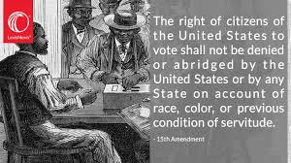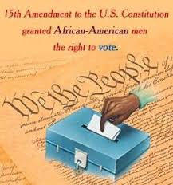
Kappa Alpha Psi Fraternity, Inc. a proud partner of The When We All Vote Team offers:
Voter Registration Resources: Assisting Partners with Getting Out the Vote
Voter Registration Portal: When We All Vote provides a customized voter registration portal that can be integrated into various ways to increase voter engagement efforts. You can track your organization’s incoming voter registrations through this unique link: https://www.whenweallvote.org/kapsi
Custom QR Code: A resource for voter registration is to access your customized voter registration portal by placing a QR code, readable by any smartphone, on a physical flyer, postcards, or event pamphlet. Please click the below link and download the image. Link: https://drive.google.com/file/d/1Nv8AITDmg6YWUVysUPqg16H78yh_98p_/view?usp=sharing
Embed Code: This is a code to use on the backend of your website that you can add to your customized voter registration portal on your website. Code: https://drive.google.com/file/d/1V7zHZJMn3kIuLWuYiZ1w8RSgcTYUG91B/view?usp=sharing
Printable Flyer: This is a document that can be distributed at large and printed in large quantities to facilitate voter registration at in-person events. Link: https://drive.google.com/file/d/12L_blQ7NapPqVayjoELgNJon9ZG1W2VI/view?usp=sharing
Outreach Resources Partner Starter Guide: A key document for getting started, which includes draft email language, newsletter/bulletin language, social media language, 2020 tentative timeline, and other resources Link: https://www.whenweallvote.org/wp-content/uploads/2020/01/Partner-Starter-Guide-0114 2020.pdf
Partner Activation Kit: The Partner's Activation Kit is to be used only by official When We All Vote partners to facilitate voter registration efforts. This kit includes placards, stickers, and voter registration postcards. If your organization has its own voter registration portal and would like your postcards to be linked to your portal, please contact partners@whenweallvote.org Link: https://store.whenweallvote.org/
Kappa Alpha Psi Fraternity Member Colin Kaepernick Amnesty International Speech link: https://www.dropbox.com/s/39qa5npxd4zigtu/kap_amnesty_award_speech.mp4?dl=0

Members of Alpha Kappa Alpha Sorority Inc. are leading the charge with registrations and are almost halfway to their registration goal. Keep it up!!!
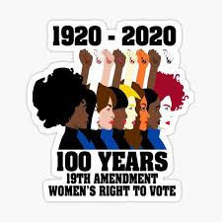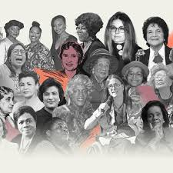
Jennifer A. Santiago, Esquire, NPHC-SEPA, President
Zeta Phi Beta Sorority, Incorporated, Beta Delta Zeta Chapter

Voting Challenge Video Challenge Link: https://www.youtube.com/watch?v=r5hGdZahwBA&feature=youtu.be Wherein she talks from the heart about #whyIvote #whyIwillvote2020.

Vote from the Comfort and Safety of Your Living Room
Voting by mail is easier and safer during the pandemic & is the cure to avoiding # 45 post office plot.
Apply for a mail-in ballot as soon as you can using one online form. Plus ---
A Valid PA Drivers' license, or PennDOT ID, or the last 4 digits of your social security number is needed to vote in Pennsylvania’s Nov. 4th election. Begin the process by clicking on register
Register

Check Your Ballot Status: Type in your name and birthdate to track your ballot's progress.
Ballot Status

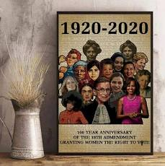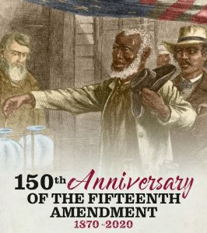
National Poll Worker Recruitment Day & Request Your Ballot Day of Action With the ongoing COVID crisis, states around the nation are projecting a shortage of poll workers and registered voters are increasingly interested in vote by mail. We All Vote, partnered with Power the Polls, to send out a call to action to our volunteers to consider becoming a poll worker and requesting your mail-in ballots early. Sign up to become a poll worker in your community here.
National Voter Registration Week of Action will be held September 20th-27th. When We All Vote is going all out to ensure that we help 100,000 eligible voters get registered this fall.
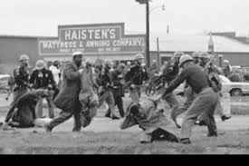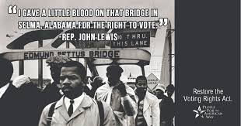https://www.msnbc.com/the-last-word/watch/morgan-freeman-reads-rep-john-lewis-last-words-89332293780 Link to Morgan Freeman Reading Congressman John Lewis' Letter
Mark Your Calendars
Sept 10: Request Your Ballot Day of Action Sept 15: Hispanic Heritage Month Kickoff
Sept 20-27: National Voter Registration Week of Action Sept 22: National Voter Registration Day
Oct 4-11: Make a Plan to Vote Week of Action
Monday, October 19th, 2020 at 11:59 voter applications must be electronically filed or
delivered to the county by deadline. Postmarks do not count
Oct 18-25: Early Vote Week of Action & Voting Celebrations
Oct. 24: National Vote Early Day Nov. 3: Election Day

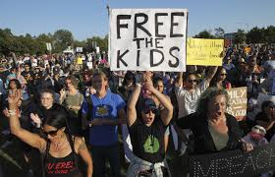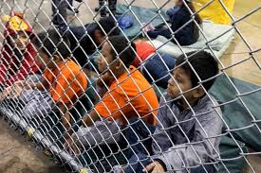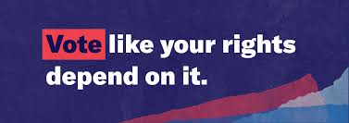
Spanish Language Access and the Voting Rights Act Section 203 of Voting Rights Act: Provides: "Whenever any State or political subdivision provides registration or voting notices, forms, instructions, assistance, or other materials or information relating to the electoral process, including ballots, it shall provide them in the language of the applicable minority group as well as in the English language in preparation for the Nov. 2020 election.
All Voting Is Local a sponsor of Section 203 of Voting Rights Act fights in states where the right to vote is under distinct attack. Click on the state name below to learn more.
Arizona Florida Georgia Michigan Nevada Ohio Pennsylvania Wisconsin
Click the links to learn more about the other sponsors, Hispanic Federation, the Lawyers Committee for Civil Right Under Law, Centro Hispano Daniel Torres, Grupo de Apoyo e Integración Hispanoamericano, & the ACLU of PA. Business for America ensures your employees, customers, and communities will have a voice on November 3. Sign up.
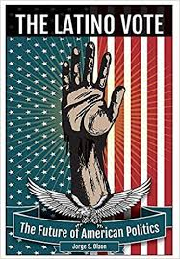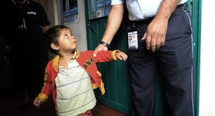
- Download and mail this form, in English mail-in ballot paper application form and follow the instructions. In Spanish download this mail-in ballot paper application form, and follow the instructions.
- If you do not have a valid PA driver's license or a non-driver's ID. Download the below paper application and mail it to your County Board of Elections. Otherwise, take it to or fill one out at your local county elections office.
  - For an absentee application in English, download the absentee paper application form.
  - For an absentee application in Spanish, download the absentee paper application form
  - Notice For Military and Overseas Voters: When applying for an absentee ballot, use this federal form.
  - 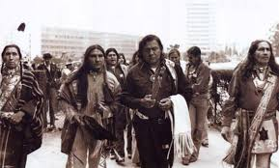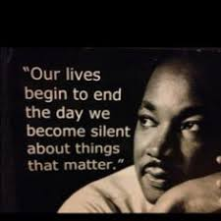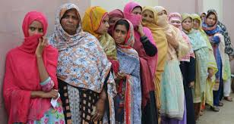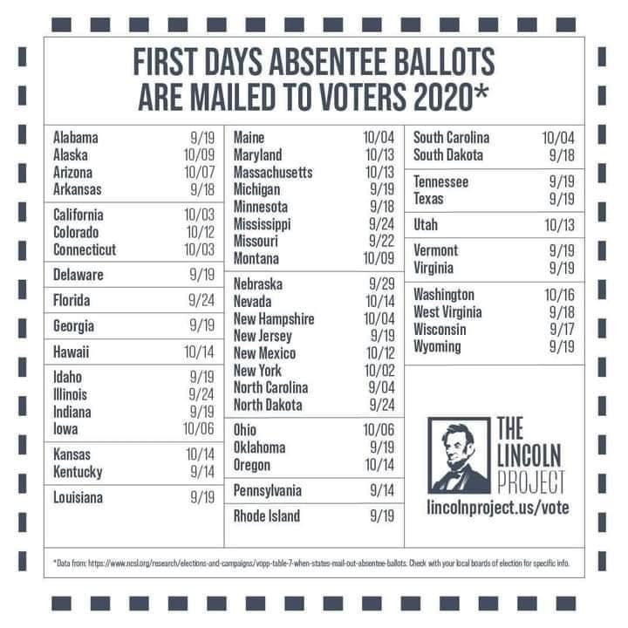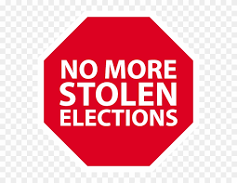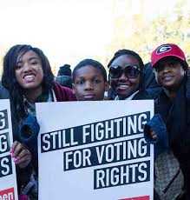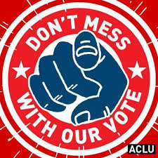
Watch "Chadwick Boseman's Howard University commencement speech https://youtu.be/QGYaDEs-K3I
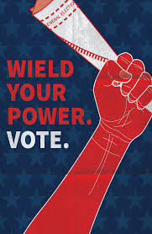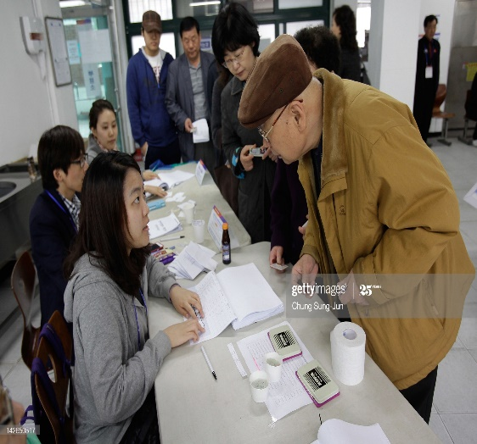
The links https://timesofindia.indiatimes.com/videos/international/us-president-donald-trump-blames-china-for-covid-19-terms-it-kung-flu/videoshow/76549515.cms and https://www.youtube.com/watch?v=ydnxK-M7pxM highlight # 45 attempt to put his slow response to the COVID-19 pandemic, the true reason for as of Sept. 7, 2020 over 190,000 COVID-19 U.S. citizens deaths and 6, 226, 879 million U.S. citizens contracting COVID-19, on China. To salvage his re-election chances # 45 have chosen to revert to the racist card once again, this time putting all of COVID-19 atrocities on China. Thus, putting the fastest-growing segment of eligible voters out of the major racial & ethnic groups in the United States in danger. More than 11 million Asian Americans will be able to vote this year, making up nearly 5% of the nation’s eligible voters (for this analysis, U.S. citizens ages 18 and older). From 2000 to 2020, the number of Asian American eligible voters more than doubled, growing by 139%. The Hispanic electorate grew at a similar rate (121%), but the black and white electorates grew far more slowly (33% and 7%). Prior to the election of President Obama as the 44th President of the United States, Asian Americans overwhelmingly voted for the GOP. Including and following President Obama’s election Asians Americans casted their votes overwhelmingly for the Democratic Party. They are also the only major racial or ethnic group in which naturalized citizens – rather than the U.S. born – make up a majority of eligible voters: Click & download the voter application in the language of your choice.
English Application Chinese (Simplified) Application Chinese (Traditional) Application Japanese Application Vietnamese Application Korean Application
Arabic Application Haitian Creole Application Russian Application
French Application Portuguese Application Khmer Application Bengali Application Spanish Application Hindi Application
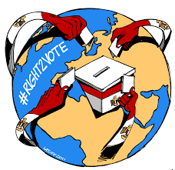
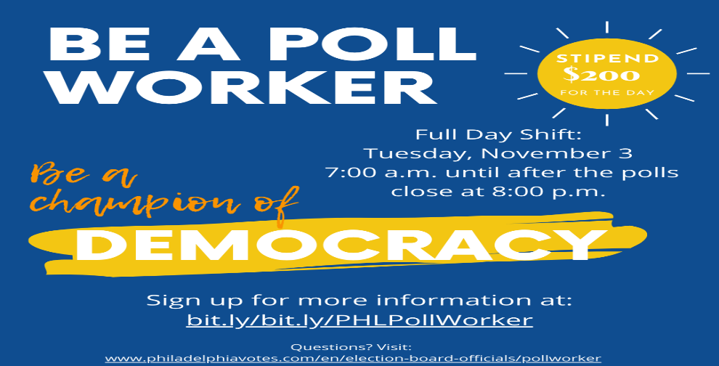
Help champion democracy—become a poll worker today.
To become a poll worker, you must:
Be a citizen of the United States. Be a registered voter in Philadelphia.

If you are not a register voter register online at www.philadelphiavotes.com by clicking “Register to Vote

Be 18 years of age (unless you are 17 years old and actively enrolled in high school or secondary school).

All counties need poll workers—Poll workers receive $50 when they participate in training and will be paid $200 for their services on Election Day (November 3, 2020). Click to
Become a Poll Worker!

Link to Philadelphia Youth Commission First Vote 2020 Announcement Video

Click Link to view video: https://drive.google.com/file/d/11kjRx6MPo-oFRIHzY1Q9s8QHuqq_re9X/view?mc_cid=7d7759b222&mc_eid=f03dcf6a36
First Vote 2020 is a coordinated voter education and registration effort from the Mayor’s Office of Youth Engagement (OYE) sponsored by Freedom Credit Union that is geared toward engaging young people around all of the ways that one can exercise civic participation leading up to Election Day. Click to

Be A First Vote Ambassador!

Complimentary of Emma Tramble: Founder of My Family Votes

You’re a Click Away From Voting References of interest

Mail-in Voting>>

Check Your Ballot Status>>

Voting Machines - Know-before you go>>

Who's Running for Office?>>

PA Register to Vote - Deadline October 19th, 2020>>

Check Your Voter Registration Status>>

Find Your Polling Place>>

Find a Dropbox - Don't risk mailing your ballot too late>>
Click on the Link to View Pennsylvania’s 2020 Primary Election Report https://healthyelections.org/sites/default/files/2020-07/Pennsylvania%20Pre-%20and%20Post-Mortem%20Memo.pdf which highlight the importance of and need for volunteer Poll workers. This report helps with gaining an understanding of 2020 primary election’s issues which is a strong indicator of what can occur during a COVID-19 pandemic election process. These 2020 primary election indicators help with formulating the correct voting strategy, and putting in place the correct voting plan to win the November 4th 2020 election. Family we can’t afford to repeat the mistakes of November’s 2016 elections. The Nov. 2020 election hosted during the 100th band 150th anniversary of the 15th and 19th Amendment is the most important election in our lifetime.
PA 2020 Primary Report Table of Contents
Introduction 2
Pennsylvania Response to COVID-19 2
Expansion of Mail Balloting 3
Polling Places 4
Ballot Drop Boxes 5
PPE Procurement 5
Implementation Challenges 6
Logistical Challenges 6
Political Challenges 8
Legal Challenges 8
Election Day 9
Turnout 9
Polling Place Issues 10
Vote-by-Mail Issues 10
Other Helpful Resources 11
Barack Obama 2020 DNC Speech https://www.youtube.com/watch?v=nx6Zptj3VR8
Joe Biden Acceptance Speech at 2020 DNC https://www.youtube.com/watch?v=pnmQr0WfSvo
Kamala Harris Acceptance 2020 DNC Speech https://www.youtube.com/watch?v=JijFLcbIqMs

Michelle Obama 2020 DNC Speech https://www.youtube.com/watch?v=Linx1XLUbYo
Bill Clinton 2020 DNC Speech https://www.youtube.com/watch?v=SKwirBEEL3s
