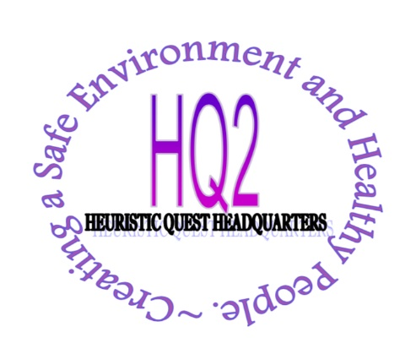
HEURISTIC HEALING INC.

1222 W. 95th St
CHICAGO, ILLINOIS 60643
PHONE: 773-238-5555
FAX: 773-238-5533

HH Inc and HQ2 CLIENT NON-DISCRIMINATION POLICY

HH Inc and HQ2 will not discriminate in the provision of health care services to an individual:
1. Because the individual is unable to pay for the health care services;
2. Because payment for those services would be made under Medicare, Medicaid, or the Children’s Health Insurance Program (CHIP); or
3. Based upon the individual’s race, color, sex, age, national origin, disability, religion, gender identity or sexual orientation.

