Copy-Rights
&
Copy-Wrongs

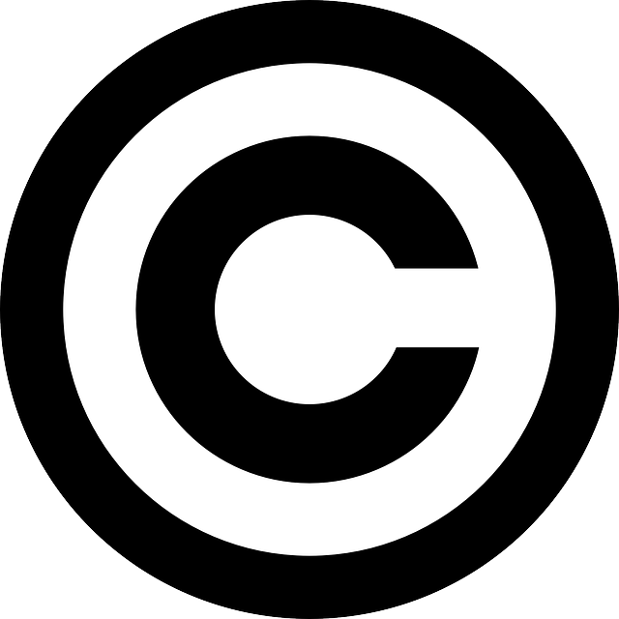

A booklet to help you decide how you use other people’s work, in your coursework and at home, without breaking the law!

So What is Copyright?

The top 5 ways people break copyright law:

How can I use text from the World Wide Web in my coursework without breaking the law?

How can I use images from the World Wide Web in my coursework without breaking the law?

How can I download music and films at home without breaking the law?

What could happen if I break copyright law in the future?

