APPLICATION CHECKLIST

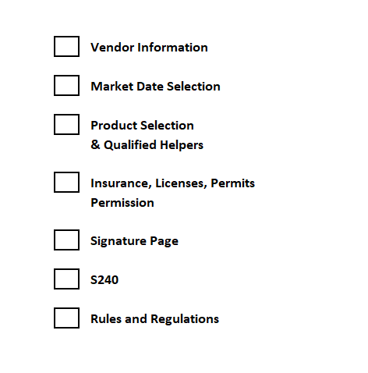
You will be invoiced for payment after you have been approved.

Equal Opportunity: The Richfield Farmers Market is committed to equal opportunity in employment and vendor selection practices. Employees and vendors will not be discriminated against based on race, sex, age, religious or political beliefs, national origin, sexual orientation, marital and parental status, or disability. The Richfield Farmers Market is held on property owned and managed by the Village of Richfield. The vendor agrees to abide by the rules and regulations without exception.
Questions:​ Contact Market Manager Judy@RichfieldFarmersMarket.com

