DREAMTIME GIRL CATERING MENUS

These catering menus have been carefully selected to compliment Dreamtime Girl boat charter events on Sydney Harbour.
Our caterers have been chosen for outstanding freshness, quality, reliability, rave reviews and many years of experience in boat catering.

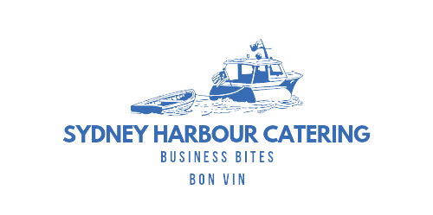

Table of Contents
DREAMTIME GIRL CATERING MENUS 1
CANAPE MENUS - PRICED PER PERSON) 3
LIGHT CANAPE MENU $37 pp (Min 10 pax) 3
MOSTLY VEGETARIAN CANAPÉ MENU ~ 6 PIECES $37 pp (Min 10 pax) 4
CANAPÉ MENU ONE ~ 12 PIECES $66 pp (Min 10 pax) 5
CANAPÉ MENU TWO ~ 14 PIECES $77 pp (Min 10 pax) 6
BBQ MENUS - PRICED PER PERSON 7
BBQ MENU 1 $53 pp (Min 10 pax) 7
BBQ MENU 2 $63 pp (Min 10 pax) 8
BBQ MENU FOR SMALL NUMBERS $77 pp (Min 2 pax) 10
BUFFET MENUS - PRICED PER PERSON 11
BUFFET MENU ONE $51 pp (Min 10 pax) 11
BUFFET MENU TWO $58 pp (Min 10 pax) 12
ASIAN BUFFET MENU $74 pp (Min 15 pax) 13
BREAKFAST / BRUNCH MENU $25 pp (Min 15 pax) 15
PLATTER MENUS - PRICED PER PLATTER (Min 1 ) 16
CHARCUTERIE / ANTIPASTO PLATTER - $132 16

SEAFOOD PLATTER - $170 16

SUSHI PLATTER ~ NORI - $132 16

SMOKED SALMON PLATTER - $132 16

RICE PAPER ROLL PLATTER - $105 16

CHEESE PLATTER - $145 16

FRESH FRUIT PLATTER - $80 16

SWEET BITES PLATTER - $76 16

BAKED BITES PLATTER (27 Pieces) $145 17

WRAPS PLATTER (12 Pieces in Total) - $67 18

POINT SANDWICH PLATTER -$132 (10 sandwiches in total) 18
Read what real customers have said about Dreamtime Girl catering and service: 19
CATERING ORDER FORM Please complete this form and send your order to operations@dreamtimegirlcharters.com.au 20
PRICE NOTES : PLEASE NOTE A DELIVERY FEE of $50 APPLIES TO EACH ORDER 20

CANAPE MENUS - PRICED PER PERSON
LIGHT CANAPE MENU $37 pp (Min 10 pax)

Item | Image | Serving Notes | Vegan | Veg | Gluten- Free | Halal | Menu  Price
 |  | Total 6 |  |  |  |  | $37 pp
SMOKED SALMON TARTLET  Puff Pastry / Shallots / Dill | 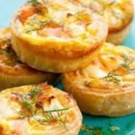 | X 1
PRAWN RICE PAPER PARCELS  Mint / Coriander / Chili Sauce | 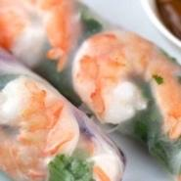 | X 1 |  | V
MOROCCAN COCKTAIL PIE  Vegan / High Top | 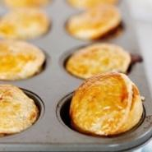 | X 1 | V+ | V
SKEWERED LAMB KOFTA  Cumin Spiced / Cucumber Tzatziki | 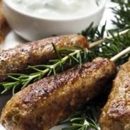 | X 1
ARANCINI  Mushroom / Parmesan / Truffle Mayo | 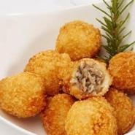 | X 1 |  |  | GF
SPICY CHICKEN EMPANADA  Spiced Aioli / Coriander / Shallot | 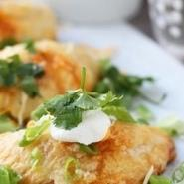 | X 1

MOSTLY VEGETARIAN CANAPÉ MENU ~ 6 PIECES $37 pp (Min 10 pax)

Item | Image | Serving Notes | Vegan | Veg | Gluten- Free | Halal | Menu  Price
 |  | Total 6 |  |  |  |  | $37 pp
POLENTA ONION TART  Rosemary / Fig | 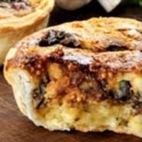 | X 1 |  | V
MOROCCAN COCKTAIL PIE  Vegan / High Top |  | X 1 | V+ | V
SMOKED SALMON TARTLET  Puff Pastry / Shallots / Dill |  | X 1
THAI BEEF RICE PAPER ROLL  Snow Pea / Capsicum / Cucumber / Coriander Mint Lime | 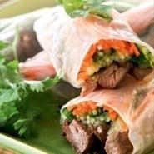 | X 1 |  |  | GF
ARANCINI  Mushroom / Parmesan / Truffle Mayo |  | X 1 |  |  | GF
MEDITERRANEAN FILLED PUMPKIN FLOWER  Diced Pumpkin / Coriander / Onion / Cumin | 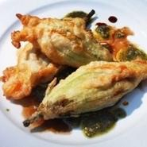 | X 1 |  | V

CANAPÉ MENU ONE ~ 12 PIECES $66 pp (Min 10 pax)

Item | Image | Serving Notes | Vegan | Veg | Gluten- Free | Halal | Menu  Price
 |  | Total 12 |  |  |  |  | $66 pp
ARANCINI  Mushroom / Parmesan / Truffle Mayo |  | X 2 |  | V | GF
MOROCCAN COCKTAIL PIE  Vegan / High Top |  | X 1 | V+ | V
PRAWN RICE PAPER PARCELS  Mint / Coriander / Chili Sauce |  | X 2 |  | V
PETITE CHICKEN & LEEK PIE  Celery / Spring Onions | 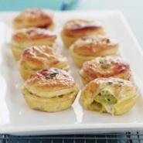 | X 1
BEST MARKET OYSTERS  Lime Emulsion | 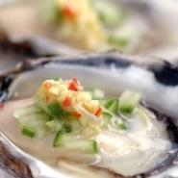 | X 1 |  |  | GF
VIETNAMESE INSPIRED SUGAR CANE PRAWNS  Coconut Dusted / Citrus Sauce | 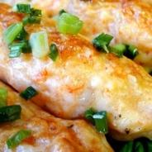 | X 1
PUMPKIN GOATS CHEESE TARTLET Caramelised Onion / Pine-nut | 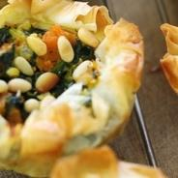 | X 1 |  | V
SMOKED SALMON TARTLET  Puff Pastry / Shallots / Dill | 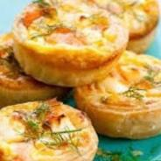 | X 1
SKEWERED LAMB KOFTA  Cumin Spiced / Cucumber Tzatziki |  | X 2

CANAPÉ MENU TWO ~ 14 PIECES $77 pp (Min 10 pax)
Item | Image | Serving Notes | Vegan | Veg | Gluten- Free | Halal | Menu  Price
 |  | Total 14 |  |  |  |  | $77 pp
ARANCINI  Mushroom / Parmesan / Truffle Mayo |  | X 1 |  | V | GF
MOROCCAN COCKTAIL PIE  Vegan / High Top |  | X 1 | V+ | V
PRAWN RICE PAPER PARCELS  Mint / Coriander / Chili Sauce |  | X 2 |  | V
SATAY CHICKEN PEANUT COCONUT SAMBAL SKEWERS  Coriander / Dry Fried Onion (Halal) | 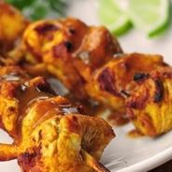 | X 2 |  |  | GF | H
BEST MARKET OYSTERS  Lime Emulsion |  | X 2 |  |  | GF
VIETNAMESE INSPIRED SUGAR CANE PRAWNS  Coconut Dusted / Lime Sauce * |  | X 2
ASSORTED NORI ROLLS  Fish / Prawn / Chicken / Veg / Egg | 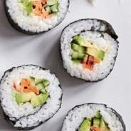 | X 1 |  | V
SMOKED SALMON TARTLET  Puff Pastry / Shallots / Dill |  | X 2
STEAK GREEN PEPPERCORN PIE  Tomato Ketchup | 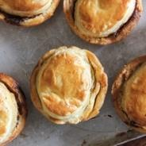 | X 1

BBQ MENUS - PRICED PER PERSON
BBQ MENU 1 $53 pp (Min 10 pax)

Item | Image | Serving Notes | Vegan | Veg | Gluten- Free | Halal | Menu  Price
 |  | Total 7 |  |  |  |  | $53pp
CHARCUTERIE / ANTIPASTO  Bresaola / Prosciutto / Salami / Eggplant ~ Chickpea ~ Tzatziki Dip / Vege Crudités / Olives / Feta / Bread / Cracker | 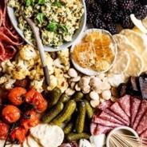 | X 1
CLASSIC POTATO SALAD  Potato / Parsley / Dill Pickles / Egg Mustard Mayonnaise /Spring Onion | 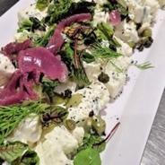 | X 1 |  | V | GF | H
MEDITERRANEAN SPICED CHICKEN TENDERLOIN  Honey Mustard Dressing | 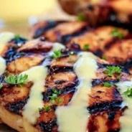 | X 1
ASSORTED GOURMET PORK SAUSAGES  Caramelized Onion / Tomato Relish / Mustard | 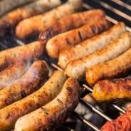 | X 1
PEPPERED RUMP STEAK  Chimichurri Sauce on The Side | 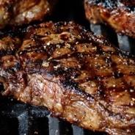 | X 1
GREEK SALAD  Marinated Feta / Kalamata Olive / Plum Tomato / Cucumber /Red Onion / Crisp Lettuce / Lemon Oregano dressing | 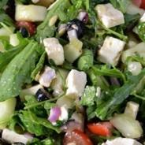 | X 1 |  | V | GF
CRUSTY FRENCH BAGUETTE | 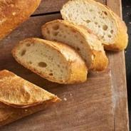 | X 1

BBQ MENU 2 $63 pp (Min 10 pax)

Item | Image | Serving Notes | Vegan | Veg | Gluten- Free | Halal | Menu  Price
 |  | Total 8 |  |  |  |  | $63pp
CHARCUTERIE / ANTIPASTO  Bresaola / Prosciutto / Salami / Eggplant ~ Chickpea ~ Tzatziki Dip / Vege Crudités / Olives / Feta / Bread / Cracker |  | X 1
GRILLED LAMB CUTLETS  Rosemary Tomato Relish | 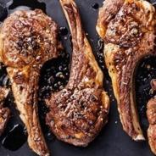 | X 1
LEMON CHICKEN  Parsley/ Minted Yoghurt | 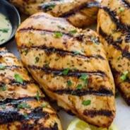 | X 1
CLASSIC POTATO SALAD  Potato / Parsley / Dill Pickles / Egg Mustard Mayonnaise /Spring Onion |  | X 1 |  | V | GF | H
TERIYAKI SALMON FILLET  Wasabi Mayonnaise | 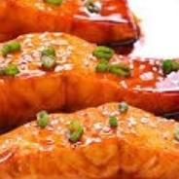 | X 1
GREEK SALAD  Marinated Feta / Kalamata Olive / Plum Tomato / Cucumber /Red Onion / Crisp Lettuce / Lemon Oregano |  | X 1 |  | V | GF
QUINOA SALAD  Roast Pumpkin / Coconut / Seeds /Mint | 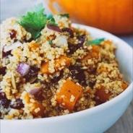 | X 1 | V+ | V | GF | H
CRUSTY FRENCH BAGUETTE |  | X 1

BBQ MENU FOR SMALL NUMBERS $77 pp (Min 2 pax)

Item | Image | Serving Notes | Vegan | Veg | Gluten- Free | Halal | Menu  Price
 |  | Total 8 |  |  |  |  | $77pp
CHARCUTERIE / ANTIPASTO  Bresaola / Prosciutto / Salami / Eggplant ~ Chickpea ~ Tzatziki Dip / Vege Crudités / Olives / Feta / Bread / Cracker |  | X 1
SCOTCH FILLET STEAK  Dijonnaise / Thyme / Horseradish Cream on The Side | 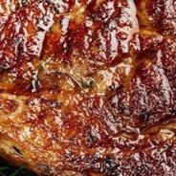 | X 1 |  |  | GF | H
SMOKED SALMON PLATTER  Crusty Baguette / Grilled Lemon /Capers / Pickled Red Onion / Dill /Horseradish Cream | 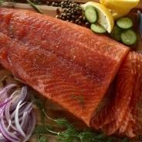
LEMON CHICKEN  Parsley/ Minted Yoghurt |  | X 1
CLASSIC POTATO SALAD  Potato / Parsley / Dill Pickles / Egg Mustard Mayonnaise /Spring Onion |  | X 1 |  | V | GF | H
QUINOA SALAD  Roast Pumpkin / Coconut / Seeds /Mint |  | X 1 | V+ | V | GF | H
CRUSTY FRENCH BAGUETTE
SWEET TREATS PLATTER  Double Chocolate Brownie Square /GF Passion-fruit Polenta Cake /French Macaroons | 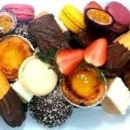

BUFFET MENUS - PRICED PER PERSON
BUFFET MENU ONE $51 pp (Min 10 pax)

Item | Image | Serving Notes | Vegan | Veg | Gluten- Free | Halal | Menu  Price
 |  | Total 6 |  |  |  |  | $51pp
CHARCUTERIE / ANTIPASTO  Bresaola / Prosciutto / Salami / Eggplant ~ Chickpea ~ Tzatziki Dip / Vege Crudités / Olives / Feta / Bread / Cracker |  | X 1
LEMON ROASTED CHICKEN  Charred Lemon / Rosemary / Thyme | 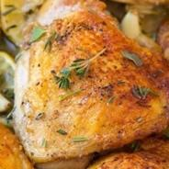 | X 1 |  |  | GF | H
THAI BEEF SALAD  Glass Noodles / Snow Pea / Capsicum / Choy Sum / Baby Corn / Cucumber / Coriander Mint Lime Dressing | 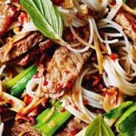 | X 1 |  |  | GF | H
QUINOA SALAD  Roast Pumpkin / Coconut / Seeds / Mint |  | X 1 | V+ | V | GF | H
KUMERA SALAD  Baby Spinach / Roasted Pine Nut / Chickpea / Shallot /Balsamic | 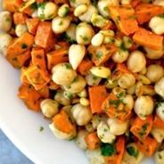 | X 1 | V+ | V | GF | H
CRUSTY FRENCH BAGUETTE |  | X 1

BUFFET MENU TWO $58 pp (Min 10 pax)

Item | Image | Serving Notes | Vegan | Veg | Gluten- Free | Halal | Menu  Price
 |  | Total 8 |  |  |  |  | $58pp
CHARCUTERIE / ANTIPASTO  Bresaola / Prosciutto / Salami / Eggplant ~ Chickpea ~ Tzatziki Dip / Vege Crudités / Olives / Feta / Bread / Cracker |  | X 1
LEMON ROASTED CHICKEN Charred Lemon / Rosemary / Thyme |  | X 1 |  |  | GF | H
THAI BEEF SALAD  Glass Noodles / Snow Pea / Capsicum / Choy Sum / Baby Corn / Cucumber / Coriander Mint Lime Dressing |  | X 1 |  |  | GF | H
SMOKED SALMON  Crusty Baguette / Grilled Lemon / Capers / Pickled Red Onion / Dill / Horseradish Cream |  | X 1
CARAMELISED ONION PUMPKIN & PEPPER  Polenta Tart | 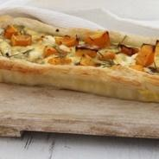 | X 1 |  | V
KUMERA SALAD  Baby Spinach / Roasted Pine Nut / Chickpea / Shallot /Balsamic |  | X 1 | V+ | V | GF | H
EXOTIC RICE SALAD  Black Rice / Pickled Beetroot / Walnuts / Baby Spinach / Feta / Balsamic | 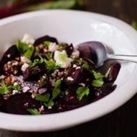 | X 1
CRUSTY FRENCH BAGUETTE |  | X 1

ASIAN BUFFET MENU $74 pp (Min 15 pax)

Item | Image | Serving Notes | Vegan | Veg | Gluten- Free | Halal | Menu  Price
 |  | Total 12 |  |  |  |  | $74pp
SATAY PEANUT COCONUT SAMBAL  Coriander / Dry Fried Onion (Halal) |  | X 1 |  |  | GF | H
PEKING DUCK SPRING ROLL  Hoisin Plum Dipping Sauce | 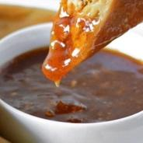 | X 1
DUMPLINGS  Prawn w Soy & Hot Chili ~ Pork Dim Sim w Ginger Soy ~ Vegan w Masterstock | 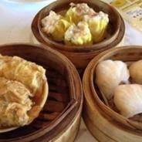 | X 1
MARINATED OCEAN TROUT  Ginger Soy / Baked / Crispy Skin /Snow Peas | 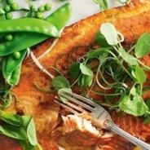 | X 1
TOFU & BLACK MUSHROOMS  Julianne Carrots / Chili Sesame Oil Dressing | 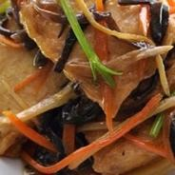 | X 1 | V+ | V
DRUNKEN CHICKEN BREAST  Szechuan Star Anise Master Stock | 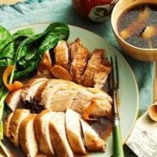 | X 1
BRAISED KING PRAWNS  Broccolini / Garlic / Chili | 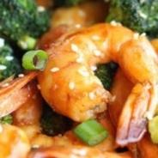 | X 1
BBQ PORK NOODLES  BBQ Pork / Curried Singapore Noodles / Shallot / Julienne Carrots | 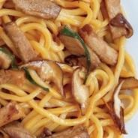 | X 1
ASIAN BUFFET MENU Items (continued) | Image | Serving Notes | Vegan | Veg | Gluten- Free | Halal | Menu  Price
CHINESE GREENS  Pak Choi or Choy Sum / Oyster Sauce | 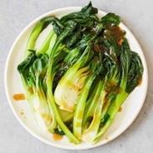 | X 1 | V+ | V |  | H
STEAMED RICE | 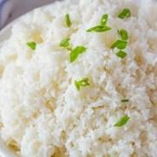 | X 1
FRESH FRUIT PLATTER  Seasonal Best / Sliced / Skin Off | 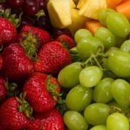 | X 1 |  | V
CUSTARD TART | 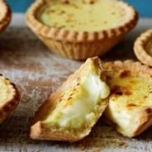 | X 1

BREAKFAST / BRUNCH MENU $25 pp (Min 15 pax)

Item | Image | Serving Notes | Vegan | Veg | Gluten- Free | Halal | Menu  Price
 |  | Total 5 |  |  |  |  | $25pp
FRESH FRUIT SKEWERS  6 Inch Bamboo Skewers of Seasonal Fruit |  | X 1 | V+ | V | GF
MINI DANISH PASTRIES  Assorted Varieties | 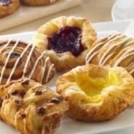 | X 1 |  | V
BANANA BREAD  (GF Available on Request) | 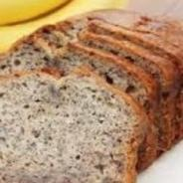 | X 1 |  | V | GF
POLENTA ONION TART  Rosemary / Fig | 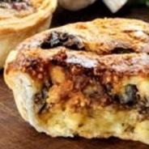 | X 1 |  | V
SAVOURY MUFFINS  House Made Caramelised Onion / Olives / Seasonal Roast Veg / Pesto |  | X 1

PLATTER MENUS - PRICED PER PLATTER (Min 1)

Item | Image | Serving Notes | Vegan | Veg | Gluten- Free | Halal | Platter  Price
CHARCUTERIE / ANTIPASTO PLATTER - $132  Bresaola / Prosciutto / Salami / Eggplant ~ Chickpea ~ Tzatziki Dip / Vege Crudités / Olives / Feta / Bread / Cracker |  | X 1 |  |  |  |  | $132
SEAFOOD PLATTER - $170  Oysters (12)  Peeled King Prawns (12)  Hickory Smoked Salmon (12 Slices) Accompaniments / Baguette | 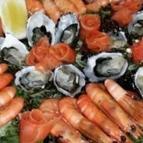 | X 1 |  |  |  |  | $170
SUSHI PLATTER ~ NORI - $132  Salmon / Tuna / Teriyaki Chicken /California / Tempura Prawn / Tofu /Egg / Cucumber / Avocado | 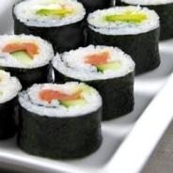 | X 1 |  |  |  |  | $132
SMOKED SALMON PLATTER - $132  Crusty Baguette / Grilled Lemon /Capers / Pickled Red Onion / Dill /Horseradish Cream |  | X 1 |  |  |  |  | $132
RICE PAPER ROLL PLATTER - $105  (10 Rolls in Total / Cut In half) | 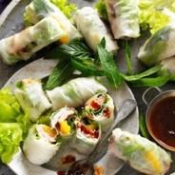 | X 1 |  |  | GF |  | $105
CHEESE PLATTER - $145  Australian & Imported / Cheddar /Wash Rind / Blue / Brie / Crackers /Dried Fruits / Nuts | 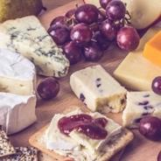 | X 1 |  | V |  |  | $145
FRESH FRUIT PLATTER - $80  Seasonal Best / Sliced / Skin Off |  | X 1 |  | V |  |  | $80
SWEET BITES PLATTER - $76  Double Chocolate Brownie Square /GF Passion-fruit Polenta Cake /French Macaroons |  | X 1 |  |  |  |  | $76
BAKED BITES PLATTER (27 Pieces) -$145  3 x Cauliflower ´Sausage´ Roll  3 x Petite Chicken & Leek Pie  Celery / Spring Onions / Crisp Golden Pastry  3 x Baked Vegetarian Samosa  -Minted Yoghurt Raita  3 x Steak Green Peppercorn Mini Gourmet Pies  - Tomato Ketchup  3 x Pork & Fennel Mini Sausage Rolls  - Ketchup  3 x Spicy Chicken Empanada  - Spiced Aioli / Coriander / Shallot  3 x Moroccan Vegan High-Top Cocktail Pie  3 x Smoked Salmon Tartlet  -Puff Pastry / Shallots / Dill  3 x Arancini ~ Mushroom & Parmesan  - Truffle Mayonnaise (Gluten Free / Vegetarian) | 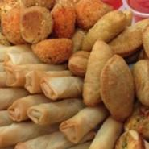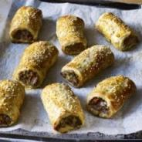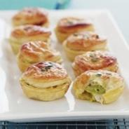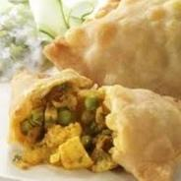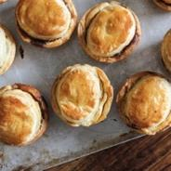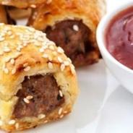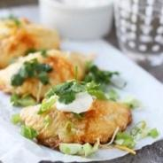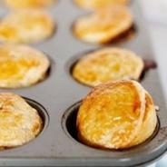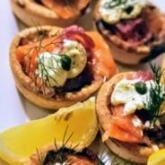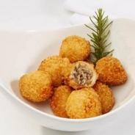 | X 1 |  |  |  |  | $145
WRAPS PLATTER (12 Pieces in Total) - $67  3 x Falafel Wrap  -Cucumber / Lettuce / Red Onion / Tomato / Minted Yoghurt / Chili  3 x Smoked Salmon Wrap  Creme Cheese / Pickled Onion / Capers / Spinach  3 x Double Smoked Ham Wrap / Cheddar / Roma Tomato / Mayo / Baby Spinach  3 x Chicken Caesar Schnitzel Wrap  - Cos Lettuce / Shaved Parmesan / Crispy Bacon / Caesar Dressing | 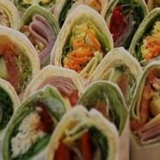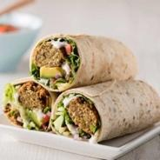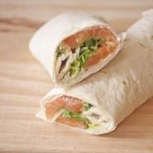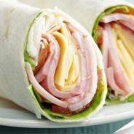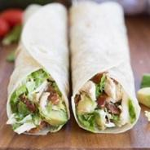 | X 1 |  |  |  |  | $67
POINT SANDWICH PLATTER -$132  (10 sandwiches in total)  includes:  -2 x Chicken/parsley/ Mayonnaise on white bread  -2 x Beef/ cheese/ onion/mustard/ pickles/ lettuce/ chutney on Multigrain bread  -2 x Salad-Avocado/tomato/cucumber/ Lettuce/ no butter on wholemeal bread  (V+ V GF Dairy free/ Nut Free/ Halal)  - 2 x Ham/ smoked cheddar/ roma tomato/house mayo/ baby spinach on multigrain  -2 x Hand chopped egg/ mayonnaise/ chive/ lettuce on brown bread | 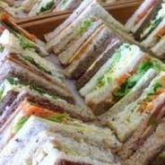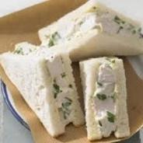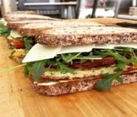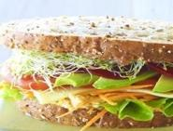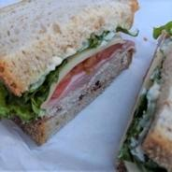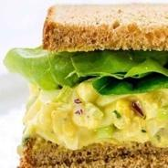 | X 1 |  |  |  |  | $132

Read what real customers say about Dreamtime Girl catering and service:
Couldn’t have asked for more on my 30th!
I have been raving about the service my guests and I received at the weekend by the fantastic crew aboard Dreamtime Girl catamaran, on a sunset cruise. From start to finish our experience was faultless, a beautiful boat, exceptional service and delicious food. The staff were all really friendly and added great value to the overall birthday vibes!
Thanks again for a super experience.
Maxine Verified Buyer

Great night on the harbour for sisters visit
My sister was visiting from the UK and it was a magical evening and night on the harbour and a treasured memory for her. Best way to celebrate a special birthday in Sydney. Recommended. PS BBQ and service was fantastic too.
James Verified Buyer
Corporate Christmas Cruise
Thanks to both Robyn and Andries who worked so hard to make our day special from organising the beautiful luncheon to the stunning spot we anchored near Taronga Zoo to swim, paddle board and feast. Our boat Dreamtime Girl was just awesome and so relaxed. Thoroughly recommended.
April Verified Buyer
Phenomenal time on Dreamtime Girl
Our team had a phenomenal time on Dreamtime Girl. At some point we were worried about sitting space in the shade (for those not too akin to the sun) for a team of 30 but we had more than enough space. The crew were so amazing to get everything, and literally everything done for us, from just preparing snacks in bowls to BBQing – they were so helpful and respected our space. I cannot recommend this boat enough- it will be your best decision this year!
John Verified Buyer
Dreamtime Girl Party
Everyone enjoyed the day out & the additional hour was an easy decision! The Captain and deckhand were fantastic, informative, hardworking and unobtrusive. Their service, preparing the yacht, receiving the liquor delivery from Rose Bay Liquor (also great!), to preparing the food we brought on board, cooking & cleaning was first class. Coming from a hospitality business we are used to delivering that service & it was unexpected to receive high quality service, not having to do anything on the day! Please thank the boys for us. We'll be back.
James Verified Buyer

CATERING ORDER FORM
Please complete this form and send your order to operations@dreamtimegirlcharters.com.au

PRICE NOTES
Monday - Friday Minimum Order $600
Saturday Minimum Order $600
Sunday Minimum Order $650

Prices in $AUD include GST
Prices are subject to change without notice.
10% Surcharge applies on Sunday
10% Surcharge applies on NYE, and Public Holidays
$50 catering delivery fee applies to all orders
Images are indicative only and may vary slightly in presentation for each order. (e.g. using seasonal garnishes)

I wish to order the following ticked items to compliment my charter on Dreamtime Girl Catamaran. In submitting this form, I agree to the price notes as stated on this page.
Name:
Phone No:
Charter Date:
Charter Date Time:

Order Number if Known:

Pick Up Wharf:

Special Requirements:

Dreamtime Girl Catering Order Form | Price | Quantity  Required | $ Sub Total | $ Total
CANAPE MENUS - PRICED PER PERSON
LIGHT CANAPE MENU $37 pp (Min 10 pax)
MOSTLY VEGETARIAN CANAPÉ MENU ~ 6 PIECES $37 pp (Min 10 pax)
CANAPÉ MENU ONE ~ 12 PIECES $66 pp (Min 10 pax)
CANAPÉ MENU TWO ~ 14 PIECES $77 pp (Min 10 pax)
BBQ MENUS - PRICED PER PERSON
BBQ MENU 1 $53 pp (Min 10 pax)
BBQ MENU 2 $63 pp (Min 10 pax)
BBQ MENU FOR SMALL NUMBERS $77 pp (Min 2 pax)
Dreamtime Girl Catering Order Form Continued | Price | Quantity  Required | $ Sub Total | $ Total
BUFFET MENUS - PRICED PER PERSON
BUFFET MENU ONE $51 pp (Min 10 pax)
BUFFET MENU TWO $58 pp (Min 10 pax)
ASIAN BUFFET MENU $74 pp (Min 15 pax)
BREAKFAST / BRUNCH MENU $25 pp (Min 15 pax)
PLATTER MENUS - PRICED PER PLATTER
CHARCUTERIE / ANTIPASTO PLATTER - $132
SEAFOOD PLATTER - $170
SUSHI PLATTER ~ NORI - $132
SMOKED SALMON PLATTER - $132
RICE PAPER ROLL PLATTER - $105
CHEESE PLATTER - $145
FRESH FRUIT PLATTER - $80
SWEET BITES PLATTER - $76
BAKED BITES PLATTER (27 Pieces) -$145
WRAPS PLATTER (12 Pieces in Total) - $67
POINT SANDWICH PLATTER -$132 (10 sandwiches in total)
Catering DELIVERY FEE | $50 | 1
SUB TOTAL
TOTAL
NB Please check your order total to comply with MINIMUM ORDER PRICING :
Monday - Friday $600, Saturday -$600, Sunday -$650
We looking forward to seeing your selections and we will send you an invoice soon.

