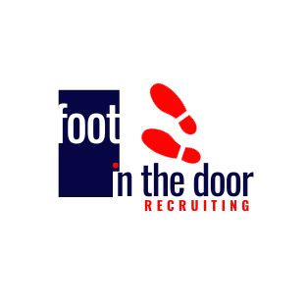

Vice President of Sales-US (Manufacturing and Transportation)

My client is experiencing explosive growth globally and is looking to add a seasoned “new pursuit leader”, focusing on BPO services in North America. This is an induvial contributor position, responsible for driving sales and revenue growth by acquiring new clients within the North American client sectors. My client is looking for an industry leader to leverage their industry knowledge and sales expertise to identify business opportunities, develop strategic relationships, and deliver tailored solutions to meet the unique needs of US based clients.

You will be responsible for cultivating my client’s presence in the market and growing business development opportunities with new clients that my client has not had previously worked with.

The successful candidate must have specific experience as an individual contributor selling BPO & Advisory services to clients in the US.

Responsibilities:
• Be responsible for Strategic New Logo Acquisition and managing the sales cycle from deal origination to closure and successful transition to the Account Manager subsequently.
•Bring a deep industry knowledge within your target client sector marketplace and competitor offerings to drive the company’s growth strategy and investments.
•Working closely with Industry Business Unit leads to work on targeted account strategies, agree on strategic target logos, and pursue to deliver high value and high growth new logos.
•Build a predictable pipeline 3X of new business to generate repeatable and profitable revenues across the various Business Units
•Can effectively identify and translate client needs into the company service offerings. Develop an understanding of customers’ business needs, matching them with the company capabilities, and developing winning proposals for the company.
•Be a key intermediary between the service delivery team and the customer.

Experience and Skills Qualifications:
•The person hired for this role must have solid current experience as an individual contributor selling multi – year / multi - million-dollar New Business BPO & Advisory engagements in to the forementioned client sectors

*Experience in closing deals with ACV > $2M and TCV > $ 10M selling BPO services to the forementioned client industries.

Send your resume to Laura@footinthedoorrecruiting.com

