Welcome to Hawaii
Everyone always asks about the weather here in Hawaii. The best App to use is the Hawaii News Now Weather App. Another good thing to remember is: Leave your expensive watches and jewelry at home. I consider Hawaii a safe island
in the way of crime, I’m from Chicago. But most minor crimes (robberies) are committed against tourists. I hear it in the
news every day.
Also, if you plan to go to the top of any volcano or take a helicopter tour, please remember to bring warm clothes, it’s
cold and windy at the tops of the volcanos.
To find out what is happening around Oahu: https://www.thisweekhawaii.com/oahu/

Someone asked about bringing fruits back to the mainland: https://www.aphis.usda.gov/aphis/resources/traveler/hawaii/hawaiian_products?fbclid=IwAR29Ktp242kq0IGZ1cIdxRtH pE89RFj2QmJRjMZAl1kdzMDIvl-krbuh_t0

Things to do on Oahu
Port Address - Honolulu, HI (Oahu), Pier 2 Cruise Terminal, 521 Ala Moana Blvd, Honolulu, HI 96813, USA 808-450-7886 There are so many things to do on Oahu I do not even know where to start.
Don’t forget: If you want to go up Diamondhead and are a non-resident you need to make reservations. https://dlnr.hawaii.gov/dsp/parks/oahu/diamond-head-state-monument/ https://gostateparks.hawaii.gov

Taxi’s
Charley's Taxi & Limousine - 1451 S King St #300, Honolulu, HI 96814, 808-233-3333, https://charleystaxi.com/ Royal Hawaiian Taxi - 2421 Tusitala St, Honolulu, HI 96815, (808) 223 1773
Honolulu Airport Transfer – (800) 929 1219, http://honoluluairporttransfer.com/

Beaches
Waikīkī Beach - Honolulu, HI 96815
Fort DeRussy Beach - Honolulu, HI 96815

Tour Companies
Shore Excursions Group - https://www.shoreexcursionsgroup.com/hawaii-shore-excursions (866) 999 6590
Polynesian Adventure Tours - 2965 N Nimitz Hwy, Honolulu, HI 96819, (808) 833 3000, https://www.polyad.com/

Tours
Polynesian Cultural Center - 55-370 Kamehameha Hwy, Laie, HI 96762, (800) 367 7060, https://www.polynesia.com/ Pearl Harbor – the following is the link for Pearl Harbor FAQ:
https://www.nps.gov/perl/faqs.htm?fbclid=IwAR0k2pxsHpHwghBweqngGQE1BIINjQ5cYuJ076r7Dtuu7ymNH7wBTz91U WE

Dole Plantation - 64-1550 Kamehameha Hwy, Wahiawa, HI 96786, (808) 621 8408, https://www.doleplantation.com/
Honolulu Zoo - 151 Kapahulu Ave, Honolulu, HI 96815, (808) 926 3191, http://honoluluzoo.org/
Honolulu Aquarium - 2777 Kalakaua Ave, Honolulu, HI 96815, (808) 923 9741, https://www.waikikiaquarium.org/
Bernice Pauahi Bishop Museum - 1525 Bernice St, Honolulu, HI 96817, (808) 847 3511, http://www.bishopmuseum.org/ Tours by Locals - https://www.toursbylocals.com/ Another idea for tours.
Oahu Hawaii Travel Guise – a free guide to things to do around Oahu, https://OahuHawaii.ca/
Oahu Photography Tours - 2421 Tusitala St, Honolulu, HI 96815, (808) 679 1938, https://www.oahuphotographytours.com/

Restaurants
There are so many restaurants on Oahu. The North Shore ones are the ones that I have spent a lot of time at. I used to work up near the North Shore.

North Shore
Haleiwa Joe's - 66-011 Kamehameha Hwy, Haleiwa, HI 96712, (808) 637 8005, https://haleiwajoes.com/ My Favorite.
Breakers Restaurant & Bar - 66-250 Kamehameha Hwy G120, Haleiwa, HI 96712, (808) 637 9898, http://breakersnorthshore.com/ another favorite for lunches. Every time I am in town I’m here.
Cholo's Homestyle Mexican - 66-250 Kamehameha Hwy, Haleiwa, HI 96712, (808) 637 3059, http://www.cholos.mx/ Another favorite if you like Mexican.
Matsumoto Shave Ice - 66-111 Kamehameha Hwy #605, Haleiwa, HI 96712, (808) 637 4827, http://matsumotoshaveice.com/

Shrimp Trucks – there are shrimp trucks all over the island but the ones listed here are up in the North Shore area.
Honos Shrimp Truck - Hours: 10:30 a.m. to 5 p.m. daily, closed Thursday, 66-472 Kamehameha Highway, Hale‘iwa, (808)
341-7166
Jenny’s Shrimp - Hours: 9:30 a.m. to 6:30 p.m. daily, 66-532 Kamehameha Highway, Hale‘iwa, (808) 429-3522
Big Wave Shrimp - Hours: 10:30 a.m. to 6:30 p.m. daily, 66-521 Kamehameha Highway, Hale‘iwa, (808) 366-2016, www.bigwaveshrimp.com
Fumi’s Kahuku Shrimp - Hours: 10 a.m. to 7:30 p.m. daily, 56-777 Kamehameha Highway, Kahuku, (808) 232-8881
Famous Kahuku Shrimp - Kahuku—Hours: 10 a.m. to 6 p.m. daily, 56-565 Kamehameha Highway, Kahuku, (808) 389- 1173; Waialua—Hours: 10 a.m. to 6 p.m. daily, 67-21 Waialua Beach Road, Waialua.
Giovanni’s Shrimp Truck - Hale‘iwa—Hours: 10:30 a.m. to 5 p.m. daily, 66-472 Kamehameha Highway; Kahuku—Hours: 10:30 a.m. to 6:30 p.m. daily, 56-505 Kamehameha Highway; (808) 293-1839, www.giovannisshrimptruck.com

South
Kona Brewing Co. - 7192 Kalanianole Highway, Honolulu, HI 96825, (808) 396 5662, http://www.konabrewingco.com/
Restaurant 604 - 57 Arizona Memorial Dr, Honolulu, HI 96818, (808) 888 7616
The Original Roy's in Hawaii Kai - 6600 Kalanianaʻole Hwy Suite 110, Honolulu, HI 96825, (808) 396 7697,
https://www.royyamaguchi.com/roys-hawaiikai expensive
Hy's Steak House - 2440 Kūhiō Ave., Honolulu, HI 96815, (808) 922 5555, http://www.hyshawaii.com/ expensive

Rainbow Drive-In - 3308 Kanaina Ave, Honolulu, HI 96815, (808) 737 0177, http://www.rainbowdrivein.com/ Local Landmark.
Duke's Waikiki - 2335 Kalakaua Ave #116, Honolulu, HI 96815, (808) 922 2268, http://www.dukeswaikiki.com/ a must if you are in town.

East
Haleiwa Joe's Haiku Gardens - 46-336 Haiku Rd, Kaneohe, HI 96744, (808) 247 6671, http://haleiwajoes.com/

West
Monkeypod Kitchen by Merriman - Ko Olina - 92-1048 Olani St, Kapolei, HI 96707, (808) 380 4086, http://www.monkeypodkitchen.com/

Luau’s
On Oahu there are so many Luaus to choose from and almost every hotel has one.
Polynesian Cultural Center - 55-370 Kamehameha Hwy, Laie, HI 96762, (800) 367 7060, https://www.polynesia.com/
Diamond Head Luau - 2777 Kalakaua Ave #4027, Honolulu, HI 96815, (808) 926 3800, http://www.diamondheadbeachluau.com/
Chief's Luau - 400 Farrington Hwy, Kapolei, HI 96707, (808) 664 0448, http://www.chiefsluauhawaii.com/
Toa Luau - 59-864 Kamehameha Hwy, Haleiwa, HI 96712, (877) 778 8505, https://www.toaluau.com/
Paradise Cove Luau - 92-1089 Aliinui Dr, Kapolei, HI 96707, (808) 842 5911, https://www.paradisecove.com/
Germaine's Luau - 91-119 Olai St, Kapolei, HI 96707, (808) 947 1244, https://www.germainesluau.com/
Hilton Hawaiian Village’s Waikiki Starlight Luau - 2005 Kalia road, Honolulu, HI, 96815, (808) 949 4321 https://www3.hilton.com/en/hotels/hawaii/hilton-hawaiian-village-waikiki-beach-resort-HNLHVHH/attractions/resort- activities-info.html is currently available on Mondays, Tuesdays, Thursdays & Fridays (weather-permitting) on the Great Lawn — located off of the Duke Kahanamoku Lagoon (schedule subject to change)
Experience Nutridge - 3280 Round Top Dr, Honolulu, HI 96822, (808) 531 5050, https://www.experiencenutridge.com/ I am hearing nothing but good things. Very small and intimate and a great view of the island as you drive up.
Ka Moana Luau - 41-202 Kalanianaʻole Hwy, Waimanalo, HI 96795, (808) 926 3800, http://moanaluau.com/

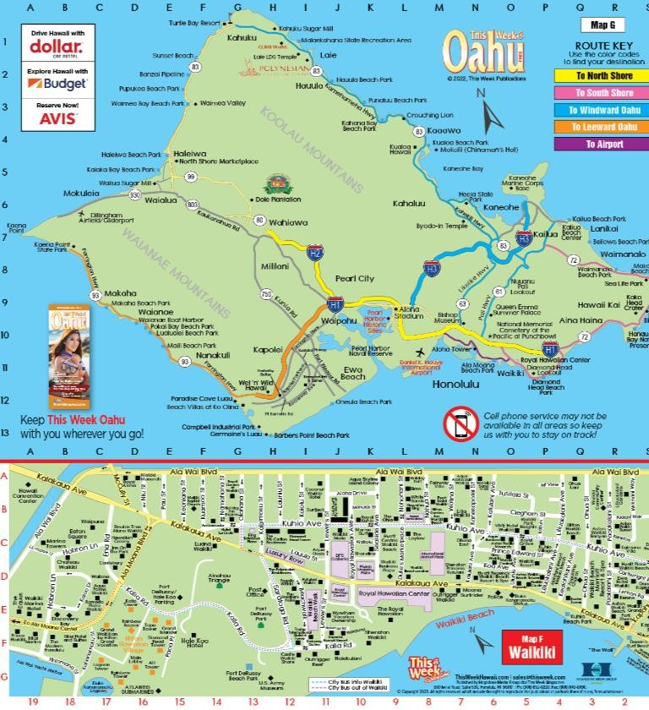

Things to do on Maui
Port Address - Kahului, Maui, 130 Ala Luina St. Kahului, HI 96732, USA 808-873-3350
Don’t forget: Non-residents must make reservations for Waianapanapa State Park on Maui. https://www.gowaianapanapa.com/
Reservations are required at certain times (sunrise) to visit Haleakala National Park on Maui. If you go with a tour, they take care of that for you. https://www.nps.gov/hale/planyourvisit/permitsandreservations.htm For those of you that want to go to the top of Haleakala please remember to bring warm clothes, it’s very cold and windy at the top. During the winter months remember to bring gloves also.
To find out what is happening around Maui: https://www.thisweekhawaii.com/maui/

Taxi’s
Maui Taxi 808 - 3311 Old Haleakala Hwy, Makawao, HI 96768, (808) 573 8294
Haiku Taxi – Shuttle - 84 Noho Pl, Makawao, HI 96768, (808) 579 8294
Taxi Services LLC - 160 Keonekai Rd #5-101, Kihei, HI 96753, (808) 870 4137
Surf Taxi Maui - 61 E Waiko Rd, Wailuku, HI 96793, (808) 870 9974
Wailea Tours and Taxi - 1771 Hoomua Dr, Kihei, HI 96753, (808) 250 9638

Restaurants
Mama's Fish House - 799 Poho Pl, Paia, HI 96779, (808) 579 8488, http://www.mamasfishhouse.com/ Make reservations early, there is a 3 to 6 month waiting list. It’s a little expensive and I’ve eaten here a few times.
Fleetwood's on Front St. - 744 Front St, Lahaina, HI 96761, (808) 669 6425, http://www.fleetwoodsonfrontst.com/
Cheeseburger In Paradise - 811 Front St, Lahaina, HI 96761, (808) 661 4855, http://cheeseburgernation.com/
Tommy Bahama Marlin Bar - 900 Front St Unit B2, Lahaina, HI 96761, (8080 500 6204, https://www.tommybahama.com/restaurants/marlin-bars/lahaina-hi.html
Waikiki Brewing Company, Lahaina - 900 Front St B-1, Lahaina, HI 96761, (808) 856 0036, http://www.waikikibrewing.com/
Lahaina Fish Co - 831 Front St, Lahaina, HI 96761, (808) 661 3472, http://www.lahainafishco.com/

Tours
Hoaloha Jeep Adventures - https://hoalohajeepadventures.com/
Valley Isle Excursions - 466 E Ahuli'u Way, Wailuku, HI 96793, (808) 871 5224, https://www.tourmaui.com/
Polynesian Adventure Tours - 850 W Mokuea Pl, Kahului, HI 96732, (808) 877 4242, https://www.polyad.com/
Hana Tours of Maui – (808) 575 2317, http://www.hanatoursofmaui.com/
Jared Maui Tours – (808) 250 1613
Skyline Hawaii - Kaanapali Zipline Tours - 2580 Kekaa Dr #115, Lahaina, HI 96761, (808) 427 2771, https://www.skylinehawaii.com/
Skyline Hawaii – Haleakala - 18303 Haleakala Hwy, Kula, HI 96790, (808) 219 0472, https://www.skylinehawaii.com/maui/
Haleakalā Visitor Center - Haleakala Hwy, Kula, HI 96790, (808) 572 4400, http://www.nps.gov/hale
Haleakala EcoTours - 810 Haiku Rd, Haiku, HI 96708, (808) 575 9575, https://haleakalaecotours.com/

Trilogy Excursions - 207 Kupuohi St, Lahaina, HI 96761, (808) 874 5649, https://sailtrilogy.com/
Maui Ocean Center, The Aquarium of Hawaii - 192 Maalaea Rd, Wailuku, HI 96793, (808) 270 7000, https://www.mauioceancenter.com/
Helicopter Tours - 280 Pua Pl, Wailuku, HI 96793, (808) 460 8194, https://www.helicoptertours.com/
Maui Helicopter Tours - 5095 Napilihau St 109B PMB 254, Lahaina, HI 96761, (808) 638 3230, https://mauihelicoptertours.com/
Maui Arts & Cultural Center - 1 Cameron Way, Kahului, HI 96732, http://www.mauiarts.org/ (808) 242 7469, Check out to see if there are any shows/concerts the first night you are on Maui. I have seen several shows here.
Maui 24/7 – A useful Facebook page with current beach conditions and such. https://www.facebook.com/maui247

Luau’s
Old Lahaina Luau - 1251 Front St, Lahaina, HI 96761, (808) 667 1998, https://oldlahainaluau.com/
A Grand Wailea Lū‘au - Luau Entrance, 3850 Wailea Alanui Dr, Wailea, HI 96753, (808) 875 1234, https://www.grandwailea.com/experiences/luau
Te Au Moana - 3700 Wailea Alanui Dr, Wailea, HI 96753, (877) 827 2740, http://www.teaumoana.com/
Drums of the Pacific Lū‘au - 200 Nohea Kai Dr, Lahaina, HI 96761, (808) 667 4727, http://drumsofthepacificmaui.com/ Myths of Maui luau - 2780 Kekaa Dr, Lahaina, HI 96761, (877) 273 7394, https://www.mythsofmaui.com/
Feast at Lele - 505 Front St, Lahaina, HI 96761, (808) 667 5353, https://www.feastatlele.com/
Maui Tickets For Less - 505 Front St, Lahaina, HI 96761, (855) 268 0387, http://www.mauiticketsforless.com/
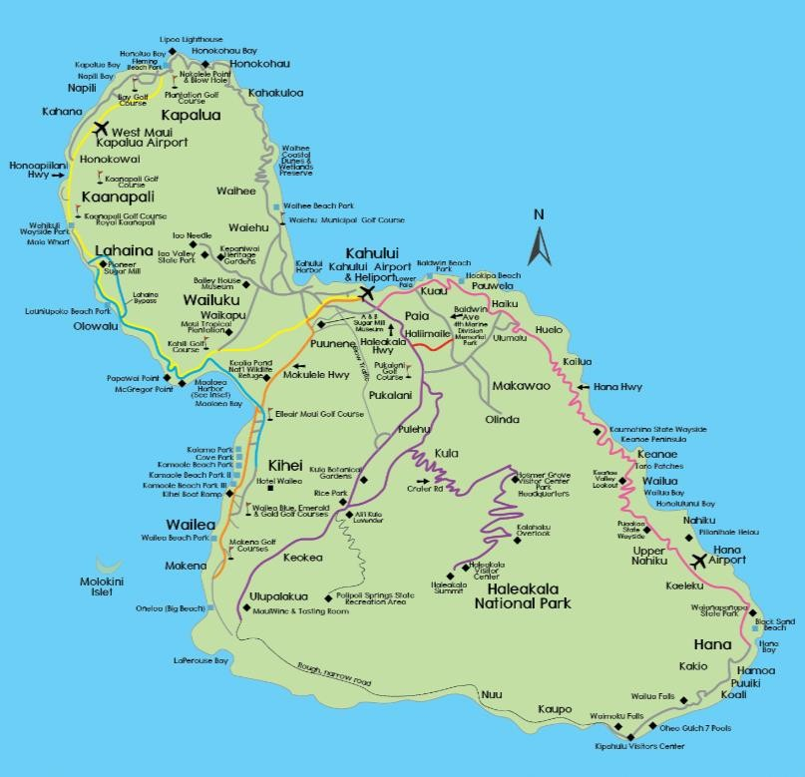

Things to do on the Big Island
To find out what is happening around the big island go to https://www.ThisWeekHawaii.com/event-calendar/big-island/

North
Pololu Valley – Pololu means “long spear” in the Hawaiian language. Pololu Valley is the northernmost valley along the east coast of the Kohala Mountains on the Island of Hawaii. It’s a nice drive to the lookout. You can hike down to the beach but it takes about an hour to walk down and it can be muddy/slippery due to the rains. Not recommended for those not in good health, hiking shoes are needed.
Kohala Zipline – 55-515 Hawi Rd, Hawi, HI 96719, (808) 331 3620, http://www.kohalazipline.com/

Kohala UTV Adventure - 55-517 Hawi Rd, Hawi, HI 96719, (808) 933 4294, http://kohalautv.com/

Waipiʻo Valley Lookout – 48-5546 Waipio Valley Rd, Waimea, HI 96743, (808) 961 8311

Pu'ukohola Heiau National Park – https://NPS.gov/puhe/index.htm/ Pu'ukohola Heiau NHS is open all year round and shares the history of the beginning stages of the Hawaiian Kingdom.

Hapuna Beach State Recreation Area – Old Puako Rd, Waimea, HI 96743, (808) 961 9540, http://dlnr.hawaii.gov/dsp/parks/hawaii/hapuna-beach-state-recreation-area/ Mile Marker 69, The best beach on this island.

Restaurants
Bamboo Restaurant & Gallery – 55-3415 Akoni Pule Hwy, Hawi, HI 96719, (808) 889 5555, http://www.bamboorestauranthawaii.com/ a nice place to eat after going to Pololu Valley or to do Kohala Zipline tour.

Kohala Burger & Taco - 613665 Akoni Pule Hwy, Waimea, HI 96743, (808) 880 1923, http://www.kohalaburgerandtaco.com/ great burgers - beef or fish, small hole in the wall place to stop before or after the trip up north.

South
Hawaii Coffee Company, 83-5427 Mamalahoa Hwy., Captain Cook, Hawaii 96704, 808-328-2511. We have never been here.

Punaluʻu Beach, Black Sand beach – Nice place to see turtles resting.
Papakōlea Green Sand Beach – You need the locals to drive you there, about $10 per person. South Point – The southernmost point on the islands and the US.
Punalu'u Bake Shop - HI-11, Naalehu, HI 96772, (866) 366 3501, http://www.bakeshophawaii.com/ the southern most bakery in the US.

East - Hilo
Port Address - Port of Hilo, 80 Kuhio St. Hilo, HI 96720, USA 808-933-8850

Taxi’s
Stan's Taxi - 133 Laukona St, Hilo, HI 96720, (808) 443 8810
AA Marshall's Taxi - https://www.taxihilo.com/ (808) 936 2654

JB’s Taxi - http://www.jbstaxi-hilo.com/ (808) 430 7301

Makana Taxi and Tours - 104 Kaumana Dr, Hilo, HI 96720, (808) 319 0819, https://makana-taxi-and-tours.business.site/

Da Best Taxi LLC – (808) 557 7059

There is a shuttle from the port to the airport car rental. The airport is just a mile or so right down from the pier.

Tours
Big Island Aina Tours - Hilo, HI 96720, (808) 315-3097

Maikai Ohana Tours - 260 Kamehameha Ave Ste 209, Hilo, HI 96720, (808) 969-1030, http://www.maikaiohana.com/ Japanese guest tours

Safari Helicopters - 2220 Kekuanaoa St, Hilo, HI 96720, (808) 969-1259, https://safarihelicopters.com/

Paradise Helicopters - (866) 876 7422, http://www.paradisecopters.com/

Botanical World Adventures – (808) 963 5427, http://botanicalworld.com/

KapohoKine Adventures - 93 Banyan Dr, Hilo, HI 96720, (808) 964 1000, http://www.kapohokine.com/

Polynesian Adventure Tours - https://www.polyad.com/tour-destination/big-island/ 808-833-3000 or 800-622-3011

Restaurants
Ken's House of Pancakes – 1730 Kamehameha Ave, Hilo, HI 96720, (808) 935 8711, http://www.kenshouseofpancakes.com/ Closest place to eat near the port. Nice diner atmosphere.

Cafe Pesto Hilo Bay – 308 Kamehameha Ave #101, Hilo, HI 96720, (808) 969 6640, http://www.cafepesto.com/ great food.
Jackie Rey's Ohana Grill – 64 Keawe St, Hilo, HI 96720, (808) 961 2572, http://www.jackiereyshilo.com/ great food.

Hilo Burger Joint - 776 Kilauea Ave, Hilo, HI 96720, (808) 935 8880, http://www.hiloburgerjoint.com/ great burgers

Other Ideas
Muana Loa Macadamia Nut Visitor Center – 16-701 Macadamia Road, Keaau, HI 96749, (808) 966 8618, http://www.maunaloa.com/, they are currently closed and scheduled to open 1 Aug. They have a great store to buy all kinds of their products.
Mokupapapa Discovery Center, Free and open to the public. Open Tues. through Sat., 9 a.m. to 4 p.m., 76 Kamehameha Avenue, Hilo, (808) 933-8180, http://www.papahanaumokuakea.gov/education/center.html We have never been here.

Hawai'i Volcanoes National Park – 1 Crater Rim Drive, Volcano, HI, United States, Hawaii, (808) 985 6000, https://www.nps.gov/havo/index.htm you can spend an hour or all day here. If you just spend an hour or so that will have time to do some waterfalls. If you drive yourself to the park and have a National Parks ID Card, please remember to bring it. It will save you $30. Dress warm and wear proper shoes.
Volcano Winery - 35 Piimauna Dr, Volcano, HI 96785, (808) 967 7772, http://www.volcanowinery.com/

Lavaloha Chocolate Farm, Mon- Sat: 9:00 am - 5:00 pm, https://lavaloha.com/ (808) 987-3649, 1820 Amauulu Road, Hilo, HI 96720, They do a very nice tour, great place to buy local chocolate. Call for tours. Done it once.
Hawaii Vanilla Company - https://hawaiianvanilla.com/ 43-2007 Paauilo Mauka Rd, Paauilo, HI 96776, (808) 776 1771 Reservations required. Lunch and tour. We have done this 4 times.
Tex Drive-In - 45-690 Pakalana St #19, Honokaa, HI 96727, (808) 775 0598, http://www.texdriveinhawaii.com/ Longtime pit stop known for deep-fried dough balls called malasadas, plus burgers & Hawaiian food. We stop by every time we are in the area.

Waterfalls – There are lots of waterfalls on the Hilo side of the island. Rainbow Falls - Waianuenue Ave, Hilo, HI 96720
Akaka Falls - 875 Akaka Falls Rd, Honomu, HI 96728
Pe’epe’e Falls - 99 Peepee Falls St, Hilo, HI 96720
Waihilau Falls - Maalo Rd,off Hwy 580, Lihue, Kauai, Hawaii

West - Kona
Port Address - Kailua Pier (Kona), Kaahumanu Pl. Kailua, HI 96740, USA 808-464-0840

The closest beach to the pier is at the Courtyard Marriott right at the end of the pier. You can rent equipment right across the street at: Alii Adventures - 75-5663 Palani Rd Unit A, Kailua-Kona, HI 96740, https://aliiadventureshack.com/ (808) 657 4606

Taxi’s
R Jay Taxi - https://www.kailuakonataxicab.com/ (808) 201-1780

Jazirh Taxi - 76-6192 Plumeria Rd, Kailua-Kona, HI 96740, (808) 238 1407
Gold Coast Town Cars Services – Http://Goldcoasttowncars.com/ (808) 756-7375

Cruz'n Taxi – (808) 325 1234
Kona Taxicab LLC - https://konataxicab.com/ (808) 324 4444

Speedishuttle - 74555 Honokohau St #D10, Kailua-Kona, HI 96740, http://www.speedishuttle.com/ (808) 242 7777

Kona Trolly – There is a trolly stop right by the pier. Use Google Maps and search Kona Trolly near Kona to see stops.

Tour Companies
Hawaii Forest & Trail - 73-5593 A, 73-5593 Olowalu St, Kailua-Kona, HI 96740, (808) 331 8505, http://www.hawaii-forest.com/

Kailani Tours Hawaii - 74-555 Honokohau St, Ste. B8, Kailua-Kona, HI 96740, (808) 938 4057, https://www.kailanitourshawaii.com/

Wasabi Tours Hawaii - 74-581 Honokohau St, Kailua Kona, HI 96740, (808) 238-5222, http://www.wasabitourshawaii.com/

Body Glove Cruises - 75 5629 Kuakini Highway, Kailua-Kona, HI 96740 (800) 551-8911, https://www.bodyglovehawaii.com/ Snorkeling at Cpt. Cook Monument, they depart from the pier.

Fair Wind Cruises - 78-7130 Kaleiopapa St, Kailua Kona, HI 96740 (808) 322-2788 http://www.fair-winds.com/ Snorkeling at Cpt. Cook Monument, call for reservations. I have done this tour 6 times.

Blue Hawaiian Helicopters - 68-690 Waikoloa Rd, Waikoloa Village, HI 96738, (808) 961 5600, https://www.bluehawaiian.com/en/bigisland

Atlantis Submarines Kona - 75-5660 Palani Rd #304, Kailua-Kona, HI 96740, http://www.atlantisadventures.com/kona (800) 381 0237. They depart from the pier.

Hang Loose Boat Tours - 74-380 Kealakehe Pkwy, Kailua-Kona, HI 96740, http://www.hawaiitourboat.com/ (808) 345 4262

Captain Zodiac Snorkeling and Whale Watching tours - 74-425 Kealakehe Pkwy #16, Kailua-Kona, HI 96740, https://www.captainzodiac.com/ (808) 329 3199

UFO Parasail, inside the Marriott Hotel, (800) 359 4836, http://www.UFOParasail.net they depart from the pier.

Adventures in Paradise Kayak & Snorkel -82-6038 Puuhonua Rd, Captain Cook, HI 96704, (808) 447 0080 http://bigislandkayak.com/

Captain Cook Snorkeling Cruises - 78-7130 Keauhou Harbor, Kaleiopapa St, Kailua, HI 96740, https://captaincooksnorkelingcruises.com/ (808) 378 7515, (855) 855 6417

Skyline Hawaii - Kaanapali Zipline Tours - https://www.skylinehawaii.com/ (808) 963 6353

Tours
Mountain Thunder Coffee Plantation - 73-1942 Ha'o St, Kailua-Kona, HI 96740, http://mountainthunder.com/ free tours every hour on the hour.Right down the stree from

Kona Cloud Forest Guided Walking Tours - 73-1865 Hao St #3, Kailua-Kona, HI 96740, http://www.konacloudforest.org/ (808) 640 3888
Kona Sea Salt Farm Tours - 73-907 Makako Bay Dr, Kailua-Kona, HI 96740, http://www.konaseasalt.com/ (808) 326 9301

Ocean Rider Seahorse Farm Tours - 73-4388 Ilikai Pl, Kailua-Kona, HI 96740 (808) 329-6840, https://seahorse.com/ Tour Length: 1½ hours Best for: 12 and older
Kanaloa Octopus Farm - 73-4460 Queen Ka'ahumanu Hwy Ste 138, Kailua-Kona, HI 96740, (808) 747 6895 http://www.kanaloaoctopus.com/

The Vanillerie - 73-4301 Laui St, Kailua-Kona, HI 96740, http://www.thevanillerie.com/ (808) 331 8535, local vanilla farm

Kaloko-Honokōhau National Historical Park - Kailua-Kona, HI 96740, http://www.nps.gov/kaho/contacts.htm (808) 329 6881

Greenwell Farms - 81-6581 Mamalahoa Hwy, Kealakekua, HI 96750, (808) 323 9616, http://www.greenwellfarms.com/. There are lots of coffee farms in the area.

Shopping
Wal-Mart - 75-1015 Henry St, Kailua-Kona, HI 96740, (808) 334 0466, about a mile from the pier
ABC Store - 75-5744 Ali‘i Dr, Kailua-Kona, HI 96740, (808) 326 4824, in town just a few minutes’ walk from the pier

Hilo Hattie - 75-5744 Ali'i Drive Unit 96 Unit 96, Kailua-Kona, HI 96740, (808) 329 7200, in town just a few minutes’ walk
from the pier https://www.hilohattie.com/pages/store-locations

Target - 74-5455 Makala Blvd, Kailua-Kona, HI 96740, (808) 334 4020, about 2 miles from the pier

Farmer’s Markets
Ho'oulu Community Farmers Market & Artisans Fair - 78-128 Ehukai St, Kailua-Kona, HI 96740, (808) 930 4900, this is only open on Wednesdays and is all local vendors, down by the Outrigger Resort. You need transportation to get there.
Kona Farmers Market - 75-5767 Ali‘i Dr, Kailua-Kona, HI 96740, a very short walk from the pier, lots of local stuff

Fitness
Planet Fitness - 75-1000 Henry St Ste 100, Kailua-Kona, HI 96740, (808) 451 2900, open 24/5. 7am – 10 pm on weekends. Nice place. About a mile from the pier.

Resorts
Lava Lava Beach Club Restaurant – Waikoloa - 369007015, Waikoloa Village, HI 96738, (808) 769 5282, https://lavalavabeachclub.com/bigisland/ Nice place to eat, great beach.

Four Seasons Resort Hualalai - 72-100 Ka'upulehu Drive, Kailua-Kona, HI 96740, (808) 325 8000 https://www.fourseasons.com/hualalai/ Great place for lunch.

Courtyard by Marriott King Kamehameha's Kona Beach Hotel, 75-5660 Palani Rd, Kailua-Kona, HI 96740, (808) 329 2911 https://www.marriott.com/hotels/travel/koacy-courtyard-king-kamehamehas-kona-beach-hotel/ – Closest place to get some beach time. Great poolside bar. Cabanas.

Royal Kona Resort - 75-5852 Ali‘i Dr, Kailua-Kona, HI 96740, (808) 329 3111, https://www.royalkona.com/ see #1 below

Outrigger Kona Resort and Spa - 78-128 Ehukai St, Kailua-Kona, HI 96740, (808) 930 4900, https://www.outriggerkona.com/

Great places to eat and within walking distance from the pier.
In order from Farthest to closet to the pier

- Royal Kona Resort - 75-5852 Ali‘i Dr, Kailua-Kona, HI 96740, (808) 329 3111 https://www.royalkona.com/ Don's Mai Tai Bar- Quesadilla, Nachos are great and the Mai Tai's are delicious!

- Huggos on the Rocks/Huggos - 75-5824 Kahakai Rd, Kailua-Kona, HI 96740, (808) 329 8711, http://huggosontherocks.com/ It is right next to the Royal Kona Resort. Great place for lunch/dinner. Great sunset view.

- Humpy's Big Island Alehouse - 75-5815 Ali‘i Dr, Kailua-Kona, HI 96740, (808) 324 2337, https://www.humpysalaska.com/kona Great burgers, fish & chips, craft beers, great views. One of my favorites places to eat.
- Laverne's Sports Bar – 75-5819 Ali‘i Dr, Kailua-Kona, HI 96740, (808) 331 2633, http://laverneskona.com/, next door
to Humpy’s upstairs. Same menu, different vibe.
- Foster's Kitchen – 75-5805 Ali‘i Dr, Kailua-Kona, HI 96740, (808) 326 1600 http://www.fosterskitchen.com/ Upstairs, right next to Lava Java. Great menu, we eat here often.
- Island Lava Java - 75-5801 Ali‘i Dr Building 1, Kailua-Kona, HI 96740, (808) 327 2161, http://islandlavajava.com/ I like Lava Java and they just moved to their new location.
- Papa Kona Restaurant & Bar - The Waterfront Row, 75-5770 Ali‘i Dr 1st Floor, Kailua-Kona, HI 96740, (808) 300 0044 http://www.papakona.com/ Nice place for breakfast/lunch. Try to get a seat by the water or a seat upstairs. Used to be Daylight Minds.
- Kai Eats and Drinks – 75-5776 Ali‘i Dr, Kailua-Kona, HI 96740, (808) 900 3328, http://kaieats.com/ used to be Bubba
Gump’s, a little expensive, 75-5776 Ali‘i Dr, Kailua-Kona, HI 96740
- Kona Inn Restaurant - 75-5744 Ali‘i Dr, Kailua-Kona, HI 96740, (808) 329 4455, http://konainnrestaurant.com/ A very nice place for lunch/dinner (fine dining), great sunset view so get there early.
- Kona Canoe Club – 75-5744 Ali‘i Dr #21, Kailua-Kona, HI 96740, (808) 331 1155, http://konacanoeclub.com/ Nice place to eat. We do lunch here often. A great view of the bay.

- Ola Brew Company - 74-5598 Luhia St, Kailua-Kona, HI 96740, (808) 339 3599, https://www.olabrewco.com/taproom

- Kona Brew Pub – our favorite, we have been going every Tuesday for the last 7 years. They do tours of the brewery but you have to make reservations. 74-5612 Pawai Place Kailua Kona, HI 96740, (808) 396 5662, https://konabrewingco.com/

- Fish Hopper Kona - 75-5683 Ali‘i Dr, Kailua-Kona, HI 96740, (808) 326 2002, https://www.fishhopperkona.com/

- Big Kahuna Beach Grill, really good for breakfast, lunches and dinners are great with very large portions. Across the street from the pier. www.bigkahunabeachgrill.com
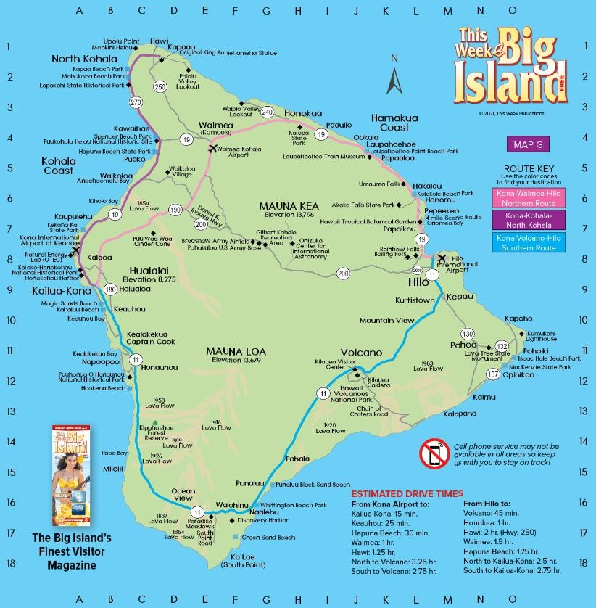

Things to do on Kauai
Port Address - Nawiliwili Harbor (Kauai), Waapa Rd. Lihue, HI 96766, USA 808-241-3115
Non-residents must make reservations for Haena State Park on Kauai. https://dlnr.hawaii.gov/dsp/parks/kauai/haena- state-park/

To find out what is happening around Kauai: https://www.thisweekhawaii.com/kauai/

Taxi’s
Nawiliwili Cruise Pier - 3150 Waapa Rd, Lihue, HI 96766,
Pono Express - 3-2600 Kaumualii Hwy #1300, Lihue, HI 96766, (808) 651 4779
Jolex Taxi - 4270 Hardy St, Lihue, HI 96766, (808) 278 0877
Speedishuttle - 4444 Rice St, Lihue, HI 96766, (808) 246 4777
Shuttle N Tours of Hawaii - 3159 Fujii St, Lihue, HI 96766, (808) 855 8438
A1 Lift - www.KauaiWheelchair.com/ KC-(808) 651 6351, (808) 647 0427
Caroline Castillo – (808) 635 9747, (808) 631 3004, carolcastillo965@gmail.com
Aloha Kauai Riders – Glenn: 720 353 2345, Robb: 808 266 0238
Carlex Taxi - https://carlex-taxi.business.site/ (808) 652-9332 (808) 631-3004

Beach/Restaurants
Kalapaki Beach – right next to the port
Marriott Vacation Club - 3610 Rice Street Kalapaki Beach, Lihue, HI 96766, (808) 818 3500, great place to hang out, nice beach bar
Duke's Kauai - 3610 Rice St, Lihue, HI 96766, http://www.dukeskauai.com/ (808) 246 9599. Next door to the Marriott, great place to eat. Make reservations to be sure you get a seat.
Cafe Portofino - 3481 Ho'Olaulea Way, Lihue, HI 96766, http://www.cafeportofino.com/ (808) 245 2121
Lilikoi Bar and Grill - 3501 Rice St #2009, Lihue, HI 96766, https://lilikoibarandgrill.com/ (808) 320 3066
Kukui's on Kalapaki Beach - 3610 Rice St, Lihue, HI 96766, https://www.sonesta.com/us/hawaii/lihue/royal-sonesta- kauai-resort-lihue/kukuis-kalapaki-beach (808) 246 5042

Helicopter Tours
Airborne Aviation - 3651 Ahukini Rd, Lihue, HI 96766, (877) 444 0144, (808) 828 0282, https://airborneaviationtours.com/
Jack Harter Helicopters - 4231 Ahukini Rd, Lihue, HI 96766, (808) 245 3774, http://www.helicopters-kauai.com/ I have done this tour. They give you a great view of the island. They will pick you up at the port.
Island Helicopters Kauai - 3788 Ahukini Rd, Lihue, HI 96766, (808) 245 8588, http://www.islandhelicopters.com/
Blue Hawaiian Helicopters - Lihue Airport, 3730 Ahukini Rd #8, Lihue, HI 96766, (808) 245 5800, https://www.bluehawaiian.com/

Tours
Kipu Ranch Adventures - 235 Kipu Rd, Lihue, HI 96766, (808) 246 9288, http://www.kiputours.com/
Outfitters Kauai - 230 Kipu Rd, Lihue, HI 96766, (808) 742 9667, https://outfitterskauai.com/

Holo Holo Charters - 4353 Waialo Rd #5a, Eleele, HI 96705, (808) 335 0815, https://www.holoholokauaiboattours.com/
Makana Charters - Tour Kauai's Napali Coast - 4516 Alawai Rd, Waimea, HI 96796, (808) 338 9980, https://makanacharters.com/
Blue Ocean Adventure Tours - Kikiaʻola Small Boat Harbor, Kekaha, HI 96752, (800) 451 6133, http://www.goblueadventures.com/
Kauai Z-Tourz - 3417 Poipu Rd #105, Koloa, HI 96756, (808) 742 7422, http://www.kauaiztours.com/
Wings Over Kauai Air Tours - 3745 Ahukini Rd, Lihue, HI 96766, (808) 635 0815, http://www.wingsoverkauai.com/
Skyline Hawaii - Poipu Zipline Tours - 2829 Ala Kalanikaumaka St b121, Koloa, HI 96756, (808) 800 4732, https://www.skylinehawaii.com/
Kauai Mountain Tubing Adventure - 3-4131 Kuhio Hwy, Lihue, HI 96766, (855) 846 0092, https://kauaibackcountry.com/tubing/

Luau’s
Lu’au Kalamaku - 3-2087 Kaumualii Hwy, Lihue, HI 96766, (877) 622 1780, http://luaukalamaku.com/ Monday/Tuesday
Thursday/Friday Luaus’
Aulii Luau - @ Sheraton Kauai Resort Villas - 2440 Hoonani Rd, Koloa, HI 96756, (808) 634 1499, https://www.auliiluau.com/ Thursday/Saturday Luaus’
Smith Family Garden Luau - 3-5971 Kuhio Hwy, Kapaʻa, HI 96746, (808) 821 6895, http://www.smithskauai.com/
