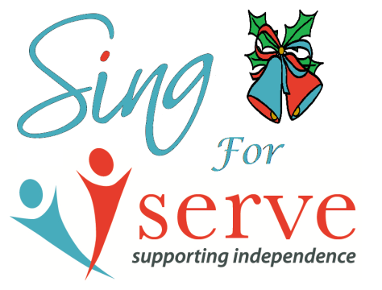
The Susan Hollowell Memorial Award 2023 Nomination Form

Please return to Ruth Moore at 8 West Street, Rushden by 4pm on Friday 17th November 2023

I wish to nominate: …………………………………………………………………………………..

My reason: (no more than 50 words)

…………………………………………………………………………………………………………………

…………………………………………………………………………………………………………………

…………………………………………………………………………………………………………………

…………………………………………………………………………………………………………………

…………………………………………………………………………………………………………………

…………………………………………………………………………………………………………………

Your Name: Signature:
Your Contact info:

