Albuquerque Aril & Iris Society
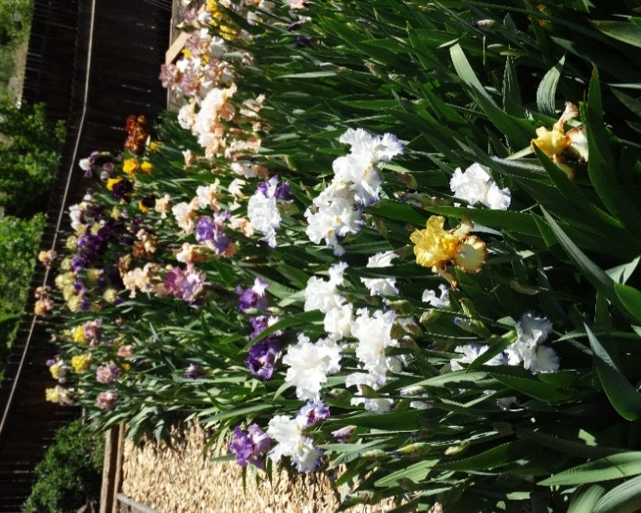
Irises are more than pretty purple flowers that bloom in the spring. They come in an amazing array of varieties, styles, and astonishing color combinations. The Albuquerque Aril & Iris Society is an affiliate of the American Iris Society (irises.org), a national organization dedicated to the education, proliferation, and sharing of all things IRIS. AAIS holds a juried Annual Iris Show in the spring at the Albuquerque Garden Center, and an Iris Sale in summer. Meetings are held several times a year, featuring a variety of topics relevant to the growing & showing of iris. Join us and see what all this IRIS EXCITEMENT is about!
Membership Application Date___________
Name:___________________________________________________________
Address:_________________________________________________________
________________________________________________________________
Phone:__________________________________________________________
Cell:____________________________________________________________
Email:___________________________________________________________
Dues are $15/person/year. Make checks payable to AAIS and mail to:
Linn Furnish, 7120 Aztec Rd NE, Albuquerque, NM 87110

For more information, or a schedule of meetings & activities, contact:
President – Eva Barry, eva13barry@gmail.com, 505-350-0382
Or go to our website: albuquerquearilandirissociety.com
Check out our facebook page too!

