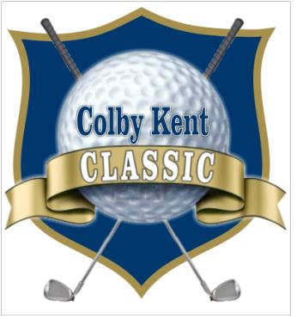

# Colby Jay Kent Golf Classic

A fundraiser benefiting the Colby Jay Kent Foundation

Saturday, October 8th. Shotgun Start 9:00 am. Registration Starts at 7:00 am.

## River Bend Golf Club Floresville

Our 9th annual Colby Jay Kent Golf Classic, Raffle, Awards Banquet, and Hamburger Steak Dinner will be held on Saturday October 8th, 2022 at the River Bend Golf Club located at 101 Club Drive, Floresville, Texas, 78114. The phone number is 830-216-2800 and the Club Pro/Manager is Myles Dumont.

The mission of the Colby Jay Kent Foundation is to give strength and courage to those affected by the loss of a loved one; to keep Colby’s spirit strong and ever present and to strengthen his memory in the community. The Foundation was created to make donations of the foundation’s funds to various charitable organizations, individuals with needs, and to provide scholarship support to students who best exemplify the outstanding qualities exhibited by Colby during his time on God’s Earth. The Colby Jay Kent Foundation was created by friends and family in the hope that his name will live on through the works of those closest to him.

We request the support of area businesses, professionals, and friends to help with our fundraising for the support of the Colby Jay Kent Foundation. This is a unique opportunity to market your company while contributing to the charitable efforts of the CJK Foundation. Hole and Event Sponsors will be recognized throughout the golf course. During the Christmas Holidays we will recognize all sponsors in a full-page ad in the Wilson County & La Vernia News.

Please fill out your team forms completely to establish your handicap.

Team entry fee is $500.00 per team of four. This includes 4 drink tickets for each golfer, goodies, cart, range balls, Three Par 3 Closest to The Pin Contests, Club Toss Contest, TRAKMAN Longest Drive Contest, Putting Contest, and a Hamburger Steak Dinner during the awards ceremony. Monetary Awards will be presented to the 1st, 2nd, & 3rd place teams, Par 3 closest to the pin (2), Longest Club Toss, Closest Drive Guess, Putting Contest, and the Dead Ass Last Award. $5.00 Mulligans will be available at registration limit 2 per golfer. Entry fees can be paid at registration and we do accept credit cards. Limited to the first 144 golfers registered.

Proceeds from this event will go towards scholarships assisting students who attend higher learning educations, assisting local youth group Christian Ministries, contributing to exhibitors and their projects at the Annual La Vernia Youth Show, & other charitable donations.

*Our 501(c) and EIN number is: 46-3168816

Colby Jay Kent Foundation 2013



# 9th Annual Colby Jay Kent Golf Classic

A fundraiser benefiting the Colby Jay Kent Foundation

Saturday, October 8th, 2022

# Sponsorship Entry Form

Please check the level of sponsorship that you have chosen:

* Platinum Sponsor = $2,000.00
* Gold Sponsor = $1,000.00
* Silver Sponsor = $500.00
* Bronze Sponsor = $250.00
* Hole Sponsor = $150.00

Donation Amount or Item: _____________________________

BUSINESS NAME: ___________________________________________________________

CONTACT NAME: ___________________________________________________________ MAILING ADDRESS: ________________________________________________________

CITY: ________________________________ STATE: ____________ ZIP: ____________

PHONE: __________________________________ FAX: ____________________________

EMAIL ADDRESS: ___________________________________________________________

WEBSITE ADDRESS: _________________________________________________________

## SIGNATURE: ________________________________________________________________

## *Make checks payable to “Colby Jay Kent Foundation” and mail to:

Colby Jay Kent Foundation

P.O. Box 748

La Vernia, Texas 78121

For further information please contact:

**Danny Kent**

210-724-5272

dannykent@lavernia.net

**Joe Stanush**

210-394-8770

Colby Jay Kent Foundation 2013