Tasting Notes
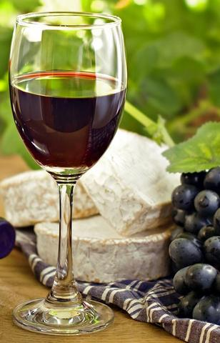
grapestuff.ca
Aged Wines - Auction Wine Tasting
Thursday, March 1, 2018 7:00–9:00 pm
Vendange Institute 440 Albert Street, Suite C108
Guild President Bill Ellis had assembled a number of well-aged wines through auctions over the past few years for our members to taste and rate.
Having focused on Bordeaux in the past, this time we have added some Chateauneuf-du-Pape, Hermitage and even an older Caymus. Please join us to enjoy what will prove to be educational and enjoyable!
Here are the wines we tasted:
· 1988 Chateau Gruaud Larose Saint-Julien
· 1995 Caymus Cabernet Special Selection
· 1996 Chateau Ducru-Beaucaillou
· 1999 Chateauneuf-du-Pape Boursan
· 2000 Chateauneuf-du-Pape Michelle
· 2000 Chateauneuf-du-Pape Roger Perrin
· 2001 Chateau Fonroque Saint-Emilion
· 2003 Chateau Duhart-Milon Paulliac
· 2005 Chateau Sociando-Mallet
· 2005 Chateau Destieux Saint-Emilion
· 2005 Hermitage Delas Bessards
· 2006 Hermitage Delas Bessards
Vintages Pre-Release Tasting—California Premium—Have your Say!
Thursday, March 3, 2016
At the tasting led by Guild President Bill Ellis, we tasted the premium products in the Vintages release. This was a great offer for those that appreciate California wines in that the release had enough for us to taste a full selection from California products. Of note were 2 products, the Treana due to its unique attributes as well as the Josh Cellars due to the value offered.
The rest of the wines were well made and well appreciated with the Shafer being the group overall favourite. Bill took us through the product tastings while providing a slide deck talking to touring the Napa and Sonoma Valleys.
Here’s a listing of what was tasted from the release:
Flight 1
Frei Brothers, Chardonnay, #317891, $24.95 This is a barrel-aged Chardonnay from the Russian River Valley AVA where we found toasty butterscotch on nose with flavours of apple and orange on the palate. It was the second favourite of the flight.
Macrostie, Chardonnay, #244467, $35.95 Lemon pie on the nose. Zesty minerality on palate on the finish.
Treana, White Blend, #011247, $29.95 An interesting wine, group was surprised to see that it was from Treana/Liberty School. 50/50 blend of Marsanne and Viognier, offers notes of peach, pear and tangerine. Rich palate with good acidity and bright citrus and surprising length. An amazing wine timed perfectly for spring! This was the favourite of the flight.
Flight 2
Duckhorn, Zinfandel, #327502, $31.95 (not from the release) Sweet and spicy red berry fruit aromas. It’s robust with juicy acidity. Fruit well showcased, it was the second favourite of the flight.
Storybook Mountain, Zinfandel, #682989, $69.95 A well-balanced Zinfandel showcasing succulent fruit with good acids and firm grip.
Ridge, Zinfandel, #652875, $35.95 A blend of 80% Zinfandel, 11% Carignan, 8% Petite Sirah and a splash of Alicante Bouschet. Lots of berry fruits, bramble, spice-box and licorice. It’s not like the Lytton Spring, but it’s a full-flavored. Priced to enjoy! This was the favourite of the flight.
Flight 3
Shafer, Merlot, #346262, $94.95 This is a rich full bodied with great tannins and will age exceptionally well. Full red and blue fruit, graphite, smoke, tobacco and menthol. Proves the saying that you get what you pay for! This wine was the favourite of the flight.
The Prisoner, #104299, $49.95 Noteworthy is that the winemaker Jen Beloz worked for 10 years with the Zinfandel specialist Joel Peterson of Ravenswood. Dark berry and cigar and spice on the nose, full robust mouth filling wine with some surprising floral attributes.
Jonata, #218941, $79.95 Blend in this wine is 75% Syrah, 13% Cabernet Sauvignon, 4% Grenache, 4% Sangiovese, 2% Viognier, 1% Petit Verdot and 1% Merlot. Shows notes of blackberry, violets with food friendly mouthwatering acids and approachable tannin in this well made wine.
Josh Cellars, Cabernet Sauvignon, #412320, $17.00 They liked this “value wine” at the 2015 San Francisco International Wine Competition awarding it with double gold. Dark fruit and cocoa on both the nose and palate. Price won’t break the bank for this enjoyable wine. This wine was well-liked and considered a best value buy.
Brandlin, Cabernet Sauvignon, #340513, $54.95 Dark berry, anise, cedar and earthiness with firm yet tannins.
Joseph Phelps, Cabernet Sauvignon, #189795, $106.95 This is a big wine with robust tannins and berry fruit and spices. Another Phelps blockbuster that will age gracefully. Lay it down for a while and enjoy in 5+ years. A definite cellar selection! This wine was the second favourite of the flight.
Garden Party with Greek Wines
Tuesday, September 8, 2015
Reported by Rod Story
On a warm summer-like evening in early September, 37 members joined Gay Cook and her sister Grete Hale to dine al fresco at their lovely stone house in the Civic Hospital area. Built in 1837, the Bayne-Morrison house is the oldest house in Ottawa. It has been several years since the Guild has held an event with Gay Cook and it was great to be back.
The food for the event was catered by Tulips and Maple and started with stand-up canapés (Ahi Tuna Tartare and House Cured Quebec Duck Breast Fried Bocconcini Pearl and Crispy Prawn Lollipop) followed by five small plates: Mini Frisee Salad, Alberta Beef Tartar, Mac & Cheese Arancini, Seared Scallop, Peppercorn Crusted Lamb Loin Chop and ended with a selection of petit fours. Each course was accompanied by a unique Greek wine. There were a total of eight wines which were all consignment wines sold by the Kolonaki Group. Check out http://www.shopgreekwine.com if you would like to purchase any of these wines.
The first wine of the evening was the sparkling white wine Santo Brut from the island of Santorini. As is typical with Santorini whites, it was made from 100% Assyrtiko and it had great minerality which comes from the volcanic soils of the island. The wine was served with the canapés and was a perfect match. The wine was crisp with a solid, understated fruit core that comes with low yield production.
The first plate of the evening was a frisee salad with bacon. The bacon gave the salad weight and as an experiment it was paired with Skalani, a red blend of Syrah and Kotsifali from the island of Crete. The wine had the acidity and low tannin to work with the acid in the dressing, but was still a bit too much for the salad, but was lovely with bacon chunks likely because of the toast and bacon notes in the palate. The wine would have worked very well with planked salmon.
The second plate of the evening was beef tartar which was matched with the red wine Rapsani Reserve which is an equal blend of the three Greek grapes Xinomavro, Stavroto, and Krassato. Though there were numerous good wine and food matches throughout the evening, this one was the home run. The beef tartar was lightly seasoned with garlic and herbs which matched the dried herb flavours in the wine. Also, the light tannins and fresh acidity of the wine was a great contrast to the richness of the tartar. The wine would also be a great match with veal or chicken dishes with tomato sauces.
The third plate of the evening was arancini made with macaroni and cheese rather than the usual risotto. It was wonderful comfort food. It was served with the red wine Driopi Reserve, a 100% Agiorgitiko wine. The wine had earthy, smokey notes, with leather and black fruit on palate. Many folks liked the wine and the dish separately, but not necessarily together unless there was some of the tomato sauce on the fork, which then turned it into a nice match. The wine was definitely one of the favourites for many.
The fourth plate of the evening was a seared scallop served with Argyros Estate which is a Santorini white wine made from 100% Assyrtiko. This was the same grape that was in the sparkling wine that started the evening. Consistent with the sparkling wine, this one had great minerality, dry fruit core and fresh acidity that was a great match for the scallop. It is not a surprise that Santorini white wines go well with seafood considering it is an island in the Mediterranean.
The fifth plate of the evening was lamb loin chops that were paired with a white and a red. The white was Gerovassiliou Malgousia which is 100% Malgousia. The Gerovassiliou winery has taken it upon itself to reintroduce indigenous Greek grape varietals that were disappearing, one of which is Malgousia. The wine was quite complex. It was simultaneously rich and unctuous, but this was all focused in very tight fruit core that was held together with zippy acidity and structure. It was a wine that could easily last 10 years and would mellow and broaden with age. The flavours were in the herbaceous vein: think the richest and thickest Sauvignon Blanc. Though the wine had the heft and weight to stand up to the lamb chops, the flavour of the lamb dominated the flavour of the wine. Maybe with more age the flavours would broaden to match the lamb. The second wine with the lamb was Two Olives by Kir Yianni which is a blend of Syrah, Merlot, and Xinomavro. This wine worked quite well with the lamb by taking the pepper of the Syrah, the suppleness of the Merlot and the dried herbs of the Xinomavro to match the flavour and texture of the rare loin chop. This was the second best match of the evening after the Rapsani Reserve with beef tartar.
The final course of the evening was petit fours served with Vin Santo, which was the third wine of the evening from the island of Santorini. Most people, when they hear Vin Santo, they think of the dessert wine from Tuscany made from white grapes that are dried for a period of time before being pressed. It is said that Vin Santo from Santorini was the original which was copied by the Tuscans. With this interpretation, Vin Santo represents wine of Santorini rather than wine of saints. The Greek Vin Santo is closer in flavour to that of a sweet Olorosso Sherry, except with less alcohol and a great acid/sweetness balance. The petit fours were a mixture of different flavours: white chocolate, dark chocolate, caramel and lemon to name just a few. It would be a challenge for any dessert wine to match all the various flavours of the petit fours but the Vin Santo worked well with caramel flavours some of the chocolate petit fours that had sweet liquid filling. Overall, the Vin Santo was a great finish to the meal. It would also work with cheese and nuts as well as spice cakes and even banana bread.
Appetizers
Santo Brut by Santo Wines, Santorini (Assyrtiko), $33.50
Mini Frisee Salad
2011 Skalani by Boutari, Crete (blend of Syrah & Kotsifali), $38.20
Alberta Beef Tartar
2010 Rapsani Reserve, Tsantali, Rapsani & Thessaly (blend of Xinomavro, Stavroto & Krassato, $18.95
Mac & Cheese Arancini
2012 Driiopi Reserve, Tselepos, Nemea (Agiorgitiko), $26.95
Seared Scallop
2013 Argyros Estate, Argyros, Santroini (Assyrtiko), $25.95
Peppercorn Crusted Lamb Loin Chop
2014 Gerovassiliou Malgousia, Gerovassiliou from Epanomi (Malagousia), $23.95
2010 Two Olives, Kir Yianni from Imathis (blend of Syrah, Merlot, Xinomavro), $36.95
Dessert
2006 VinSanto, Santo Wines from Santorini (blend of Assyrtiko, Aidani), $27.95
Port, Port and More Port!
Thursday, March 26, 2015
Lead by Guild President Bill Ellis, Reported by Dawn Harvie
The opening “Chip Port” was served cold with a “chip” of lemon peel and was a refreshing sipping wine.
The wines were served in themed flights with a plate of blue and brie cheeses and dark chocolate.
The second flight featured Ruby, Reserve and Late Bottled Vintage or LBV ports. On its own, tasters thought it was not that interesting, but when paired with dark chocolate. The Taylor Fladgate First Estate Reserve was easy drinking, but the favourite of the flight was the LBV because of its complexity. The Organic was noted for its bite on the finish.
The third flight featured Vintage Ports. Tasters thought the Sandeman Port was nice for what it was and that if it were tasted with the second flight, it would have been favourite. It did not have the complexity of the others. Tasters liked it with the chocolate. The Churchillʼs was unfortunately corked. The Quinta Do Noval was the favourite of the flight. It was rich and complex. The Grahamʼs, as noted by Rod Story, is typically softer in style than the Taylor Ports. This one was not exception. It was a nice, easy drinking Port.
The Colheita was tasted on its own at the end of the flight. It was described as being like a sweet Oloroso and having lots of oak notes and flavours. It was nice with the blue cheese.
The fourth flight featured the Taylor 10, 20, 30 and 40 Year Old Tawnys. It is always interesting to do this type of flight—to see the distinction between the different Ports. There was a an increase in aromas and flavours as one moved from one wine to the next, but the wines were not as distinct as tasters thought they would be or were in fact, when we did this same flight several years ago. Although tasters appreciated the quality of the 30 and 40 Year Old Tawnyʼs, they would not be willing to pay the prices at the higher end.
Opening Wine • Fonseca White Port, 276816, $16.95
Flight 1 – “Old School” Ports
• Kopke Fine Ruby Port, 35766, $15.50
• Taylor Fladgate First Estate Reserve Port, 309401, $15.50
• Taylor Fladgate Late Bottled Vintage Port, 46946, $16.50
• Fonseca Terra Prima Organic Reserve Port, 67132, $26.95
Flight 2 – Vintage / Colheita
• Sandeman Vau Vintage Port, 251090, $19.95
• Quinta Do Noval Vintage Port 2011, 362525, $90.00
• Churchillʼs Vintage Port 2011, 362384, $90.00
• Grahamʼs Vintage Port 2011, 362269, $95.00
• Dalva Colheita Port 1995, 69930, $32.95
Flight 3 – Taylor “100 Years Of Port”
• Taylor Fladgate 10-Year-Old Tawny Port, 121749, $34.95
• Taylor Fladgate 20-Year-Old Tawny Port, 149047, $68.95
• Taylor Fladgate 30 Year Old Tawny Port, 540252, $183.00
• Taylor Fladgate 40 Year Old Tawny Port, 540260, $245.00
10 – 12 years of Château Gaby Tutored Bordeaux Tasting
Thursday, February 9, 2015
Reported by Marie-France Boudreault-Champagne
The Must Kitchen & Wine Bar proved to be the perfect venue for the tasking of Château Gaby wines from 1998 to 2008 led by Guild President Bill Ellis and Director Marie-France Champagne. The room and the food was splendid. The charcuterie plates were a great kick off to the evening as guests settled in. The prosciutto and fig tartine with aged cheddar paired very well with the older vintages. The “fall of the bone” bison short rib was a clear winner!
Château Gaby has gone thru many changes over the years from new ownership, uprooting Cabernet Sauvignon vines to going organic. The wines have been thru stellar vintages, to good ones, to well … 1999 and 2007. The 2000, 2005, 2008 vintages were clearly favourites amongst our members.
It was a great (for some a first) experience tasting so many vintages from the same estate. Certainly a great way to spend a frigid February evening!
NCSG - Vintages Pre Release Tasting Iconic Wines Offering - Nov. 20, 2014
​ Flight 1 White Wines 2013 Cave de Ribeauville Pinot Gris, Alsace This flight’s favorite of most. Nice body, zippy and fresh tasting. Straw yellow in colour, clear. Lighter mouthfeel then one would typically expect with a pinot gris. And this really is not a typical pinot gris. Nice aromas of flowers, peaches, citrus, honey, and a whiff of bubble gum. Very pleasant sipping type of wine with some residual sugar ….. but not sweet. The acidity is juicy and keeps the sweetness in balance. Tastes of apples, light peaches, lemony. Nice pleasant finish with spices at the end. Well balanced, round, refreshing and easy drinking . Great value for the money. 2012 Salomon-Undhof Alte Reben Gruner Veltliner, DAC Kremstal Several had this as their favourite white wine of the flight. Straw yellow in colour, with almost a green tinge to the colour. Showed slight petrol aromas as well as grassy, oaky, smokey, lanolin, with a tinge of vegetal at the end. Good acidity, a bit of heat on the finish. More depth of flavours on this wine then the first wine. Green apples, grapefruit, pepper spice, and chewy peach flavours (unripe peaches?). Grassy and some minerality. Very nice wine that continued to develop in the glass as it opened up. 2010 Domaine Michel Caillot La Barre Dessus-Clos Meursault The yin of the Pahlmeyer (see below) yang. A pale yellow colour. An odd citrusy, dusty, vegetal, minerally aroma. One described it as being a subtle aroma of dryer Bounce. Flavours of slight butterscotch, lemon oil, sulfur, and a waxy citrus. But if you left this to sit for an hour the wine really opened up . Amazing in my opinion. Aromas turned more floral, with a wet stone/steeliness, freshness, citrusy, grassy herbs. With flavours of zesty lemon, apricots, pears, toast, steely minerality. Balanced and fresh with a long finish. Good structure with medium oak, and great acidity ( nice spritz/zest/freshness to the wine). However, on the initial taste, this wine was not a favorite among the tasters. Although after getting air, it became my favorite. This should age well. 2012 Pahlmeyer Chardonnay , Napa Valley A favorite of a third of the tasters. Dull golden yellow, cloudy (as it is unfiltered) in appearance. Aromas of toffee, buttered popcorn, citrus/lemon andorange zest. A “thick” or heavy aroma. This is one of the styles of California chardonnay that has become popular over the years. Aged in French oak, and underwent malolactic fermentation. It is a big burly rich chard with buttery, toffee, oaky, nuttiness, and vanilla flavors. Lots of tropical fruits and citrus notes. Thick mouthfeel. Heat on the finish, but the finish is lengthy (is that because of the oak or the fruit??). Some will love this style. Some will not like the style. Second Flight The next 2 wines were actually from the Nouvelle Beaujolais release earlier in November. Simple wines meant for short term drinking. While neither was complex, both were what they were ….. simple decent wines to be quaffed in short order. So pour a glass and relax. And their prices are pretty easy on the wallet. 2014 Duboeuf Beaujolais Villages Nouveau Light bright red/purple in colour. Fresh, dry and floral flavours. Some beetroot, cranberry and a nice minerality/wet stone/herbs. Pop and pour. Light bodied. 2014 Cantina Negra Novello Del Veneto From Italy (Valpolicella region). A pale ruby. Earthier then the other Nouveau. Simple wine of cranberry and red fruit flavours, with some minerality. Light bodied. Third Flight All 4 reds in this flight were well received, although the most popular were the Faustino and Beaucastel. I was the only one who preferred the Burgundy. 2012 Chateau de Segure Fitou A very nice wine at a great price. Ruby red, see through a bit so not inky. Red fruit aromas, with cloves, licorice and floral notes. Some found a bit of menthol. Flavours included a bit of sour cherry at the start, red raspberries, licorice and kitchen spices (cloves). Medium bodied, drying and puckering and chewy tannins. Simple red with good complexity. Drinking wine, smooth and easy going. Good wine to serve to the crowd you are having for dinner …. Easy on the pocketbook. 2001 Faustino I Gran Reserva A crowd favourite to drink now. Not one for the cellar as this seems to be at its peak now. Garnet in colour ….. browning on the edges. Aromas of burnt brown sugar, oak, dark fruits. Smells like a typical Rioja. Flavours replay ….. dark fruits, oak, burnt brown sugar, vanilla, orange rind, tobacco, earth and spices. Good complexity and all wound together in a very balanced flavor. Good smooth tannins, medium acidity. Very nice wine at a good price. 2011 Daniel Rion & Fils Les Grandes Vignes Nuits-Saint Georges Dull red in colour. Is a bit transparent. Aromas of graphite, ash, red fruits and a bit of stoney minerality. All of this plays through to the flavours. Also some cranberry and cherry, cedar, spices on the finish. Elegant wine …. Medium weight. Good structure, soft silky tannins. A bit tight, young wine. Some heat on the finish. Came across initially as young Bordeaux to me. In retrospect, the wine is a bit lighter then Bordeaux, the tannins are softer and the fruit is a bit more bitter. Medium length to finish. All in all a nice wine. 2012 Chateau de Beaucastel Chateauneuf-du-Pape Dark opaque red colour, but not thick or inky. Layers of aromas of dark fruits, licorice. Full bodied and rich, fresh….. not thick or weighty. Some heat on the finish. Flavours of dark fruits, plums, spices (like nutmeg) and pepper. Great structure and probably long aging ahead of it. Drying tannins, and tannins are very smooth, dusty. Long finish. Most liked this wine and thought it to be the most expensive (served blind ). Possibly wine of the night with Faustino just behind it. Flight 4 All wines in this last flight were received very well. Carnival of Love slightly edged out the Brezza Barolo and Grant Burge. 2011 Grant Burge The Holy Trinity, Barossa Valley Ruby coloured. Medium bodied, good structure. Aromas of berry fruit dominate along with an odour of pot pourri. Flavours of blackberry, raspberry, fruit cake, chocolate. Also getting pepper, cedar. Not a heavy handed wine at all. Juicy acidity, medium and subtle tannins. Well balanced, easy drinking with good complexity. 2009 Brezza Sarmassa Barolo Granite/red in colour, can see through it. Interesting aromas of florals, medicinal, dusty, licorice, oil paint. Many described as funky. Medium bodied, tight. Flavours of tar, graphite, red fruit, savoury and earthy. Nicely balanced. Basic Barolo. Drying, chewy tannins. Not as deep in complexity as many barolos. But a very nice drinking wine. 2010 Mollydooker Carnival of Love Shiraz A very interesting textural wine. Its almost like a meal. I don’t know if you could have food with this wine. Very thick, inky and weighty mouthfeel although not syrupy. Aromas are big and bold, luscious, and rich. Many will like it, many will not. Big and bold and rich flavours of blueberry jam, blackberries, chocolate, licorice. High alcohol level is well hidden, but there is still some heat on the finish. Crazy long finish, dusty tannins, good acidity. This is a massive wine and if you are not fond of the weighty fruit bomb style wine then this is not for you. If you are a fan, but the price is a tad high, then take a look at 2 other wines available in the LCBO from the same winemaker, Mollydooker (The Boxer Shiraz at $29, and the Maitre D’ Cabernet Sauvignon at $29). NV Torres Floralis Moscatel Oro Great little dessert sipper. Deep golden in colour. Beautiful aromas of orange rind, honey, marmalade, cloves, burnt brown sugar. Similar flavours to aroma. Not syrupy but a bit viscous. Nice sweetness with some acidity to help keep it in check ……. So not cloyingly sweet.

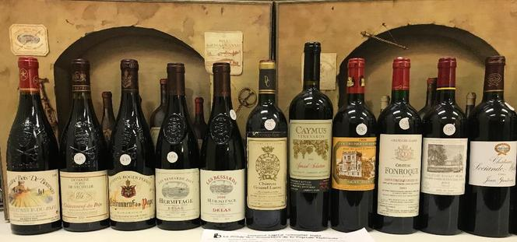

Aged Wines - Auction Wine Tasting
Thursday, March 1, 2018 7:00–9:00 pm
Vendange Institute 440 Albert Street, Suite C108
Have you ever wondered what the effect of age is on a good wine but haven’t made the investment to find out? Ever give any thought to the condition and quality that wines bought at auction may deliver? To answer these questions Guild President Bill Ellis has been assembling a number of well-aged wines through auctions over the past few years for our members to taste and rate.
Having focused on Bordeaux in the past, this time we have added some Chateauneuf-du-Pape, Hermitage and even an older Caymus. Please join us to enjoy what will prove to be educational and enjoyable!
Here are the wines for the tasting:
· 1988 Chateau Gruaud Larose Saint-Julien
· 1995 Caymus Cabernet Special Selection
· 1996 Chateau Ducru-Beaucaillou
· 1999 Chateauneuf-du-Pape Boursan
· 2000 Chateauneuf-du-Pape Michelle
· 2000 Chateauneuf-du-Pape Roger Perrin
· 2001 Chateau Fonroque Saint-Emilion
· 2003 Chateau Duhart-Milon Paulliac
· 2005 Chateau Sociando-Mallet
· 2005 Chateau Destieux Saint-Emilion
· 2005 Hermitage Delas Bessards
· 2006 Hermitage Delas Bessards
This is a member only event so please register soon to avoid disappointment.
Members: $100.00 (Includes HST)
Here's the link to order:
https://www.eventbrite.com/e/aged-wines-auction-wine-tasting-tickets-43308848933

wines......
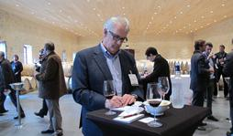

As President of the National Capital Sommelier Guild I am proud of the tastings that we do for our members and guests. Beyond our tastings I will try to post those of our partners and other friends for your enjoyment.

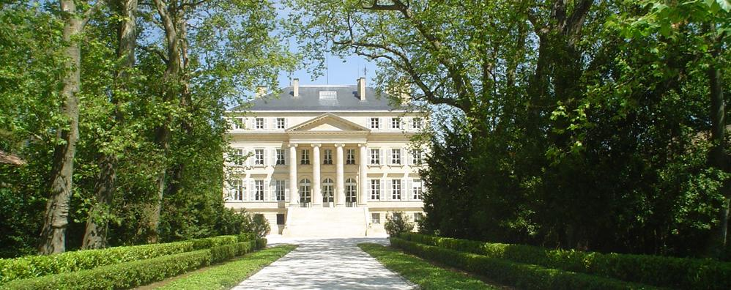
I have had the opportunity to taste some great wines at all price points that are enjoyable to everyone. Please feel free to browse. Remember, a good wine is one that YOU enjoy!

I have had the opportunity to taste some great wines at all price points that are enjoyable to everyone. Please feel free to browse. Remember, a good wine is one that YOU enjoy!
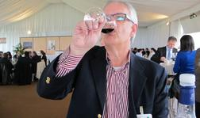
Generally I have the opportunity to travel to different wine regions both in and outside of Canada. I hope that some of my experiences will make your travel more enjoyable.
As President of the National Capital Sommelier Guild I am proud of the tastings that we do for our members and guests. Beyond our tastings I will try to post those of our partners and other friends for your enjoyment.

As President of the National Capital Sommelier Guild I am proud of the tastings that we do for our members and guests. Beyond our tastings I will try to post those of our partners and other friends for your enjoyment.

