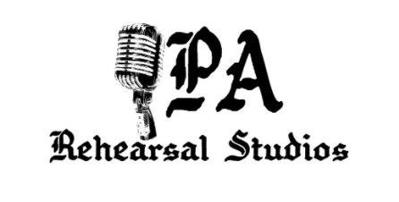

Recording Studio policies, terms, and conditions

Booking time and rates
- Minimum 2 hours must be booked for recording
- 50% deposit is due 7 days prior to booked time or at the time of booking a session
- All cancelations must be done 48 hours prior to the booked time. We will keep the deposit and apply it to your next booked session
- No show or late cancellation will result in full payment of the booked hours.
- Full payment is due at the end of each session
Billable time
- Charges apply at the start of the exact time booked for the session
- If extra time is needed for recording we will extend the time if there are no bookings after the session and if time allows
- Full payment applies regardless of the lunch or break time taken by the clients
- We are not responsible for the time taken by issues malfunctions, or errors caused by your personal or equipment rented outside of the studio
- We are responsible for the time lost caused by our equipment malfunction, error, or otherwise

What you need to bring
- You must bring your own external hard drive for the recording session. We are not responsible for your equipment error
- Our recording rooms come with a full backline at no extra charge to you. Please refer to the list of equipment for each room
- We do have more equipment to rent if needed. Please refer to the add-ons page on our web page
Damaged equipment
- The person that books the session is responsible for any damages to our equipment, as a result of negligence, violence or carelessness
- If any equipment or instrument is damaged by the client, that item will be repaired or replaced at the cost of the client, plus the rental fee for the duration that the equipment is being replaced or fixed if it applies.
Basic rules
- No smoking/vaping inside the studio. We do have a private smoking patio for your convenient
- No hot or strong smelling food inside of the recording rooms
- You may bring your own snakes and beverages inside the room. Just please keep away from the equipment.
- If anyone appears to be under the influence of drugs or alcohol, they will be asked to leave, or the session will be cancelled, but the deposit remains with us, we will make the decision of either applying it to the next booked session or refund the it back to the client. In such a situation we will calculate the time spent in the studio to refund the remaining deposit, if more than half the session is passed, the used time will be billed to the client.
- Zero tolerance policy for illegal drugs at the studio
- No weapons allowed
- We reserve the right to refuse service to anyone
Our advice before booking
- Estimate the time needed for your recording
- Avoid bringing a big entourage, it will take precious time and focus away from your paid session.
- We want you to relax and enjoy the process, but please do it responsibly

I have fully read and agree to all of the above terms

Print full Name Phone number

Email address Band, performer (stage) Name

Signature Date

