FACTS ABOUT TEETH

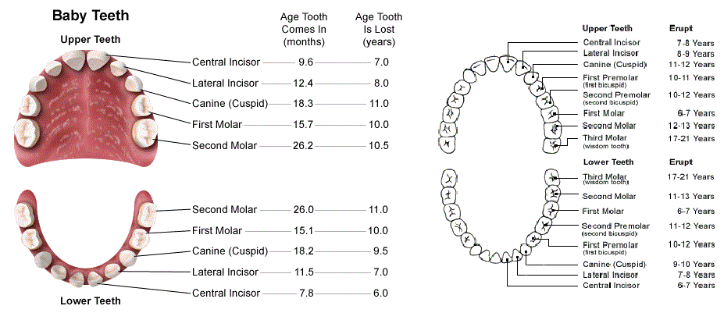
ABOUT TEETH
Adult Teeth
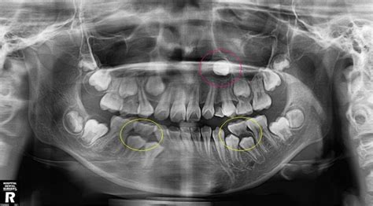

Humans get two sets of teeth in their lifetime. A child has 20 baby teeth, which can start showing up at 6 months old and once all the teeth have erupted an adult will have 32 teeth. When the baby teeth get loose it is because the adult teeth are starting to move into place.
There are four different types of teeth and each type has a specific function – they are the incisors, canines, premolars and molars.
The incisors are meant for biting off pieces of food, the canines are meant for holding and tearing apart the food and the molars are meant for grinding the food. The biters, the tearers, the chewers and grinders.

There are four main components of a human tooth - they are the enamel, dentin, cementum and pulp.
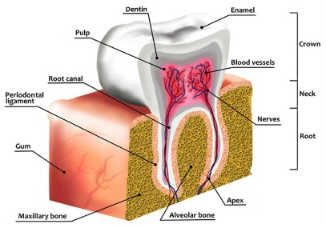
Enamel surrounds the crown of the tooth surface and is the hardest substance in our bodies. The crown of the tooth is 1/3 of the total tooth. Enamel will not grow back once it is gone.
Dentin is calcified tissue underneath the enamel surface. New dentin can form to help protect the tooth.
Cementum surrounds the root of a tooth and helps the tooth attach to tissue in the jaw bone. The root of the tooth is 2/3 of the total tooth.
Pulp is tissue made up of blood vessels and nerves that help provide nutrients, detect pain, defend against infections and help the tooth produce more dentin.

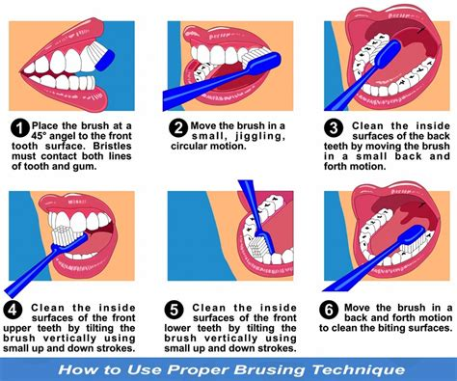
TAKING CARE OF YOUR TEETH
Brushing and flossing your teeth will help prevent tooth decay as well as dental diseases.
Brushing your teeth should be done 2 times a day for a minimum of 2 minutes and you should change your toothbrush out 2 times a year. (Remember the rule of 2’s). Brushing should be done early morning, before breakfast and before you go to sleep. Brushing teeth right after eating is not recommended due to acidic conditions and softer enamel.

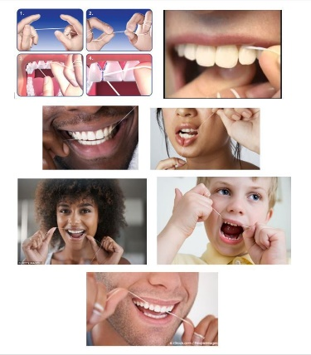
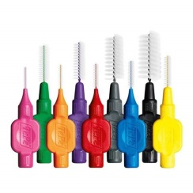
Brushing only cleans approximately 2/3 of your teeth. Flossing cleans the other 1/3. Flossing is the main thing you can do to avoid cavities because cavities usually start in-between the teeth.
Whether you use traditional string floss, floss picks/travel flossers, proxabrushes, toothpicks, a dental water jet etc, make sure you are cleaning inbetween all the teeth as well as brushing them daily.

THE HISTORY AND CULTURES REGARDING TEETH
The first toothpaste to be made was by the Egyptians some 5000 years ago. It was just a mixture of pumice and wine.
Ancient cultures often used twigs for brushing their teeth and the use of twigs (miswak) as toothbrushes still continue in many countries such as India. These twigs are often obtained from trees like neem and cinnamon that have antibacterial properties. Studies show that these twigs are equally effective as modern toothbrushes.
The Chinese were the first people to have invented an object closer to modern-day toothbrush. The handle was made using bamboo and the bristles were made using boar hair.
Chinese researchers are trying to grow teeth synthetically. They collected human stem cells and used them to grow human teeth in the mouth of a mouse. Beginnings of enamel and dental pulp were recorded but there is still a long way to go.
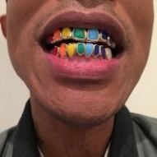
In Asian countries like Malaysia, Indonesia and Thailand, fake tooth braces are actually style statements kind of like the grills that were made a “thing” with the rapper genre.
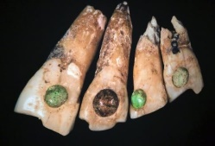
Men in ancient Mayan civilization had small holes made on their teeth and fitted those holes with gemstones. They believed that doing so helped to make their mouths pretty.

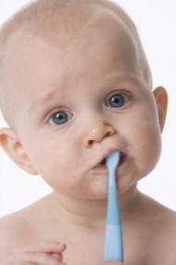
Norway has world’s largest tooth bank which stores milk teeth from babies. The bank has 17,000 teeth stored. According to Norwegian Mother and Child Cohort Study (MoBa) researchers, studying the milk teeth along with urine and blood samples from parents help them to find out how environmental pollutions impact the health of both child and mother because the researchers believe that the milk teeth are good indicators of environmental pollutions.

A 17 year-old boy named Ashik Gavai from India was suffering from composite odontoma which led to the formation of a tumor in his lower jaw. The tumor was operated and doctors removed 232 teeth from his mouth. In addition, the doctors also found a brick-like marble structure that they had to break apart using chisel and hammer to remove it completely.
Lucy Beaman Hobbs was the world’s first licensed female dentist. She received her license in 1866.
World’s first known dentist lived 5000 years ago. He was an Egyptian by the name Hesi-Re.

ODD AND INTERESTING FACTS
There are more bacteria in your mouth than people who have every lived on the face of the earth, only a few are bad for you and your teeth.
The scientific term used to describe a toothache is Odontalgia. Odonto – meaning tooth and algia meaning pain.
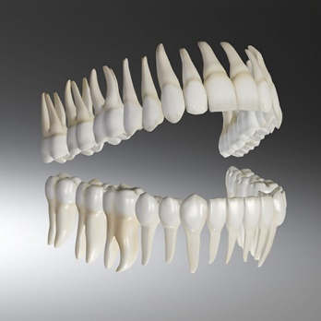
Every tooth has unique prints like finger prints. We can differentiate a person by a tooth print as well. No two humans have identical teeth prints.
The average tooth is approximately 2 inches long
Men have teeth that are more square shaped than women.
Right-handed people will usually chew their food on the right side and left-handed on the left side. However, you should make a point to chew food on both sides so one side does not breakdown before the other.
The most preferred and commonly used toothbrush color is blue.
Human teeth as well as saliva are used to break down and start digesting food before its swallowed and actually enters the digestive system.
Saliva is good for your teeth. It helps control bacteria.
If your mouth is too dry you will develop more plaque which will lead to more cavities that form at a faster rate.
Cheese can help protect the teeth from cavities, not because of the calcium but because of the fat. Sugars and simple carbohydrates like chips, crackers, breads and popcorn that break down into sugars are all cavity producing foods.

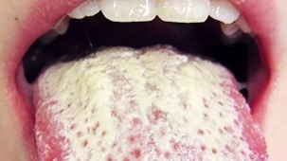
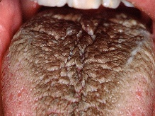
The tongue will hold the most bacteria in the mouth and can have a white or black coating on it that looks like and is called a “hairy tongue”.
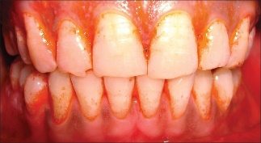
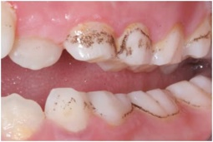
There are certain types of bacteria in your mouth that can turn your teeth green or an orange (Cheeto color) it is called chromogenic bacteria.

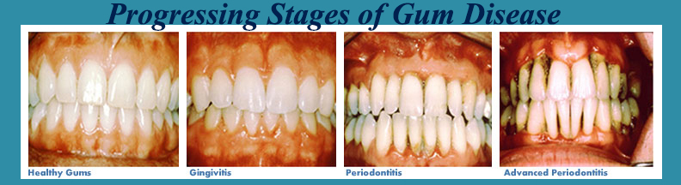
Cavities or dental caries (usually referred to as tooth decay) is one of the most common diseases found in the world. And they do classify cavities as a disease process, one that can be prevented.

Examples of tooth and gum disease are cavities, gingivitis (red, swollen, painful gingival tissue, bad breath) and periodontal disease (red, swollen, not painful, bone loss, loose, drifting or missing teeth, bad breath).
Several diseases have a connection to oral health and the bacteria there such as diabetes, osteoporosis and heart disease. Doctors and researchers are finding more connections all the time.
25 % of people in the world on any given day have tooth decay pain.

