StreetCare Volunteers application form

Before you complete this application form, please be sure to read the Volunteer Handbook that we ask all our volunteers to agree to. This form is used by us to record important information about our volunteers. We store all personal data securely and do not use it for anything other than the stated purpose. You can read our full privacy policy on our website at https://www.StreetCareScotland/privacy-cookies
If you have any concerns with any of the questions below, please discuss this with a member of staff. All information will be kept confidential to relevant staff and volunteers coordinating volunteers. When completed, please return this form to CraigCampbell@StreetCareVolunteers.Co.Uk

Basic Details
This is the information we need to keep in touch with you – and I will only be used by staff and volunteers here at StreetCare Volunteers (SCV) for this purpose.

Full Name
[Please insert response here]

Address including Postcode
[Please insert response here]

Mobile Telephone Number
[Please insert response here]

Email Address
[Please insert response here]

Do you drive a car & plan to use this to commute for volunteering?
[Please insert response here]
If Yes is it LEZ Complaint ?

Emergency Contact Details
This information is only used in the event of an emergency (or concern for your welfare) to notify your chosen contact/s.

Emergency Contact Name & Relationship
[Please insert response here]

Emergency Contact Telephone details
[Please insert response here]

Volunteering Role
This is to help us make sure your time spent volunteering with us is a pleasant one and to make sure you find it as fulfilling as possible.

What is the name of the volunteer role you are applying for?*
T-Drop (Daily – Car Required)
T-Walk (Weekly – Wednesday – walking required)
Admin Support (Rota’s and mailings)

Why would you like to volunteer with us? What motivates you and what do you have to offer?

What would you like to get out of your volunteering? Please tell us about any relevant interests you have, skills that you wish to develop or experience you wish to gain:

If you have any health conditions or allergies you would like us to be aware of, please describe them here (and let us know how we can best support you):

Are there any other areas of support you might need to enable you to volunteer with us? If so, please describe here:

How did you hear about this opportunity?

Self-Disclosure
We ask all volunteers with us to give us information of previous convictions. Having a previous conviction does not automatically bar you from volunteering with us but it will help us, in discussion with you, decide if the opportunity you have applied for is the most suitable. All information given here will be kept in your personal file which can only be accessed by authorised staff and designated volunteers.
Under the terms of the Rehabilitation of Offenders Act 1974 you are entitled to withhold information about any convictions against you which are now '‘spent'’.
Scroll down for full details about this.
You may only withhold information on ‘spent’ convictions.
Please ask us if you need any help completing this section of the form and we will be happy to assist you.
Please include details of convictions and date of occurrence:
Details of details of any pending convictions
Further Information about ‘Spent’ Convictions and Rehabilitation Periods
(REHABILITATION OF OFFENDERS ACT 1974: REHABILITATION PERIODS)
What is a ‘Spent’ Conviction?
Convictions are ‘spent’ when a specific period of time – known as a ‘rehabilitation period’ – has passed since you were convicted and you have not re-offended during that period.
How long is a ‘Rehabilitation Period’?
The length of a ‘rehabilitation period’ will depend on the sentence received, and sentences longer than 30 months imprisonment can never be ‘spent’. The tables below and over the page give details of the length of ‘rehabilitation periods’ for various sentences.
Criminal Court Sentences - for information:
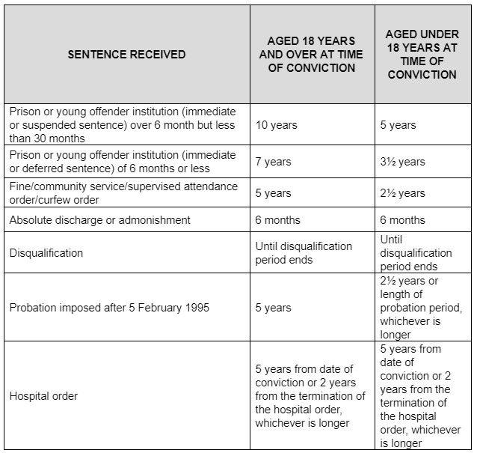
DISCHARGE ETC FROM HER MAJESTY’S SERVICE - for information:
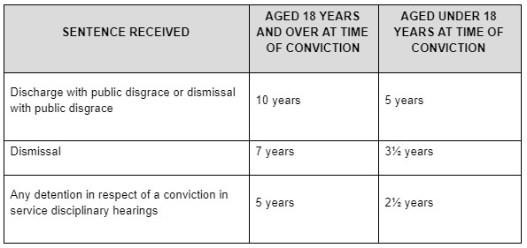
Suspended sentences - for information:
Suspended sentences (England and Wales) will carry a rehabilitation date should the sentence be imposed.

Declaration & Agreement
I declare that I am aged eighteen years or over, and to the best of my knowledge, the above information is correct. I understand that if I take up a volunteer opportunity and it is found that I have deliberately given false information or withheld relevant information then the opportunity may be withdrawn. I understand that personal and special category data provided in this form will be stored on SCV database for the above mentioned purposes relating to the administration and development of my volunteering activities, and that my data may also be used anonymously for various purposes by SCV.*
I confirm that I have read and agree to the above statement
(Yes- I confirm / No- I do not confirm)

Name [Please insert response here] Date [Please insert response here]

