Youth Team Wavier/Roster 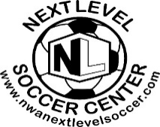 Team Name: ______________________________________
Birth Year: ________________ Boys/Girls: __________________
Coach/Manager Name: ________________ Contact: _______________________
Parent/Guardian release: This is to certify that my son/daughter has permission to participate in all Soccer/futsal activities at NLS, LLC. This is to certify that I assume all risks and hazards incidental to my child’s participation at NLS, LLC and I do hereby agree to hold harmless the staff of the Next Level Soccer LLC, referees, and administrators from all claims arising out of any injury to myself. Furthermore, this verifies that the player can participate in all soccer activities. In the event of injury my permission is granted for treatment as required at the nearest medical treatment facility.
Every Player Must Have Legal Guardian Read and Sign Waiver/Roster Release before playing.
Player full Name | Birth Date | Guardian Signature
1
2
3
4
5
6
7
8
9
10
11
12
- A maximum of 12 players are allowed on the roster per team.
- Un máximo de 12 jugadores es permitido en la lista por cada equipo.
- Rosters CLOSE after Game 2!! Be sure every player’s guardian has signed by game #2.

