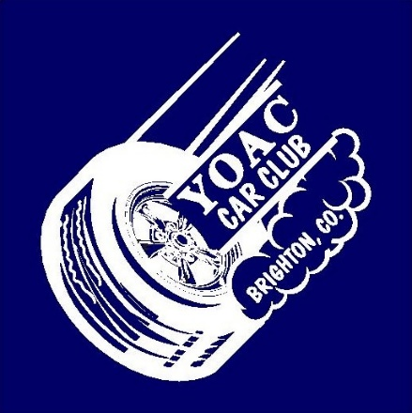

“RAIN
or SHINE”

Ye Olde Auto Club’s 14th Annual Car Show
Saturday June 22, 2024
Located at the Adams County Historical Society Museum—Brighton, CO 9601 Henderson Rd. (West of Hwy 85 on 124th approx.1.1 miles) FREE Museum Admission— 100’s of historical pieces

Trophies and Door Prizes

Food and beverages available

A portion of the proceeds will go to the Museum

Spectators are free

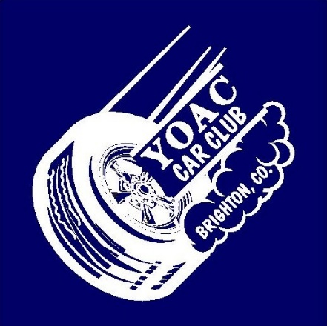
All Classics, Rods, Trucks, Bikes and Specialty Vehicles are Welcome
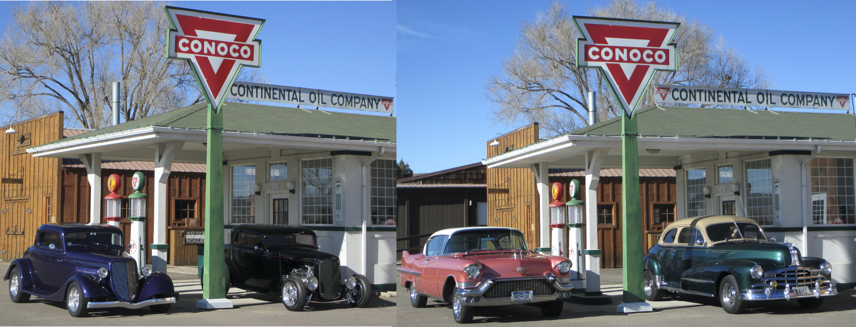
For more information:
Sonny Swarts 720-966-3707
Al McCracken 720-685-3425
Mike Alexander 720-949-4942

REGISTRATION BEGINS at 9:00 AM; Awards at 1:00 PM

$15 registration fee—$5 second car (same owner)

Visit us on Facebook: Ye Olde Auto Club-Brighton, CO

