Moham Wang 王峥
Portfolio 作品集

- Artist Statement 艺术家自述

I am an artist of Chinese and ethnic minority background. Growing up in an ethnic minority family, I learned Chinese ink art from my grandpa, a calligrapher, and studied patterns and materials with my grandma, a Mien craftsman. It was the start of my art life there. After moving to Wuhan for my education, I went back to Guilin for most of my school breaks to reconnect with the influences of my hometown. While living with my grandparents, I was able to continue my initial interest in art by participating in my grandpa's workshops there. After primary school in Wuhan, I expanded my interest to writing and comics and sometimes both.

However, it was not until the summer of 2014, when I started university in America, that I realized I should make art my subject and career. After becoming a studio art major at Rice University, I began exploring my specific areas of passion. I serendipitously found painting along with drawing and installation. With these mediums I feel most comfortable with, I explore the individual experience of living a discreet geography and struggling with multiple identities just as I do. Apart from my studio life, I also received an art history degree from Rice University, and I finished my MA degree in Critical Studies (Art Criticism) at the California Institute of Arts in Valencia, California. I am currently pursuing an interdisciplinary Ph.D. in Art History and Theory specializing in Chinese media art history and its relationship with the Eastern Body at the the School of Art, Design and Media at Nanyang Technological University, Singapore.

As a result, the audience can always observe a propensity in my artworks to combine the theoretical aspect and the material/making aspect of Chinese and American art, which I see as an influence from my second background as a curator and writer. In fact, I am constantly incorporating textual elements including poetry, criticism, and film, into my installations and watercolors. No matter what mediums I utilize, I strive to bring out the intriguing and urgent tension between tradition and contemporality, East and West, in a non-binary fashion.

I believe I will continue to explore more subjects and mediums but always in the service of my objective: to allow my audiences to live their experiences through me, an individual vehicle of discreet life and culture, just like anyone else.

- Visual Works 视觉作品

1.
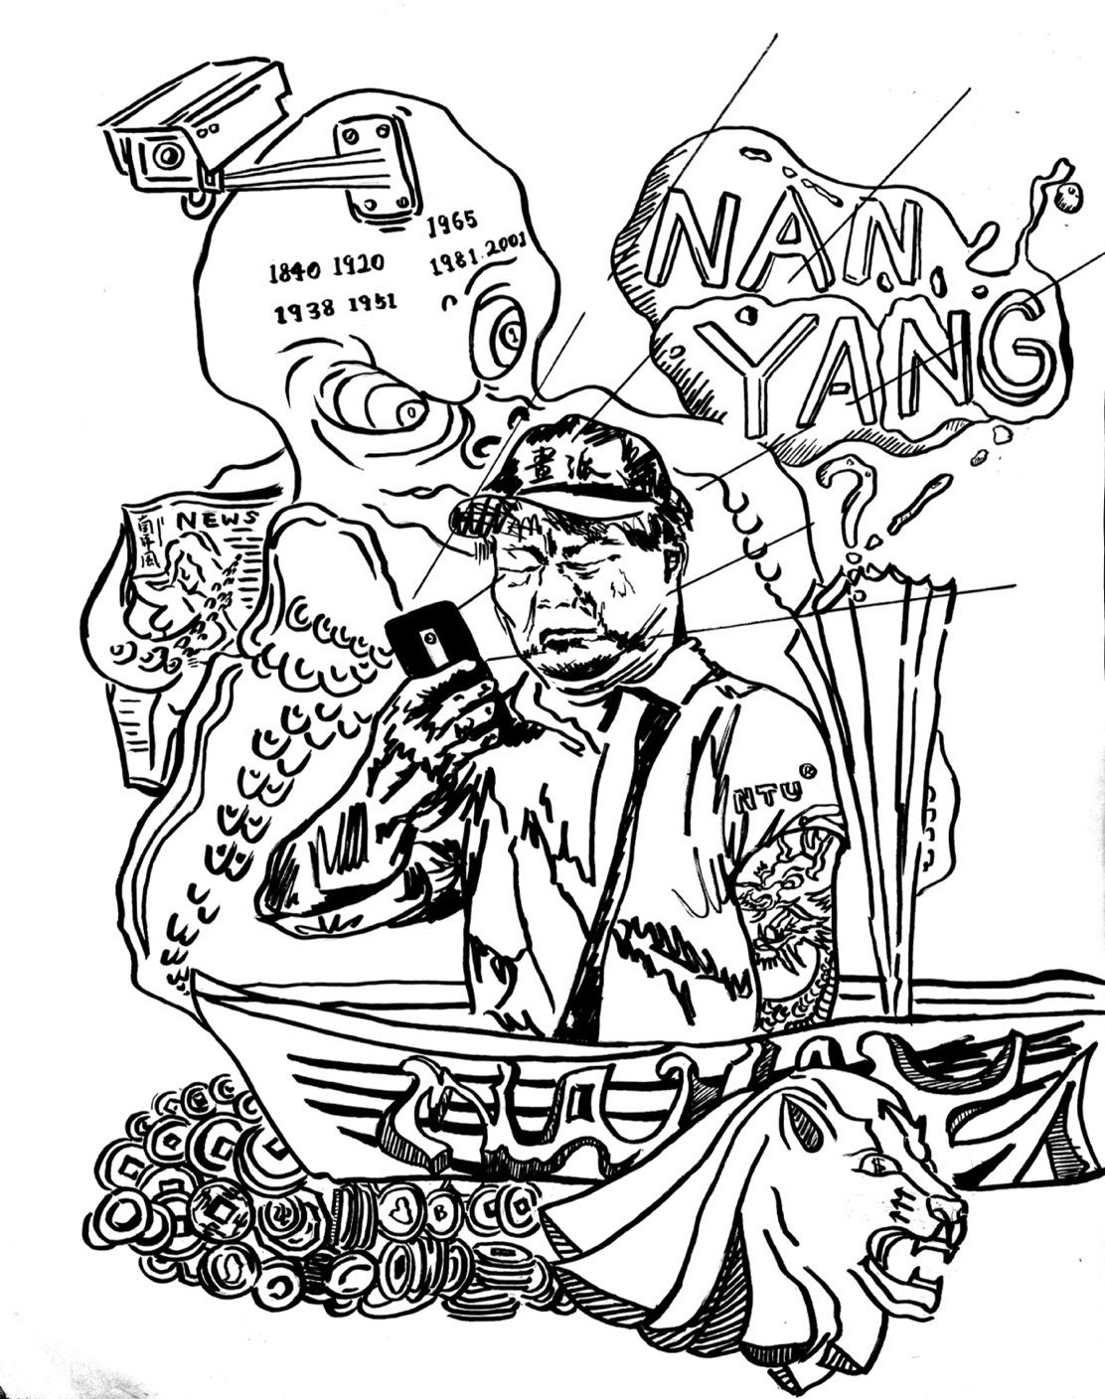

Nanyang Style, 2022
南洋风，2022
Ink on paper
纸本水墨漫画
28 x 35.5 cm

2.
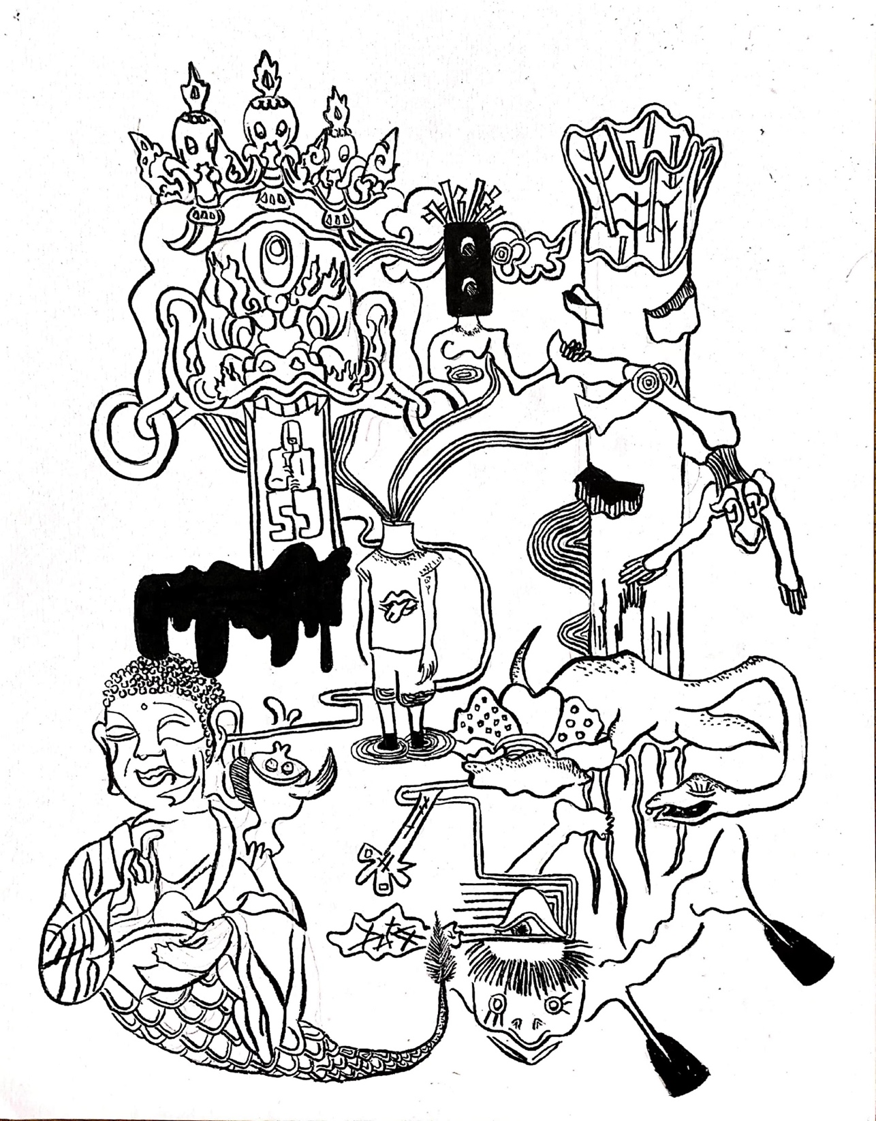

Chungking Alien Series No.1—The Monster of Loch Lixiang, 2021
山城系列一—黎香湖水怪，2021
Ink on paper
纸本水墨漫画
28 x 35.5 cm
3.

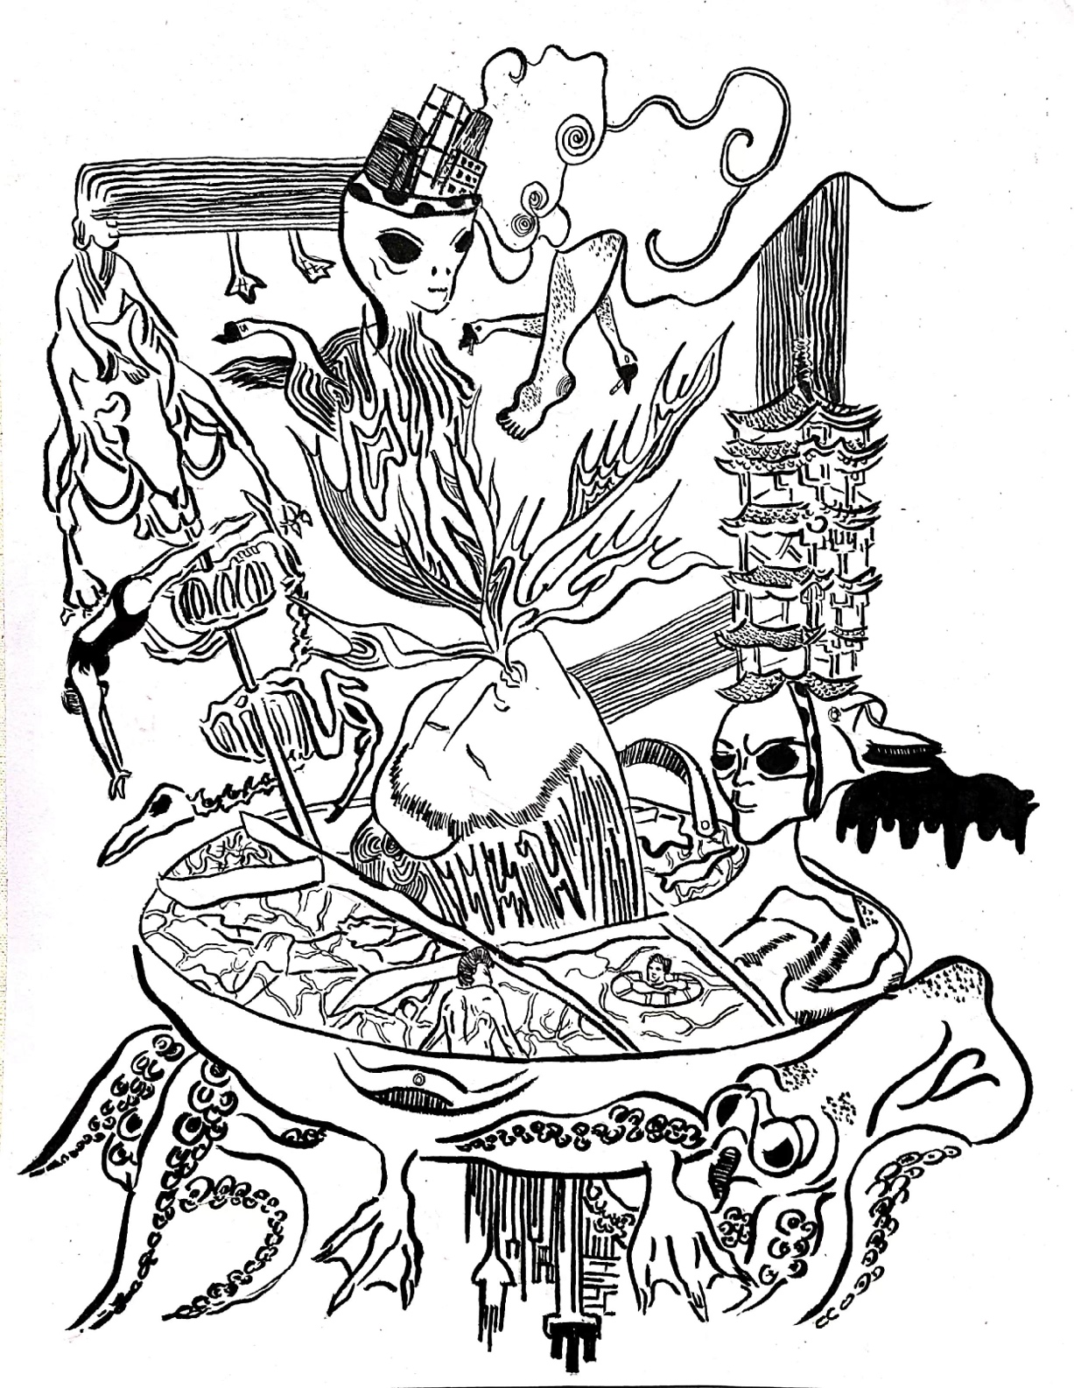

Chungking Alien Series No.1—The God of Fire, 2021
山城系列二—火神
Ink on paper
纸本水墨漫画
28 x 35.5 cm

4.

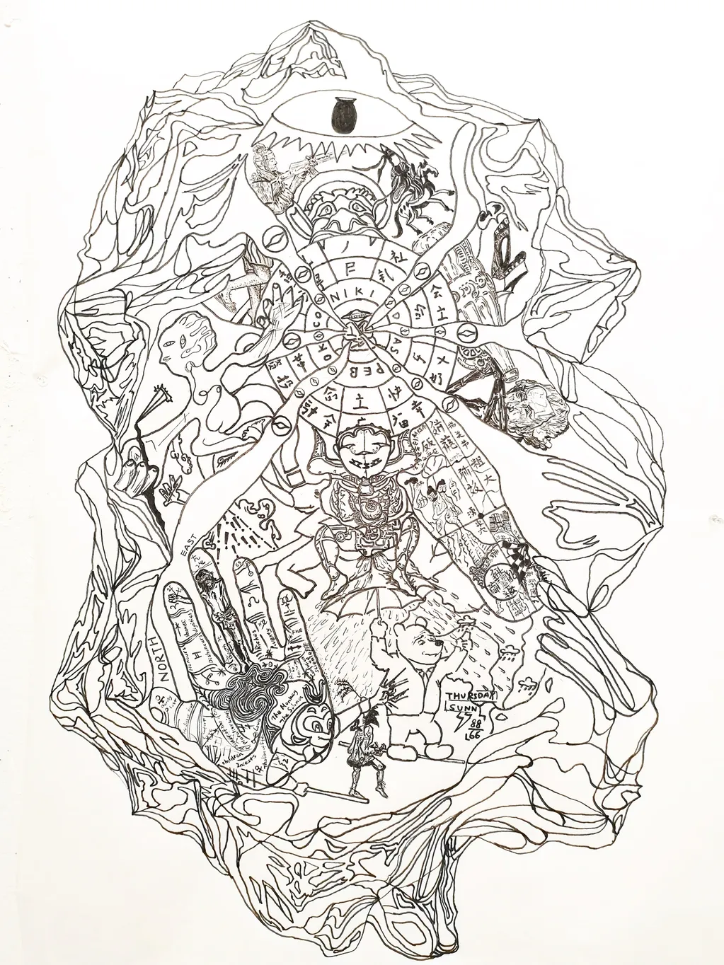

Somnium Sinica, 2020
黄粱一梦，2020
Ink on paper
纸本水墨漫画
1.2 x 1.8 m

5.
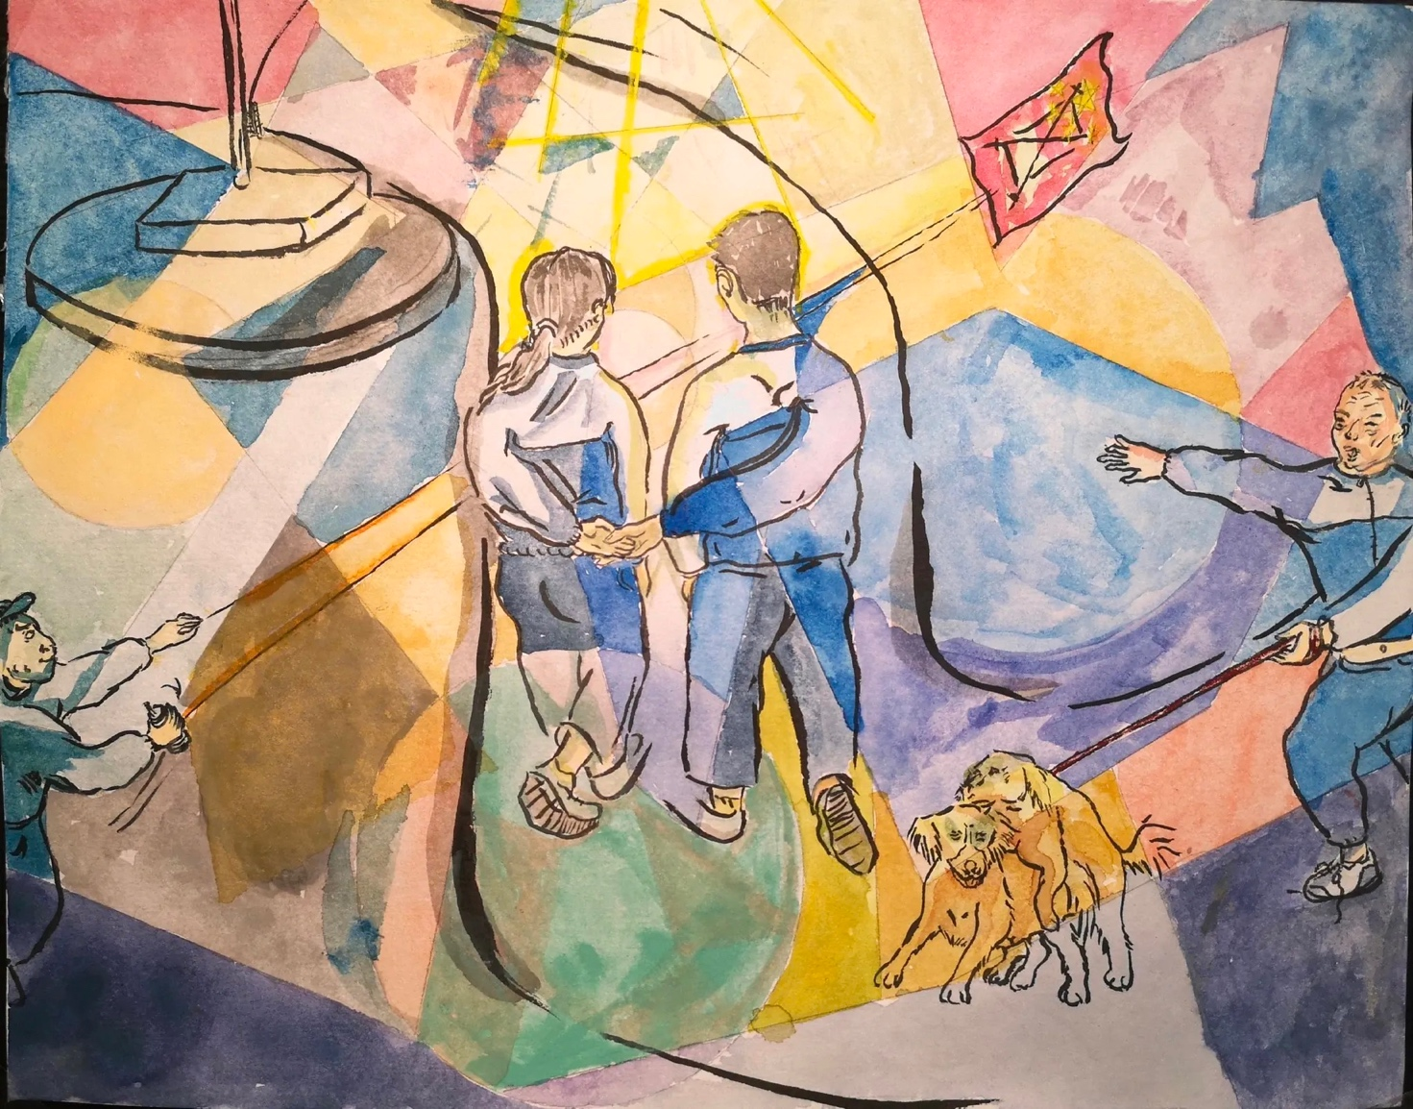

Wuhah Series No. 1—Secret Love, 2021
武哈系列一—秘密之爱，2021
Watercolor on paper
纸本水彩
28 x 35.5 m

6.

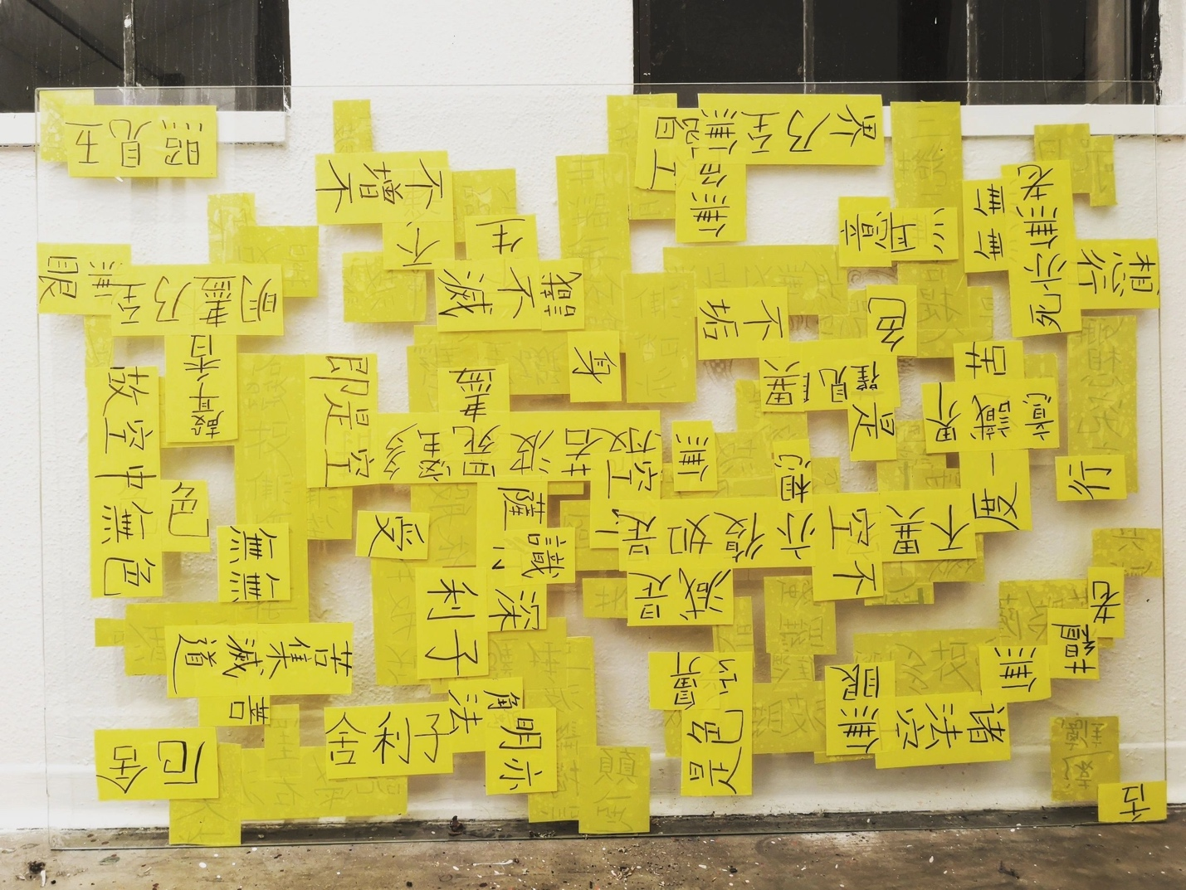

Glass Prajna, 2020
玻璃般若，2020
Yellow tape paper on the glass screen
多材料装置
1.5 x 2.2 m

7.

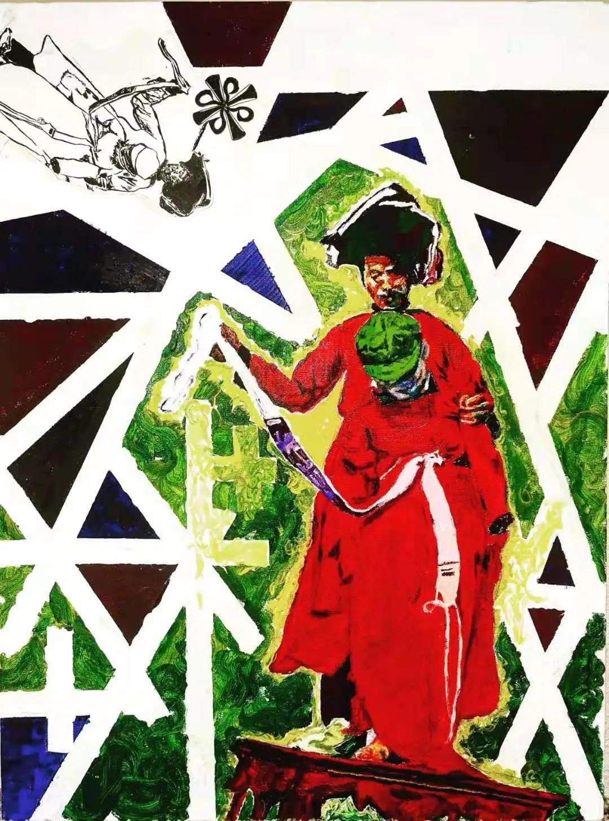

The Ritual of Passge for Iu-Mien People, 2019 (private collection)
瑶族成人礼, 2019（私人收藏）
Oil on canvas
架上油画
45 x 75 cm
8.

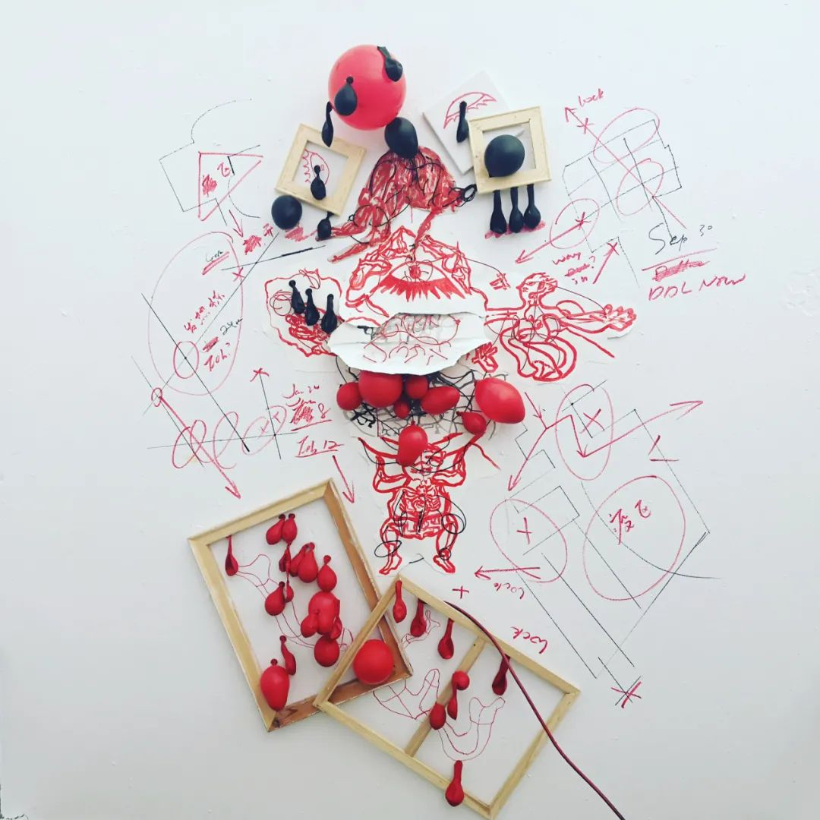

Virus-Body, 2020 (photographed by Rice Magazine)
病毒体, 2020（摄于莱斯杂志）
Drawing and installation
绘画装置
Variable dimensions
尺寸可变

9.

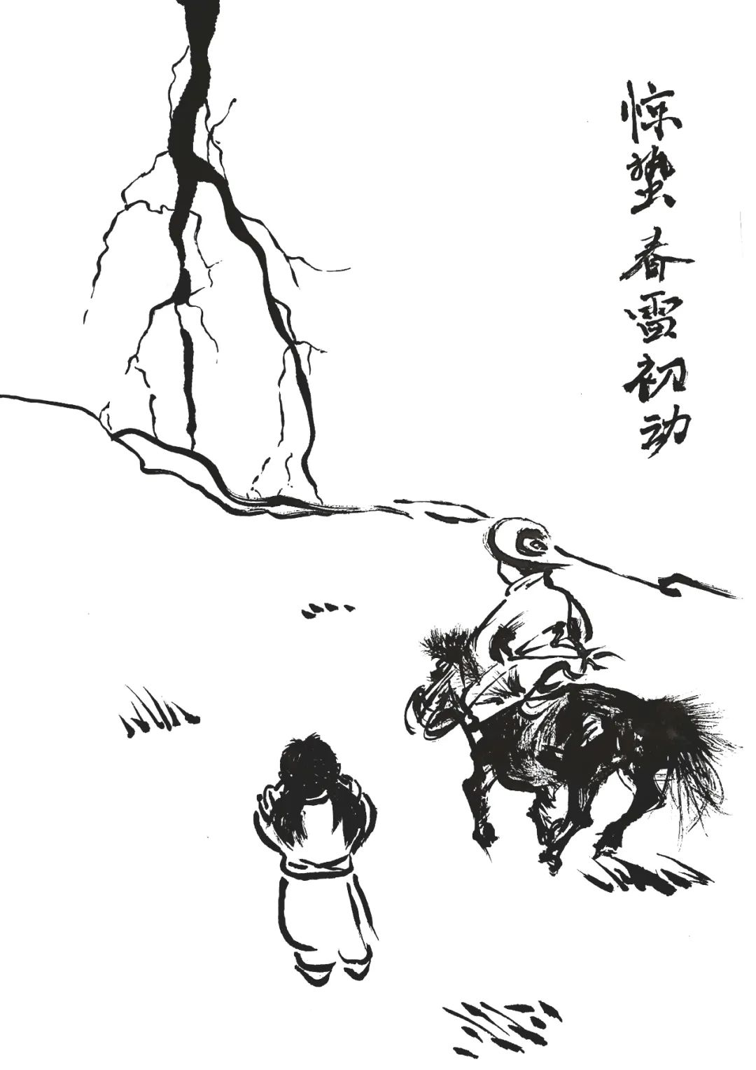

惊蛰 The Awakening of Insects, 2020
Part of the 24 Solar Terms of Ethnic Minorities
少数民族二十四节气系列之一
纸上水墨
Ink wash on rice paper
35 x 55 cm

10.

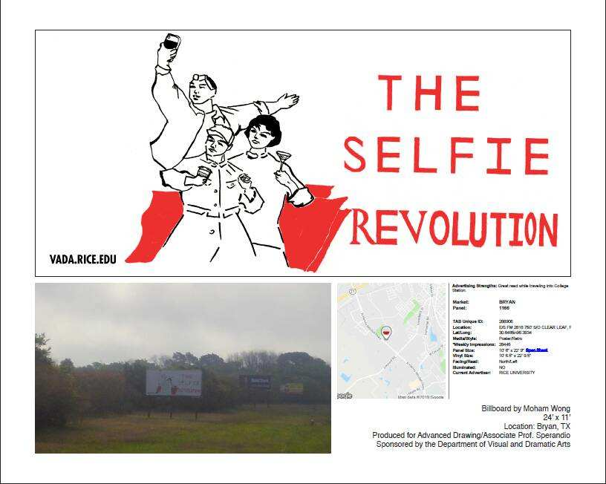

The Selfie Revolution, 2019
自拍革命，2019
Billboard Print
广告拍打印
11 x 14 feet
11 x 14 英尺

11.
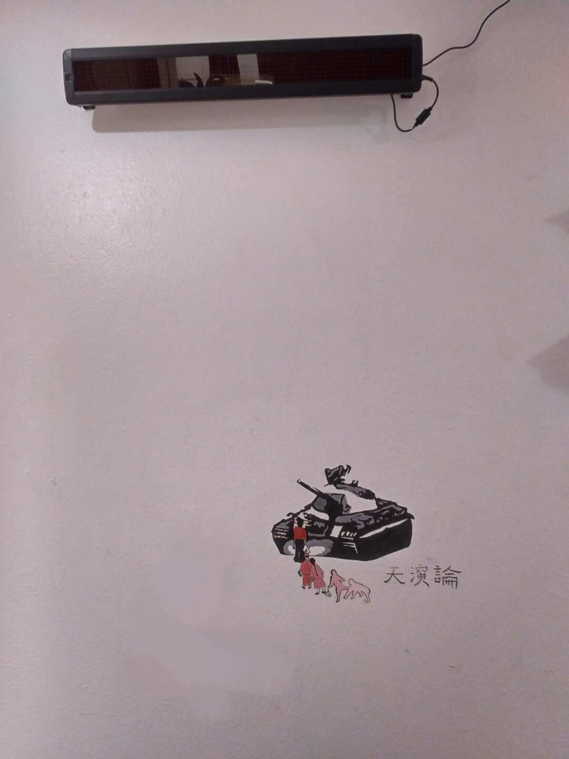

Evolution Theory, 2019
天演论，2019
Stencil on wall
墙上涂鸦
Variable dimension
尺寸可变

12.

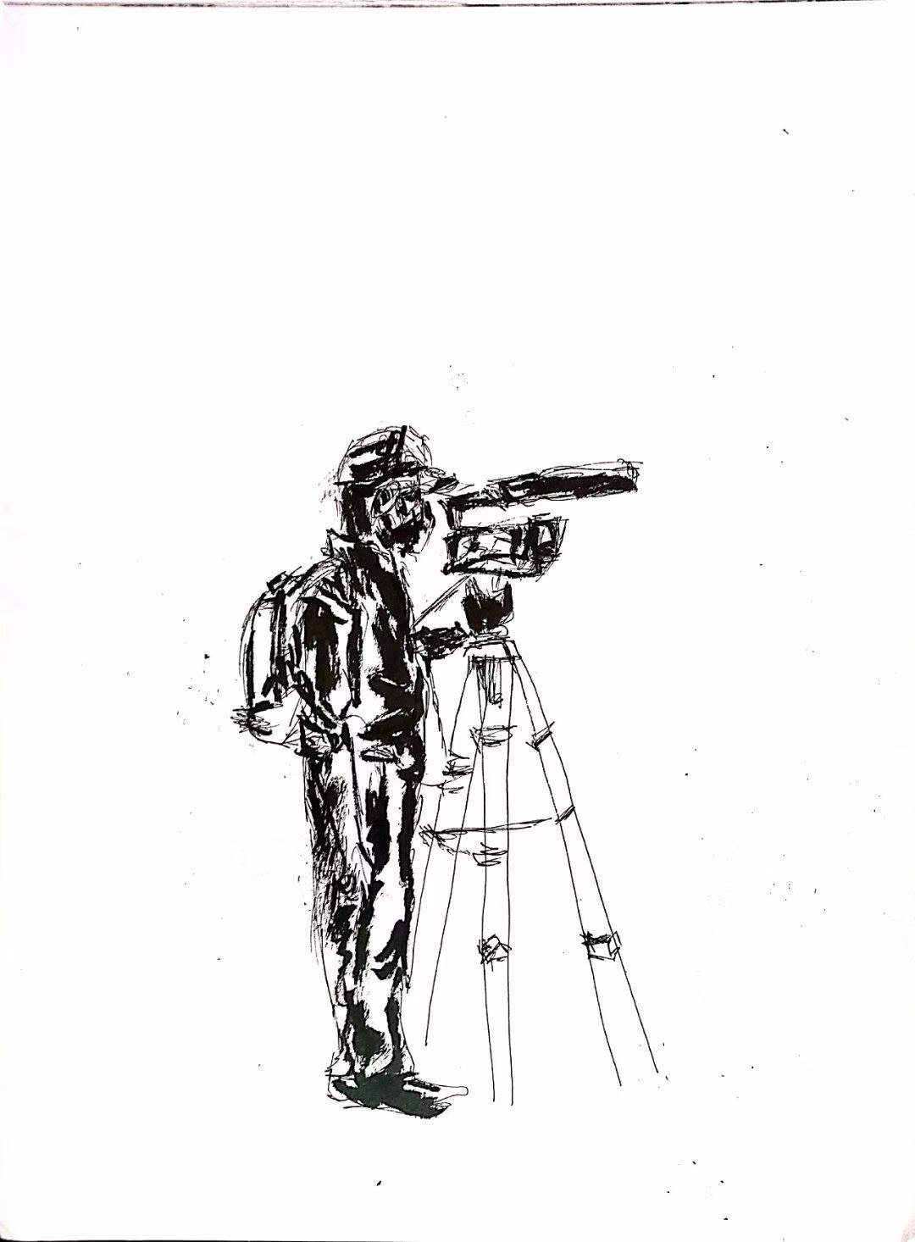

Anti-Asian Hate Protest Drawing Series I, 2021 (published by Sine Theta magazine)
反亚裔歧视示威绘画系列一，2021（发表于Sine Theta杂志）
纸上水墨绘画
Ink on paper
10 x 14 inches
10 x 14英寸

13
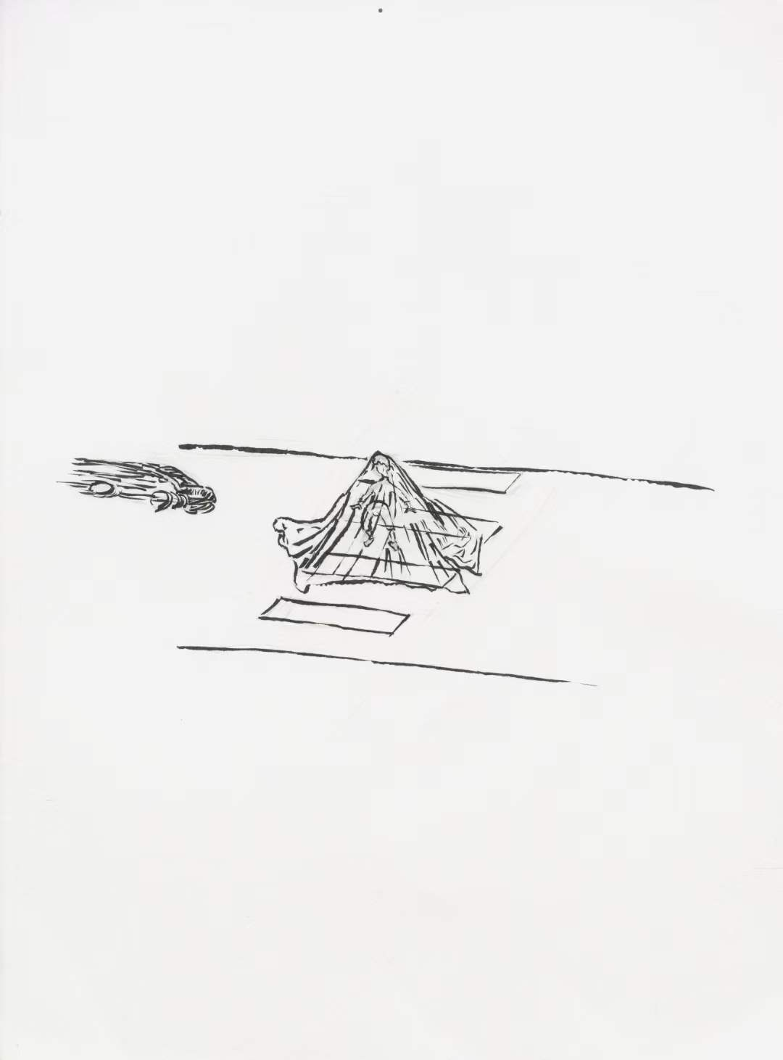

The Invisible Cloak (part of Taipai Dream Series), 2019
隐形衣（太白梦集之一），2019
纸上水墨漫画
Ink on paper
10 x 14 inches
10 x 14英寸
13.
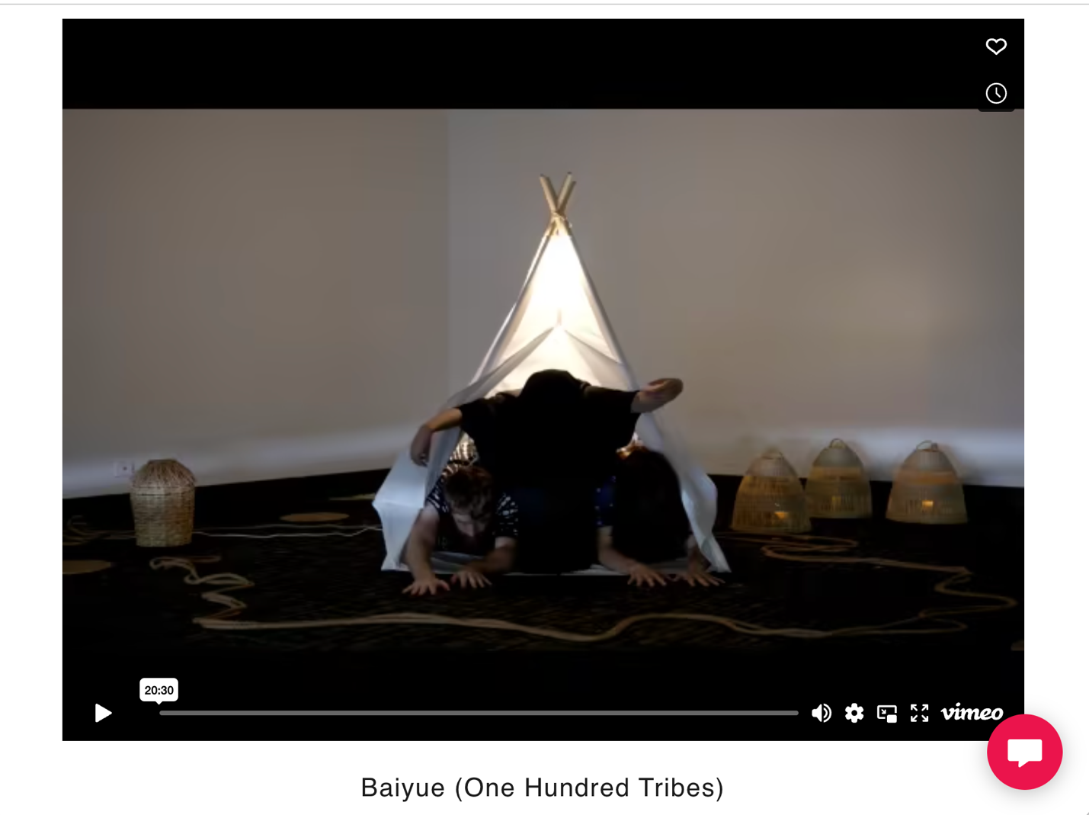

One Hundred Tribes, 2022
百越，2022
Theater and single-channel video
诗剧及单频道视频
Duration: 20: 30 mins
时长：20: 30分
具体链接 Link to video：

https://mohamstudio.com/video-%26-film
https://pushtheboatout.org/subtitled-accent-society-residency/(from 28:20)

- Textual Works 文字作品

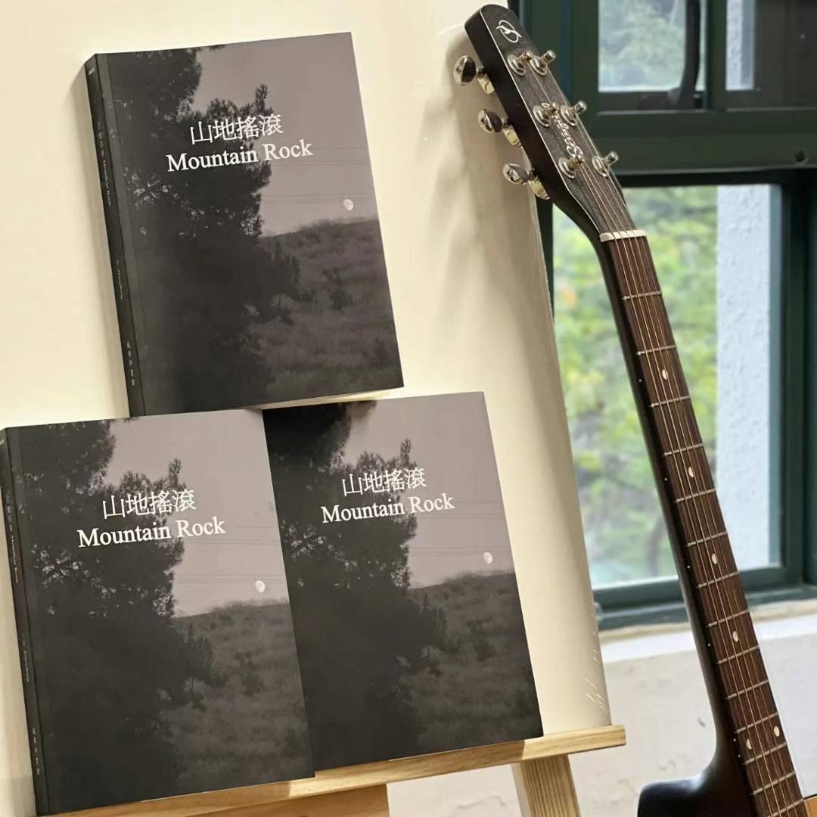

Mountain Rock, 2022
山地摇滚，2022
Published book (illustrations and bilingual poetry)
出版图书（插画及双语诗歌）
300 pages
300页
链接 Link：
https://www.blinks.com.sg/product/productdetails/oc-MAIN/ii-13844

Selected poems:
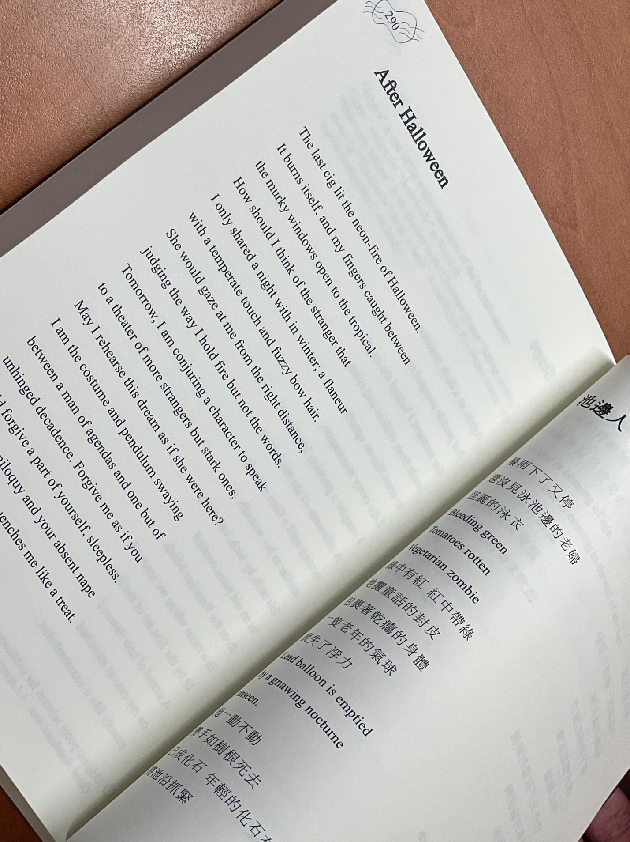
Book Introduction：

This collection of poems is named "Mountain Rock," and through the connection between different chapters, a certain musical rhythm is formed. Still, the narrative always runs through the rugged and grotesque cultural and geographical background of the "Mountain." This collection of poems is essentially developed from the unique experience and artistic journey of the author, an ethnic minority poet and artist from China who has lived through a discrete map of the world through mainland China, Hong Kong, Taiwan, the Americas, Europe, and eventually Singapore as his most recent stop. Mountain Rock begins with the mountains and takes rock as the rhythm to proffer readers a new aesthetic experience through the personalized style and the poetic dynamics among Chinese, English, and other languages. In an age of increasing openness and heightened conflict, this poetry collection is intended to act like the opening of an imaginary concert—and the rest of which will continue to unfold with our generation and our time.

书籍介绍：

这本诗集是作者——一位来自中国的少数民族诗人、艺术创作者，在经歷了中国大陆、港澳地区、美洲、欧洲，以及最终来到南洋的一系列旅途和生活中所留下的独特感受及艺文记录。山地摇滚以山地为开端，以摇滚为节奏，希望能通过个人化的语言风格，和中英及其他语言间的诗意碰撞，为读者带来全新的审美体验。在这个日益开放也冲突加剧的时代，这诗集愿为一场想像中音乐会的开场——而剩下的部分将继续延展为我们这一代人，和我们这个时代的续篇。

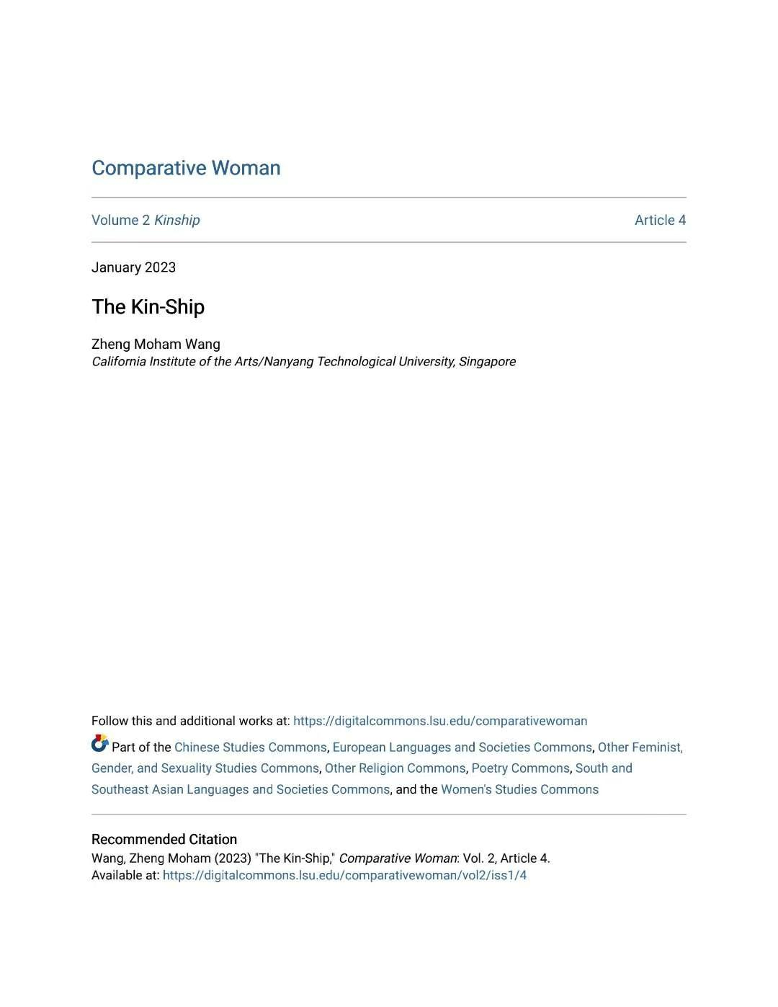

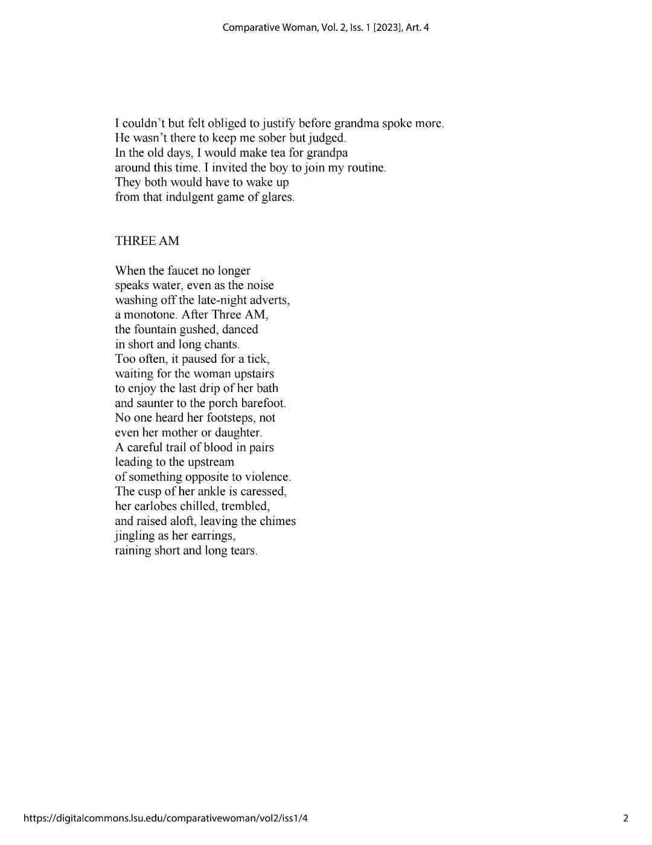

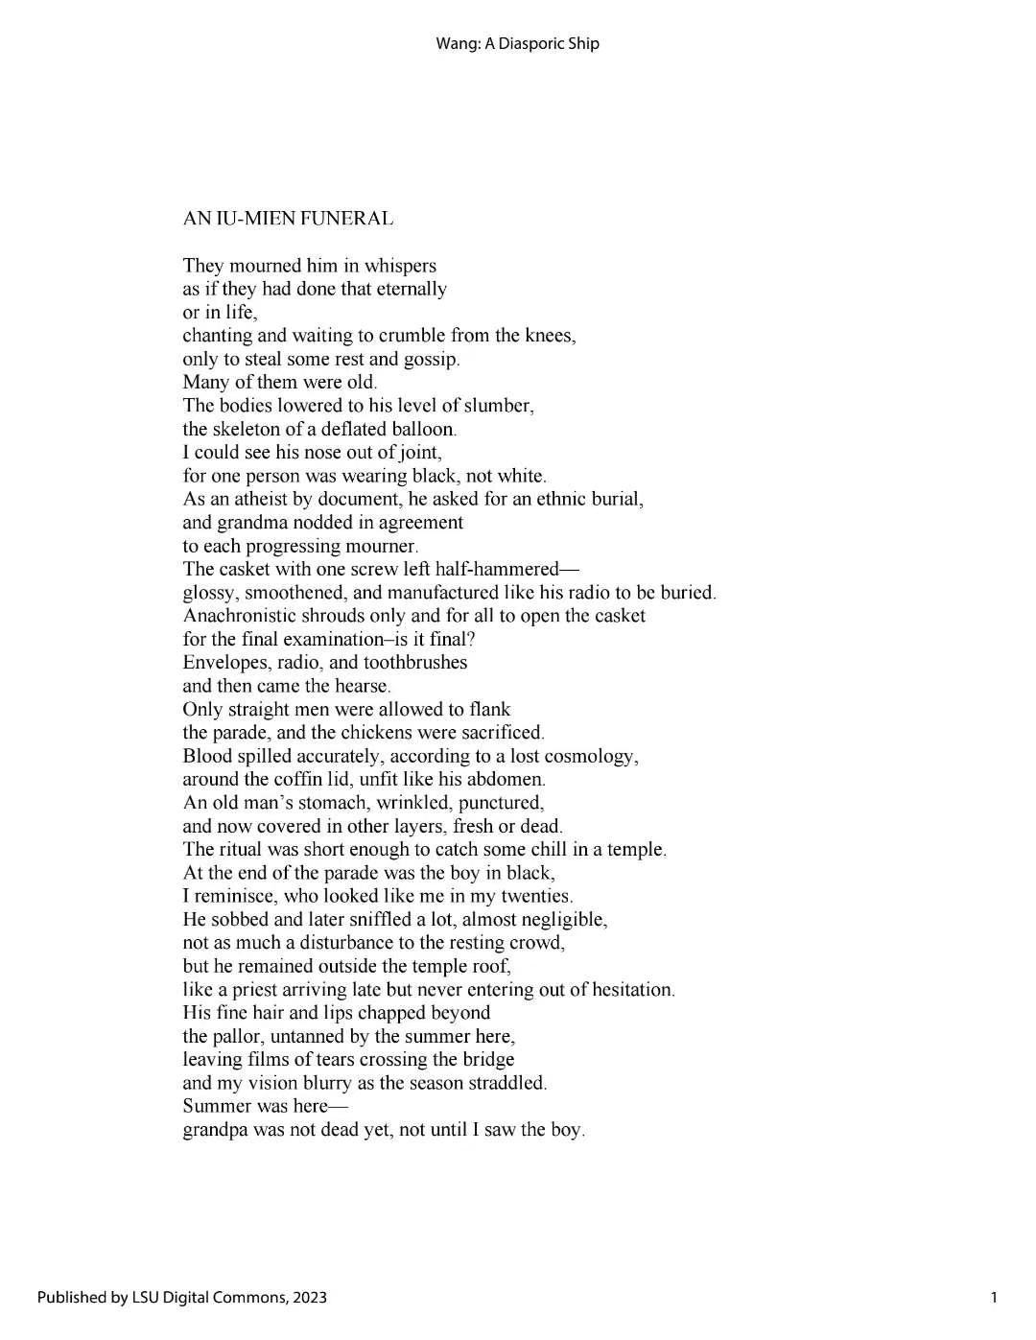
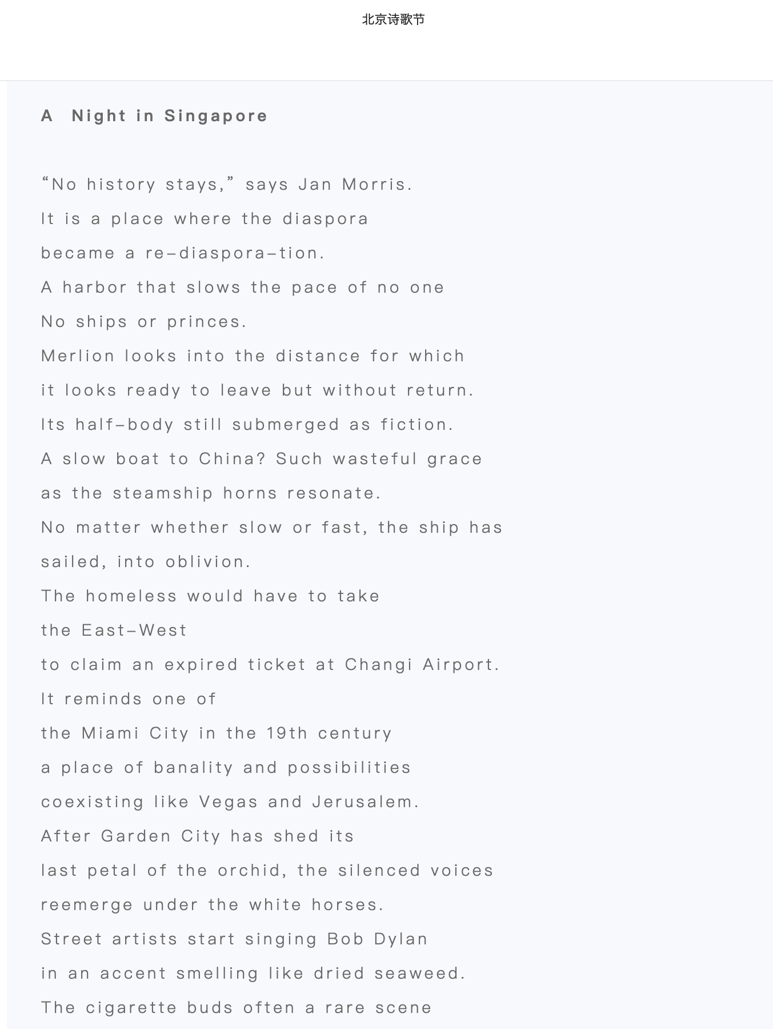

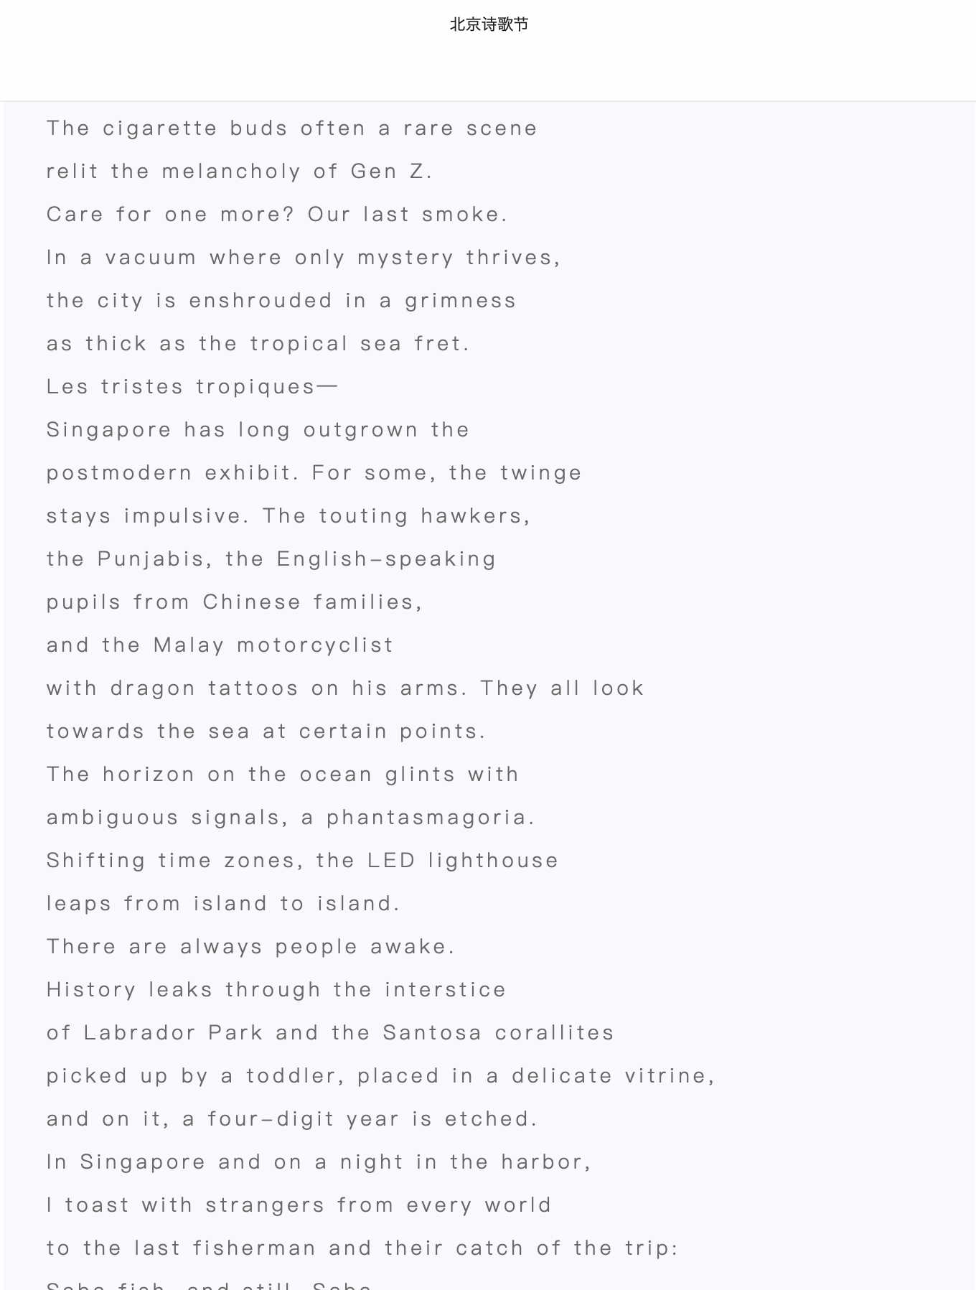

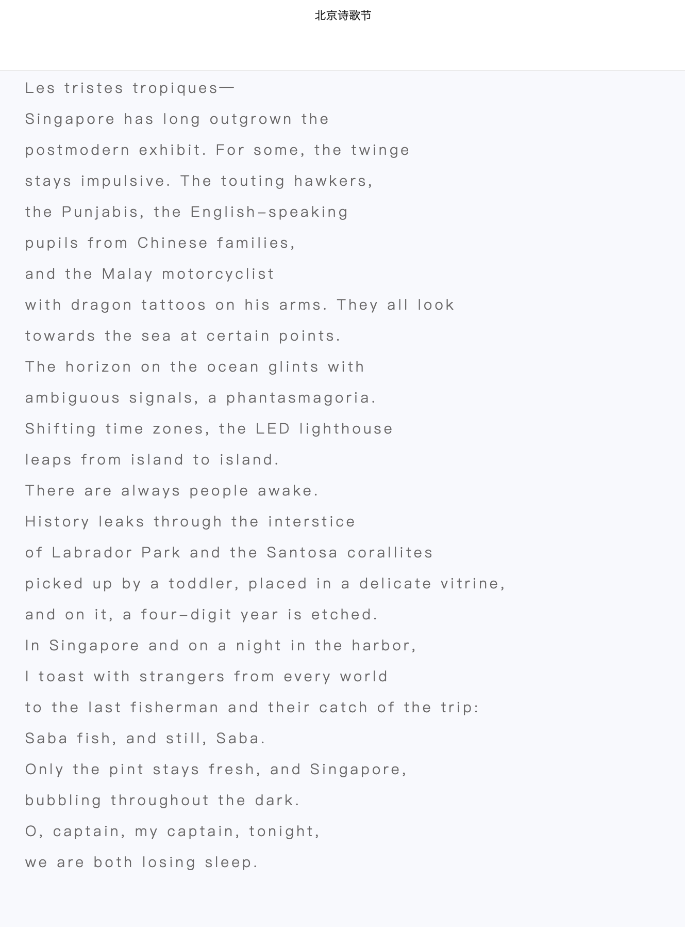

Publication Record 文字作品：

2019, “Duihua 对话 [Dialogue],” Qingdao Wenxue 青岛文学 [Qingdao Literature], 488(3), 2019, 101-102.
2020, “Lianxiqu 练习曲 [Etude],” Qingnian Wenxuejia 青年文学家 [Young Writers], 724(06), June 2020, Poetry Special Issue, 78.
2020, “Xiusidun Ertie 休斯頓二帖 [Two Blogs of Houston],” June 13, 2020 issue, China Daily Taiwan, Taiwan, A6.
2020, “Benmingnian 本命年 [The Zodiac Year],” July 7, 2020 issue, China Daily Taiwan, Taiwan, A6.
2020, “Daguchang 打谷场 [Threshing Ground],” The Fenghuanghu Poetry Journal凤凰湖 [The Phoenix Lake Poetry Journal],” 6(1), 2020, 52.
2020, “Chuidiao 垂钓 [Fishing],” August 10, 2020 issue, China Daily Taiwan, Taiwan, A6.
2020, “Yige Dongxi 一個東西 [A Thing],” July 7, 2020 issue, China Daily Taiwan, Taiwan, A6.
2020, “Xin 信 [The Letter],” Changjiang Shige 长江诗歌 [Yangtze River Poetry], 205(9), Second Edition, 2020.
2020, “Feizhou Zhimeng 非洲之夢 [Dream of Africa],” September 23, 2020 issue, China Daily Taiwan, Taiwan, A6.
2020, “Yaozu Minge Ertie 瑤族民歌二帖 [Two Scripts of the Iu-Mien Folk Songs],” October 27, 2020 issue, China Daily Taiwan, Taiwan, A6. (Also later selected to be in the 2020 Taiwan Literature Chronicle).
2020, “Zheshi Xiangcun 这是乡村 [This Is Country],” Wenxue Yuebao 文学月报 [Literature Monthly], 157(1), 2021, Hong Kong.
2020, “Yuyan 預言 [Premonition],” September 23, 2020 issue, China Daily Taiwan, Taiwan, A6.
2021, “Siji 四季 [Seasons],” January 19, 2021 issue, China Daily Taiwan, Taiwan, A6.
2021, “Chenai Zhengzai Luoxia 塵埃正在落下 [Falling Is the Dust],” ·January ·29, ·2021 ·issue, China Daily Taiwan, Taiwan, A6.
2021, “Quqi 曲奇 [Cookies],” February 6, 2021 issue, China Daily Taiwan, Taiwan, A6.
2021, “Xinjiapo De Zuihou Yitouniu 新加坡的最後一頭牛 [The Last Cow in Singapore],” Voice and Verse Poetry Magazine, 58(2), March to May 2021, Hong Kong, 26.
2021, “Luoshanji Yitie 洛杉磯一帖 [A Blog About Los Angeles],” April 16, 2021 issue, China Daily Taiwan, Taiwan, A6.
2021, “Xiaojiu De Lvxing 小舅的旅行 [The Trip to Peking of My Younger Uncle],” The Vineyard Poetry Quarterly, 230(2), Summer Edition 2021, Taiwan, 52.
2021, “Dangwo Muyu 當我沐浴 [When I Bathe],” May 3, 2021 issue, China Daily Taiwan, Taiwan, A6.
2021, “Dongye 冬夜 [A Winter Night],” May 22, 2021 issue, China Daily Taiwan, Taiwan, A6.
2021, “Miandian Zhi Chun 緬甸之春 [The Spring of Myanmar],” Voice and Verse Poetry Magazine, 59, 60(4), June to August 2021, Hong Kong.
2020, “Gouge Jiehun (Yaozu Minge) 狗哥結婚（瑤族民歌） [The Wedding of Brother Dawg (An Iu-Mien Folk Song)],” August 27, 2021 issue, China Daily Taiwan, Taiwan, A6.
2021, “Wuti 無題 [Untitled],” October 24, 2021 issue, China Daily Taiwan, Taiwan, A6.
2021, “Xue 雪 [Snow],” November 30, 2021 issue, China Daily Taiwan, Taiwan, A6.
2022, “Baiyue 百越（詩劇） [One Hundred Tribes (Poetry Theater)],” January 4, 2022 issue, China Daily Taiwan, Taiwan, A6. (Later received CalArts Interdisciplinary fund of 600 USD for theater adaptions).
2022, “Bulianxu Ju 不連續劇 [TV Un-Series],” February 2, 2022 issue, China Daily Taiwan, Taiwan, A6.
2022, “Gezhe 歌者 [The Singer],” April 27, 2022 issue, China Daily Taiwan, Taiwan, A6.
2022, “Wanchun 晚春 [Late Spring],” May 14, 2022 issue, China Daily Taiwan, Taiwan, A6.
2022, “Liuyue 六月 [June],” June 22, 2022 issue, China Daily Taiwan, Taiwan, A6.
2022, “Hei Taiyang 黑太陽 [Black Sun],” Voice and Verse Poetry Magazine, 64(4), April 2021, Hong Kong, 63.
2022, “Jiejie 姐姐 [Sister],” July 26, 2022 issue, China Daily Taiwan, Taiwan, A6.
2022, “Tang 糖 [Candy],” August 8, 2022 issue, China Daily Taiwan, Taiwan, A6.
2022, “Liangzuo Dao 兩座島 [The Dual Islands],” September 18, 2022 issue, China Daily Taiwan, Taiwan, A6.
2021, “Delingha De Waixingren 德令哈的外星人 [The Aliens of the Plateau],” serialized from June 11 to June 15, 2022 issue, China Daily Taiwan, Taiwan, A6, https://today.line.me/tw/v2/article/0zZEXl.
2022, “Laoxiong Zaocandian 老熊早餐店 [Hsiung’s Breakfast Diner],” serialized from March 11 to March 12, 2022 issue, China Daily Taiwan, Taiwan, A6, https://www.cdns.com.tw/articles/548599.
2022, “Laoxiong Zaocandian 老熊早餐店 [Hsiung’s Breakfast Diner],” Qingchun 青春 [Youth], 979(6), 2022, 21-26, https://m.fx361.com/news/2022/0601/10348377.html.

- Curatorial Works 策展作品

See CV 请看简历。

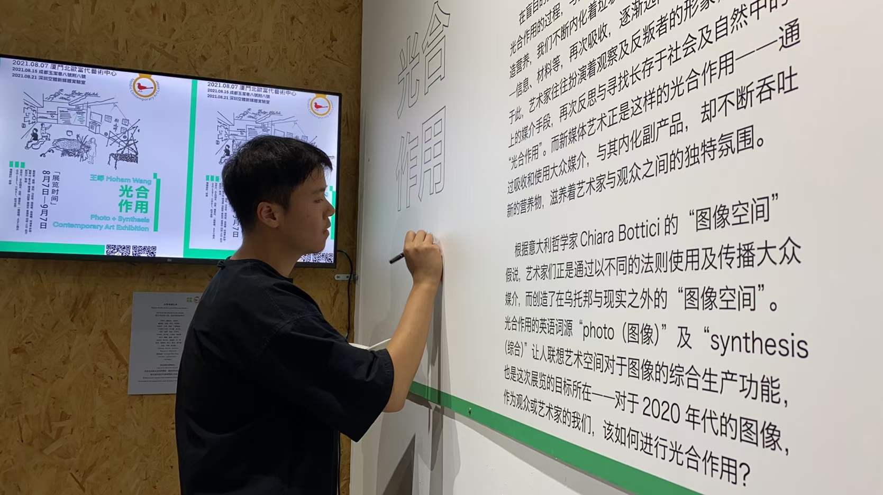

- Academic Works 学术作品

See CV 请看简历。

Author Bio:

Moham Wang is an alumnus of Rice University with a B.A. in Art History and a graduate of the California Institute of the Arts with an M.A. in Aesthetics and Politics. He’s pursuing his Ph.D. in Art, Design, and Media with Research Scholarship at Nanyang Technological University, Singapore.

He’s a curator, artist, and writer of the Iu-Mien ethnicity. Wang’s creative and writing works can be found internationally across multiple exhibitions and press.

Contact:

Email: mohampangum@alum.calarts.edu
Mobile: +65 87906932

艺术家信息：

王峥（mohamstudio.com）：青年瑶族艺术家、策展人及作者，现居新加坡。本科毕业于美国莱斯大学艺术史及纯艺术双专业，硕士毕业于洛杉矶加州艺术学院艺术批评硕士，博士就读于新加坡南洋理工大学艺术设计系艺术史论，主攻亚洲当代艺术，并获Research Scholarship （学术研究）全额奖学金。视觉、文字及学术作品见于海内外杂志及展览。其装置、水墨及多媒介作品见于意大利米兰M.A.D.S. Gallery画廊，加拿大温哥华《Sine Theta》杂志，美国《Rice Magazine》杂志等；其论著《绘画如何解决当代艺术困境》发表于中国人民美术出版社《美育》期刊2021年第二期。研论“The Pagoda in Flux”发表于葡萄牙里斯本大学出版社《User Experience and Urban Creativity》第四期2022年第一辑。双语艺术诗集《山地摇滚》出版于台湾城邦印书馆。

联系方式：

微信：a875517010
邮箱：875517010@qq.com
电话：（国内父母）15337265759；（新加坡）+65 87906932

