COSTAR INSIGHT

Philadelphia Office Market Sees Slowdown in Leasing Recovery

Leasing Volumes Drop Near Pandemic-Level Lows
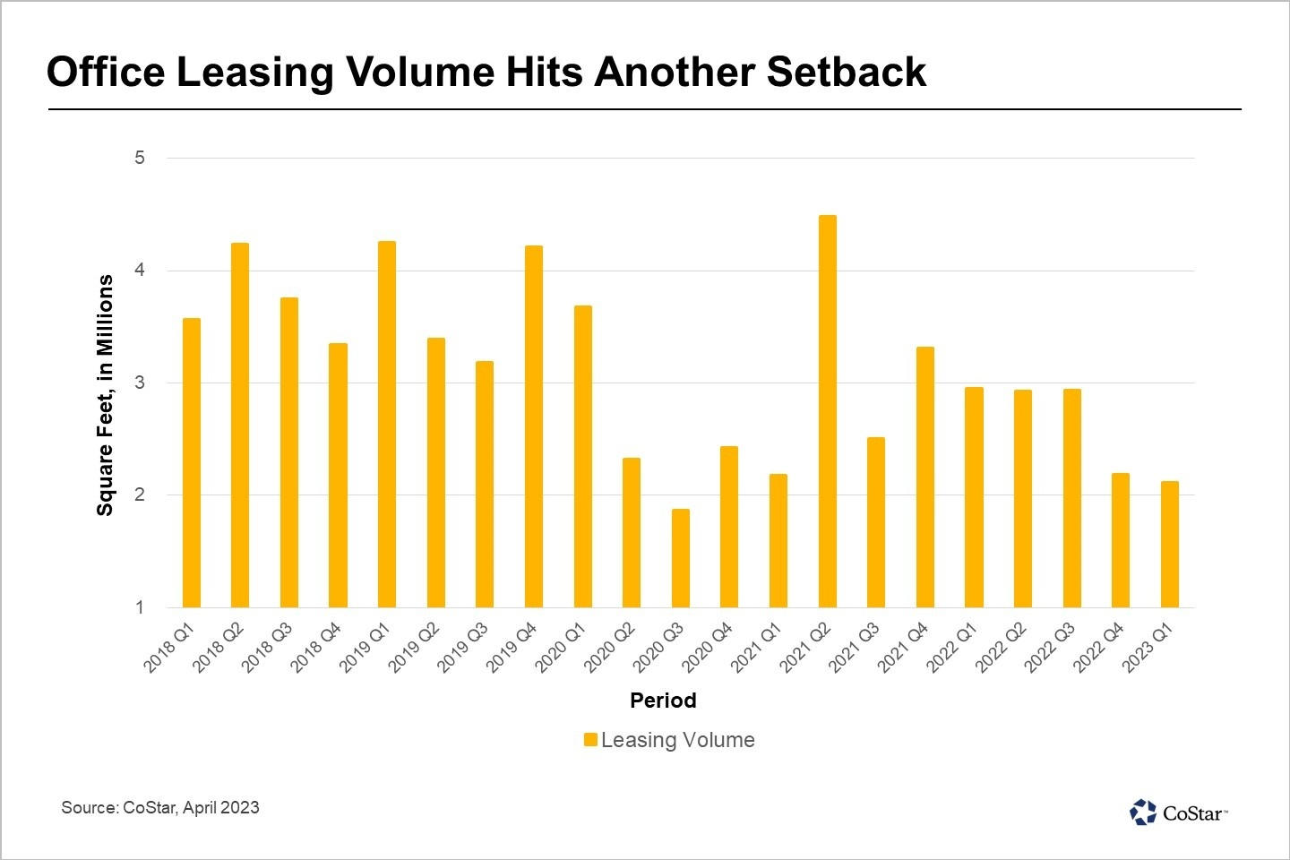
By Brenda Nguyen
April 12, 2023 | 2:54 P.M.
After a period of noteworthy leasing recovery since mid-2021, the Philadelphia office market has hit another setback.
Business decisions, and subsequently leasing momentum, have given way to inflationary measures and economic uncertainty in recent months. The past two quarters have recorded the lowest leasing levels since the height of the pandemic.
After recovering to 80% of pre-pandemic levels in 2021, the annual leasing volume fell to 70% recovery levels in 2022 due to a weak fourth quarter.
This year is already off to a rocky start, and given current economic headwinds, performance is unlikely to keep up with the recent leasing recovery for the remainder of 2023.
While this presents another obstacle in an already uphill battle for the office market, it’s important to note lease transactions have not disappeared altogether. Although occurring in lower volumes overall, significant leases are still being signed, particularly for high-end four- and five-star buildings, build-to-suit office towers and dedicated life science spaces.
Of course, Philadelphia is not the only office market to face this challenge caused by macroeconomic headwinds. Markets across the country, including New York, Boston and Charlotte, North Carolina, have also experienced a pullback toward pandemic-level lows. Some markets hit levels that were even lower than their pandemic low, such as Washington D.C., Atlanta and Baltimore.

