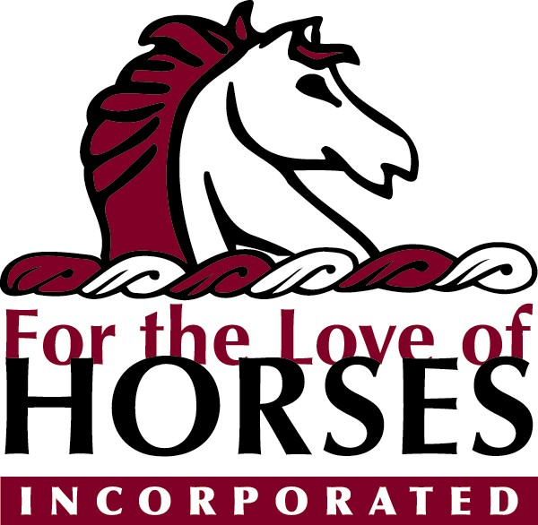

2018 Raise the Bar Show Dates:

March 10 Gallery Farm
May 5 Celtic Cross
May 19 Eastwick Stables
June 16 Paradigm Farm
July 7 Paradigm Farm
September 15 Eastwick Stables
October 7 Celtic Cross
October 28 Gallery Farm

2018 Go Show Dates:

Jan 27-28 OKC fairgrounds
Mar 23-25 NLT-Purcell
Mar 31 Cadence- Edmond
Apr 7 River Run- Tulsa
Apr 11-12 Tulsa Expo
May 4-6 NLT- Purcell
May 12 George Morris clinic-Mounds
May 19 KJM-Broken Arrow
Jun 2 Sonrise- Broken Arrow
Jun 9 Revery- Mounds
Jun 30 Cadence- Edmond
July 11-16 OKC fairgrounds
Sep 1 Cadence- Edmond
Sep 8 River Run- Tulsa
Sep 22 Revery- Mounds
Sep 29 Lambanks- Mounds
Oct 6 Sonrise- Broken Arrow
Oct 13-14 Cadence- Edmond
Oct 20 JMG- Harrah
Oct 27 KJM- Broken Arrow
Nov 3 Cadence- Edmond
Nov 15-19 Tulsa Expo

