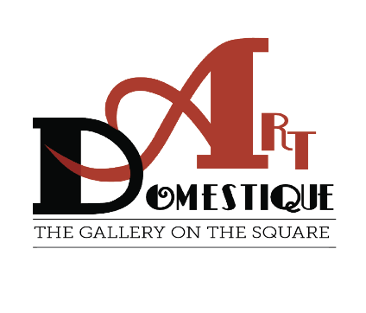
Art Domestique Membership 2024

Artist Name________________________________________
Address____________________________________________
Phone_________________ Email_______________________

Membership Fees
Family $35.00
Individuals/ARTIST $25.00
Students K-12 $15.00

Artist can join in any category
Membership is Tax Deductible
Membership is from January-December

