Aggressive Pricing
Leading Commissions
Responsive and Efficient Funding

http://www.culaincapital.com
(716) 919-1322

Double Click Image below to download

Or
Copy and Paste information below
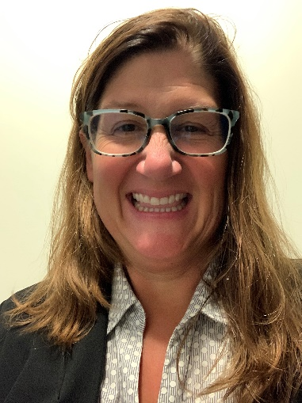
Cindy Borden
Culain Capital Management LLC
Account Executive
cborden@culaincapital.com
716.919.1322
1780 Wehrle Drive
Buffalo, NY 14221
www.culaincapital.com

Contact us today to see how we can help small to medium sized businesses with their financing needs!

