Case Study 4

Sam Moldenhauer, Ryan Clark,
Nicholas Haggard, Joe Jaskolski,
Michael Winder

4BITS CONSULTING
University of Wisconsin – Stout (CNIT382 Online)
Instructor: Brice Blankenship
December 20, 2023

Contents
Executive Summary 2
Assumptions 4
Recommendations 4
Proposed network and new topology 6
Figure 1. 7
Table 1. 8
Maintenance and Support 9
Monitoring 10
Budget summary 11
Table 2. 12
Table 3. 12
Project timetable 12
Table 6. 14
Table 7. 14
Table 8. 15
Table 9. 15
Table 10a. 16
Table 10b. 17
Table 11. 17
Future Improvements 17
Contributions 19
Bibliography (Education) 22

Executive Summary

The Louisiana Department of Education has put forth a request for proposal to update the Bring Your Own Device (BYOD), Local Area Network (LAN) and Wide Area Network (WAN) connectivity service. They would like to upgrade the systems at seven different schools across multiple parishes within the state. This proposal must meet all technical requirements as outlined within Section IV of the RFP document.
While the schools already have established networks at each location, this proposal is intended to update the schools to current networking and end-point management standards and allow for ease of monitoring and security of all end point devices including but not limited to phones, and laptops. This will be accomplished by using a multitude of software and hardware that allows for the ease of monitoring, control, security and use.
4 BIT CONSULTING is providing a hierarchical network design that can be duplicated for each school, with the only difference being the number of switches. To save on cloud maintenance costs we are proposing to connect the school networks using MPLS VPN. Each site will have wireless for both staff and students and will have a full camera security system. We will be implementing quality of service techniques to prioritize VoIP, video conferencing, and security system traffic. This will be important so that the most important traffic will not be impeded.
For software, Microsoft’s software suite will be used under the Microsoft 365 A3 license. This will provide almost all the software needed including productivity tools such as Microsoft Word. This license also provides Entra ID and Intune which will be used for identity management, asset management, and mobile device management. Staff will also have the Intune Suite addon license which will allow them to request temporary admin access and have better remote-control support from the IT team.
For a monitoring solution, 4BITS CONSULTING will be implementing LogicMonitor. This solution will allow integration into our existing network monitoring solutions. This software will also allow integration with our ticketing software solutions to increase efficiency when dealing with a network error or issue.

Assumptions

To provide the Louisiana Department of Education with the best proposal we can, we needed to make a few assumptions. Our first assumption is that since we are not being asked to provide a plan for a district office, there is already a district office setup that we can use as our base for this project. We also assume that there is an IT department for the district that will handle day-to-day operations, and our support will be supplemental to that. In other words, we will be providing vender support and not a full support system. We are also assuming that the majority of the wiring is in place with the current setup and can be reused. We will then run new cables only where needed.

Recommendations

For the LDE we recommend using the Microsoft Suite software under a Microsoft A3 license. A large part of the request from LDE is a robust and reliable device management system to manage both the districts’ devices but also allow for the implementation of a bring your own device (BYOD) policy. A combination of Entra ID (formally known as Azure Active Directory) and Intune is included in this license and provides this functionality.
Entra ID is a directory services platform that allows for users and device management. Intune is a Mobile Device Management (MDM) tool that allows you to create management policies for both company owned devices (COD), with the company being the district, and BYOD devices. Using these tools together will provide LDE with granular control over any device that is used to access district resources.
4 BITS CONSULTING will work with LDE to fine tune a MDM policy, but the following is our proposed starting policy. There should be two separate main policies managed. One for COD and for BYOD. As the COD devices are owned by the district, they will be locked down further and set to get their software and policies only from Intune. On top of this, there will be monitoring of device use and security through Microsoft Defender for Endpoint. If needed these devices can be remotely locked to revoke access or wiped to protect data if the device is lost or stolen. For CODs used by the staff, we will have upgraded licenses that add Microsoft Intune Suite. This will allow IT staff to remote into the devices with greater functionality to assist in problem solving but also allow the staff to request admin access for certain items without needing to provide full device admin. This provides an audit trail and greatly increases security. This policy should also be set up with Microsoft Autopilot to allow for easy provisioning of devices. This allows you to order devices right from an OEM or reseller and have them automatically enroll in your systems and install approved software.
The second policy we recommend is a BYOD policy. This will be used for any devices used by students or staff that are not owned by the school district but need to access district data. This will manage the device but only give the district access to parts of the device that a connected to the management profile. For instance, there will still be usage visibility, but only for programs installed from the Company Portal. You will also be able to still lock users out of district data and wipe district data, but not the individuals’ personal files.
For both policies we recommend setting devices up to automatically connect to the district wireless network as well as utilize Entra ID Single Sign On for applications installed from the company portal. Since we are using the Entra ID accounts to sign into devices and services, we will also want to set the environment up to work with self-service password changes and resets to free up the IT staff’s time and get users in quicker. It is also important that both policies are set up to accept all device types used by the district such as Microsoft, Apple, and Google.
The A3 license includes a plethora of Microsoft products, and 4 BIT CONSULTING highly recommends using as many of them as meet your needs to maximize product value as well as increase software interoperability. From a collaboration standpoint we will set up a Viva (formally known as Yammer) environment for the school district. This can be used as a private social media platform for students and staff. Microsoft Teams is also included and is an excellent video conferencing and chat program that will be utilized for communication ranging from remote classes to group work. Microsoft Teams will then be integrated with OneDrive for file sharing and storage as well as SharePoint where teachers can create class websites. Videos for students and projects need to be stored as well and for this we recommend Microsoft Stream as a private alternative to YouTube or Vimeo. The simplest but most used feature of this will license will be the Office Suite. This includes software such as Word, Excel, and PowerPoint. All of these will be instrumental to the learning from students.

Proposed network and new topology

The network being proposed brings high availability and increased security while limiting subscription services by utilizing MPLS VPN to connect the schools within the district. Traffic shaping will be introduced to prioritize certain data flows, such as VOIP, Video Chat, and IP Camera streams. Two independent ISPs should be used to ensure internet availability. A full mesh network design is being proposed at the Core and Access layers. Two firewalls will be leveraged to protect the network against malicious and unnecessary network traffic. The network equipment being suggested consists of redundant Cisco C8300 core routers, Cisco 9200 core switches, and Cisco FirePower 3110 firewalls. To provide each school with a solid Wi-Fi environment, the Meraki Go GR62 access points will be used. For the requested IP cameras and phones, we have decided to go with the Ubiquiti ecosystem. Ubiquiti has easy configuration, monitoring, and management for their various technology offerings. Choosing Ubiquiti will allow for a simpler integration of future products that would be beneficial for the school district. Traffic segmentation via VLANs is configured throughout the proposed network, which will help in preventing broadcast storms. As seen in Table 1., the IP subnet scheme has a standardized approach and offers flexibility in network and peripheral growth over the years.

Figure 1.
New network topology
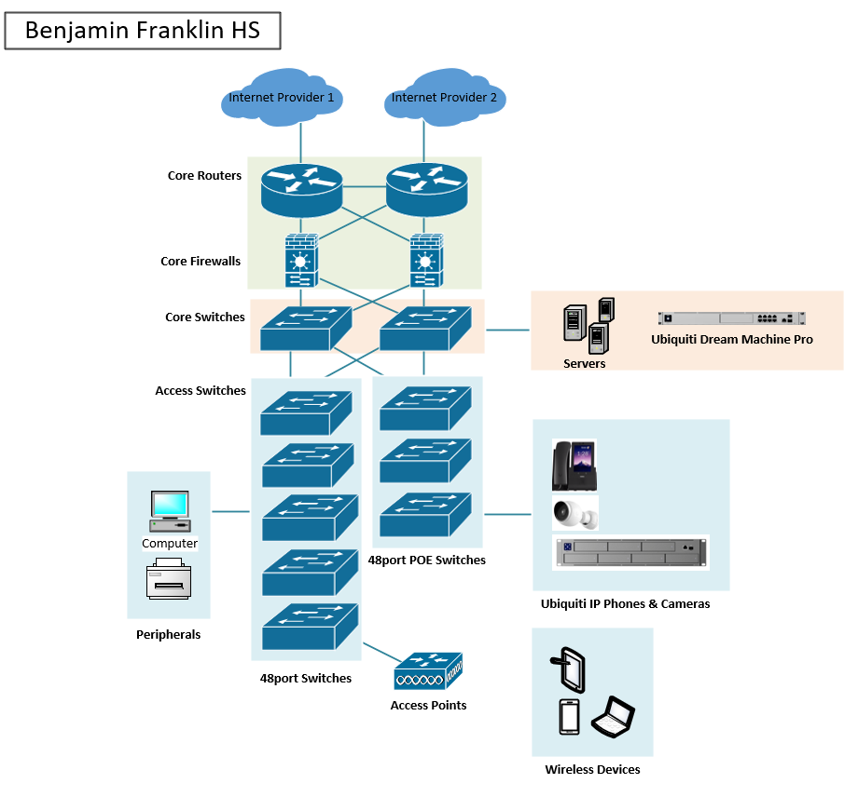

Table 1.
Subnet and VLAN Scheme
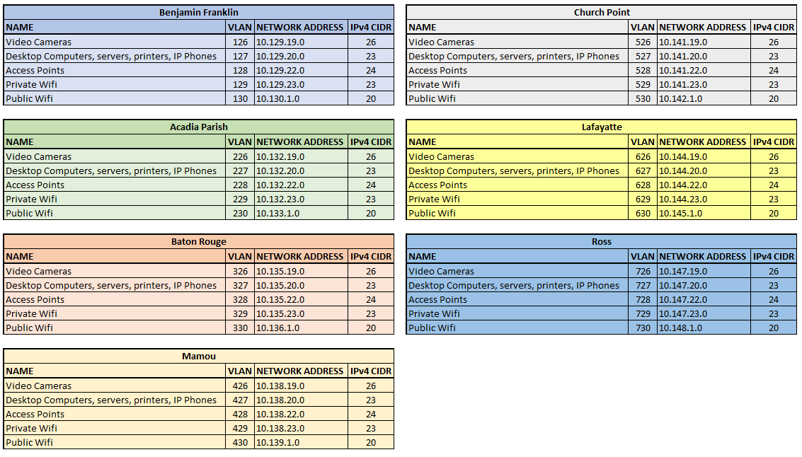

Maintenance and Support

Fixed network maintenance windows on weekends or after-school hours only. Only emergency disruptions allowed during school hours. Email notifications to school board personnel for emergency network maintenance outages that are not pre-scheduled, even if this occurs in nights and weekends. We will be providing proactive monitoring of its infrastructure components to include the hours of 7am to 5pm using Microsoft Intune Suite. We will provide dispatch support services for maintenance on its infrastructure equipment through this same service along with Jira ticketing software.
Give access of Jira to the school’s staff so that when they have a problem with their technology, they can create a ticket of what is happening and what is wrong. We will create a new project on our end within our current Jira tenet. This new project will include the following, a personal email address for employees of LDE to open tickets via email, a custom portal for opening ticket, with customized forms with all the information that will be needed to get proper support in a timely manner. They will then have access to information about what is happening to fix it and an estimate of when the problem can be resolved. The IT staff will also be given access to Microsoft Intune Suite. Microsoft Intune Suite will allow the IT staff to get remote access to the devices with better functionality to assist in troubleshooting any tickets that the staff submit into Jira.

Monitoring

There are a couple of different options we offer when it comes to monitoring network infrastructure. We offer a cloud-based solution (Logic Monitor) that uses Java applets to gather information and report back, and then we offer an on-premises (SolarWinds) solution that requires a server onsite. Both solutions use SNMP protocols and are minimal in relation to network traffic.
The cloud-based solution’s cost is based on the number of devices that are being monitored. If we include the end point devices within each school, we have roughly 1400 devices that are being monitored. Which comes to a rough cost of around $5.00 per device, or $6,990 per month, and a yearly cost of $83,880. This does not include the initial licensing costs of $59,324.99 for a total in the first year of $143,204.99. After the first year the costs per year will only be $83,880. For a total over the three-year contract of $310,964.99.
The on-premises solution is a yearly cost and does not include costs per device since the server that monitors everything is located on site, and we do not have to pay for equipment that you will not own. The cost for the on-premises solution comes to $101,606.98 per year. The total over the three-year contract of $304,820.94. However, this solution comes with a bit more configuration setup that is needed along with a bit more work when adding new devices.
With this said, it is our recommendation to go with the Logic Monitor software for network monitoring. This is due to the ease of expansion should more devices get added to the system down the road. Also, this system integrates well with other software that we are implementing with this proposal. A couple of examples of different integrations that Logic Monitor works with are as follows, Microsoft Azure, AWS, Cisco, Cisco Meraki, and Aruba. This integration allows for seamless integration and monitoring of all aspects of the proposed network. Along with a timely response to any potential network related issues.

Budget summary

Our total budget came out to an upfront cost of $3,299,035.15 with a yearly re-occurring Cisco subscription cost of $377,231.32. Of this, labor for the complete network upgrade totals 17,316 hours and a cost of $1,731,600.00. The Networking equipment came out to a total upfront cost of $1,200,433.58 and a re-occurring cost of $15,165.10. The MDM solution has an upfront and yearly cost of $364,445.41. The security system has a total upfront cost of $20,308.00. There is a budget sheet for each school as seen in Table 3, which can be found in the attached budget sheet.

Table 2.
Budget Summary
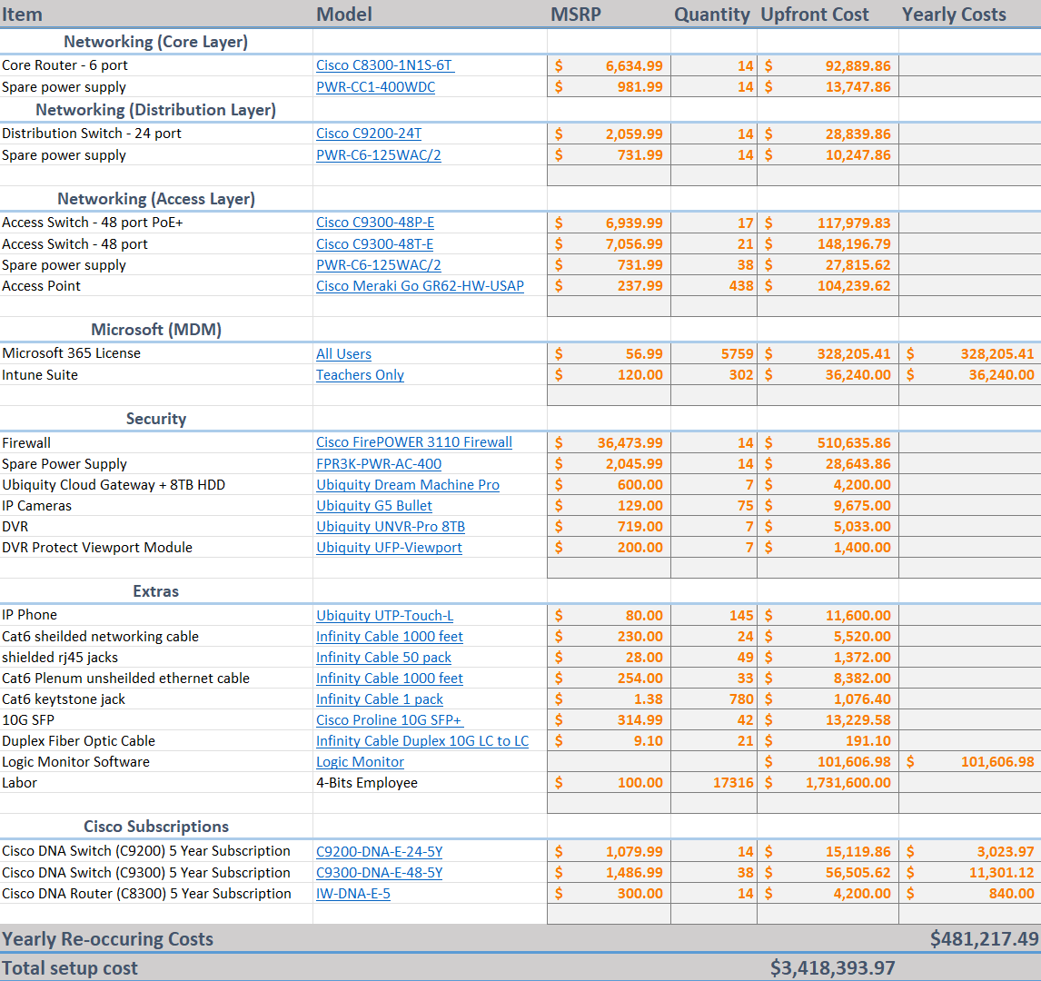

Table 3.
School Budget

Project timetable
The total project runtime is 10 months and 3 days with a start date of 11/30/2023 and an end date of 10/3/2024. The planning phase will take 81 days and covers procuring hardware, network design, budget analysis, and raising production changes. The implementation phase will start on 5/24/2024 alongside the start of summer break and end on 8/12/2024 right before school starts again. Lafayette will take the longest at 80 days and Church point, Ross, and Mamou will take 71 days. Each of the school network implementations will take place in parallel. The monitoring phase will start on 8/12/2024 and end on 10/3/2024. There will be an on-site consultation at each building and 30 days of monitoring. There is extended support for three years, ending on 7/25/2027. Looking at the specific school implementation for Benjamin Franklin High School, the implementation phase will take place over 82 days during summer break. The core and distribution layer implementation in the green section will take place in parallel. Similarly, the access layer and access points in the yellow section will take place in parallel. Each building will have an on-site consultation and follow up period for any further actions.

Table 6.
Project Planning Phase
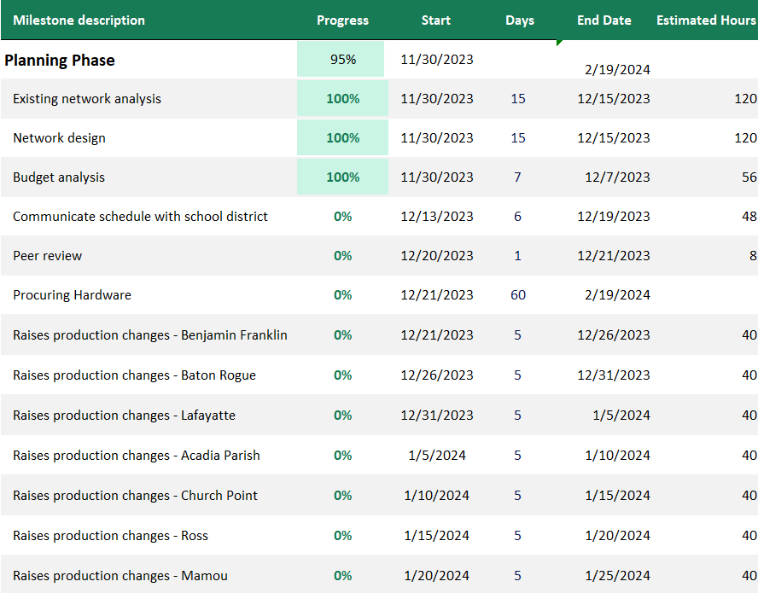

Table 7.
Project Implementation Phase
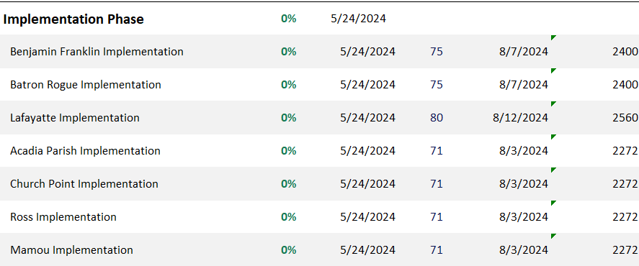

Table 8.
Project Monitoring Phase
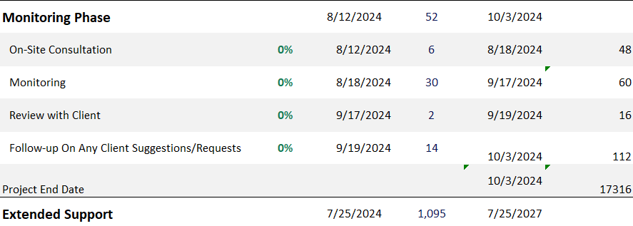

Table 9.
School Planning Phase
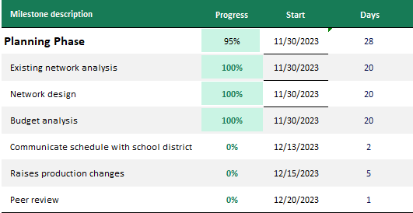

Table 10a.
School Implementation Phase
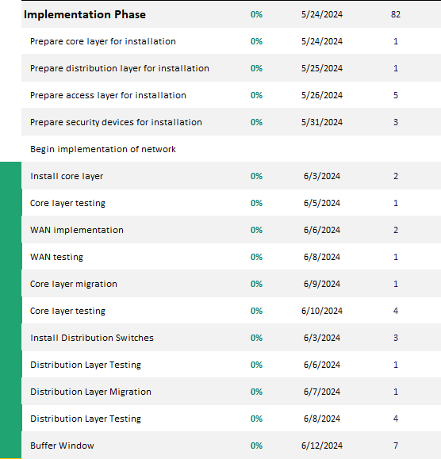

Table 10b.
School Implementation Phase
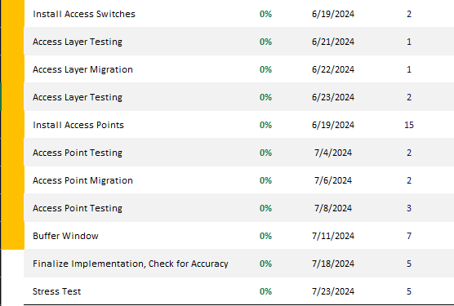

Table 11.
School Monitoring Phase
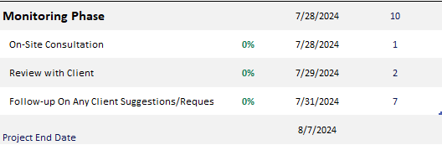

Future Improvements

While 4 BIT CONSULTING believes this is a robust plan, there is always more that can be added in the future. Virtual machines could be added to the device estate for class tasks that need more power such as programing or video editing. This could easily slot in with the current ecosystem by utilizing Azure Virtual Machines where you pay based on your usage, or the new Windows 365 devices that are a set cost.
We also recommend some infrastructure upgrades in the future. To add more reliability power backup on-site would be a good idea. This could be either on-site generators or battery backup allowing classes to continue in a power outage. We have supplied all schools with a camera system but there is more that can be done for security. We recommend installing a building access system that utilizes RFID. Ubiquity offers a system like this that will integrate with the camera system, and it can be used to audit who enters the building and when.

Contributions

Nick
Contributions: At the start of the project, I contributed to the research of the schools and the information needed for the formation of the network system. After that I worked on the maintenance and support section of the paper and presentation while also helping others of my group with any questions that they might have of the case study.
Lessons Learned: I learned that there is a lot of things that are needed when interacting with a school as you need to be able to fix anything for the school without interrupting the schools occupants. Whenever I was in school I know it would have easily distracted me quickly if someone that is not part of the class comes into the classroom or the school. This has been a great learning opportunity to find out the behind the scenes of what is needed to get technology networks up and kept running while not distracting the already distractable teenage or younger students from their schooling.
Sam
Contributions: My main contribution was planning out the Microsoft licensing. With this I made plans for how to use all the products. The main part of this was the MDM strategy for LDE. I also joined all group meetings and helped with the discussions on hardware selection. With the rest of the group, I worked on the paper and the presentation, particularly focusing on the assumption, Microsoft/MDM, and future recommendations sections.
Lessons Learned: There was a lot to learn with this case study. MDM is a huge topic, and while I know a large amount of it from work, I was able to expand on this knowledge. Particularly I learned a lot more about the licensing for this. This is also the first case study we have used a mixed vender solution and that took some learning to determine what we liked most about each vender.
Ryan
Contributions: I created the budget sheet and timeline. Within the budget sheet I tried to account for every cost that we would run into when implementing the proposed network. Likewise, there is an overview timeline and specific timelines for each school. I helped coordinate meetings and divide up the work among teammates.
Lessons Learned: I learned about how many companies do not have a redundant access point management system. We tried to go with cheaper vendors such as Ubiquity, Netgear, and tp-link but none of them had redundant systems. Even though Cisco was much more expensive, we needed them for the redundancy. I also learned all about fiber network cables and compatible SFP modules.
Joe
Contributions: I created the Visio network topology and gathered the routers, switches, Wi-Fi access points, and peripherals quantities for each school. I participated in all of the discussions and offered opinions and suggestions.
Lessons learned: Designing a network for a school was new, and trying to price the network out to be competitive was new as well.
Mike
Contributions: For this project my main contribution was working on and planning the network monitoring and ITSM software solutions. I went with the two that we chose due to the integration that they both have with each other and the ease of use and implementation of both. I also worked with the team on our paper, and PowerPoint presentation focusing on monitoring and ticketing software.
Lessons Learned: When it comes to working on and planning an RFP for a company there are a lot of things that need to be considered, including when you are looking at this from the point of a General Contractor and may need to include the costs of sub-contractors. Overall, this was an interesting case study, and I learned a lot.

References

Bibliography (Education)
Education, L. D. (n.d.). Department of Education. Retrieved from doa.louisiana.gov: https://doa.louisiana.gov/media/fbkdyrbj/departmentofeducation.pdf
Employees, M. (n.d.). Office 365 Education service description. Retrieved from Microsoft.com: https://learn.microsoft.com/en-us/office365/servicedescriptions/office-365-platform-service-description/office-365-education
Microsoft. (n.d.). learn.microsoft.com. Retrieved from learn.microsoft.com: https://learn.microsoft.com/en-us/

