Wintec conference 1, 2 December
This year's Jeanz conference is scheduled for Thursday 1 and Friday 2 December at Wintec's City Campus in Hamilton. The AGM will be held on the Friday. A JTO/Jeanz workshop day will be held on Wednesday 30 November.
The conference theme is: Education for the fragile craft: Teaching journalism during a time of rapid change. However the convenor, Charles Riddle, says papers are welcome on other topics. Abstracts should be sent to Jim Tully at Canterbury.
Convenor: Charles Riddle (Charles.riddle@wintec.ac.nz)
Secretary: Jeremy Smith (Jeremy.smith@wintec.ac.nz)
Abstracts: Jim Tully (jim.tully@canterbury.ac.nz)
Workplace training and media images diploma discussed at JTO meeting
There are 39 trainees currently signed up for the JTO's workplace training scheme, executive director Mike Fletcher told the March 2011 sector committee meeting in Wellington. The target is 30 new trainees for 2011. Jeanz Rep Bernie Whelan proposed a new Diploma in Media Images, combining videography and photography, a programme he said was driven by the demands of multimedia convergence.
Jeanz representative's minutes from the JTO meeting
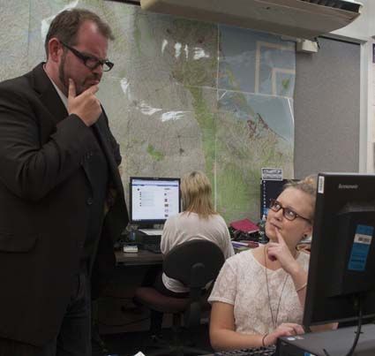
'Bomber' Bradbury in Wintec editor role
Newly appointed Wintec editor-in-residence, media man Martyn ‘Bomber’ Bradbury, is leaping into his role as mentor and advisor to this year’s journalism and communication students.
A noted political blogger and self-described media junkie, Bomber has been making a career in the industry for 20 years.
Head of the School of media Arts at Wintec, Margi Moore, said Bomber was a perhaps unusual editor-in-residence but his experience in alternative New Zealand media has given him a unique view of the industry as well as the ability to teach others.
He started his career in Auckland student magazine Craccum, eventually working his way up to editor. It wasn’t the smoothest run. At one point, after writing a satirical piece on the construction of nuclear bombs, Bradbury was hauled into the police station and held for questioning.
Bomber has hosted a night show on radio station Channel Z, was an executive producer on television network AltTV and was editor of music magazine Rip It Up. Now he hosts two news shows on Stratos TV, runs the blog Tumeke along with Tim Selwyn and can sometimes be heard on Radio NZ.
Bomber started his term by addressing a group of students about the media and gave tips on how to survive in a rapidly changing industry. His most urgent advice: get a blog going, sort yourself out some business cards and jump in with both feet. That’s the only way to make an impact in this contracting, cost-slashing business.
He predicted this is the year social media will become the most important tool in the journalist’s kit, especially in the upcoming election, and urged the students to get onto every form of social media to get involved in that debate.
“You have power through the internet to alter the mainstream opinion. You should be using it to provide information and a different viewpoint for readers.”
As part of Bradbury’s post he will be organising Wintec’s very popular Media Bites, a series of seminars that host media personalities from New Zealand, and this year possibly from overseas. It was at a Media Bites last year that Bradbury decided to go for the editor-in-residence post. (Story by Kushla Tunstall, pic by Claire Goldsworthy)
Caption: 'Bomber' Bradbury and Rachel Thomas
Call for papers for JMAD conference
The AUT-based Journalism, Media and Democracy Research Centre is inviting papers for a two-day conference in September entitled Political Economy of Communication.
Three leading international scholars in the political economy of communication will kick-start the conference: Graham Murdock, Janet Wasko and Dwayne Winseck are well known for their research and writing in the field.
Conference theme: There is a deepening symbiosis between capitalism and communication. Convergences across mass media, telecommunication and computer technologies have opened up new sectors of production and profit realisation. These same technologies also shape the networks of finance, production, symbolic representation and consumer culture. For scholars and policy makers such developments have generated concerns about regulation, cultural expression, ideological obfuscation and communication rights. Meanwhile, evolving information and communication technologies directly facilitate local-global activism against prevailing relations of power.
For more detail on themes and sub-themes or to register visit the conference site.
Abstracts are due by 31 May, 2011. Full papers are due by 31 July 2011. Email these to jmad@aut.ac.nz.
The JMAD conference earlybird rate $295, students $145.
Dates: Thursday, Friday 15-16 September, 2011. Venue: AUT – Auckland
Excellence in engineering journalism award
An award of $5000 is being offered to a journalist who has most improved the public's understanding of engineers or engineering. The journalism award is part of the wider NewZealand engineering excellence awards. Entries close on July 1. Sheridan Gundry won the award last year for a series of articles in a provincial newspaper that explained the nature of a large-scale wastewater treatment design and construction project for the local district council.
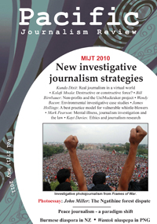
Investigators call for "UniMuckraker" J school collaborations
Two leading investigative journalists who are also media educators have called on university journalism schools to pool their top student resources to undertake investigative journalism projects. They have also appealed to journalism schools to work collaboratively across institutions and borders to target major investigations.
They present their case – including a proposal to set up a so-called UniMuckraker project for the Australia-NZ-Pacific region – in the latest edition of Pacific Journalism Review.
Australian Bill Birnbauer of Monash University, who is a member of the US-based International Consortium of Investigative Journalists, proposed the UniMuckraker strategy for collaboration with a joint multimedia website in an article examining non-profit foundations and their support for investigative journalism in the US. He says “absence of corporate interference, government control, daily deadline pressures, or the need to attract advertising” puts universities in a strong position to produce quality investigative journalism.
He provides a case study of a multimedia website set up at his university to investigate the “toxic legacy” of the Environmental Protection Agency in Victoria. Professor Wendy Bacon of the Australian Centre for Independent Journalism provides a series of case studies on collaborative environmental investigative journalism involving eight universities from Australia to Denmark.
One of the keynote speakers at NZ’s inaugural Media, Investigative Journalism and Technology (MIJT) conference hosted at AUT University by the Pacific Media Centre last December, Bacon says this was a “sign that universities in the Pacific region are growing as sites for innovation, discussion and production of investigative reporting as journalists and the public struggle to respond to a decline in old business models of journalism”.
The Australian investigators’ views were echoed by NZ investigative journalist Nicky Hager, who told the conference that investigative journalism needed to be “detached from the news media” to ensure its survival.
Editor David Robie said this edition celebrated some of the best investigative journalism in New Zealand and focused on strategies to strengthen probing reporting of the future.
Another keynote speaker, Nepali Times editor-in-chief Kunda Dixit, said in his article: “Dumbing down content undermines democracy. That is why we need to unleash the full power of investigative journalism.”
A selection of photographs from his Frames of War exhibition are featured in this edition of PJR.
Among other wide-ranging articles are an investigation into the Ngatihine forestry controversy in the 1970s by photojournalist John Miller.
Conference proceedings from the MIJT10 conference
More on current edition
Call for papers for the next edition
Pacific Journalism Review

