Timaru conference programme released
Planning is well in hand for the Jeanz conference in Timaru on December 2 and 3, and the combined JTO/Jeanz workshop on December 1. Members who have indicated they will attend but have yet to register are encouraged to do so asap. The conference will be held in the Godley block at Aoraki Polytechnic. The conference dinner is on December 2.
Conference programme and abstracts (pdf)
The combined JTO/Jeanz workshop on Wednesday December 1 will start at 9.30am. On the agenda are moderation, the L5 review, possible new units for NatDipJ, iwi radio and the foundation certificate.
The conference theme is "What editors want", encouraging educators to discuss whether they are delivering what industry wants. There will be plenty of opportunity for networking, and what better place than at Aoraki Polytechnic in Timaru, the centre of the Mainland.
Travel and accommodation
The local i-Site offers one point of contact to make your stay easy:
Timaru i-SITE Visitor Centre
2 George Street, Timaru
Ph: 03 687 9997. Free phone: 0800 484 6278
timaruinfo@southisland.org.nz
One venue the organisers recommend is Aspen on King for quality accommodation in a quiet setting located about 1km from the conference venue. Go to www.aspenonking.co.nz
There are direct flights into Timaru from Wellington (on what we call the flying pencil), or fly to Christchurch and hire a car (Christchurch to Timaru two hours). A courtesy vehicle will collect people from their accommodation each morning.
Registration
Registration fee is $150 (including dinner). Please use the registration form (pdf), or registration form (doc).
Contacts
Registration: Julie.katene@aoraki.ac.nz
Papers: jim.tully@canterbury.ac.nz
Convenors: peter.oneill@aoraki.ac.nz; janine.burgess@aoraki.ac.nz
Level 5 unit standards review discussed at JTO meeting
The unit standard on internet reporting has been referred to the industry for comment and updating, JTO executive director Mike Fletcher told the October 28 CMITO sector committee meeting in Wellington. Written four years ago, the unit was more about writing for the internet rather than using the platform for newsgathering. As well as the level 5 unit standards review the meetilng discussed the new external moderation programme, CMITO funding and the challenging conditions across the publishing and printing sectors.
Jeanz representative's minutes from the JTO meeting
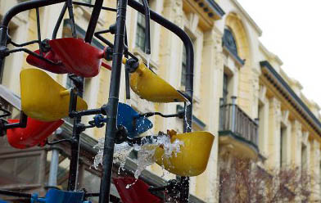
Expansion and new radio journalism diploma at Whitireia school
The Whitireia journalism and publishing school is being joined by the recently acquired NZ Radio Training School and the polytechnic's creative writing school to form the Whitireia NZ Media Training Centre. The new centre will open early next year at Whitireia's refurbished premises near the Bucket Fountain in Cuba Mall, Wellington. A new radio journalism diploma will be introduced next April.
Report from Whitireia (pdf)
Meanwhile, Virginia McMillan is leaving Whitireia Polytechnic after three years. She will return to freelance writing and sub-editing for health and business publications. Bernie Whelan will move to the National Diploma in Journalism (Multimedia) after successfully steering the new Certificate in Multimedia Journalism through its first year. An appointment for the certificate will be announced soon. Whitireia is currently seeking a tutor to deliver the new one-year level 5 Diploma in Radio Journalism.
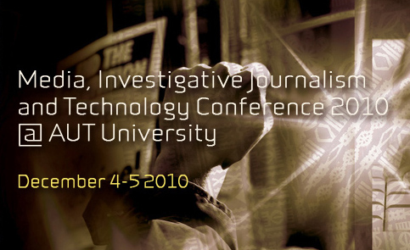
Barbara Dreaver joins speakers for investigative journalism conference
Television New Zealand Pacific correspondent Barbara Dreaver is the latest keynote speaker to join the Media, Investigative Journalism and Technology conference - New Zealand's first - at AUT University on December 4/5. She has broken many stories around the region and investigated many key issues.
She joins Kunda Dixit, editor-in-chief of the Nepali Times and an Asia-Pacific investigative journalist; New Zealand investigative journalist Nicky Hager; and Professor Wendy Bacon, director of the Australian Centre for Independent Journalism and who runs a global environmental investigative journalism programme.
As well as the main conference, the Pacific Media Centre is also hosting a masterclass in investigative journalism for student journalists and younger journalists facilitated by a team of international investigative journalists, led by facilitators Simon Collins and James Hollings, and a specialist peace journalism seminar organised by Dr Heather Devere of the National Centre for Peace and Conflict Studies and Rukhsana Aslam, a peace journalism educator from Pakistan.
Exhibitions of photojournalism by a collective facilitated by Kunda Dixit and New Zealand social issues photographer John Miller (featuring Ngatihine) plus workshops about groundbreaking documentaries by Jim Marbrook and Selwyn Manning are also part of the programme.
Conference flyer (PDF) Facebook link
Draft programme, keynote speakers, registrations etc: conference website
Conference chair: Associate Professor David Robie david.robie@aut.ac.nz
Conference organiser: Andrea Steward anj_steward@hotmail.com
When: December 4/5, 2010 Where: AUT University Conference Centre
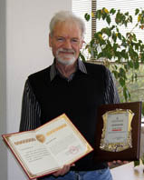
PJR wins global creative industries award
Pacific Journalism Review has won a Creative Stimulus Award for academic journals in the inaugural Academy Awards of the Global Creative Industries in Beijing, China, this month.
The journal, published by AUT University’s Pacific Media Centre and now in its 16th year, was one of five international journals to receive awards. Other journals honoured include the British-based International Journal of Cultural Studies.
Left: PJR managing editor David Robie with the award.
Full story
Pacific Journalism Review

