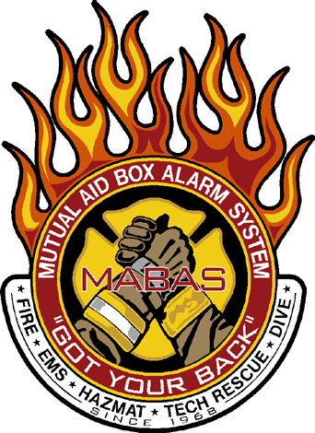
To: MABAS Division 2 Chiefs
From: A/C Bert Lancaster
Date: 10/14/10
Re: Special Teams Constitutions

Chief:
I have attached the updated special team constitutions for your review. We went back and looked over our training requirements that had noticeable differences between the teams and we came up with common training requirements between all teams. I feel that these constitutions will give the teams the needed framework to operate within the division. I would like you to use the month of October for your comment period, and if there are no major changes approval at the November Chiefs meeting with implementation January 1, 2011.

Sincerely,
Bert Lancaster

