WHEATON SWIMMING POOL 2017

1601 2nd Ave S - Wheaton, MN 56296 - 320/563-0649
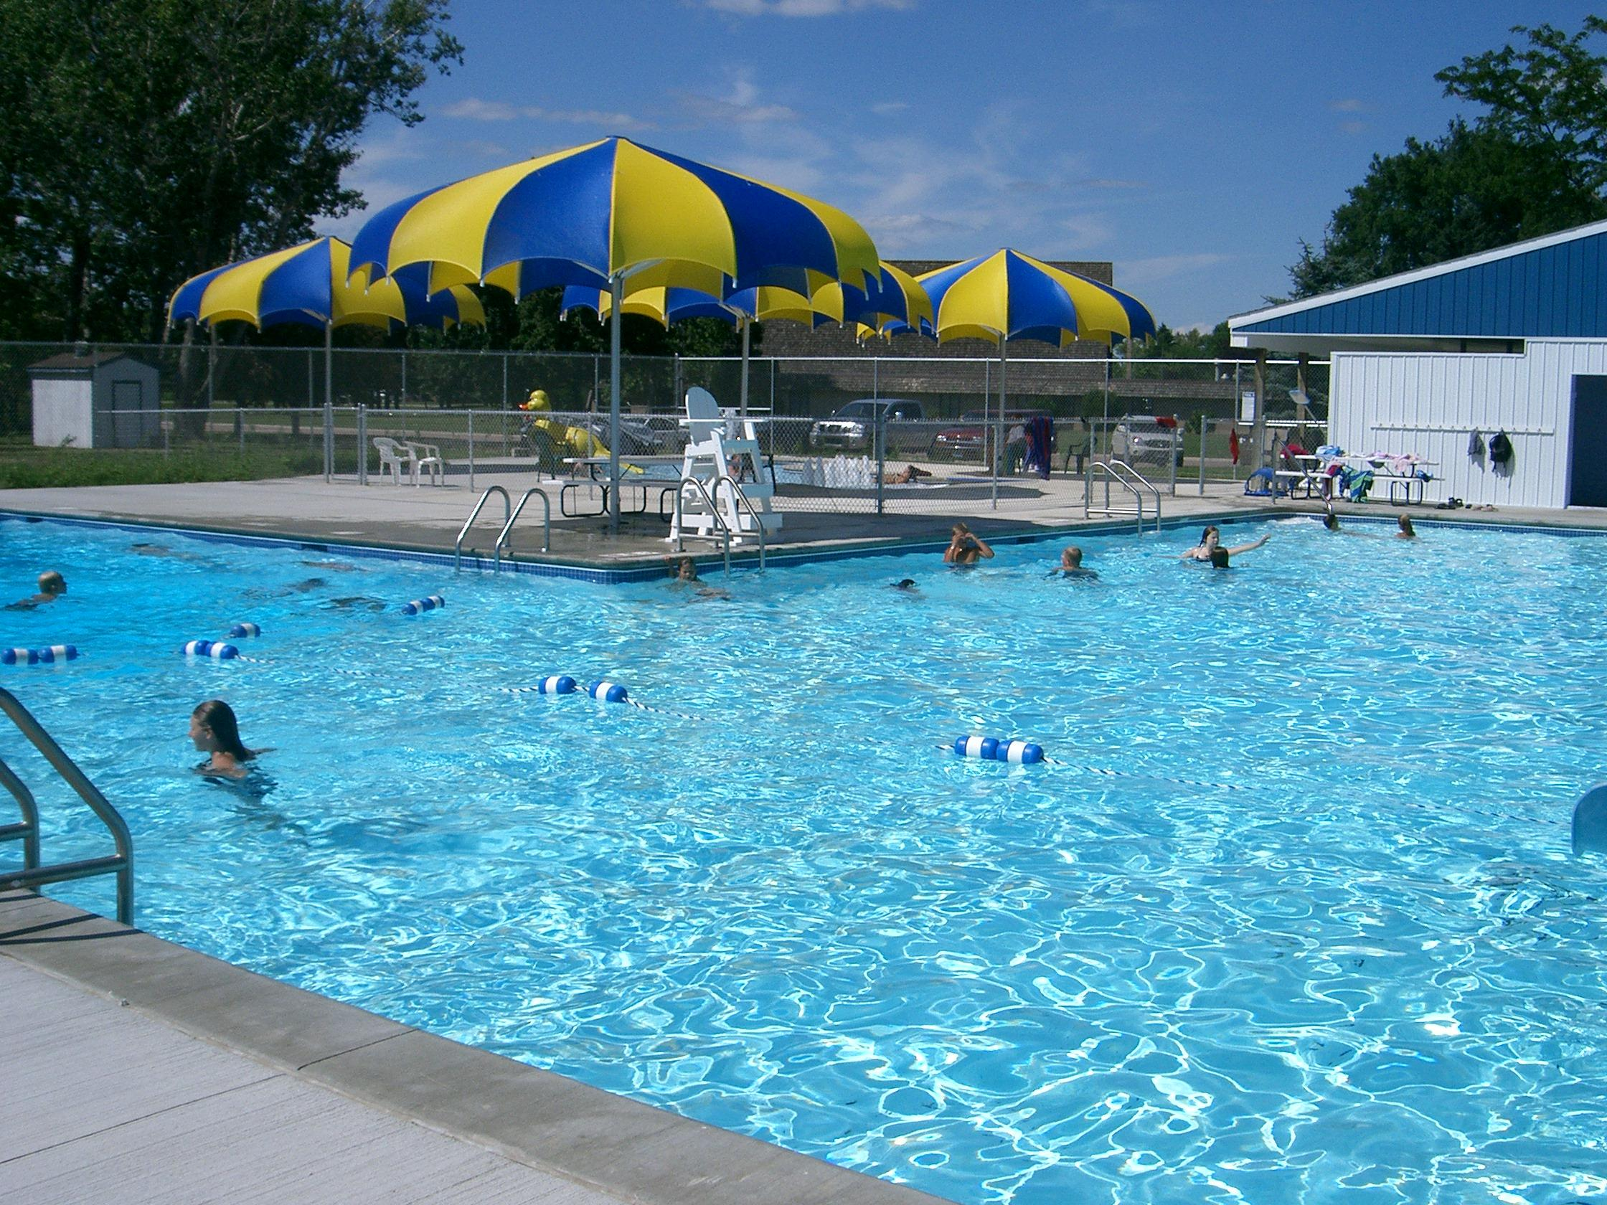
June 4th, 2018 – August 19th, 2018

OPEN SWIM HOURS:
JUNE & JULY Day Swim: 1:00 PM – 4:50 PM
Evening Swim: 7:00 PM – 8:50 PM

AUGUST Day Swim: 1:00 PM – 4:50 PM
Evening Swim: 6:30 PM – 8:20 PM
Dates and Times are subject to weather, and the attendance of at least 5 patrons.

NON-REFUNDABLE POOL FEES:
Day Swim Lap Pool, Splash Pool…………………………………………………………....$3.00,$2.00
Evening Swim Lap Pool, Splash Pool……………………………………………………....$2.00,$1.00

Individual Season Pass $40.00
Family Season Pass $80.00
The Wheaton Parks & Recreation Board policy defines “family” as one or two parents or legal guardians, and their dependents (up to age 21) who live at the same household, and one sitter/childcare provider over the age of 15 years.
Individual Week Pass $20.00
Family Week Pass $35.00

Group American Red Cross Swimming Lessons $25.00 First Child, $24.00
Second Child; $23.00, Third Child, etc.
Private American Red Cross Swimming Lessons $100.00 Per Child,
Dependent Upon Instructor Availability

Aerobics $3.00 per Session
Pool Party $75.00 for 2 hrs, $37.50 for 1 hr

AMERICAN RED CROSS SWIMMING LESSON INFORMATION:
Session I Monday, June 18 – Friday, June 29
Session II Monday, July 9 – Friday, July 20
Session III Monday, July 23 – Friday, August 3

Level I Introduction to Water Skills (Tadpoles), 4yrs or older 11:30 - Noon
Level II Fundamental/Aquatic Skills (Turtles) 11:00 – 11:30
Level III Stroke Development (Sharks) 10:00 – 11:00
Level IV Stroke Improvement (Whales) 9:00 – 10:00
Level V Stroke Refinement 10:00 – 11:00
Level VI Skill Proficiency – Personal Water Safety 9:00 – 10:00

LESSON REGISTRATION:
- Lesson Registration should be brought to: Wheaton Pool beginning May 28th, from 1-3 pm M-F, or mailed to Wheaton City Hall, PO Box 868 Wheaton, MN 56296; Registration form can be found online at www.cityofwheaton.com.
- Payment is due at the time of registration, or by the first day of lessons.
- Lessons must be taken in-sequence, and students may only take one class per session.

CITY OF WHEATON
PO Box 868
Wheaton, MN 56296
Phone: 320/563-4110 Fax: 320/563-4823


2018 WHEATON SWIMMING POOL LESSON REGISTRATION

STUDENT INFORMATION
Last Name |  | First Name
Mailing Address
City |  | State |  | ZIP
Parent’s Name |  | Telephone # to Reach Parent, in case of inclement weather

lesson information
Please Select One:
◻ Session I Monday, June 18 – Friday, June 29
◻ Session II Monday, July 9 – Friday, July 20
◻ Session III Monday, July 23 – Friday, August 3
◻ Other Private Lessons, upon availability. Please provide parent’s email
address and parent will be contacted to schedule the lessons:
___________________________________________________________________

Please Select One:
◻ Level I Intro. To Water Skills (Tadpoles), 4yrs or older 11:30 - Noon
◻ Level II Fundamental Aquatic Skills (Turtles) 11:00 – 11:30
◻ Level III Stroke Development (Sharks) 10:00 – 11:00
◻ Level IV Stroke Improvement (Whales) 9:00 – 10:00
◻ Level V Stroke Refinement 10:00 – 11:00
◻ Level VI Skill Proficiency – Personal Water Safety 9:00 – 10:00

If you are not sure which class your child should take, please contact the City Pool at 320/563-0649, or by email to cityhall@cityofwheaton.com

lesson fees
Payment is due at the time of registration, or by the first day of lessons.

Group American Red Cross Swimming Lessons $25.00 First Child
$24.00 Second Child
$23.00 Third Child, etc.
Private American Red Cross Swimming Lessons $100.00 Per Child, Dependent Upon Instructor Availability

Please return this form to: Wheaton City Pool, PO Box 868, Wheaton, MN 56296

