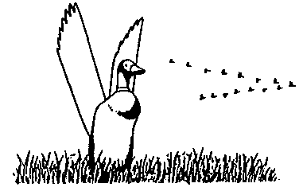

city of wheaton

Skating Rink Attendant, Temporary, Seasonal Position

Division/Department |  | Parks & Recreation
Job Title | Skating Rink Attendant
Reports to |  |  | Skating Rink Supervisor
Pay Range  Minimum Wage - $8.00, depending on qualifications  $9.50, if over 18 years old |  |  |  | Type of position:  Full-time  Part-time  Contract  Intern | Hours 10 - 30 / week  Exempt  Nonexempt  Dec – Feb, weather permitting. After school, evening, weekend, and school break hours will be available, in coordination with the schedule set by the Rink Supervisor.

Summary:
Rink Attendants are responsible for the daily operation of the Wheaton Skating Rink at Falk Park.

Duties, responsibilities, and expectations:
- Open, attend and close the skating rinks, Falk Lodge and/or Warming House.
- Maintain clean and orderly facilities (including Falk Lodge and Warming House): sweep, vacuum, wash floors, clean bathrooms (including sinks and toilets), wipe down tables, carry garbage to dumpster, etc.
- Sell concessions.
- Supervise skaters: assist young skaters, support skater safety, enforce facility rules and disciplinary measures, aid in cases of injury (contact emergency services, if necessary)
- Maintain skates: clean and organize.
- Track equipment (skates, sticks, pucks, etc.)
- Document skating attendance, injuries, concessions, etc.

Knowledge, skills, and abilities:
- Must be 16 years of age or older.
- Must be trustworthy, responsible, organized, and have leadership abilities.
- Ability to make change and record sales.

working conditions:
- This position will be required to work outdoors during cold weather; employee must dress for outdoor weather work conditions.
- Must be able to physically complete the duties as assigned
- May be required to lift up to 25 lbs.

