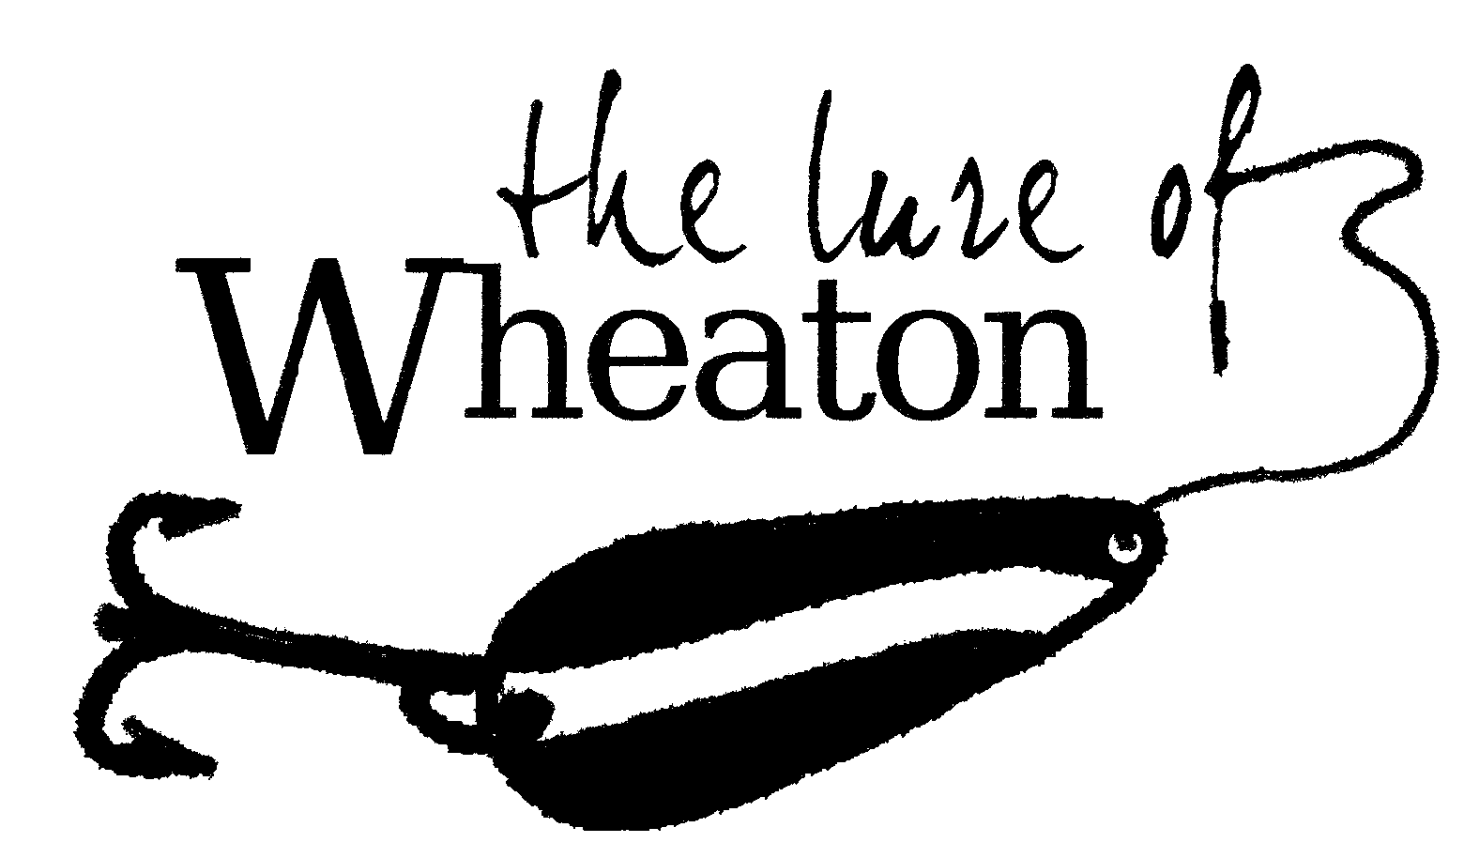
Wheaton Clean-up Day

In an effort to help and encourage residents to improve the condition and appearance of their properties, the Wheaton City Council has designated
Tuesday, June 8, 2021 as Clean-Up Day for the City of Wheaton,
From 2 pm – 7 pm.
Demolition slips must be completed and brought with you on Clean-up day. No material will be accepted without the appropriate documentation.
Please stop by city hall or print the slip from our website www.cityofwheaton.com

- Residential materials only; no contractors.
- Please be prepared to provide proof of Wheaton City residency, with a current driver’s license or utility bill.
- Materials may be brought to the Demolition Site (East End of Falk Park) on Clean-Up Day.
- NO GARBAGE WILL BE ACCEPTED. Plastic Items are considered garbage.
- Please be prepared to un-load your own materials

Materials Accepted at Clean-Up Day

Please Check All that Apply

- Furniture
- Electronics
- Leaves, Tree Trimmings, Grass Clippings, and Brush
- Mattresses
- Metal Goods (including appliances)
- New Construction Remnants
- Gypsum board
- Roofing material
- Insulation materials
- Plastic Siding and metal building parts
- Glass
- Concrete
- Masonry material
- Renovation Debris
- Carpet
- Untreated wood
- Masonry
- Bricks
- Rock
- Bituminous concrete

Materials Not Accepted on Clean-Up Day
Tires, Batteries, Paint, Chemicals, Pesticides, Plastic items, Garbage and Rubbish

Clean-Up Day Rules
The goal of Clean-Up Day in the City of Wheaton is to encourage and help individual residents improve the appearance and condition of their properties. In order to ensure that Clean-Up Day is a productive, effective, beneficial event, participating residents must follow these rules:

- Proof of Wheaton Residency is required – a current utility bill or driver’s license, that identifies your Wheaton city address, must be shown upon entering the cleanup day site.

- Clean-Up Day is intended for residential waste; no contractors.

- When loading your vehicle or trailer, please sort materials into piles of furniture, appliances, brush/lawn clippings, tree limbs, and demolition/construction debris.

- To ensure safety, no children will be allowed outside of personal vehicles.

- To protect public property and comply with Minnesota State regulations, no household hazardous waste, paint, pesticides, chemicals, motor oil, tires or batteries will be accepted.

- Staff and volunteers may make an on-site determination that individual items will not be accepted.

- Please feel free to contact our office ahead of time, if you are uncertain whether a particular item can be brought to Clean-Up Day. Review the List of Materials that will be accepted and denied.

Frequently Asked Questions
- If I am unable to come to the Cleanup Day, will you let me bring
items at no charge on another day?
No. Wheaton residents may bring items to the Demolition Site during its regular hours or by appointment and the regular fees will be charged.

- Is this event for City of Wheaton residents only?
Yes, and proof of residency is required. A current driver’s license or a utility bill, that shows your Wheaton city address, must be shown upon entering the cleanup day site.

- Will you accept old paint or motor oil at the cleanup event?
No, these items are collected by Traverse County, who coordinates their own pickup events.

4. We are remodeling our home; will you accept old carpeting, flooring, kitchen sinks, countertops, etc, at the cleanup event?
Yes, the cleanup event is a city-wide beautification effort to encourage citizens to cleanup around their homes and bring us their hard-to-get-rid-of items, such as: old carpet, appliances, scrap metal, whole tree limbs, old fence panels, old lawn mowers (please drain fuel), lumber, concrete, brick, and furniture.

5. Will you recycle any of the items received at the cleanup event?
Yes, with the help of Hormann’s Recycling, we will salvage as much material as possible.

6. Where can I bring tree limbs and brush?
Tree trimmings and grass clippings can be deposited in the designated bunkers at the Demolition Site, free of charge, at any time.

7. If it rains, will Clean-Up Day be rescheduled?
No, the event will be held rain or shine. We may have to limit what is taken up to the actual site, but we will issue vouchers.

Due to Covid-19 Public Works will NOT be unloading for you. Please be prepared to unload yourself!

You will need to unload your items in the following order!
Stop 1. Furniture Stop 2. Demo
Stop 3. Electronics Stop 4. Metal

I have read and understand the above:

Signature

