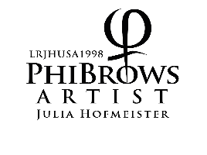
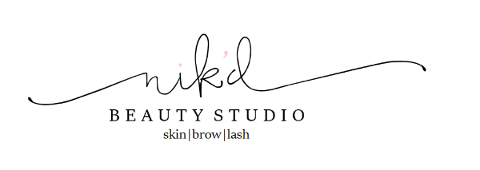
What is microblading?

INTRO:
Phibrows is a manual skill of semi-permanent eyebrow drawing. Shape of the eyebrows is calculated according to the golden intersection (phi 1.618) and face morphology. The pigment is applied into the surface layer of the dermis using sterilized tools. This is an advanced brow technique whereby a row of superfine needles in used to create the thin, hair-like strokes on the skin. The pigment is chosen so to match the natural hair or eyebrows color. These precisely placed, hair- like tattoo strokes mimic the growth of the natural hair direction creating natural and defined brows with a hyper-realistic look.
After the healing, the color may become several hues lighter that the natural hairs’ color. Symmetry is achieved through PhiBrows application and it is calculated while the clients’ eyes are closed because in that way mimetic muscles that can affect eyebrows’ symmetry are relaxed. When a client has very few natural hairs, manual technique is combined for shading in order to get shadows that improve the volume. The combination of both techniques is called PhiFusion or microblading + manual shading. Treatment is performed with disposable sterile tools (PhiBrush), and pigments are produced in accordance with the highest standards (PhiBrows microblading pigments). Touch-up is done a month after the treatment, because between 10 and 15% (and sometimes more) of drawn strokes disappear after the first treatment. Color is extremely dark during the first 5 to 7 days. After this, it loses 40 to 50% of its intensity. If you think the color is too dark, do not try to remove it yourself by any means. Patiently wait 7 days for the color to fade on its own after the healing of the skin. Color duration primarily depends on how oily the skin is. The oilier the skin, the shorter the color lasts. Sweating and sun exposure also reduce color fastness. On average, suggested time until a new color refreshment is between 10 and 12 months. With oily skin it is up to 6 months. The healing is fully completed after 28 days and this is when we perform an obligatory addition of the pigment that has been lost (touch up). With problematic and oily skins, we can have several additions (corrections). Post-treatment flow makes 70% of the treatment’s success. Conscientiously obey advice, because if you don’t do so you may lose up to 80% of drawn strokes. Rinsing and applying creams is of great importance. Pain during the treatment is relative. Scared clients and clients who are on their menstrual cycle usually feel stronger pain, while the other clients compare the pain to the one they feel when tweezing eyebrows. We use topical anesthetics in form of cream or liquid that can entirely eliminate the pain before and during the treatment.
The success of the treatment depends on the: skin quality, post-treatment flow and care, exposure to different external factors- All of these factors are out of the artist’s control, so any possibility to provide guarantees for the treatment is excluded. PhiAcademy guarantees their artists for their quality and experience.

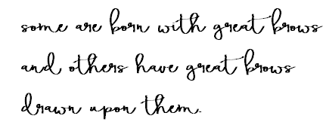
MORE FAQ:

Who is not a candidate for microblading?*
*A Consultation and SIGNED consent form including all contraindications will be necessary before performing any microblading procedure.
-Those under the age of 18
-People with diabetes- doctors consent must be provided
-People with glaucoma and people who are taking blood thinners (e.g., aspirin)
-People with skin diseases such as psoriasis, extreme eczema, and undiagnosed rashes or blisters on the site that is to be treated
-People with allergies to makeup or pigments
-People with allergies to topical anaesthetics including betacaine, lidocaine, and tetracaine
-Those with easily triggered post-inflammatory hyperpigmentation
-Active skin cancer in the area to be tattooed
-Are a hemophiliac
-Have healing disorders, on blood thinners, uncontrolled high blood pressure or had mitral valve disorder
-Those on any skin medication such as ro-accutaine, steroids which thin and oversensitive
-Tendency to keloid scar
-Flu or cold- please reschedule if you have a cold, flu, or respiratory infection
-Cancers/Chemotherapy- doctor's clearance will be necessary
-Juvederm or other fillers- ask your juvederm tech for clearance
-Shingles- If you have shingles on your face, wait several months to get permanent makeup
-Any cold sores on the face
-Any visible skin conditions in the brow area including eczema, psoriasis or severe acne
- existing permanent makeup that is not 70-90% faded

Get familiar with the post-treatment flow thoroughly before the treatment. Before Treatment The skin must not be in the inflammatory process or the process of healing and regeneration before each treatment.

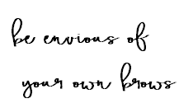
The following treatments are not recommended 30 days before the treatment:
• botox and fillers
• fruit or milk acids
• laser treatments
• chemical peelings
• exposure to strong sunlight

Why choose microblading?
-No longer do you have to worry about running out the door without your brows on, wiping them off during an intense workout session, or purchasing every single brow product on the market. Together with your microblade artist, create your dream brow.

This advanced technique has many benefits:
-Create a whole NEW brow look. Fuller and more even
-Fuller brows create a more youthful look, instantly take years off with this procedure
-Takes time off your morning makeup routine
-Sweat proof waterproof smudge proof

What is the process of microblading?
Consultation and brow design (30 minutes)
Together we will shape and design a set of brows to enhance your natural facial features. You will make changes as you wish and approve the final shape before we begin Microblading. Pigment colors are mixed and matched to complement your natural hair color.
Numbing (30 minutes)
A topical anesthetic (5% lidocaine ointment) is applied for 30 minutes PRIOR to the procedure to ensure maximum comfort. During the process a SEPARATE numbing agent is used to enhance numbing effects.
Microblading (35-45 minutes)
Precise hair strokes are placed within the brow design using a super fine, disposable blade. The needles on the blade are three times finer than a normal tattoo needle.

Microblading is a two step process
Results will vary from person to person depending on skin type and color used. Each person’s retention will vary slightly. Individuals will require 2 (sometimes 3) sessions to perfect their brows. This will ensure that we assess and correct any spots that may have scabbed off, or healed imperfectly.

Does it hurt?
It's the number one question. Pain tolerance varies from person to person. Two SEPARATE numbing gels are used, one prior and one during the entire procedure to ensure comfort. Clients have related the procedure with eyebrow threading, plucking multiple hairs at once, or a light scratching of the skin. (Average 2 on a 10 scale)

Can I do this if I am pregnant or breastfeeding?
No. If you are pregnant or breastfeeding, it is suggested that you wait until you are no longer pregnant or breastfeeding.

Do I shave my natural brow hairs?
No. You will want to keep all of natural brow hair you have as we incorporate that to blend with the microbladed strokes. Any stray hairs that are outside the brow design will be removed.

What will it look like and feel like after the procedure?
Temporary redness is minimal and some swelling may occur. Clients can return to work after the process. After the numbness wears off there may be a slight discomfort in the area similar to a sunburn. The eyebrows will appear darker and crisper in the days following the treatment (3-5 up to 7 days). Some flaking may occur and the strokes may lighten by 40-50%. A perfecting session should be scheduled 4-6 weeks after initial procedure.

How long does it take to heal?
It takes about 2 weeks for the superficial layers to heal. The deeper layers will take about 6-8 weeks to fully heal. The first 3-5 days will appear darker, but around day 4 or 5, strokes will appear much lighter and softer.

What will my healed brow look like?
No two brows are alike. There are no guarantees and results will vary from client to client depending on skin type, lifestyle, and immediate and long term after care. Your follow up perfecting session will help ensure your desired brows.

How long will it last?
Microblading may last 12-18 months depending on after care, lifestyle, sun exposure, and skin type. We suggest a color boost at 10-12 months and sooner for oily skin types.

Results vary from person to person.
After care products and information will be provided.
Be PATIENT with the process and it will be worth it!
