Cathartic Arts CIC Complaints Policy - 16th August 2023
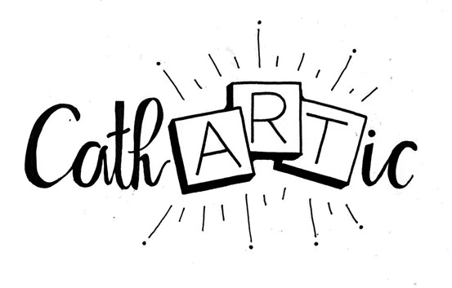

1. Introduction
Cathartic Arts CIC aims to provide a high-quality, responsive service. We welcome every opportunity to monitor and improve the services we provide and having a ‘complaints and compliments’ policy and a clear procedure for resolving complaints is one way of doing this.
This policy covers complaints and compliments relating to the service provided by Cathartic Arts CIC.

2. Complementing our service
Compliments are valuable, welcome and important and when they are received, either verbally or in writing, they will be recorded. Compliments enable us to:

- understand that our service is being provided to the satisfaction of all third parties
- provide positive feedback to our staff
- influence our organisational and service development
- inform our quality assurance programme
It is good practice to acknowledge any compliments received.

3. Complaining about our service
We define a complaint as a situation or instance where either an individual or organisation considers that Cathartic Arts CIC has fallen short of their reasonable expectations and wishes to express dissatisfaction.
We do recognise that there will be times when we make mistakes and/or get things wrong. In order to learn from such mistakes the Directors need to know about these mistakes and encourage people to comment or complain.
Such comments or complaints will always be taken seriously, recorded or responded to as set out in the procedure which forms part of this policy. We recognise that we can learn from our mistakes and improve our service from the learning we capture in the process.
4. Procedure for resolving complaints
Stage 1
We hope that the majority of complaints can be resolved informally by speaking directly to the person or persons involved. If, however, this does not prove possible Stages 2 and 3 are available to support complainants.
If it has not been possible to resolve your complaint at Stage 1 you should move to Stage 2.

Stage 2
We take all complaints seriously and aim to resolve complaints quickly, fairly and effectively. We promise to deal with your complaint sensitively.
We ask all complainants to put their complaint in writing and send this, marked Private & Confidential, to:-
Cathartic Arts CIC
Oak Yard
Rear of 131, Queens Road
Watford
WD24 7ND

or
complaints@catharticcic.com
Following receipt of the complaint an initial assessment will be made.
Timescale:
Your complaint will be acknowledged within 5 working days of receipt. Wherever possible, we will provide a full resolution of your complaint at the same time.
Where your concerns require us to undertake further investigation, and we are not able to provide a full resolution as part of our initial response, we will, within 3 working days of receipt, provide you with an expected timescale for our response and keep you up to date at regular intervals throughout our investigation. We will also tell you who is managing your complaint so you have a point of contact should you need to get in touch with us. You should expect a full response from us within 15 working days from the date we received your complaint.
In order to assist us with our investigation, please provide your contact details and explain your concerns as clearly and as fully as possible. There may be some occasions where we need to seek further information from you in order to investigate your concerns fully and if this is the case your kind response will enable us to resolve your complaint as promptly as possible.
If you are not satisfied by the response at Stage 2 you should move to Stage 3.
Stage 3
If you continue to have concerns you can ask us to review your complaint. At Stage 3 your letter will be acknowledged within 5 working days of receipt and we aim to provide a full written response within 20 working days. If this timeframe is delayed because of annual leave or sickness absence you will be informed of this when your complaint is acknowledged.
This is the final stage in the complaints and compliments procedure. If, following completion of Stage 3, you are still not satisfied this does not affect your right to take the matter further.

5. Monitoring of Complaints
All complaints will be recorded regardless of whether the complaint was meritorious or not. This is to enable Cathartic Arts CIC to analyse the complaint to determine what actually happened or what could potentially have happened arising out of the issues of which the complaint was made.
Complaints reports will provide an overview of the complaint and how it was resolved. The report will also set out the findings and recommendations for measures to be taken to prevent further complaints of this nature or to improve/adapt/adjust our services to minimise the likelihood of any further complaints.
Quarterly reviews of any complaints received will be carried out to identify any emergent trends or patterns. If patterns or trends do emerge, this will be recorded and will be considered by the Directors. Measures will be identified to prevent further complaints or minimise the likelihood of such complaints and to continually improve our services. This may include, but is not limited to, adapting paperwork and procedures and carrying out additional training.

6. Review
This policy will be reviewed on an annual basis to check its effectiveness.

Cathartic Arts CIC- 07838176466 / complaints@catharticcic.com

Hertfordshire County Council:
Complaints Manager Neuza Mendonca (Complaints Manager) acs.complaints@hertfordshire.gov.uk
01992556685

Ombudsman -
Telephone - 0330 440 1614

- Communications Ombudsman
P.O. Box 730
Warrington WA4 6WU

Email - enquiry@commsombudsman.org

