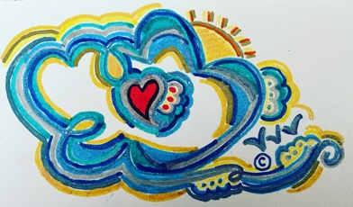
The 50/50 Artist Consignor/Consignee Inquiry Form

This is an application form for the Artist (your First & Last name here)_________________, who is an artist in the practice of (type of art: clay, jewelry, paint, wood, etc)________________. He/She (circle one) is applying for one of the consignor positions on the company website for Puffy Cloud Creations, LLC, at online address, www.puffycloudcreations.com.

If accepted, the Artist/consignor will be given one page which will link to the shop. Customers, family and friends of the Artist/consignor can visit the artist’s page/link in shop to purchase their items. The artist will receive complimentary business cards from Puffy Cloud Creations, which lists the Puffy Cloud Creations site, along with the artists page, for clients to purchase directly from the Artist. These business cards can be used by the Artist/consignor at their place of business, at craft fairs, etc.

Building the page and the design of the page, as well as any photos etc, are all at the discretion of the Puffy Cloud Creations, LLC company. Once accepted, the Artist e-mails or mails (by post) up to 100 photographs/images of products for sale, a pet/company mascot, their logo- anything that the artist feels represents their company.What is used is always at the discretion of the PCC company. Before the page is published, a ‘mock’ page is sent to the Artist for final approval.

All correspondence can be discussed by e-mail at PuffyCloudCreations@gmail.com, or by text/phone at (516) 419-9242. We can also be reached by post at 425 N Broadway, Unit #332, Jericho, NY 11753.

Here’s How It Works:
This form is not an automatic acceptance of any Artist. Please fill out this form and submit 10-20 of your best Artist examples of your work. If we feel your artwork is a good fit for the site and we don’t already have our quota for that genre filled (for example we don’t need more than 4-6 photographers) then we will move to the next stage- Approval!

We will contact you by either e-mail, text or post, whether we’ll approve you or not. If you’re approved as an artist, we’ll ask for a Zoom interview. Once in the Zoom interview, we’ll fill in any details that you have questions about & move further. If you’re not approved, don’t despair, we’ll just ask you to re-apply in 3-6 months time!
Good luck & we can’t wait to see your work!
- Name (Last, First): _______________________DOB:________________
- Address:____________________________________________________
- Amt of Examples Submitted:_____Company Name:_________________
- E-mail:___________________________________

