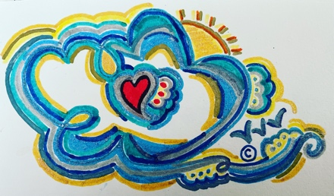
PUFFY CLOUD PUBLISHERS RETURN FORM
Please Note: This form is for returns/exchanges associated with any physical purchases from Puffy Cloud Publishers only. Any digital purchases from Puffy Cloud Publishers such as e-editions (if applicable) or any digital purchases from Feather Pen Freelance and/or Invisible Ink Creations can be dealt with by referring to our rules under Terms & Conditions @ the bottom of any page on our site.
* This form must be included with all returns/exchanges *

PRIOR TO FILLING OUT THIS FORM, PLEASE ENSURE THAT THE ITEM YOU ARE RETURNING/ EXCHANGING IS IN THE SAME CONDITION AS WHEN YOU RECEIVED IT. WE DO NOT ACCEPT ITEMS IN LESSER CONDITION. WE ASK IF THE ITEM IS IN LESS THAN NEW CONDITION ( marked pages, spine cracked, torn, etc) AND YOU DO NOT WANT THE ITEM, PERHAPS CONSIDER DONATING THE ITEM TO A LOCAL CHARITY/CHURCH. WE APOLOGIZE FOR ANY INCONVENIENCE.

IF THE ITEM IS WITHIN THE 30-DAY GRACE PERIOD, YOU WILL RECEIVE YOUR MONEY BACK BY WAY OF VENMO OR APPLE PAY. WE ALLOW ONE OR TWO DAYS PAST THE 30. HOWEVER, IF PAST THIS TIME, YOU WILL RECEIVE A COMPANY GIFT CARD FROM US TO BE USED ON ANY OTHER PRODUCT FROM OUR ONLINE SHOP, WITH NO EXPIRATION. IF YOU DON’T SEE ANYTHING RIGHT AWAY, PERHAPS YOU MIGHT IN FUTURE- AS BOOKS WILL BEGIN TO PRINT & POST FOR SALE EVERY FEW MONTHS, AND NEW FREELANCE JOBS WILL ALSO OPEN IN THE MONTHS TO COME. ALL REFUNDS/STORE CREDIT IS ALWAYS MINUS RETURN SHIPPING IF APPLICABLE. IF EXCHANGING, SHIPPING IS DEDUCTED FROM TOTAL CREDIT.

Name (Last, First): _________________________________
Address (Street, Town, State, Zip): _________________________________________________
______________________________________________________________________________
Is this is a Return, Exchange or Store Credit? ______________________________
Original Purchase Date (Please Attach Reciept or Copy of E-Mailed Confirmation if Available): ______________________________________________________________________________
If this is a return, why are you returning ? Is there any way we can correct this issue for you? You can reach us @ PuffyCloudPublishers@gmail.com or call/text us (516) 419-9242 __________________________________________________________________________
If this is a return within 30-32 days, do you prefer Venmo or Apple Pay for return? Please note: Any refund is always minus one-way return shipping/buyer pays return shipping. ____________
What is your Venmo name, if applicable._____________________________________________
If an exchange, what are you exchanging for & why? __________________________________
PLEASE fill out this form & mail with your item to : Puffy Cloud Publishers, 425 N Broadway, Unit # 332, Jericho, NY 11753

