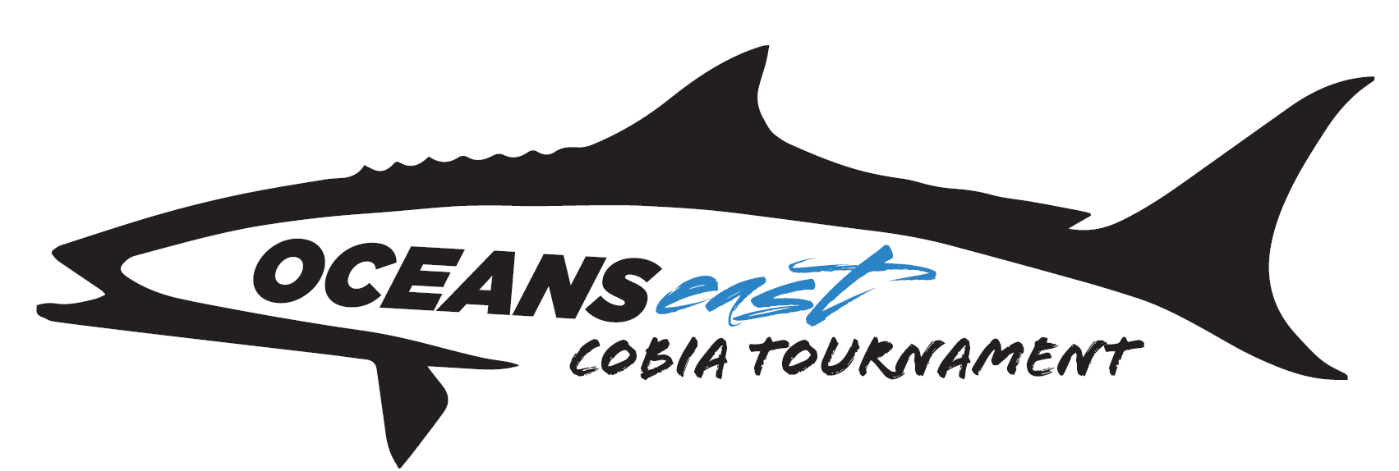

Oceans East Cobia Tournament Structure

Base Entry Dates ~

May 19TH: __________(300.00) May 20TH: __________(300.00) May 21ST: __________(300.00)

Overall Tournament Payouts~ 50/30/20 spit ~ Two fish Stringer

Trophies will be awarded to the top 3 boats

Calcutta’s (Optional)

Big Fish Daily ~ Each day pays to 2 places ~70/30 split

May 19TH: __________(200.00) May 20TH: __________(200.00) May 21ST: __________(200.00)

Stringer Daily (Level 1)~ Each Day pays to 2 places ~ 70/30 split

May 19TH: __________(200.00) May 20TH: __________(200.00) May 21ST: __________(200.00)

Stringer Daily (Level 2)~ Each Day pays to 2 places ~ 70/30 split

May 19TH: __________(300.00) May 20TH: __________(300.00) May 21ST: __________(300.00)

Jr. Angler Division

~ Single largest Cobia caught overall by a Jr. angler will receive a 250 dollar prize package.

Female Angler Division

~ Single largest Cobia caught overall by a female angler will receive a 250 dollar prize package.

