Sunday | Monday | Tuesday | Wednesday | Thursday | Friday | Saturday
Cold Cereal of choice or  Hot Cereal  Eggs  Raisin Toast  Coffee Cake  Milk/Beverage | Cold Cereal of choice or  Hot Cereal  Toast  Eggs  Waffles w/Bacon  Milk/Beverage | Cold Cereal of choice or  Hot Cereal  Toast  Eggs  Milk/Beverage | Cold Cereal of choice or  Hot Cereal  Toast  Ham & Cheese Omelet  Milk/Beverage | Cold Cereal of choice or  Hot Cereal  Toast  Eggs  Milk/Beverage | Cold Cereal of choice or  Hot Cereal  Pancakes w/fruit topping  Eggs  Toast  Milk/Beverage | Cold Cereal of choice or  Hot Cereal  Toast  Eggs  Milk/Beverage
Soup of the Day  Roast Turkey  Mashed Potatoes  & Gravy  Green Bean Casserole  Cranberry Sauce  Bread/Roll  Cherry Bar &  Ice Cream  Milk/Beverage | Soup of the Day  Chicken Parmesan  Mediterranean Blend Veggies  Cucumber Salad  Bread/Roll  Apple Crisp  w/Ice Cream  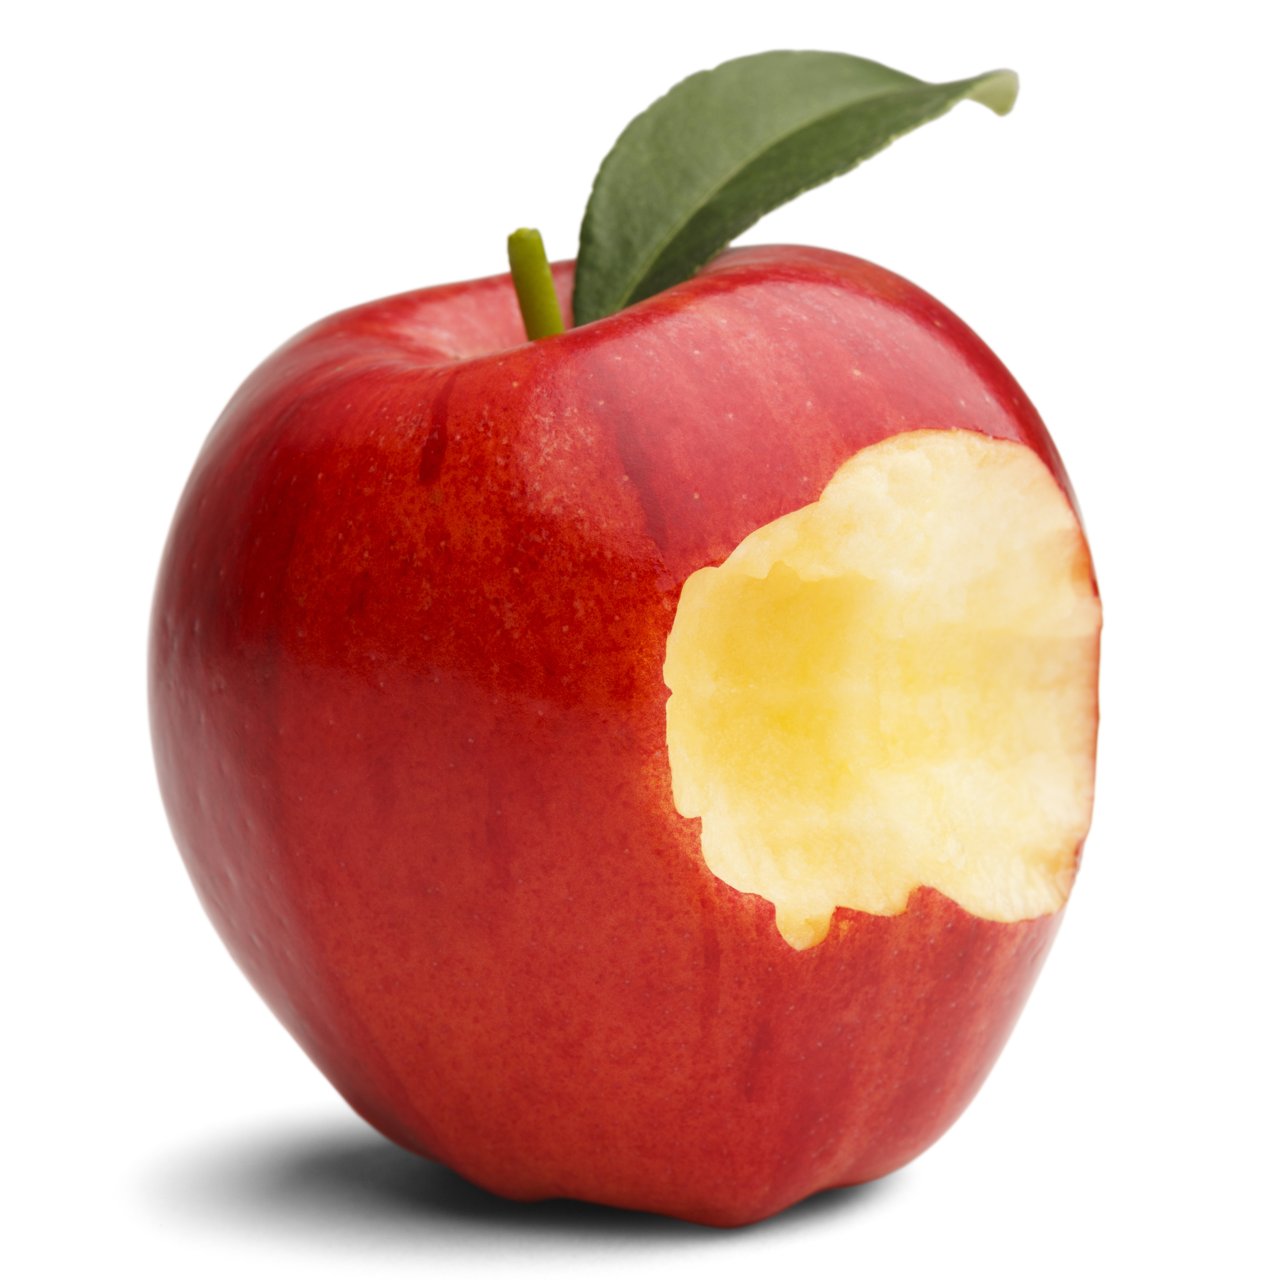  Milk/Beverage | Soup of the Day  Pork Roast and Sauerkraut  Mashed Potatoes & Gravy  Cooked Carrots  Applesauce  Bread/Roll  Lemon Pie  Milk/Beverage | Soup of the Day  Beef Stroganoff  Mashed Potatoes & Gravy  Green Beans  Tossed Salad or Whipped Jell-O  Bread/ Roll  Cherry Pie  Milk/Beverage | Soup of the Day  Meatloaf  Fried Potatoes  Mixed Vegetables  Tropical Fruit Salad  Dinner Roll  Frosted Peanut Butter Fingers  Milk/Beverage | Soup of the Day  Poor Man’s Lobster  Steak Fries  Cooked Carrots  Cole Slaw  Bread/Roll  Banana Cream Pie  Milk/Beverage | Soup of the Day  Baked Ham  Mashed Potatoes & Gravy  Broccoli/ Cauliflower  Blushing Pears  Bread/Roll  Pumpkin Pie  Milk/Beverage
BBQ Pork Sandwich  French Fries  Fresh Fruit  or  Fresh Fruit Plate w/Cottage Cheese  Golden Pumpkin Dessert  Milk/Beverage | Tuna Salad or Ground Bologna Sandwich  Chips  Orange Fluff  Pear Slices  Black Forrest Cake  Milk/Beverage | Cup of Chicken Noodle soup and Pigs in a Blanket  Fruited Jell-O Tapioca Pudding  Milk Beverage | Hamburger  Baked Beans  Chips  Pickles/Relishes  Peaches  Caramel Sundae  Milk/Beverage | Chile  Egg Salad Sandwich  Applesauce  Pineapple Torte  Milk/Beverage | Pizza  or  Deluxe salad  Mandarin Jello Salad  Ice cream Treats  Beverage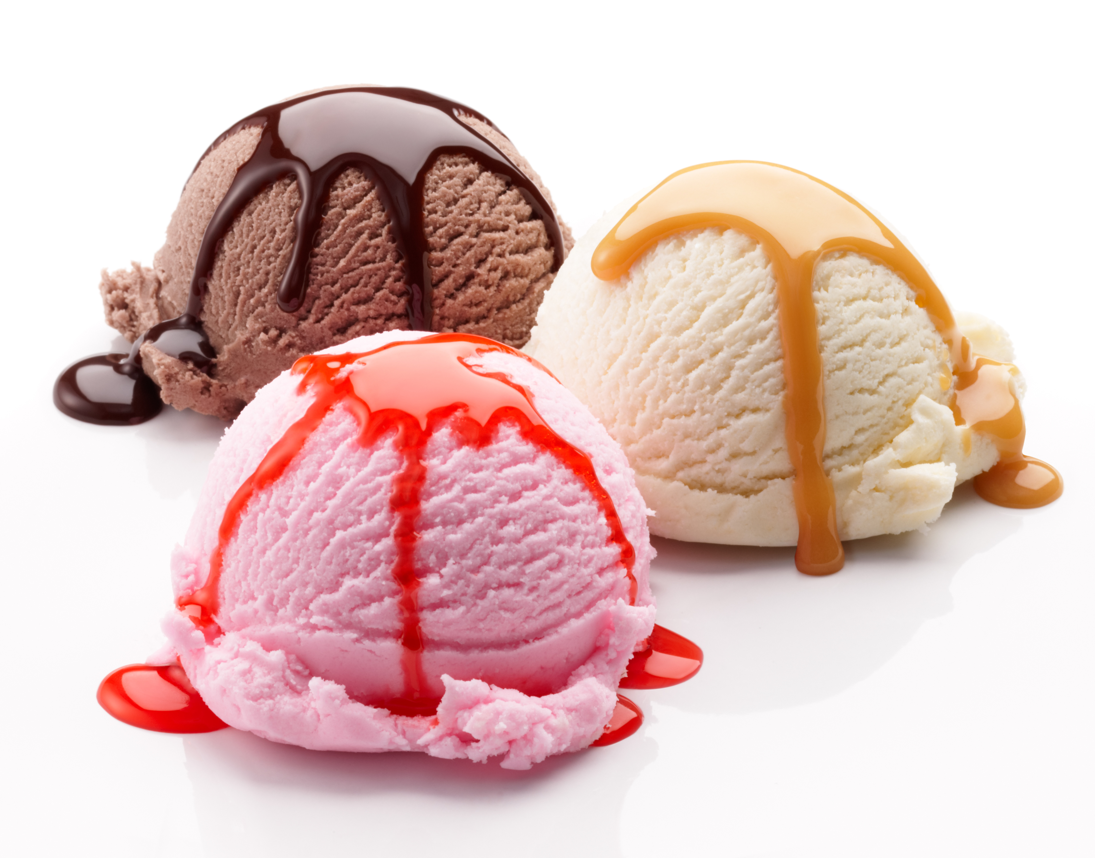 | Hot Roast Turkey on a Bun  Tater Tots  Carrot Salad  Pudding or Cookies  Milk/Beverage

