
Mere House
Day Nursery
Tel : 01942717694
Email : merehousedaynursery@gmail.com

“Because every child deserves a home away from home”

Mission statement/ethos/approach
Holistic approach
Outdoor ethos
Unique learning opportunities
Staff that are nurturing
Exciting experiences

Holistic approach – We focus on the whole child and use In The Moment Planning and The curiosity Approach to allow the child to progress at their own rate. We have done a lot of research on ‘Natural’ and ‘minimal’ distractions to aid each child individually.
Outdoor ethos – We have our own area outside designed to imitate Forest School to give each child an experience within the outside world. The 3 main rules are “Look after yourself, Look after your friends, Look after the forest”. Promoting a lot of learning and ‘risky play’ that cannot be offered inside. We also have another large outdoor space that we have free flowing access to, including vegetable plots and outdoor classrooms. We regularly take trips into the local community to encourage cultural experiences.
Unique learning opportunities – Each key worker knows their children ‘inside out’ and we moderate regularly to make sure this is correct. Next steps are focused on the needs of each individual child.
Staff that are nurturing – all staff have a great bond with their children and parents and spend a lot of time building this trust and connection. Parents are encouraged to discuss concerns and work as a team to offer the best possible opportunities for their child.
Exciting experiences – We offer lots of varieties of activities inside, outside and within the community for each child. We also offer extra opportunities such as French lessons, sports sessions, Christmas Nativities, yearly trips.

✓✓ Thank you for taking the time to read through our nursery prospectus. Our nursery is part of a group of four nurseries who all share the same vision, educational ethos and approach to working with children and families.
We are located on the grounds of Nicol Mere Primary School, allowing us to be the prime feeder into the school (as well as a few others).

Learning through play

Meet our management team

Proprietors
Mere House Day Nursery Limited is owned by Carla Lee and Harriet Wilson. Carla Lee has an NVQ level 4 and 20 years experience as an owner and manager Children’s Day Nurseries. Harriet has Qualified Teacher Status (QTS), a Post Graduate Certificate in Education and a degree in Sports and Nutrition. Harriet also has over 10 years experience as an Owner and Area Manager of the nurseries.
Management
The manager at Mere House Day Nursery is Lauren & the deputy manager is Lesley Ann. Lauren is Level 3 qualified & has 12 years experience in early years. Lesley Ann has an Early Years Degree & over 20 years experience in early years.

The rest of our team
Each of our rooms is supported by a Nursery Room Lead Supervisor who is qualified to N.V.Q Level 3 or above. We also employ N.V.Q Level 2 and 3 staff who are deployed throughout the building. All staff hold an up to date, enhanced DBS Check. It is a requirement that anyone working in our Nursery receives training and approved certificates on Child Protection/Safeguarding, Food Hygiene and First Aid. Staff are encouraged to expand their knowledge in areas of child care which is of interest to them and regularly attend courses run by our Local Early Years Department. In addition, we provide in house training to support our staff’s development .

Our special places

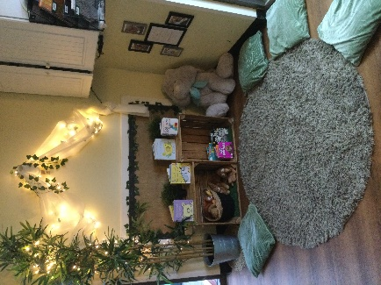
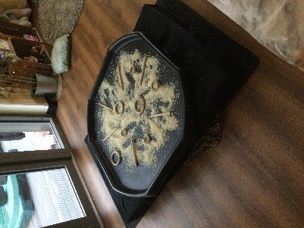
Baby room
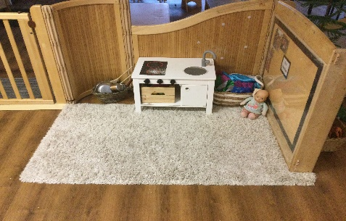

All our babies start their journey at Mere House in this room. The routines are tailored to your individual baby while preparing them for their progression into the Toddler room. A full range of age-appropriate toys and creative activities are available for your child to learn and discover with the support of our experienced baby room staff. These staff have attended specialist training in working with babies.

Throughout the entire nursery we deliver activities which follow the EYFS curriculum. In the baby room, there is a real focus on the prime areas of learning. As part of our educational programs for babies we promote sensory play, music and movement and we deliver toddler talk activities for older babies. As a setting we strongly consider our baby room environment, making sure that there are quieter areas for the babies to access.

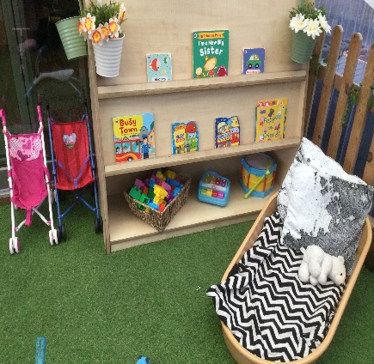
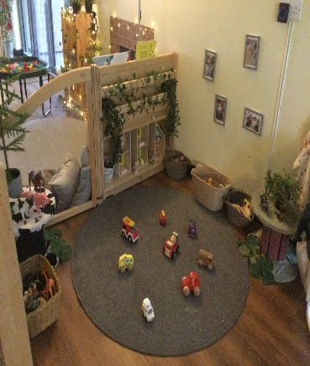
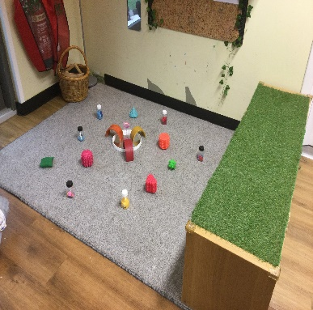

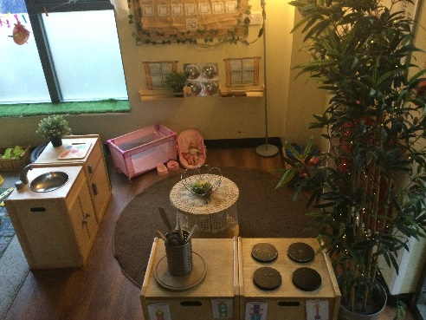
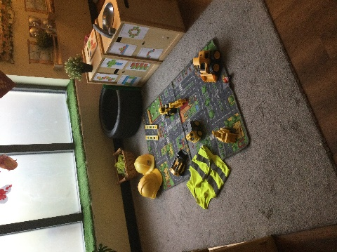
Toddler room
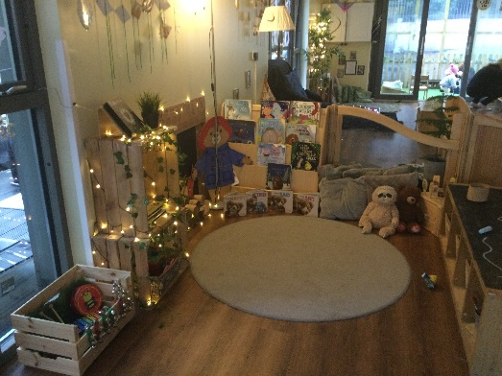

As your child grows, develops and becomes more mobile they will progress into the Toddler room. Being a toddler is often a very busy time in a child’s life and developmentally, children cover large milestones. Children are often assisted with toileting at this age, as well as learning boundaries and developing their personal, social and emotional skills. As part of the toddler room routines, we promote independence and personal choice through our continuous provision.

We continue to promote the prime areas of the EYFS, however children also begin to develop in the specific areas of learning. Focused activities are carefully planned in accordance with each child’s individual developmental requirements which are monitored. We are a language rich environment to support learning and development for toddlers.

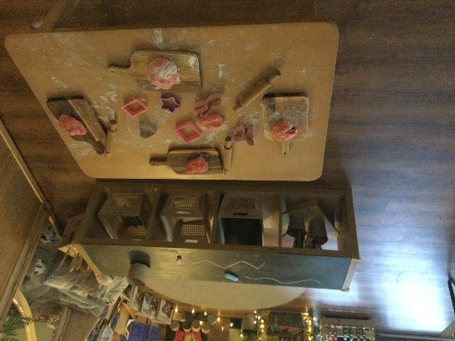
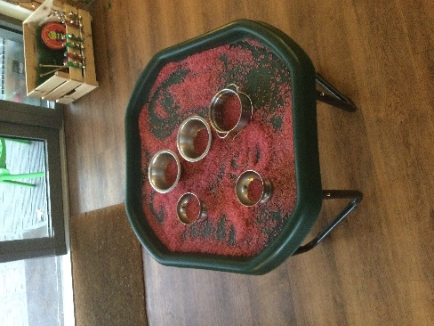
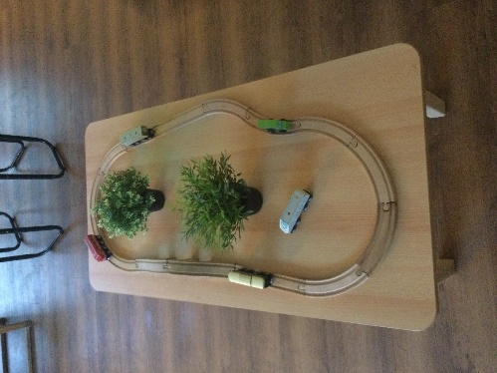

Pre school room
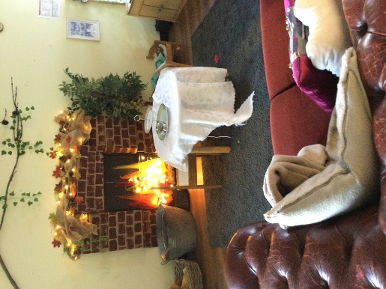
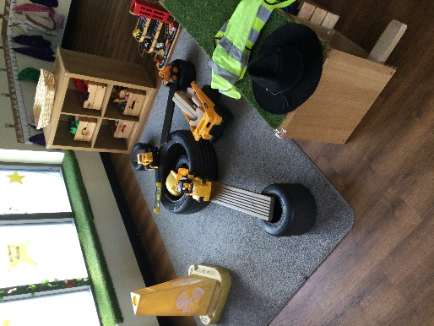
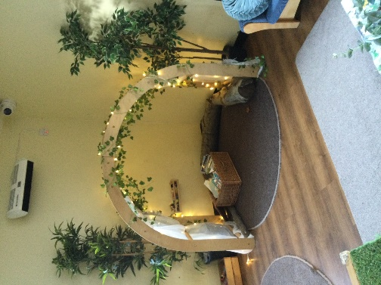

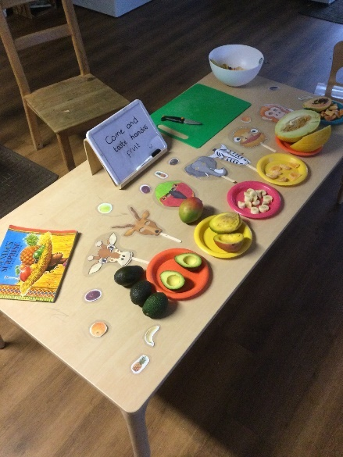
As children’s confidence grows and they start to demonstrate skills in building relationships they are becoming ready for school and we will help this transaction in our preschool room. We work with the local primary schools to ensure the child’s transition is a smooth as possible.
Through play children improve their knowledge and understanding of the world. We have the opportunity to offer interactive ICT equipment for the children, math’s, literacy, sports lessons, forest school sessions and sign language.
Again, this room has an open plan and free following design to always allow access to both inside and outside. We also introduce set group times to allow children to start to experience the focus they will be set in school, in this we will discuss phonics, math’s, social skills and culture to name a few examples.

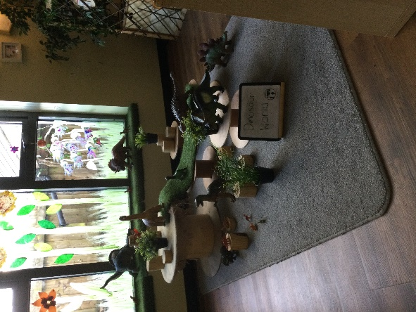
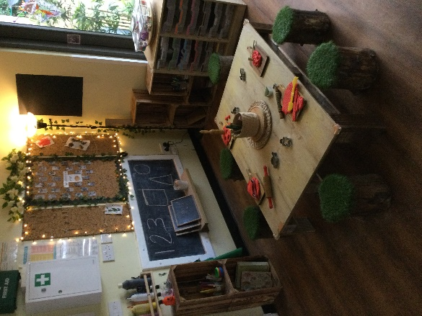

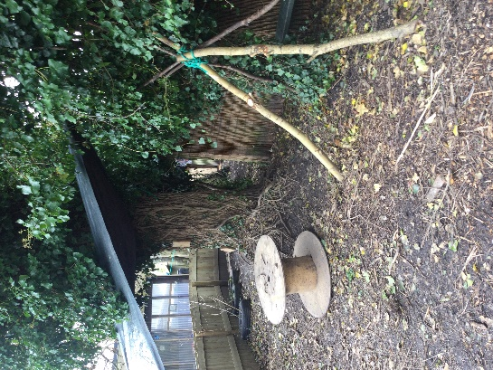
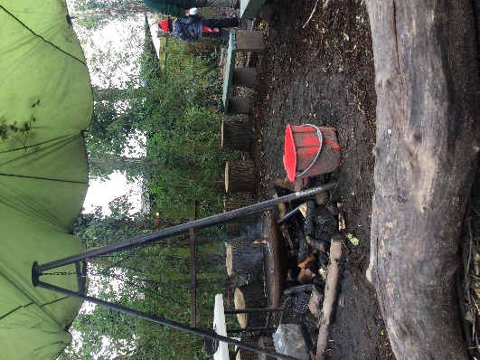
Forest school

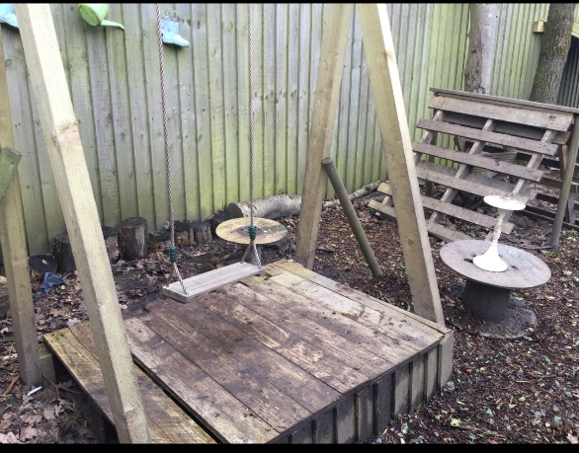
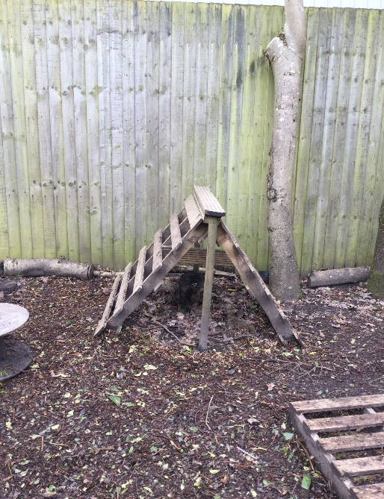
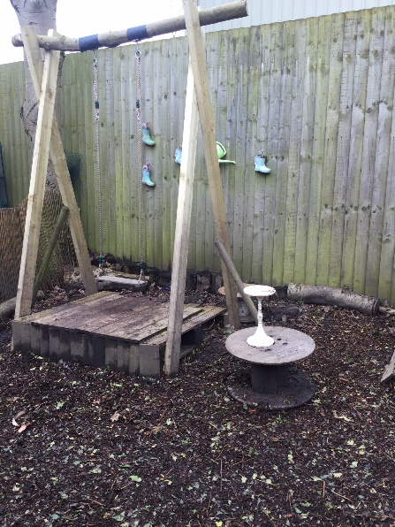
Forest school is a child led programme based in the natural environment in the grounds of the nursery. Forest school aims to provide opportunities for children to take appropriate risks and build holistic development.
Play Wilder forest school as Mere House provides a stimulating environment where both children and staff form a great bond together, whilst taking part in activities using natural resources.
The children have experiences such as den bulling, fire lighting, tool work, planting, climbing And balancing. These experiences expand the children’s knowledge helping towards their intellectual development.

Parents as partners

 Parents/main carers are children’s first and most enduring educators. When parents and practitioners work together in a nursery the results have a positive impact on a child’s development and learning. We therefore seek to develop an effective partnership with all parents. Each child is assigned a Key Person. Their role is to help your child become familiar with our nursery and to feel safe and confident within it, and also to develop their learning and understanding of the world. They also talk to parents to make sure that the needs of your child are being met appropriately.
Careful records of your child’s development and progress are created and shared with parents regularly online (2simple) and parents are asked to contribute to this journey. We also have a separate online system which is sent daily to parents to acknowledge daily needs and activities whilst the children are in our care, this includes meals ate, accidents had, activities partaken in and any other personal information parents needs to be made aware of.
 Open Door Policy:
Please feel free to visit the nursery with or without an appointment. We want parents to feel free to come into the Nursery and join in with activities, to have an informal chat about their child or to help with an activity that they may have a certain skill or knowledge about. Appointments can be made with a member of staff if a parent/carer wants to talk about their child, in confidence for a longer period.
 We want all parents to understand our curriculum (EYFS) and we share our observations with parents on a monthly basis. Parents can also send achievements/interests into nursery using the same format. We hold a termly Parents evening.

The Early Years Foundation Stage (EYFS)

 The Early Years Foundation Stage is implemented throughout the nursery. This is a very important stage as it helps your child get ready for school as well as preparing them for their future learning and successes. From when your child is born up until the age of 5, their early years experience should be happy, active, exciting, fun and secure; and support their development, care and learning needs.

 In 2024 the framework was revised to make it clearer and easier to use, with more focus on the things that matter most. This new framework also has a greater emphasis on your role in helping your child develop. It has seven learning areas, these are divided between prime and specific areas of learning and development.

 We ensure parents have the opportunity to review their child’s progress with the nursery on a regular basis. For children we produce daily records containing information about your child’s day, meals eaten, nappy changing and toileting, sleeping and rest times and a general picture of their wellbeing throughout their time at nursery. Daily handover of children both morning and evening is also used as an opportunity to share information. We also inform parents of our topics and planned activities through a regular newsletter. For more information please the visit website: www.ofsted.gov.uk.

Fees
(Fees increase annually in line with inflation) Fees accurate for 2024:
 Full time (weekly) £288 (Over 2), £302 (under 2)

 Daily rate £63 (over 2), £65.70 (under 2)

 Half - day rate £36 (over 2), £37.20 ( under 2)

 All children have free ‘settling in’ sessions prior to taking up a place at the nursery.

 Help with the cost of child care is available in a number of ways. Please contact us for further details.

 Free nursery education place: 15 or 11 hours/30 or 22 hours nursery education funding for all 3 - 5 year olds. 15 or 11 hours free childcare is also available to some 2 year olds.

 Working families tax credit: This helps working parents with the cost of childcare. Call the helpline on - 0845 300 3900

 Child tax credit: 9 out of 10 families are entitled to child tax credit whether they work or not.

 We accept childcare vouchers from employers to help with nursery fees.

