All Saints Lutheran Church, ELCA
421 SW 19th St. Blue Springs, Missouri 64015 816-229-3633
Pastor Sarah Pierce Spierce.aslcpastor@gmail.com
allsaintslc64015@gmail.com https://aslcbs.org/

Sunday, March 24, 2024

Palm Sunday

You are absolutely invited into this sacred space. We welcome all who are seeking God’s love and grace. All Saints recognizes that we are all unique and beloved children of God. We celebrate and give thanks for the many diverse gifts that God has given us. We affirm the sacredness of people of all sexual orientations, gender identities, and gender expressions. We affirm the sacredness of all those who have experienced exclusion because of race, ability, age, or culture. We are committed to working towards anti-racism in ourselves and our community. We affirm the sacredness of all those who wrestle with addiction, physical or mental health, imprisonment, socio-economic circumstances, or anything that too often divides us. We believe that through our openness we all grow in our faith through Christ’s teaching to love one another as God loves us. We need each other and our sincere hope is by being in community together, we will experience God’s presence in new and real ways.

The offering plate is by the main door to the sanctuary for your convenience.

We practice open communion at All Saints Lutheran Church. What does that mean? It means that if you believe and trust that Christ offers his body and blood For You, you are welcome at the table. At All Saints, we believe that Christ invites all people to the feast. “Come to the banquet for all is now ready.”

**Stand as you are comfortable

Prelude

Announcements

**ACCLAMATION
Blessed is the one who comes in the name of the Lord.
Hosanna in the highest.

Blessed is the one who comes in the name of the Lord.
Hosanna in the highest.

Blessed is the one who comes in the name of the Lord.
Hosanna in the highest.

**Announcement of the Processional Gospel
Glory to you, O Lord.

**Gospel: Processional Mark 11:1-11

¹As they approached Jerusalem and came to Bethphage and Bethany at the Mount of Olives, Jesus sent off two of the disciples ²with this instruction: “Go to the village straight ahead of you, and as soon as you enter it you will find tethered there a colt on which no one has ridden. Untie it and bring it back. ³If anyone says to you, ‘Why are you doing that?’ say, ‘The Rabbi needs it, but will send it back very soon.”’ ⁴So they went off, and finding a colt tethered out on the street near a gate, they untied it. ⁵Some of the bystanders said to them, “What do you mean by untying that colt?” ⁶They answered as Jesus had told them to, and the people let them take it. ⁷They brought the colt to Jesus and threw their cloaks across its back, and he sat on it. ⁸Many people spread their cloaks on the road, while others spread leafy branches which they had cut from the fields. ⁹And everyone around Jesus, in front or in back of him, cried out,
“Hosanna!
Blessed is the One who comes in the name of our God!
¹⁰Blessed is the coming reign of our ancestor David!
Hosanna in the highest!”
¹¹Jesus entered Jerusalem and went into the Temple precincts. He inspected everything there, but since it was already late in the afternoon, he went out to Bethany accompanied by the Twelve.

The Gospel of the Lord.
Praise to you, O Christ.

**BLESSING OF PALMS

The Lord be with you.
And also with you.

Let us pray.

We praise you, O God,
for redeeming the world through our Savior Jesus Christ.
Today he entered the holy city in triumph
and was proclaimed messiah and king
by those who spread garments and branches along his way.
Bless these branches and those who carry them.
Grant us grace to follow our Lord in the way of the cross,
so that, joined to his death and resurrection,
we enter into life with you;
through the same Jesus Christ,
who lives and reigns with you and the Holy Spirit,
one God, now and forever.
Amen.

**PROCESSION with Palms
Let us go forth in peace,
in the name of Christ. Amen.

**Processional Hymn All Glory, Laud, and Honor ELW#344

**Prayer of the Day

Jesus, today we cry Hosanna! Blessed is the One who comes in the name of our God! Even as we cry these words, make us mindful of those who suffer in our midst and in our community. Inspire us to accompany them in their suffering, as you accompany us. Amen.

Reading: Psalm 118:25-29

²⁵Please, YHWH, please save us!
Please, YHWH, give us prosperity now!
²⁶Blessings on the one who comes in the name of YHWH!
we bless you from YHWH’s temple!
²⁷YHWH is God and God has enlightened us.
Join the festal procession!
With palm fronds in hand,
go up to the horns of the altar!
²⁸You are my God, and I thank you;
you are my God, and I exalt you.
thank you for hearing me,
for saving me.
²⁹Thank you, YHWH, for your goodness!
Your love is everlasting!

The Word of the Lord
Thanks be to God

**Gospel Acclamation
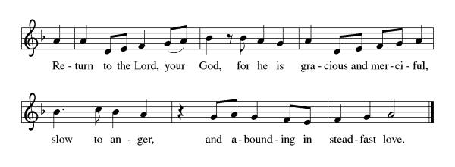
Announcement of the Gospel
Glory to you, O Lord.

Gospel: Mark 14:1-15:47

The Gospel of the Lord.
Praise to you, O Christ.

Reflection

Hymn of the Day Alas! And Did My Savior Bleed ELW#337

** Affirmation of Faith – Immigrant’s Creed by Jose Luis Casal

I believe in Almighty God, who guided the people in exile and in exodus, the God of Joseph in Egypt and Daniel in Babylon, the God of foreigners and immigrants.

I believe in Jesus Christ, a displaced Galilean, who was born away from his people and his home, who fled his country with his parents when his life was in danger. When he returned to his own country he suffered under the oppression of Pontius Pilate, the servant of a foreign power. Jesus was persecuted, beaten, tortured, and unjustly condemned to death. But on the third day Jesus rose from the dead, not as a scorned foreigner but to offer us citizenship in God’s kingdom.

I believe in the Holy Spirit, the eternal immigrant from God’s kingdom among us, who speaks all languages, lives in all countries, and reunites all races.

I believe that the Church is the secure home for foreigners and for all believers. I believe that the communion of saints begins when we embrace all God’s people in all their diversity. I believe in forgiveness, which makes us all equal before God, and in reconciliation, which heals our brokenness. I believe that in the Resurrection God will unite us as one people in which all are distinct and all are alike at the same time. I believe in life eternal, in which no one will be foreigner but all will be citizens of the kingdom where God reigns forever and ever. Amen.

**Prayers of Intercession

God, we offer our prayers for ourselves, our community and the World you love.

Blessed One, today the church sings glad hosannas as we enter Holy Week. Prepare us to bear witness to Christ’s suffering and death endured for our sake. Gather your people around the cross and comfort us with resurrection hope. Hear us, O God.
Your mercy is great.
Renew your good creation and protect the balance of life on earth. Encourage the work of foresters, scientists, arborists, gardeners, and river keepers. We pray for the health of pollinating insects, songbirds, and native plants. Hear us, O God.
Your mercy is great.
Establish peace and justice among the nations of Haiti, Ukraine, Palestine and Israel. Hold to account any with authority to judge others. Grant that courts, legislatures, and local governments will serve with integrity and compassion. Hear us, O God.
Your mercy is great.
Bring hope to any who feel forsaken or forgotten. Make a way for refugees and asylum seekers. Reunite families enduring separation. We pray for any who are incarcerated, institutionalized, or in foster care, that they may know your love. Hear us, O God.
Your mercy is great.
Give energy and joy to our pastor, deacons, worship leaders, and musicians. Bless baptismal candidates, their sponsors, confirmand Addison Antes, and teachers. Watch over those who travel. Hear us, O God.
Your mercy is great.
Merciful God, your love heals. Care tenderly for all whose loved ones perished from pandemic disease in every nation. Strengthen health care workers, first responders, and caregivers. Relieve all who live with chronic illness and pain especially Monty, Bob, Paul, Linda, Dylan, Matt, Pastor Sarah, Elaine, Becky O, Pete, Niel, Becky (Jean’s neighbor), the family of Andi (Pastor’s co-worker) and the people of Israel and Palestine. We pray especially for anyone living with cancer or chronic illness, all people who are in physical rehabilitation or addiction recovery, and those experiencing complications from long COVID. Guide us to offer hospitality, shelter, friendship, and care to any in need. Hear us, O God.
Your mercy is great.
God of learning, we lift up all who teach and all who learn. Thank you for teachers who share their knowledge and wisdom. Bless the students in our midst. Especially we remember Zach, who graduates from high school this year, Kimberly, who is studying in Prague, and Katy, who is studying in Paris. Hear us, O God.
Your mercy is great.
Blessed One, our times are in your hand. Sustain us in discipleship throughout our lives and receive us into everlasting life.
Your mercy is great.

God, we know you hear our prayers and answer them with love and care for us.
Amen.

** Sharing of the Peace

**Offering is brought forward

** Offertory Response

As the Grains of Wheat(Refrain Only) ELW #465

**Offertory Prayer

Good and loving God, we give to you these offerings of our time, our talents, and our money, for the work of your people in this place, as we seek to follow your Son. Prepare our hearts and minds to come to your Table, as you feed us with the life-giving body and blood of your son Jesus Christ, through whom we receive the gift of eternal life.
Amen.

**Dialogue
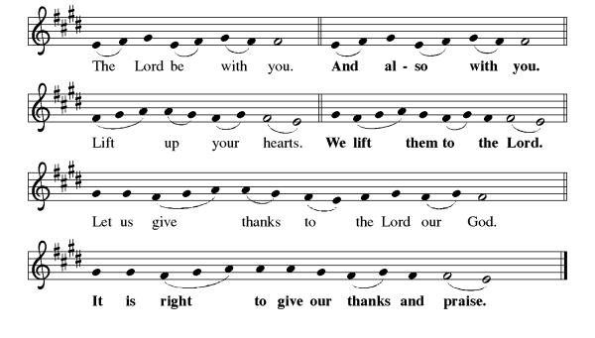
**Preface: John baptized with water…this hymn of praise:

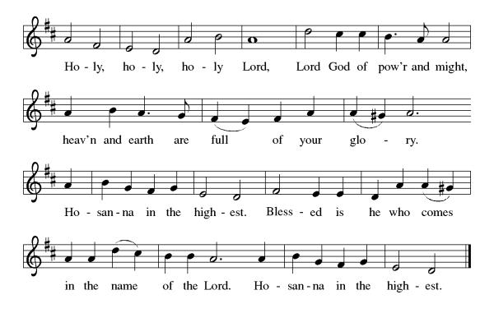
**Words of Institution

**LORD’S PRAYER
Our Loving God in heaven, hallowed be your Name,
Your kingdom come, your will be done, on earth as in heaven.
Give us today our daily bread.
Forgive us our sins as we forgive those who sin against us.
Save us from the time of trial, and deliver us from evil.
For the dominion, the power, and the glory are yours, now and forever. Amen.

Invitation to Communion

Communion Hymn Jesus, Keep Me Near the Cross ELW #335

**Sending Song

Dona nobis pacem ELW#753

**Prayer After Communion

Holy and Eternal God, we have been fed at your Table with the goodness of our Savior. Send us out, emboldened to share the good news of your promise of forgiveness and eternal life. Strengthen our resolve to respond to the needs of our neighbors and to care for your world. Amen.

**Blessing

**Closing Hymn Ride On, Ride On in Majesty! ELW#346

**Dismissal
Go in peace. Serve in Love.
THANKS BE TO GOD!

+ + + + + +

Hymns from the Evangelical Lutheran Worship are under copyright and used with permission under One License #733618-A. Specific copyright information as listed in bulletin excerpts from the ELW setting 4 and the Prayers of Intercession are under copyright and are used with permission under Augsburg Fortress Liturgy License #SB155933. All other liturgy written by Sarah Pierce.

Weekly Attendance
Week of March 17
19
******************************************************************************************
Calendar of Events
Today
- Wear your Work Clothes to Church
March 26-Creatice Friends 1:00 pm
March 26-Bells Practice 6:30 pm
March 28-Maundy Thursday Worship 7:00 pm
March 30-Easter Vigil 7:30 pm
March 31-Easter
March 31-Bells Play Jesus Shall Reign & All Glory Laud and Honor

Join us for our Annual Auction fundraiser. We will be having a semi-formal event at The Farm & The Odd Fellows, 205 W Second St Minneapolis, KS, while the auction will be held online April 22nd - 27th. Doors open at 6:00p. $50 per couple. $35 for individual. There will be food and drinks available. We can't wait to see you there!
CTS Team, #ForTheKids
You may recall that there has been an announcement in the bulletin over the past year directing you to Lutheran Immigration and Refugee Services (LIRS) if you wish to support the people of Ukraine. LIRS has changed its name to Global Refuge and can be found at globalrefuge.org. Although their name has changed, their mission remains the same: to assist and support refugees in the United States and around the world. Visit their website to see all the ways you can support this important work.

Bishop Candea reminds us that as followers of Christ, we are to pray for and support the most vulnerable among us. She pointed out that right now, the most vulnerable people in the world are the women, children, and elderly people living in the Gaza Strip.

All members are welcome to attend regularly scheduled council meetings. Additionally, the Council would like to remind you that the most recent Council reports and minutes are available on the bulletin board in the narthex.
*****************************************************************************************
BLUE SPRINGS COMMUNITY SERVICE LEAGUE is very appreciative of your continued support of your neighbor.
******************************************************************************************
Questions for Reflection and Discussion
- We make quite a journey this morning in our texts – from a triumphant entry into Jerusalem to Jesus’ arrest and crucifixion. These are familiar stories, ones we hear every year. What did you hear this year in a new way, or what did you hear that you haven’t heard before?
- Crucifixion was a common method of execution in the Roman Empire. The vertical poles would have been in place already, on the main roads leading into the cities, and Jesus would have carried the horizontal beam for his cross. The point of crucifixion was less about the execution and more about making an example, to try to scare other people out of committing the same crime.
- There are many different theological points of view on exactly why the crucifixion happened. My least favorite of these is that God engineered this whole thing – sending Jesus to earth so that he would die for our sins – because what kind of a God would do that? What kind of a parent would do that? Instead, I lean more in the direction of believing that this was politically motivated. Jesus was a trouble-maker and the powers that be, both Jewish and Roman, wanted to get him out of the way, and God used these events as they unfolded to proclaim forgiveness of sins and resurrection from the dead. What sort of theological perspective do you embrace about Jesus’ death?
- It’s easy to read this story, to picture in our minds’ eyes the taunting and abuse that Jesus received after his arrest and even while he was on the cross, and think, “Why didn’t somebody do something?” How often do we wonder this about the violence that we see unfolding in our world, sometimes in our communities? Who is the somebody who should do something? Is it us? Or should we sit back and let someone else do something?
- In the commentary for Good Friday on the Working Preacher site, Amanda Brobst-Renaud reflects on the horror of the cross, and how it mirrors our world today. She writes, “Jesus reflects this narrative back to us as we encounter human suffering. ‘God used our sin to save us from that sin. God did this so that victims of such acts would never be invisible – they look too much like Jesus.’ Jesus’ solidarity with victims of violence, oppression, and tyrannical regimes reflects back our own complicity in these systems. James Cone asserts that this solidarity is the scandal of the Gospel: ‘The real scandal of the gospel is this: humanity’s salvation is revealed in the cross of the condemned criminal Jesus, and humanity’s salvation is available only through our solidarity with the crucified people in our midst.’” (The first quote is from S. Mark Heim in “Saved by What Shouldn’t Happen: The Anti-Sacrificial Meaning of the Cross.” The second quote is from James Cone in “The Cross and the Lynching Tree.”)

******************************************************************************************

Birthday
March 25 David Fast
March 30 Carla Girkin

Anniversary
March 30 Tom & Pam Meek

Greeter
March 24 Donna Taylor

Usher
March 24 Paul Blixrud

Altar Guild
March 24 Sara Meyers

Reader
March 24 Tracy Nelson

Communion Assistant
March 24 Tracy Nelson

Tech
March 24 Gary & Zach Antes

Prayer Requests
Monty Health Concerns (May 15)
Paul Health Concerns (May 31)
Linda Health Concerns (May 16)
Dylan Military Service (September 06)
Pastor Sarah Health Concerns (October 03)
Matt Health Concerns (November 06)
Elaine Health Concerns (January 23)
Becky O Health Concerns (January 29)
Pete Health Concerns (February 05)
Becky (Jean’s neighbor) Health Concerns (March 06)
Niel Health Concerns (March 06)

Please pray for the family of Andi (Pastor’s co-worker).

Please pray for the people of Haiti, Ukraine, Israel and Palestine.
Please pray for the Homeless.

We remember all of the children and adults who are engaged in learning, as well as their teachers, instructors and professors. Please bless their partnerships in instruction so that they all are supported in the learning process. We lift up especially Zach, who is graduating from high school in May, and Katy and Kimberly who are studying abroad in Paris and Prague this semester.

