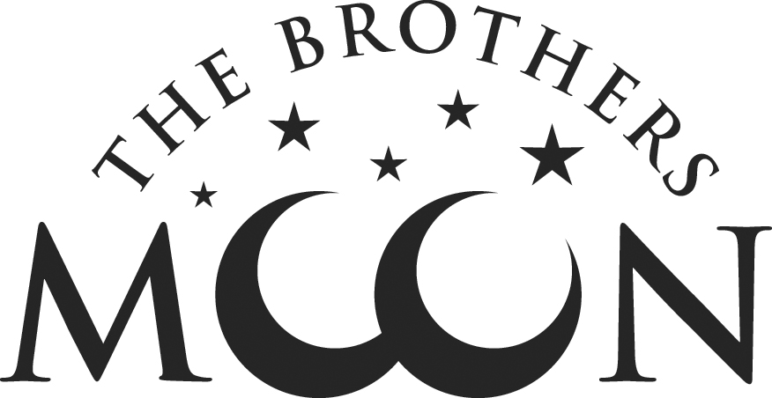
7 W. Broad Street ~ Hopewell ~ NJ 08525
609-333-1330 ~ brothersmoon.com

Vegan Menu
Friday, February 16, 2018

First Course
Butternut squash soup, sesame, zaatar 8

Tomato puree soup, quinoa, pickled garlic scape and basil 8

Grilled filoni, curry cauliflower, mushrooms, arugula, roasted garlic 9

Mesclun greens, roasted mushrooms, broccoli and balsamic vinaigrette 11

Chopped romaine and turmeric ginger kraut salad, toasted cauliflower, red pepper vinaigrette 11

Main Courses
Roasted portobello, three grain tempeh, braised cabbage, cauliflower, baba ganough 17

Locally grown mushroom risotto, coconut milk, parsley and nutritional yeast 19

Grilled asparagus over beet quinoa salad with herbs 13

Bowtie pasta, asparagus and roasted tomato, white beans, tomato sauce 16

Sesame ginger tofu, stir-fry vegetables, kimchi, maple soy glaze 17

Sides
Roasted broccoli, harissa, lemon zest 5

Parsley and olive roasted Yukon potatoes 5

Dessert 9
Mango and coconut sorbet with berries

Chocolate cake with berries and coconut caramel

Meringue, berries, berry sauce

Please like and share us on Facebook, twitter, Instagram, Pinterest

