Early Years Foundation Stage Framework
Information for Parents and Carers
The Early Years Foundation Stage (EYFS) statutory framework is a government document that all schools and Ofsted-registered early years providers in England must follow. It sets standards for the learning, development and care of your child from birth to 5 years old. The standards ensure your child will learn and develop well and are kept healthy and safe.
What Is the Early Years Foundation Stage Statutory Framework?

What Will My Child Be Learning?
The EYFS framework outlines seven areas of learning and development and educational programmes. There are three prime areas of learning, which are particularly important for your child’s development and future learning:
physical development
personal, social and emotional development
communication and language

There are four specific areas of learning, through which the prime areas are strengthened and applied:
literacy
mathematics
understanding the world
expressive arts and design
Early years practitioners also use your child’s needs and interests to plan challenging and enjoyable activities and experiences.

How Will My Child Be Learning?
The EYFS framework identifies the essential role of play in your child’s development. It is through both child-led play and play guided by an adult that your child will develop confidence and relationships with others. Through play, EYFS practitioners will help your child to extend their vocabulary and develop their communication skills.
The EYFS framework identifies three characteristics of effective teaching and learning:
playing and exploring
active learning
creating and thinking critically
Guided teaching activities will enable specific skills to be taught as your child progresses through their reception year, these will help them to prepare for year one.

How Will I Know How My Child Is Doing?
The partnership between Parent/Carer and EYFS practitioners is key to enabling a child to achieve their full potential in the Reception Year. We share information about your child’s progress formally at Oct and Feb parent meetings and informally on a daily or weekly basis through conversations and comments in the Homework book or Reading diary.
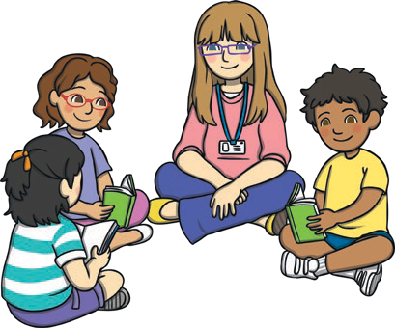
In the Summer term your child will be assessed against the Early Learning Goals (ELGs) these make up your child’s Early Years Foundation Stage Profile. We will share this with you at the end of the EYFS through the end of year report. This will inform you of your child’s progress and whether they have met or are continuing to work towards their early learning goals (ELGs). There are 17 ELGs your child is expected to achieve by the end of the EYFS.

