Steak Salad with a Horseradish Dijon dressing and Fresh Horseradish chips
Ingredients
2 ea 4 oz flat iron steaks or sirloin steaks
6 slices fresh Horseradish
1 TBSP fresh shredded horseradish
4 oz buttermilk
2 TBSP Flour
2 TBSP cornstarch
6 oz Horseradish Dressing ( see below)
4 cups mixed greens
¼ diced cucumbers
¼ carrots sliced thin
6 ea pear tomatoes, cut in half
Season steak with salt and pepper and sear or grill until your doneness
Tossed greens with dressing and place on bowl, slice steak and put over greens, top steak with the fried and shredded chips.
For Chips and shredded fried horseradish
Place sliced and shredded horseradish in the buttermilk and soak for 5 minutes. Drain through colander and toss in the flour/cornstarch mix and fry in oil until crisp. Drain in paper towels
Horseradish Dressing
1 egg
1 TBSP prepared horseradish
1 tsp fresh shredded horseradish
2 TBSP Dijon mustard
1 Teasp chopped garlic
6 oz olive oil
Combine all the ingredients except the oil in a bowl. Add the oil to the mix as you whip slowly until incorporated. Adjust with salt and pepper and let stand for 30 minutes
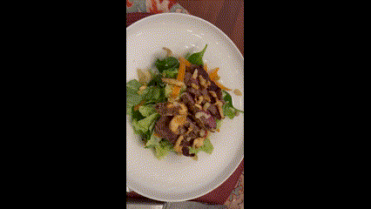

https://www.youtube.com/watch?v=rAQHDs7f1I4&t=12s

