NORTHERN CALIFORNIA CAMELLIA SOCIETY APRIL 2023

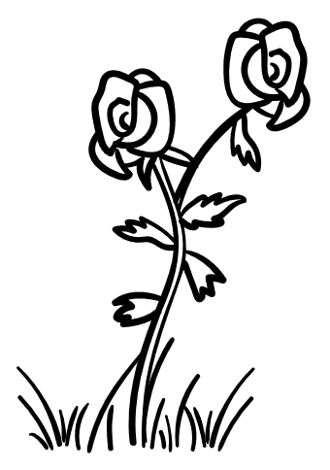 Petal Pushers

CALENDAR FOR YEAR 2023
February 5- NCCS Meeting 2PM
February 18 - Justin’s Mini Show
February 25/26 - Peninsula Show
March 4/5 - Sacramento Show
March 5 - NCCS Meeting 2PM
March 11/12 - Nor Cal Show
March 18/19 - Modesto Show
March 25 – Justin’s Mini Show
April 2 - NCCS Meeting 2PM
May 6 - DeVino’s 2PM
July 15 – Christmas in July

THINGS TO DO THIS MONTH
- Fertilize
- Keep plants hydrated

NCCS AND ACS DUES FOR 2023
NCCS + ACS - $10 + $30 = $40 2 Years
NCCS + ACS - $20 + $58 = $78 3 Years
NCCS + ACS - $30 + $80 = $110 1 Year
NCCS ONLY - $10
IF YOU HAVE NOT PAID YOUR DUES FOR 2023 PLEASE DO SO ASAP. MAKE CHECKS PAYABLE TO NCCS.

Send to NCCS
c/o Jay Humiston
754 Palm Ave
Martinez, CA 94553

FUN FACT
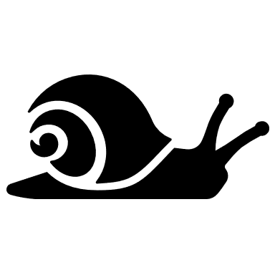
Did you know that snails take the longest naps? One nap can last up to THREE YEARS! WOW!!!

APRIL MEETING
APRIL meeting will be on Sunday, April 2nd at 2PM at Saint Andrews Celebration Center, 1601 Mary Drive, Pleasant Hill.
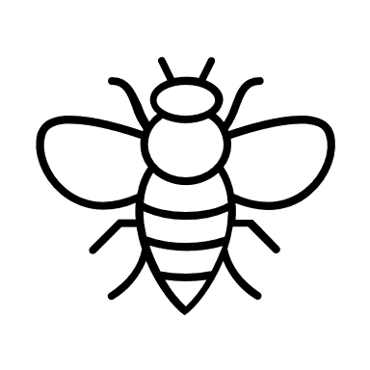
Our program this month will be all about BEES. Linda Kancev will be informing us about raising bees and the different types of honey that bees produce. Don’t miss out-we will have a chance to taste the honey. YUM!

HOT OFF THE PRESS
GUESS WHAT….That’s right another chance to enter blooms. Justin Bergamini will be hosting another mini show on Saturday, March 25th.
Let’s give our blooms one more chance to shine!

Show Details:
3675 Mount Diablo Blvd, Lafayette
Bloom placement 7AM-930AM

IN OTHER NEWS

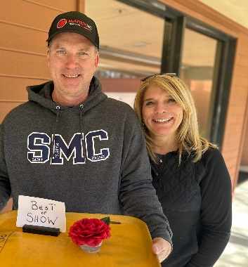
Congratulations to Jay and Joellen. They won their first Best of Show with Bella Jinhua at the mini show.

