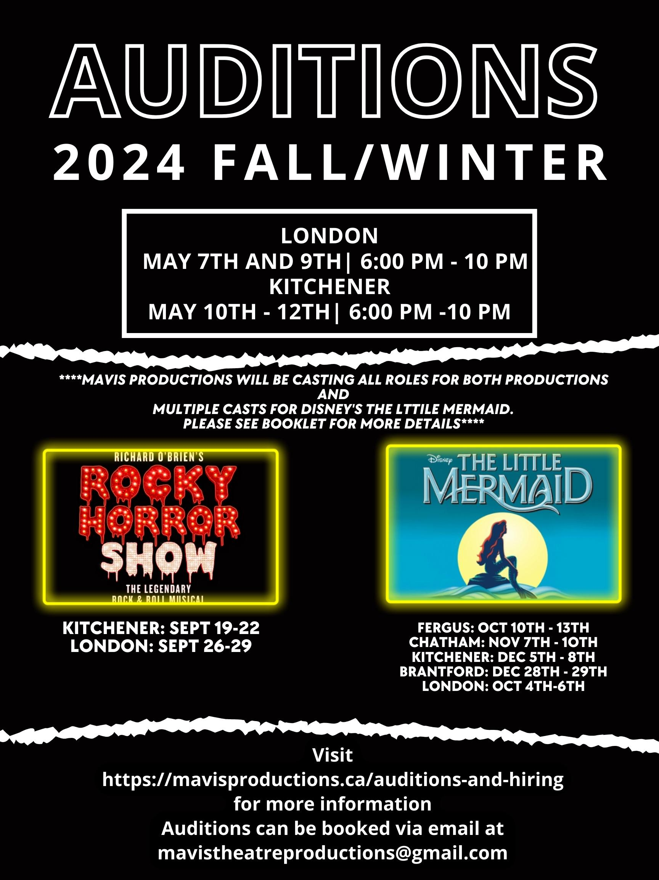
MAVIS PRODUCTIONS
FALL/WINTER 2024 AUDITION FORM
Disney’s “The Little Mermaid”
“The Rocky Horror Show”
“Evil Dead: The Musical”
Introduction
Greetings Everyone! On behalf of Mavis Productions, thank you all for your interest in our upcoming 2024 Fall/Winter Season!
Companies generally focus on 1-2 productions in 1 city per season. We have never been like most companies. We are determined to bring something unique and new to ALL our communities that have supported us so patiently.
As a result, we are producing THREE incredible productions (each with at least 2 weekends of performances, each week being in a DIFFERENT CITY ACROSS SOUTHWESTERN ONTARIO!)
This could not be done without the amazingly talented crew so thank you all so much. But, just as important, this could not be done without the talent and dedication of our performers. We are so excited to see / meet all of you. We thank you for sharing your talents with us!
We cannot wait so see you all there.
Break a Leg!
Chase Montgomery
Owner/Founder of Mavis Productions

What do I need to prepare?
Kitchener Auditions: The ArtsBuild @ 44 Gaukel St, Kitchener, ON N2G 4P3
London Auditions: The Riverbend Academy @ 2436 Gideon Dr, Delaware, ON N0L 1E0
Each audition is approx 10 minutes long. We advise everyone auditioning to wear or have comfortable clothes they can move in.
Upon arrival at the audition space, you will see a sign directing you to the waiting area. Due to the sheer volume of auditions, we are asking everyone to arrive at least 10 minutes early to warm up yourselves and get comfortable. If you are running late, while we will do everything to accommodate, we may be unable to get to your audition in a timely manner OR you might have less time to show us your abilities than arranged. So, we suggest you plan to arrive early.
When you are comfortable in the waiting area, please be sure to either have your audition form ready, or fill one out.
NOTE: We do prefer the audition forms emailed to us @
mavistheatreproductions@gmail.com in advance so we may look it over and be able to give you more time for your audition.
When we are ready, we will invite you in for your audition. The casting panel will consist of the director and some of their crew from each production.
Don’t worry, they are all lovely people and just as excited to see you.
There will be a Bluetooth speaker available for you to pair your audio device to. You are also welcome/encouraged to submit your audition/backing audio track(s) to give yourself more time to audition instead of spending time pairing.
Auditioning Performers may perform 1 song and 1 monologue OR 2 songs of contrasting styles. Each selection should be NO LONGER THAN 3 MINUTES. We may also ask you to complete a simple vocal harmony activity, to get a sense of how easily you pick up on learning vocals and sing with others.
After the songs/monologue, the directors will have you perform either a scene study OR do an improv study with you.
Generally, they ask some questions about you to get to know you better. This is a great time to ask questions as well!
When your audition is complete, all auditioning will be asked to stay for the dance audition. They will run from 7:40 to 8:10 and the last half an hour of auditions. This is meant to see how quickly you pick things up, the characterization you can bring to your dance/character, as well as the dance skills you possess. Don’t worry, it is meant to be fun and we promise to make it so. After the dance portion, we will dismiss everyone as we will have to continue on with the next set of auditions.
If you have any further questions, please don’t hesitate to reach out to us at
mavistheatreproductions@gmail.com
*****PLEASE NOTE: ANYONE UNDER THE AGE OF 18 MUST BE ACCOMPANIED BY A
PARENT/GUARDIAN*****

Audition Form
Name: ________________________________________________________________
Address (incl apt#): ______________________________________________________
City: __________________________________________
Postal Code: ______________________
Age (if under 18):______________
Cell/ Phone: _____________________________________
E-Mail Address: __________________________________________
Role(s) and Show(s) you are auditioning for:

Would you be willing to accept another role? YES or NO (PLEASE BE HONEST)
Would you like to be considered for part of the ensemble(s)? YES or NO (PLEASE BE HONEST)
Are you interested in being involved in multiple shows if needed? YES or NO (PLEASE BE HONEST)
Vocal Range: (please circle one) Soprano Alto Tenor Baritone Bass

How much time can you commit to personal practice, outside of scheduled rehearsals? ____________________________________
Previous Experience/Shows: (if you’d like to share)
__________________________________________________________________________________________________________________________________________________________________________________________________________________
How did you hear about the auditions:
____________________________________________________________________________________________________________________________________________

Should I become a member of the cast, I will (Please checkmark):
o Abide by any/all Mavis Productions’ safety protocols as mandated by the Government at any time during the rehearsal/performance period including, but not limited to, wearing a face mask, practicing social distancing, etc.
o Attend ALL rehearsals as called (unless otherwise arranged with the Director). Rehearsals are held
***The Little Mermaid:
London Cast: Thursdays 6:00 – 10:00 pm at Riverbend Academy
Kitchener Cast: Sundays 2:00–6:00 pm at C.O.R.E Dance Project (74 Scott Ave, Paris, ON N3L 3R1)
***The Rocky Horror Show***
Every Tuesday 6:00-10:00 at Riverbend Academy in Delaware
***Evil Dead: The Musical***
Every Sunday 6:00 - 10:00 at Core Dance Project (74 Scott Ave, Paris, ON N3L 3R1)
*****NOTE: THESE REHEARSAL SCHEDULES ARE SUBJECT TO BE ADJUSTED/CHANGED BASED ON CAST AVAILABILITY. We will be doing everything in our power to make sure that the schedule works best for all/majority of our performers’ schedules.****
**IMPORTANT: Please list any conflicts you are currently aware of and/or any other potential shows you may be involved with during this rehearsal period:
____________________________________________________________________________________________________________________________________________________________________________________________________________________________________________________________________________________
o Assist with venue move-in and move-out for shows.
o Assist with venue move-in and move-out for shows.
I have read and accept the information outlined above regarding rehearsals, attendance and volunteer participation and safety regulations.
Signature: __________________________________________
Date: _______________________________
Parent Signature (if under 18) ___________________________
Date: _______________________________
BONUS QUESTION WE WILL ASK YOU TO ANSWER IN YOUR AUDITION
Who is the better Disney Princess...Explain your choice
1) Ursula
2) Frank ’N’ Furter
3) Ashley Williams

