The Key to
St. Peter DECEMBER 2023

And in the same region there were shepherds out in the field, keeping watch over their flock by night. And an angel of the Lord appeared to them, and the glory of the Lord shone around them, and they were filled with great fear. And the angel said to them, “Fear not, for behold, I bring you good news of great joy that will be for all the people. For unto you is born this day in the city of David a Savior, who is Christ the Lord. And this will be a sign for you: you will find a baby wrapped in swaddling cloths and lying in a manger.” And suddenly there was with the angel a multitude of the heavenly host praising God and saying,

“Glory to God in the highest,
and on earth peace among those with whom he is pleased!”

Every year, when Christmas draws near, I pull out the “Christmas Movie” box, after watching Die Hard and Die Hard 2, I start to watch the more traditional Christmas movies. When it comes time for A Charlie Brown Christmas, I get all nostalgic. There is a scene in which I never realized the gravity. In that scene, Linus is reciting Luke’s nativity (Luke 2:1 – 20). When Linus gets to the line “Fear not, …” he drops his security blanket. Linus is physically relating what the scripture means.

Currently, we are still seeing horrific things happening around the world, but we need to listen to the message from the angel. “Fear not,”. When the time comes for God to gather us into His arms and bring us home, we will not be fearful or anxious. We will not need our security blanket.

During this time of the year, let us remember in our prayers all those who cannot be with us. Those serving in the armed forces, those living in independent living, dependent living, or nursing homes, and those living far away. May God bless all for whom we pray.

Pastor De Young

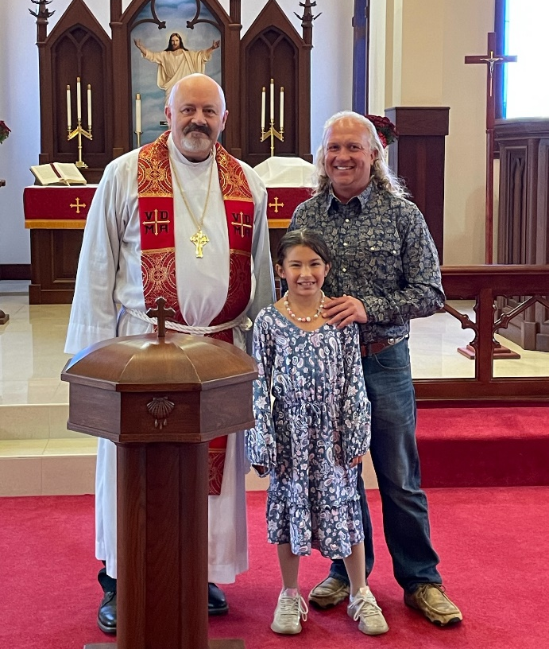
Welcome to the family of God and to St. Peter Lutheran Church,

Jo Osbon and Annellee Osbon

Baptized on Reformation Sunday 2023

We were therefore buried with him through baptism into death in order that, just as Christ was raised from the dead through the glory of the Father, we too may live a new life.
Romans 6:4

Celebrate December’s Baptism Birthdays
& their years as born-again heirs
of God’s kingdom!
1st Brent Shaw – 25 years
3rd Autumn Greenroy 40
3rd Debbie Jones 33
13th Todd Hammer 63
20th Cody Lawson 41
25th Bailey Anderson 28
25th Grace George 3
31st Davin George 5

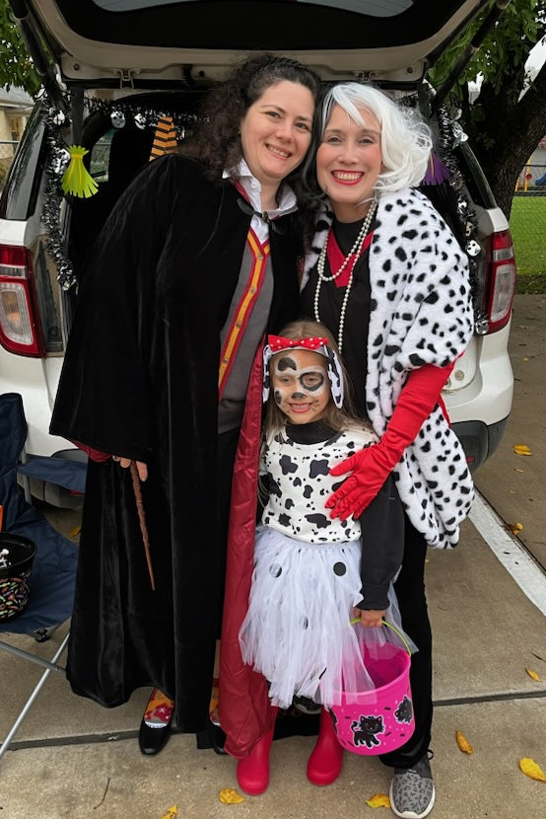
Trunk-or-Treat
&
Youth
Pumpkin Carving

You are cordially invited to this year’s
This Photo by Unknown Author is licensed under CC BY-NC
This Photo by Unknown Author is licensed under CC BY-NC
LWML CHRISTMAS PARTY

on December 11th at 6:30 p.m. in the Fellowship Hall
This Photo by Unknown Author is licensed under CC BY-NC
Bring finger foods to share.
There will be games to play.
Drinks are provided.

We will be gathering travel size hygiene products and small fleece throws for under-privileged children at Bowie Middle School.
Bring as many of these items as you can to help our young ones in need.
This Photo by Unknown Author is licensed under CC BY
This Photo by Unknown Author is licensed under CC BY-ND
Author is licensed under CC BY-NC-ND

YOUTH GARDENING DAY
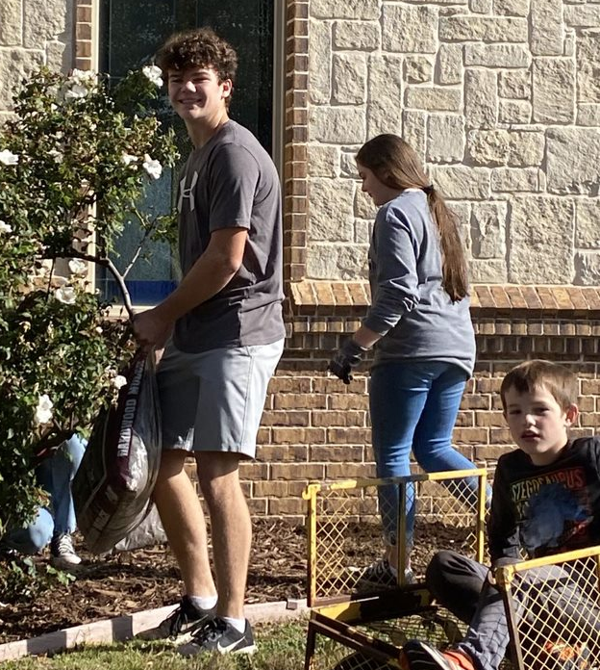

THEY CAME…
THEY CONQUERED!

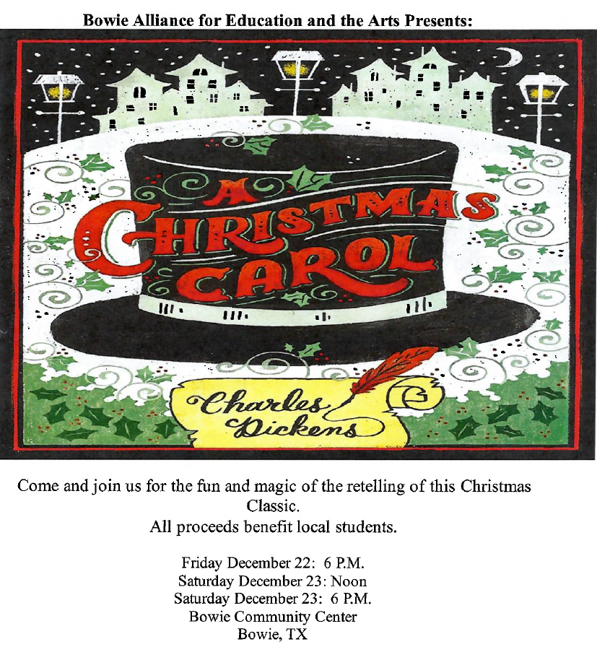
Tickets are $10 plus service fee.
Buy Tickets at
www.bowieallianceforeducationandthearts.com/events-1

2023 Convention Proceedings
are available in the church office.

The whole St Peter family extends a huge “THANK YOU” to Christy Murphree for her year of service as our Church Secretary. We are sorry that family circumstances are making a move to Wisconsin necessary. Personally, she has become a wonderful friend and great learner (and wonderful Office Organizer )and I will miss her and her daughter Erin very much. - Joanne

SERVING IN GOD’S HOUSE THIS MONTH
Readers
December 3 - Arn Anderson
December 10 – Bryan Roth
December 17 – William Pickett
December 24 – Lee Hughes
December 31 – Arn Anderson
Acolytes
December 3 – Emily Keyes & Parker Lawson
December 10 – Archer Ferguson & Max Gilmore
December 17 – Karlee & Reagan Hughes
December 24 – Charlie & Rayleigh Pace
December 31 – Bella Caswell & Ailey Pickett
Dear Church Family,
Thank you from the bottom of my heart for allowing me to work with you this past year. It has been such a blessing to be your church secretary. I have grown to love you all so very much! It is sure funny how God works in our lives; I was so afraid to take this job and now I am so sad to leave it, and all of you! Life calls me to another place…it’s a cold place…it is Wisconsin. Yikes! But I must go, and I pray you will all be well and always be fed with our God’s holy word and sacrament. What a joy and privilege to receive His word and sacrament in such a beautiful place.
My love to you all,
Christy
P.S. Don’t forget to call or text!
Altar Care
Maci Ferguson
Jana Gilmore
Altar Guild
Kristen Henry
Rebecca Horton
Counters
Darren Gill
Gary Rainwater
Elder
Don Unger

