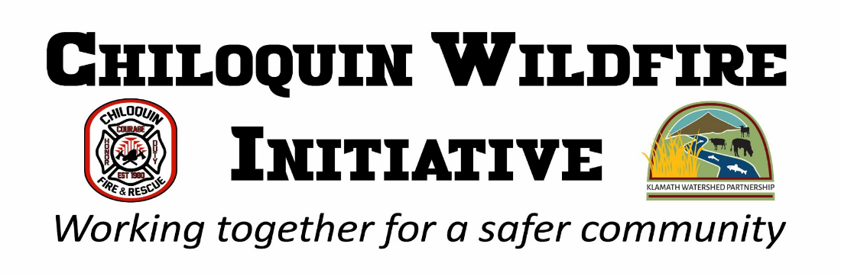

Defensible Space Mitigation Dump Trailer Request form
Name of landowner: ___________________________________
Address: _____________________________________________
Phone #: _____________________________________________
Approximate size of lot: _________________________________
Date(s) requested __________________

Are you able to do the mitigation work yourself? Y/N
If not, please email our mitigation specialist, Leslie Cook. Chiloquinwms@outlook.com
Do you have a place away from the main roadway on level (or fairly level) ground where the trailer will be able to be placed? Y/N
Does the designated place for the trailer have an easy turn-around (20 ft) or pull-through, for easy pick-up and delivery? Y/N
Have you ever participated in a defensible space program for this address? Y/N
If so, when? _____________ Through which program? _______________________
What was done? ______________________________________________________________________
____________________________________________________________________________________
____________________________________________________________________________________
Were you able to maintain the improvements? Y/N

Thank you for submitting a request. You will receive a call back within 1 working week to schedule an in-person assessment of your property. You or a representative that will be completing the work must be onsite during the assessment.
We will then schedule a time for the trailer(s) to be dropped off and picked up. At that time, we will provide a contract to participate in the Chiloquin Wildfire Initiative program and regulations for use of the trailer(s).

