Sick! Trading Card Lesson

Challenge your students to create trading cards based on the examples found on page 58 and 59 of Sick! The Twists and Turns Behind Animal Germs.

Single Lesson: Each student researches and creates one card based on the diseases included in Sick! or another single resource.

Advanced Lesson: Each student creates several cards based on characters from one chapter of Sick! The Twists and Turns Behind Animal Germs. (See chart on next page.) Using the examples found on page 58 and 59, develop grade appropriate labels for the other categories of characters (i.e for , categories may be potential hosts, part of the body, symptoms they cause, etc.). Each student researches using the book and other resources, then creates an illustration and text for the provided templates. Let the trading begin!

Animal, Warrior, Microbe (based on Rock, Paper, Scissors): Two students meet, say “Animal, Warrior, Microbe” and flip their top card. Animals beat Immune Warriors, Immune Warriors beat Microbes, Microbes beat Animals. When the same category is flipped, it is a tie. Players shake hands and play again. When a student wins, they add the loosing card to their deck, and go play someone else.

Research Resources:
Infectious Disease Trading Cards, middle and high school, https://www.cdc.gov/museum/cards.htm
Meet the Bugs, middle and high school, page 16-18 https://e-bug-prod-stack-s3bucket-qfn1eoa6k1na.s3.amazonaws.com/eu-west-2/documents/gb_c_btb_meet_the_bugs_-_2017.pdf

Characters from Sick!
(Where more than one character is listed, students may choose)

Chapter | Human | Animal | Immune Warriors (and friends) | Microbes  (& Friends)
1 | Mike Huffman,  Mohamedi Seifu Kalunde | Chimpanzee | Leaves | Nodular Worm (Oesophagostomum stephanostumum)
2 | Cori Richards Zawacki | Panamanian Golden Frog | Slime | Chytrid Fungus (Batrachochytrium dendrobatidis)
3 | Christopher Pull | Garden Ant | Acid | Metarhizium brunneum
4 | Mark Merchant | American Alligator | Neutrophil,  Antimicrobial peptides (AMPs) | Staphylococcus aureus
5 | Gary Graves | Turkey Vulture | Stomach and Enzymes | Bacteria
6 | Raymond Casterman,  Cecile Casterman | Camel | B cell, Antibody | Virus
7 | Aaron Irving | Flying Fox | Innate Immune System (Macrophage, Natural Killer Cell, Neutrophil) | Virus
8 | Heather Henter,  Nancy Moran,  Molly Hunter,  Kerry Oliver | Pea Aphid | Hamiltonella defensa,  APSE Virus | Wasp

Additional Characters:
Clostridium Bacteria (Clostridum perfringens)
Cold Virus
Coronavirus
Tapeworm
Hookworm
Macrophage
Natural Killer Cell
T Cell
Lysozymes
Dendritic Cell
Mast Cell
Skin

Artwork by Lindsey Leigh, from Sick! The Twists and Turns Behind Animal Germs
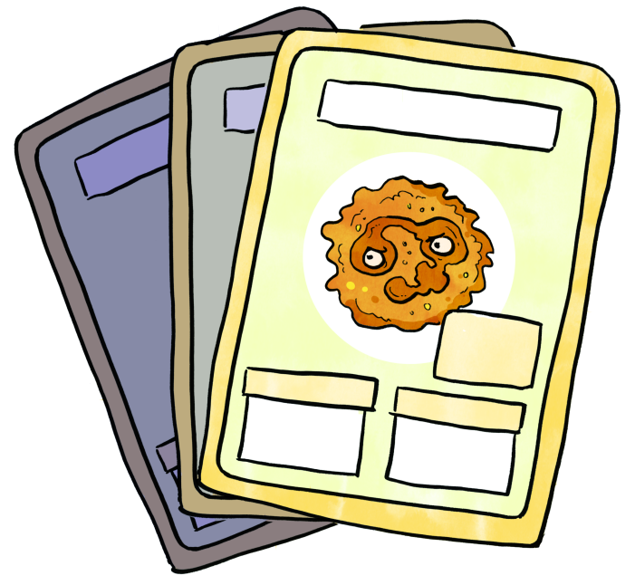
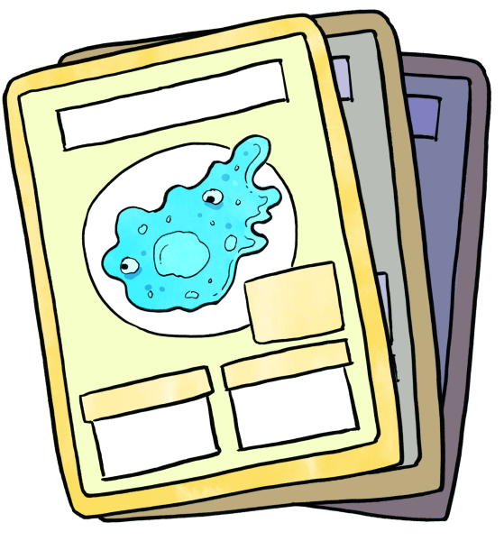
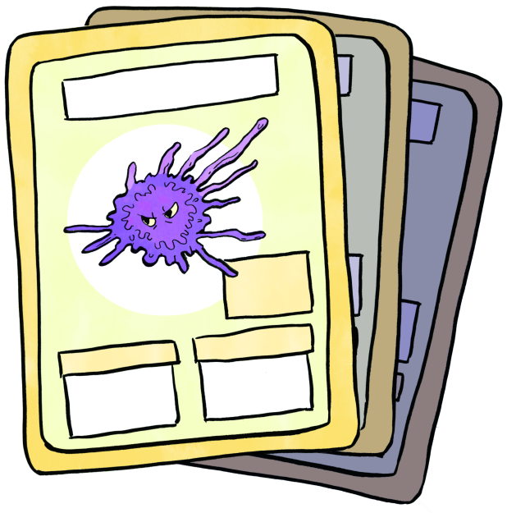
Artwork by Lindsey Leigh
From Sick! The Twists and Turns Behind Animal Germs

